TERMS OF REFERENCE
PROJECT NAME: CLIMATE-RESILIENT WASH AND LIVELIHOODS PACKAGE FOR RESILIENT SOMALI LANDSCAPES
PROJECT NUMBER: SOM 1065
TOR FOR ALUMINUM/STEEL MILK CONTAINER FOR MILK PRODUCERS AINABO AND ODWAYNE DISTRICTS.
Date: 18th February 2025
- INTRODUCTION
SOM1065 (Climate-resilient Wash and Livelihoods Package for Somali) project funded by BMZ. The project will be implemented from 18th August 2023 till 31st July 2027 in two regions namely Sool (Caynabo) and Togdheer (Odwayne) regions in Somaliland.
- BACKGROUND

The Climate-resilient WASH and Livelihoods Package for Resilient Somali Landscapes project (SOM1065) aims to strengthen the livelihoods and resilience of vulnerable agrarian and agropastoralist people by protecting and restoring key natural resources and WASH services in agrarian, pastoral, and agropastoral. Most Somaliland people are agro-pastoral families who largely depend on livestock and agriculture for their livelihoods. In Somaliland, milk is the primary source of income and sustenance for thousands of smallholder dairy farmers. The demand for dairy produce is high, and the produce is mainly sold to the peri-urban/urban sprawl. The major dairy product growth opportunity in Somaliland in general is fresh milk which impacts upon the livelihoods of tens of thousands, the vast majority of whom are low- to middle-income milk producer households. Fresh milk has a short shelf-life because of the high temperature, fresh cow milk has a shelf-life of just 5-9 hours, camel 12 hours, and goat 24 hours. Milk volume and value is also lost to high temperature and poor handling practices. This leads to unavailability of milk in the market throughout the days which also contributes to poor accessibility of safe and nutritious milk in Somaliland affecting food security and child nutrition.
Based on the participatory evaluation reports from target areas. One of the key challenges that the participatory report related to the poor hygienic conditions of utilized containers (plastic jerry cans), the mix of evening with morning milk and of milk from different animals in herd camps. Therefore, Welthungerhilfe plans to distribute modern milk collection and storage equipment along with training programs on proper handling and hygiene practices to Dairy value chain groups in Odwayne and Ainabo Districts.

- OBJECTIVES
- To encourage existing milk producers and milk bulkers businesses and effectively operate as independent milk and milk products sellers.
- To support small milk traders and catapult them from the constraints limiting the initiations and development of their business.
- To support and give them milk containers.
- To support groups, cooperatives, and association of milk producers
- To support the traders and improve their storage capacity.
- To create model milk traders for both women and youth to encourage youth to employ themselves and their fellow youth.
- EXPECTED OUTCOMES
- Encourage existing milk producers and milk bulkers businesses and effectively operate as independent milk and milk products sellers.
- Supported small milk traders and catapult them from the constraints limiting the initiations and development of their business.
- Supported and gave them milk containers.
- Supported groups, cooperatives, and association of milk producers.
- Supported the traders and improved their storage capacity.
- Created model milk traders for both women and youth to encourage youth to employ themselves and their fellow youth.

- ACTIVITY BUDGET AND BUDGET LINES
NO | ITEM | UNIT | QTY | UNIT PRICE ($) | TOTAL ($) | Budget line
A | BILL OF MATERIALS
1 | Aluminum/steel milk container | pcs | 282
2 | Milk cup 0.5 L MOVKZACV Stainless Steel Measuring Cup Milk Frothing Jug with Scale(size:5000ml) | pcs | 282
3 | Pot Aluminum 6 Quart Heavy Duty 6 mm Thick | pcs | 282
4 | Plastic Sieve Filter | pcs | 282
5 | In order to make it very clear, the project has attached a photo of the intended item as an annex
Total

- APPROVALS

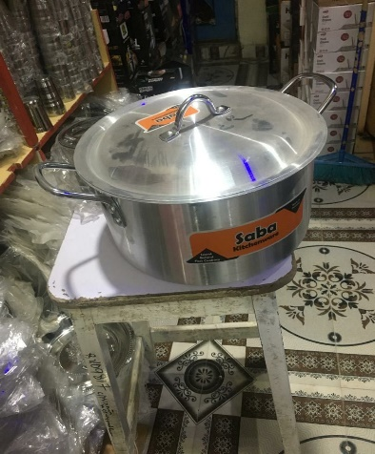
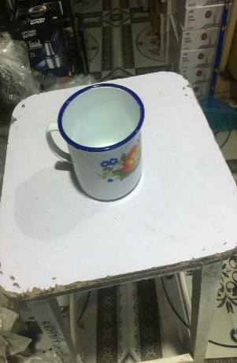
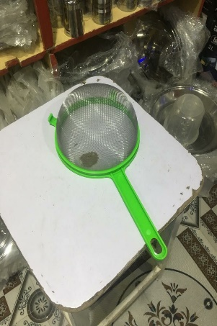
- ANNEX
Figure 1 Pot Aluminum
Figure 3 Milk cup 0.5 L
Figure 4 Plastic Sieve Filter
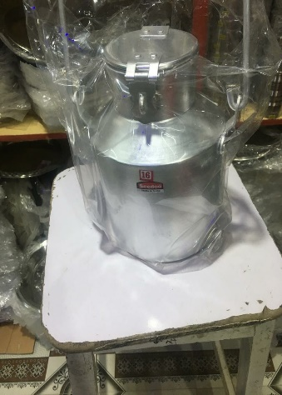
Figure 2 Aluminum/steel milk container, 5L

