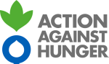

Terms of Reference
Hydrogeological/Geophysical Survey & Borehole Drilling in Jowhar district
Location: Jowhar District, Hirshabelle State, Middle Shabelle region, Somalia

- Background
Action Against Hunger is one of the major humanitarian actors in Somalia since May 1992. Action Against Hunger entry into the country was because of a major famine outbreak in 1992, which claimed many lives. During its 32-year presence, ACF has provided support in Nutrition; Health; Water, Sanitation & Hygiene; and Food Security and livelihood sectors in six (6) regions namely Lower Jubba, Banadir, Bakool, Gedo, Bay, and Nugaal regions. Currently, ACF is present in Eight regions of South-Central Somalia namely Bay, Bakool, Banadir, Middle Shabelle, Sool, Lower Juba, and Lower Shabelle, and in Puntland (Nugaal region). In 1995, due to overwhelming humanitarian needs in Mogadishu, ACF launched a health and nutrition program in the city, which has been running to date. With the deteriorating humanitarian situation in South-Central Somalia in 1999, ACF responded to the crisis by opening a base in Luuq (Gedo region) and five years later opened operations in the Bakool region, which continued to run to date. Operations in Lower Shabelle and Nugaal regions were opened in 2013/14. ACF has developed programs in nutrition, health, food security, and WASH sectors in these areas.
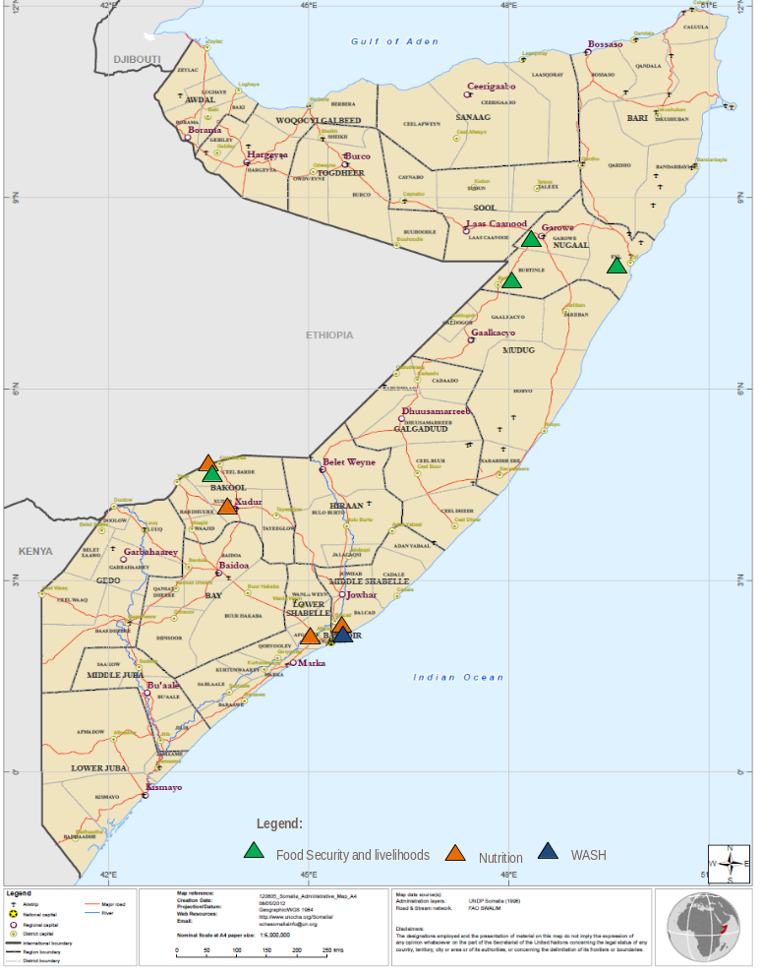

1.1 Location
Baraki Village is one of the villages under the Jowhar district administration, Middle Shabelle region. The village is 18 km Northwest of Jowhar Town and approximately 120km from Mogadishu. It sits at an altitude of 2.8346 N 45.3906 E. The village is generally hot, sunny, and dry and has an estimated population of 849 Households that are agropastoral majorly dependent on subsistence farming with several undocumented daily pastoralist movements. The village is located at an intersection and serves as a hub for five remote villages in the district.
It hosts mostly marginalized and agro-pastoralist dropouts who lost their farms and livestock during the recent droughts and subsequent flooding and shocks that affected their livelihoods. The village had been experiencing a shortage of water due to constant rain failure. The scarcity of water is a major challenge for the Baraki community and the neighboring villages, and all depend on their domestic water for Dabeyley borehole water which is around Five (5) km away from the Village. However, the Baraki communities yearn to one day have access to sustainable water infrastructure (boreholes) that can reduce the water needs and further improve access to water for multiple uses. The main source of livelihood for the community is farming accompanied by small-scale livestock rearing.

1.2 Project Description
Fostering Social Cohesion through Durable Solutions and Building Resilience to Displacement in Jowhar District, Middle Shabelle Region. funded by EU-BREACH in Jowhar district is a multi-year resilience building project whose goal is to increase the resilience of chronically vulnerable Somali people, households, communities, and systems to climatic shocks and other related risks in targeted pastoral, agro-pastoral, coastal, and peri-urban livelihood zones by 2023. CAAP process supports communities to identify water points to rehabilitate, construct, and upgrade to improve their resilience within the framework of a district-level strategy.

The multi-use water infrastructure activities under the EU BREACH Project include:

- Hydrogeological survey (5 sites to be investigated)
- Drilling and equipping of one borehole

To ensure sustained access to water for the populations in Jowhar, ACF plans to drill a multipurpose water borehole in the district supported by EU BREACH. The BH is expected to serve the neighboring villages, especially as a filling point for water bowsers during dry seasons.

In this regard, ACF is sourcing a drilling company with the capacity to conduct a comprehensive Hydro-geological /Geophysical Survey and related studies for the area (including neighboring villages) and to subsequently drill a productive borehole. The hydro-geological /geophysical survey aims to explore the possibility of identifying a groundwater source for the Baraki communities. The survey aims at evaluating the groundwater situation as it is, though.

- Collecting any available relevant data (e.g. drilling logs, use of local knowledge from the team of local experts),
- Evaluating data from the surrounding boreholes,
- Reviewing available previous hydrogeological survey reports from the neighboring districts
- Carrying out field geophysical measurements and
- Prepare the survey report which will be in accordance with standards set in this ToR and shall meet ACF, Donor, Government, and community objectives of drilling a successful borehole that will provide sufficient water for domestic and livestock use.

To support the survey ACF will consult with the beneficiary communities, government representatives, and local experts to identify 5 potential sites for a new borehole (however, these locations can be modified by the consultant depending on desk and field-level studies).

- Overall and specific objectives of the Consultancy work
The overall objective of this study is to conduct a comprehensive Hydro-geological /Geophysical Survey in Jowhar District. The Consultant is expected to use both secondary and primary data in the exercise; Secondary data will involve desk study of available information/data on existing boreholes, drill logs, reports, and maps while primary data will be obtained by carrying out Hydro-geophysical measurements within the study area using the necessary hydro-geological surveying equipment.
The outcome of the consultancy will be a detailed hydro-geological survey report giving details of the findings and recommendations.

  - Specific Objectives:
- Document existing knowledge on abstractions and groundwater in the area (make use of information provided by the local team of experts)
- Undertake a geophysical survey for 6 locations identified by ACF. For each site assess feasibility and if possible, recommend installation depth for pump and estimated yield.
- Prepare water balance for the area and identify a safe level of water abstraction.
- Prepared summary of areas of hydrogeology and geology including major faults
- Prepare indicative construction BOQs and drawings for new water points.

- Scope of the Work:
The hydro-geological/geophysical investigations will be carried out in a multi-step approach.

- Desk study: Review of existing data, topographical maps, satellite images, existing studies and borehole site investigations in the area, meteorology, geological reports, maps (if available), borehole and surface water records, etc.
- Hydro-geological fieldwork: Detailed reconnaissance survey of the project area. (GPS co-ordinates/P-codes, water level measurements, condition and performance of these boreholes, usage, and performance where applicable) inspection of geological, geo-morphological, and structural characteristics of the investigated area; verification of existing data and findings.
- Geophysical survey at 5 sites (resistivity/IP profiling or vertical electrical/IP soundings)
- Analysis of hydro-geological/geophysical data.
- Compilation, analysis, and evaluation of the gathered data and information.
- Site selection and Prepare recommendation report.

- Expected output of the consultancy

- Hydrogeological report including
  - Desk review of hydrogeology, and geology (identify potential faults
  - Overview of existing abstractions in Jowhar District
  - Geophysics investigation results for proposed locations detailing proposed drilling depth and pump installation depth.
  - Analysis of the geology, based on desk study, current abstraction, and geophysical investigation develop Water balance, set maximum abstractions for proposed boreholes, and prepare recommendations for future drilling.
- Recommendations report prioritizing the boreholes, rehabilitations needed for the existing boreholes BOQ, and drawings for the new borehole (including drilling, pump installation, solar array, and tap stands/troughs)
- The successful execution of the geophysical survey will lead to BH drilling discussions.

- Roles and responsibilities

5.1. The drilling company/Consultant will:
- Be familiar with Somalia's context.
- Have experience in drilling, Hydrology, and geophysical investigation and show previous geophysical analysis reports.
- Have WASH experience and deliver valid testimonials that show his involvement in similar consultancy and drilling work.
- Prior agreement with the methodology of literature review, sampling, data collection, and other relevant issues.
- Cover all expenses as per the ToR.
- Delivery of reports in hard and soft copy to the client.

5.2. ACF will:
- Arrange discussion sessions on stakeholder interviews.
- Arrange discussions with the local team of experts pre and post-study.
- Prepare contractual agreement as per the offer.
- Arrange security briefing.
- Provide relevant documents available in ACF ;
- Provide official addresses of contact persons.
- Comment on the draft reports.
- Facilitate a debriefing workshop with the stakeholders.
- Effect payments as per the agreement.

- Time frame

The assignment will take Ten Days and will be conducted in July 2024. The schedule shall be determined in discussion between ACF and the Drilling company/Consultant.

Event | Responsible Persons | Timelines
Preparation phase
Desk phase – secondary data review, tools development
Review – secondary data, information | Consultant | 2
Hydro-geological fieldwork |  | 6
Synthesis phase
Analysis of hydro-geological/geophysical data | Consultant | 2
Draft Report of hydrogeological/geophysical data | Consultant | 2
Final Report with Feed back | Consultant | 2
Total Number of days excluding preparation and planning days |  | 8 Days
Mobilization for Drilling |  | TBD
- Application procedures:
The Drilling company/Consultant is required to provide the following.
- Technical proposal on how the assignment will be conducted.
- Appropriate timelines to perform the assignment.
- Financial Proposal –The financial proposal shall clearly show the breakdown of costs (professional fees, applicable taxes, and others).
- CVs of the lead Consultant, assisting hydrogeologists and drilling crew.
- Proven field technical and field experience of a Drilling company/Consultant
- Consultancies/drilling performed in the last 3 years especially in Somalia with reference letters for each hydro-geological survey consultancy and drilling.
- Proof of availability of all the equipment required to perform the survey and drilling.
- Availability to perform the assignment at the earliest possible time.

Qualified drilling companies should submit their application on or before 2nd July 2024 at 16.00hrs to the following:
E-Mail: procurement@so-actionagainsthunger.org

