

TENDER DOSSIER

Rehabilitation of three Berakds in Magaalo qalooc Awdal Region.

Tender Reference:

Candlelight/DF-BRAC/Berkad Rehab /07/2025

TABLE OF CONTENT
INSTRUCTIONS TO TENDERERS 3
1 PURPOSE OF THE TENDER DOSSIER 3
2 INVITATION TO TENDER TIMETABLE 3
3 INSTRUCTIONS TO TENDERERS 3
3.1 Supplier Application 5
3.2 Tender Proposal 5
3.2.1 Currency 5
3.2.2 Tender validity Error! Bookmark not defined.
3.2.3 Tender Presentation 5
3.2.4 Compliance 5
3.2.5 Technical Offer Error! Bookmark not defined.
3.2.6 Price proposal Error! Bookmark not defined.
4 CONDITIONS OF TENDERING 6
4.1 Questions / Request for clarification 6
4.2 Clarification meeting / site visit 6
4.3 Alteration or withdrawal of tenders 6
4.4 Costs of preparing tenders 6
4.5 Late Proposal 6
4.6 Eligibility 6
4.7 Compliance 6
4.8 Right to reject all tenders 6
4.9 Power to accept part of a tender 6
4.10 Specification 6
4.11 Confidentiality 6
4.12 Tender Process 6
4.13 Notification award and contract signature 7
4.14 Ownership of tenders 8
4.15 Type of contract 8
4.16 Cancellation of the tender procedure 8
APPENDIXES 8
Appendix A: TENDERER´S DECLARATION 9
Appendix B: TECHNICAL SPECIFICATIONS 11
Appendix C: SUPPLIER QUESTIONNAIRE 14
Appendix D:ASSETS EQUIPMENT LIST 17
Appendix E:REFERENCE 18

INSTRUCTIONS TO TENDERERS

  - PURPOSE OF THE TENDER DOSSIER

The purpose of this Tender is to obtain competitive offers for rehabilitation of three Bekads in Magaalo qalooc Awdal region.
A detailed description of the assignment and services required by Candlelight is contained in the technical specifications (see APPENDIX A – Technical specifications).

  - INVITATION TO TENDER TIMETABLE
 | DATE | TIME  (City)
Advertisement of the tender | 13th July 2025 | Hargeisa
Issuance of the Tender Dossier | 13th July 2025 | Between 8:00Am to 2:30pm
Deadline for request for any clarifications from Candlelight | 26th July 2025 | 8:00Am 2:30pm
Deadline for submission of tenders (receiving date, not sending date) | 27th July 2025 | 2:30pm
Tender Opening Date and Evaluations in Hargeisa | 29th July 2025 | 10:00Am
Notification of award to the successful tenderer | 3 August 2025 | 10:30Am
Signing of Contract | 4 August 2025 | 10:30Am
Start of contract | ASAP

  - INSTRUCTIONS TO TENDERERS
In submitting a tender, the tenderer accepts in full and without restriction the special and general conditions governing this contract as the sole basis of this tendering procedure, whatever their own conditions of sale may be.

Tenderers are expected to examine carefully and comply with all instructions, forms, provisions and specifications contained in this tender dossier.

Failure to submit a tender containing all the required information and documentation within the deadline specified will lead to the rejection of the tender.

The participation procedure will be carried out in two successive stages; both are to be submitted together
- Suppliers’ application analysis (administrative requirement – e.g. registration)
- Tender proposal analysis from qualifying applicants.

Responses should be sent in sealed single envelope which will contain all the required documents
Outer envelope to be marked as follows:

Do not open before 27 July 2025

Language: All documents shall be submitted in English

The supplier application and tender proposal shall be submitted together before the deadline for reception of applications not later than the 27^{th of} July 2025 at 2:30 pm EAT

Address.
CANDLELIGHT FOR ENVIRONMENT, EDUCATION AND HEALTH
Hargiesa sha’ab area near Golada state house, Hargeisa, Somaliland.

Phone: 00 252 523146.

Mohamed Yusuf
Candlelight Executive Director
Date:
Signature; ___________________________
It is the responsibility of the Tenderer to ensure that their offer is complete and meets Candlelight requirements. Failure to satisfy all aspects of the tender dossier may lead to the offer being rejected without further reason being given. It is therefore essential to ensure that you read this document carefully and answer in full all questions asked.

Supplier Application

The application must be submitted in an envelope entitled:

Rehabilitation of three Berkad in Magaalo qalooc

Which contains?
- APPENDIX A -Tenderer’s Declaration
- APPENDIX B- Technical specification & prices
- APPENDIX C- Supplier Questionnaire
- APPENDIX D- Asset
- APPENDIX E- References
- APPENDIX F- Ethical declaration
- Company profile indicating ownership and structure.
- Valid company registration in Somaliland & registration in different regions if any.
- Tax clearance of the company
- Relevant experience including testimonials-preferably with UN/INGOs/LNGOs
- Detailed Bank(s) statement last 6 months
- Detailed activity/work Plan (timeline/lead time) for the proposed works

All of which must be initialled and signed by an authorised person, with powers to represent the company.

NOTE: Use A4 paper to prepare the tender package, don’t attach un-necessary documents.

Tender Proposal
Tenderers are invited to submit their best technical and economic tender in English to the exact formats and specifications required by Candlelight. Tenders not respecting these formats and specifications will be rejected. Price proposal must be initialled and signed by an authorised person.

- Currency
All prices shall be expressed in United States Dollar (USD) including all associated costs. This is to allow for a fair comparison of prices, following the award of the contract.

- Tender Presentation
Tenderers may submit a tender for some, or all of the locations demanded according to their capacity to supply.

Prices and lead times, presented in the tender, should be firm and valid for the whole duration of the agreement from the date of its signature by both Parties.

The price proposal should be submitted according to the template in APPENDIX B– Technical Specification & prices (BOQs)

- Compliance
Your basic offer shall be strictly in accordance with the technical specifications specified in the APPENDIX B-Technical specifications.

Award of the contract is based on the criteria listed at paragraph 4.12 Tender Process

  - CONDITIONS OF TENDERING

- Questions / Request for clarification
Any requests for clarification may be submitted to Candlelight offices from 13 July – 27 July 2025 within business hours (8:00 to 2:30pm). Candlelight representative will answer within two days after submission of clarification request.

- Clarification meeting / site visit
No clarification meeting/ site visit planned. However, it’s suggested that suppliers read all documents carefully and request for clarification if needed. Suppliers may also at their own initiative visit the site.

- Alteration or withdrawal of tenders
Tenderers may alter or withdraw their tenders by written notification prior to the deadline for submission of tenders referred to in Article 2. No tender may be altered after this deadline. Withdrawals must be unconditional and will end all participation in the tender procedure.

- Costs of preparing tenders
All costs incurred by the tenderer in preparing and submitting the tender are not reimbursable. All such costs will be borne by the tenderer.

- Late Proposal
Tenders must be received on 12th May 2024 2:30 Pm EAT time. Tenders received after the closing date will not be considered, unless in Candlelight sole opinion there are exceptional circumstances which have caused the delay.

- Eligibility
Participation in tendering is open on equal terms to any natural and legal persons or company as per Somaliland Laws.

- Compliance
Candlelight reserves the right to reject all bids not submitted in the format specified and any bids where any of the required forms are not completed.

- Right to reject all tenders
Candlelight is under no obligation to accept any tender.

- Power to accept part of a tender
Candlelight reserves the right, unless the tenderer expressly stipulates to the contrary in the tender, to award batches separately or in any combination.

- Specification
If the tenderer wishes to propose modifications to the specification (which may provide a better way to achieve Candlelight ´s objectives) these must be considered as an alternative offer. The Tenderer must make alternative offers in a separate letter to accompany the tender. Candlelight is under no obligation to accept alternative offers.

- Confidentiality
Tenderers must treat the invitation to tender and all associated documentation supplied by Candlelight as confidential.

- Tender Process
Candlelight reserves the right to negotiate, accept or reject any or all proposals and quotations at its sole discretion and to pursue or act further on any responses it considers advantageous.
The contract will be awarded to the administratively and technically compliant tender that is the most economically advantageous, taking into account the quality of the services offered and the price of the tender.

Tenders will be evaluated on the criteria listed below.
The tender will be evaluated both technically – Minimum pass score of 40% out of 70% and financially with maximum score of 30%. See below table for the criteria.

No. | - Technical evaluation | Weight (maximum) | Scores | Remark
1.1 | Level of understanding of the tender document, Signature and Stamping | 10%
1.2 | Company Profile, valid operating licence, Bank Statement, | 10%
1.3 | Relevant experience including testimonials-preferably with UN/INGOs/LNGOs.  Knowledge and experience working in the Project Areas is highly recommended. | 20%
1.4 | Management and Technical Skill (Attach the CV for the company Site Engineer and the CV of the manager) | 10%
1.5 | Work plan, including realistic planning and proposed timeframe for completion of the work | 10%
1.6 | Capacity (attach proof of ownership of critical equipment’s mixers Tipper Truck, Wood Cutters and other necessary equipment | 10%
 | - Financial Evaluation
2.1 | Within the technically qualified bidders, this will be evaluated considering best value for money (the lowest bidder will get the highest mark) | 30%
Note:
Companies whose legal documentation (registration) and other administrative requirements are complete will be considered as eligible companies to proceed to the next steps.
Companies who have passed the minimum technical score will proceed to financial scoring.
The final award will go to the company with highest accumulative score i.e. sum of technical plus financial scores. Candlelight reserves the right to negotiate the price of all or part of items under this tender before awarding

In the interests of transparency and equal treatment and without being able to modify their tenders, tenderers may be required, at the sole written request of the evaluation committee, to provide clarifications within 48 hours. These requests can only be for clarification purposes, not for the correction of major details.

Any attempt by a tenderer to influence the evaluation committee in the process of examination, clarification, evaluation and comparison of tenders, to obtain information on how the procedure is progressing or to influence Candlelight in its decision concerning the award of the contract will result in the immediate rejection of his tender.

- Notification award and contract signature

The successful tenderer will be informed in writing that their tender has been chosen (notification of award). Candlelight will agree with the selected tenderer on the final contract version and will send the signed documents in two original copies to the successful tenderer.

The unsuccessful tenderer will be informed by e-mail/letter or Telephone within the 15 days following the award.

Within 5 working days following the reception, the successful tenderer will sign, date and send back the contract. The selected tenderer will have to communicate the number and exact references of the bank account where the payments will be executed.

If the successful tenderer fails to sign and send back the contract within 5 working days, Candlelight can consider (after notification) the award as null and void.

- Ownership of tenders
Candlelight retains ownership of all tenders received under this tender process. Consequently, tenderers have no right to have their tenders returned to them.

Candlelight guarantees that tender offers shall remain confidential.

- Type of contract
The contract that will be concluded between the successful tenderer and Candlelight is done according to Candlelight standard contract. By submitting an offer to this Invitation to Tender, the tenderer accepts Candlelight contract terms.

- Cancellation of the tender procedure
In the event of a tender procedure's cancellation, tenderers will be notified by Candlelight.

Cancellation may occur where:
- The tender procedure has been unsuccessful, namely where no qualitatively or financially worthwhile tender has been received, or where there has been no response at all.
- The economic or technical parameters of the project have been fundamentally altered.
- Exceptional circumstances or force majeure render normal performance of the project impossible.
- All technically compliant tenders exceed the financial resources available to Candlelight.
- There have been irregularities in the procedure, in particular where these have prevented fair competition.

Under no circumstances will Candlelight be liable for damages, whatever their nature (in particular damages for loss of profits) or relation with the cancellation of a tender, even if Candlelight has been warned of the possibility of damages.

Tenderers are requested not to contact Candlelight during the tender assessment period, unless through the formal questioning mechanism outlined above or if they are an existing Candlelight supplier, and then only in pursuit of existing Candlelight business.

APPENDIXES

Appendix A: Tender’s Declaration

Appendix B: Technical Specification & Prices

Appendix C: Supplier Questionnaire

Appendix D: Assets Equipment List

Appendix E: Reference

Appendix F: Supplier ethical Declaration

Appendix A: TENDERER´S DECLARATION

We the Undersigned accept in full and without restriction the conditions governing this tender as the sole basis of this competition, whatever its own conditions of sale may be, which we hereby waive.
We have examined carefully, understood and comply with all conditions, instructions, forms, provisions and specifications contained in this tender dossier. We are aware that failure to submit a tender containing all the information and documentation expressly required, within the deadline specified, may lead to the rejection of the tender at Candlelight’s discretion.

We hold no reservation in regard to the tender dossier; and are aware that any reservation may result in the rejection of the tender by Candlelight.

We are not aware of any corruption practice in relation to this competition. Should such a situation arise, we shall immediately inform Candlelight in writing.

We declare that are affected by no potential conflict of interest, and that we and our staff have no particular link with other Tenderers or parties involved in this competition. Should such a situation arise during performance of the contract, we shall immediately inform Candlelight in writting.

Company name and address:
Company’s Representative name:
Title of Representative in the Company:
Representative’s signature and stamp:
City, date:

Appendix B: TECHNICAL SPECIFICATIONS

 | BOQ for One Berket rehabilitation One Magaalo qalooc
 | Berket Dimension (12m Length x 6.5m Width ) 3.7m Deep
No | Description of Items | Unit | QTY | Rate | Amount USD
1 | site clearance and preparation and cart away unwanted materials in the Barket | Sqm | 117
2 | scratching old plaster for walls and the ground outer layer for 3cm thick | cum | 375.5 | Community Contribution
 | install new 5cm plaster with in ration of 1:3 | cum | 375.5
3 | Construct foundation stone wall above GL, (12+6.7)*2*0.4*0.5 thickness bedded and jointed with cement sand mortar of 1:4 proportion (1 cement: 4 clean coarse sand). Face of wall should be in plumb. Corner stones should be good stones dressed to correct angles and laid as headers and stretchers. Bond stones shall be provided 100cm c/c vertically and horizontally. Wall should be laid in courses of 40cm height. All the gaps between stones shall be filled with cement mortar and the wall should be kept moist for a period of at least 5 days. up to a height of 40cm above the ground level). | Cum | 6
4 | Construct stone Gabled wall for the Berkad short side Gabled roof, (6.7)*1.6m Height* *0.4) thickness in triangle shape bedded and jointed with cement sand mortar of 1:4 proportion (1 cement: 4 clean coarse sand). Face of wall should be in plumb. Corner stones should be good stones dressed to correct angles and laid as headers and stretchers. Bond stones shall be provided 100cm c/c vertically and horizontally. Wall should be laid in courses of 40cm height. All the gaps between stones shall be filled with cement mortar and wall should be kept moist for a period of at least 5 days. up to a height of 40cm above the ground level). | Cum | 4.5
5 | Gabled Roofing-(12*6.5 )*3 as in design kingpost roof, beams, rafter should not be less than (0.15mx0.05m) purling not less than(0.07mx0.05m),bracings not less than 0.10mX0.05m, CI. Sheets Gauge 30 ,the rise(1.m), and Eva-board 0.20m width include the prize all necessary accessories such as capped nails, straps and holding-down by hoop iron bars ,anchor bolts etc. The spacing of truss should not be more than 2mc/c and has to be anchored properly to the wall. The roof of the Berket Should be preprinted GI sheet roof | Sqm | 103.5
6 | use 8mm iron by damaged Palce for Walls and floor also Use 5cm plaster with in ration of 1:2 | Cum | 0.98
7 | Rehabilitation of down steps 5 steps of 0.5m high each and 3m wide as a half circle | Cum | 2.4
8 | Construction of channel water carrying out the water roof around the berket (Roof water Harvesting Channel) | CUM | 4.32
9 | install security mesh door for the inlet and outlet Channel of the Berket | item | 2
 | Subtotal
 | Construction For New silt rap Chamber 3m by 2.5m and 2m Deep
1 | Excavation of Silt trap Champer with dimensions of 2.5m by 2.5m and 2m deep and demolishing the existing One | M3 | 12.5
2 | Excavate water channel 1 m wide, 10 m long and 50 cm deep and cart away excavated material and make water canal embackment | M³ | 10
3 | Backfilling hard core stone with selected materials | M3 | 1.25
4 | Construction of RCC 100mm thick with mesh wire sand, aggregate and cement ratio of 1:2:4 95% compacted over the foundation wall | M3 | 2.5
5 | Construction of rubble stone masonry wall 2.5m high x 0.25 thick in cement & sand mortar 1:4 mix | M3 | 10
6 | Construct rubble stone masonry wall of the water channel (inlet wing walls) 0.6 m high, 2 m long and 0.4 m thick and for water passage between silt trap and barket of 1.5 m long, 0.6 m high and 0.40 m thick and 1.5 m long, 0.6 m wide and 0.4 m thick for outlet with cement/sand mortar raio of 1:4 | M³ | 2.64
7 | Plaster with 12mm thick mortar mix ratio of 1:2 on the wall troughs with smooth metal float finish in internal and external surfaces. | M2 | 25
8 | Supply and install metal cover for silt trap of 3.4m wide x 3.4 m long using longitudanal and transverse 16mm iron bars of spacing of 10cm welded with x-pin mesh and provide angle iron frame of 75 mm by 75 mm and 5mm thick welded together with iron bars, make a lockable door of 60 cm by 60 cm made up of the same iron bar size. | M3 | 1
9 | install security mesh door for the inlet and outlet Channel of the Silt trap | item | 2
 | Subtotal
 | General Total Cost For Berket

 | BOQ for Berket 2 rehabilitation in Magaalo qalooc
 | Berket Dimension (11.8m Length x 5m Width ) 3.5m Deep
No | Description of Items | Unit | QTY | Rate | Amount USD
1 | site clearance and preparation and cart away unwanted materials in the Barket | Sqm | 91
2 | scratching old plaster for walls and the ground outer layer for 3cm thick and replacing new 5cm plaster within ration of 1:3 | cum | 273.8 | Community contributions
 | install new 5cm plaster within ration of 1:3 | cum | 277.4
3 | Construct foundation stone wall 2 long sides of the berkats above GL, (11.8+11.8)0.4*0.6 ) Height bedded and jointed with cement sand mortar of 1:4 proportion (1 cement: 4 clean coarse sand). Face of wall should be in plumb. Corner stones should be good stones dressed to correct angles and laid as headers and stretchers. Bond stones shall be provided 100cm c/c vertically and horizontally. Wall should be laid in courses of 40cm height. | Cum | 5.66
4 | Construction of ground beam 0.4*0.2m*33.6 with 4 iron bars 12 Dia | cum | 2.688
5 | Construct stone Gabled triangle shaped wall for the Berkad side Gabled roof, (5+5)*0.4*1.5 height bedded and jointed with cement sand mortar of 1:4 proportion (1 cement: 4 clean coarse sand). Face of wall should be in plumb. Corner stones should be good stones dressed to correct angles and laid as headers and stretchers. Bond stones shall be provided 100cm c/c vertically and horizontally. Wall should be laid in courses of 40cm height. All the gaps between stones shall be filled with cement mortar and the wall should be kept moist for a period of at least 5 days. up to a height of 40cm above the ground level). | Cum | 6
6 | Plastering with 3 coats of cement sand mortar withal interior walls of berkats with smoothening | Sqm | 112
5 | Gabled Roofing-(11.8*5 )*3.5 as in design kingpost roof, beams, rafter should not be less than (0.15mx0.05m) purling not less than(0.07mx0.05m),bracings not less than 0.10mX0.05m, CI. Sheets Gauge 30 ,the rise(1.m), and Eva-board 0.20m width include the prize all necessary accessories such as capped nails, straps and holding-down by hoop iron bars ,anchor bolts etc. The spacing of the truss should not be more than 2mc/c and has to be anchored properly to the wall. The roof of the Berket Should be preprinted GI sheet roof | Sqm | 73.75
6 | use 8mm iron by damaged Place for Walls and floor also Use 5cm plaster within ration of 1:2 | Cum | 0.98
7 | Rehabilitation of down steps 5 steps of 0.5m high each and 3m wide as a half circle | Cum | 2.4
8 | Construction of channel water carrying out the water roof around the berket (Roof water Harvesting Channel) and outlets | CUM | 2.124
9 | install security mesh door for the inlet and outlet Channel of the Berket | item | 2
 | Subtotal
 | Rehabilitation of silt rap Chamber
1 | scratching old plaster for walls the outer layer for 3cm thick and replacing new 5cm plaster within ration of 1:3 | Cum | 20.83
 | Construct and upgrade the channels from Silt trap to the Berket at list 0.3m | cum | 0.24
2 | scratching old plaster for Inlet channel for Silt Trap 3cm thick and replacing new 5cm plaster within ratio of 1:3 | cum | 2.4
 | scarching and plaster for inlet channel for the Berket 3cm thick and replacing new 5cm plaster within ratio of 1:3 | cum | 2.88
7 | Visibility for standing billboard the Berket | No | 1
 | Sub Total
 | General Total Cost For Berket

BOQ for Berket 3 rehabilitation in Magaalo qalooc
Berket Dimension (11.8m Length x 6m Width ) 3.8m Deep
Description of Items | Unit | QTY | Rate | Amount USD
site clearance and preparation and cart away unwanted materials in the Barket | Sqm | 91
scratching old plaster for walls and the ground outer layer for 3cm thick and replacing new 5cm plaster within ration of 1:3 | cum | 348.8 | Community contributions
install new 5cm plaster within ration of 1:3 | cum | 353.5
Construct foundation stone wall 2 long sides of the berkats above GL, (11.8+11.8)0.4*0.6 ) Height bedded and jointed with cement sand mortar of 1:4 proportion (1 cement: 4 clean coarse sand). Face of wall should be in plumb. Corner stones should be good stones dressed to correct angles and laid as headers and stretchers. Bond stones shall be provided 100cm c/c vertically and horizontally. Wall should be laid in courses of 40cm height. | Cum | 5.66
Construction of ground beam 0.4*0.2m*35.5 with 4 iron bars 12 Dia | cum | 2.84
Construct stone Gabled triangle shaped wall for the Berkad side Gabled roof, (6+6)*0.4*1.5 height bedded and joined with cement sand mortar of 1:4 proportion (1 cement: 4 clean coarse sand). Face of wall should be in plumb. Corner stones should be good stones dressed to correct angles and laid as headers and stretchers. Bond stones shall be provided 100cm c/c vertically and horizontally. Wall should be laid in courses of 40cm height. All the gaps between stones shall be filled with cement mortar and wall should be kept moist for a period of at least 5 days. up to a height of 40cm above the ground level). | Cum | 7.2
Plastering with 3 coats of cement sand mortar withal interior walls of berkats with smoothening | Sqm | 124.6
Gabled Roofing-(11.8*6)*3.5 as in design kingpost roof, beams, rafter should not be less than (0.15mx0.05m) purling not less than(0.07mx0.05m),bracings not less than 0.10mX0.05m, CI. Sheets Gauge 30 ,the rise(1.m), and Eva-board 0.20m width include the prize all necessary accessories such as capped nails, straps and holding-down by hoop iron bars ,anchor bolts etc. The spacing of the truss should not be more than 2mc/c and has to be anchored properly to the wall. The roof of the Berket Should be preprinted GI sheet roof | Sqm | 88.5
use 8mm iron by damaged Place for Walls and floor also Use 5cm plaster with in ration of 1:2 | Cum | 1.064
Rehabilitation of down steps 5 steps of 0.5m high each and 3m wide as a half circle | Cum | 2.4
Construction of channel water carrying out the water roof around the berket (Roof water Harvesting Channel) and outlets | CUM | 2.124
install security mesh door for the inlet and outlet Channel of the Berket | item | 2
Subtotal
Rehibilitation of siltrap Chamber
scratching old plaster for walls the outer layer for 3cm thick and replacing new 5cm plaster within ration of 1:3 | Cum | 20.83
Construct and upgrade the channel from Silt trap to the Berket at list 0.3m | cum | 0.24
scarching and plaster for inlet channel for the Berket 3cm thick and replacing new 5cm plaster within ratio of 1:3 | cum | 2.88
Visibility for standing billboard the Berket | No | 1
Sub Total
General Total Cost For Berket

No | Description of Items | QTY | Amount USD
1 | Berkad1 | 1
2 | Berkad 2 | 1
3 | Berkad 3 | 1
TOTAL Cost

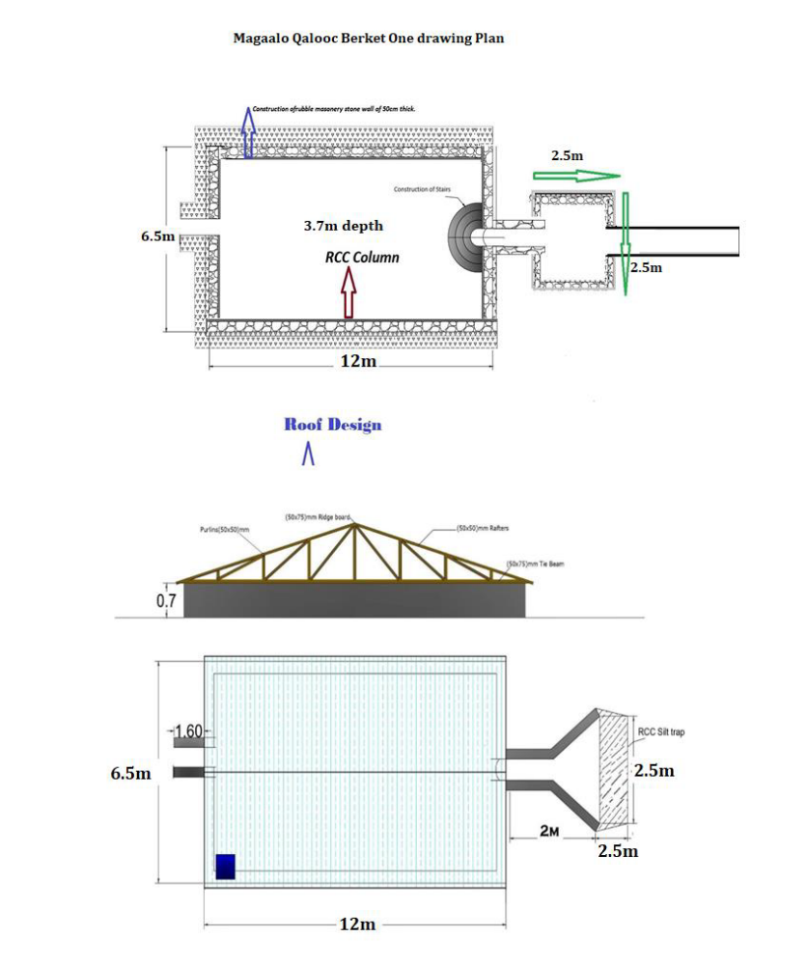

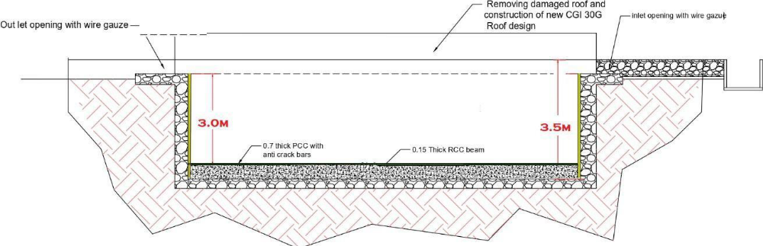

Project: BRAC Project | Title: Underground water storage (Berked) | LAYOUT PLAN
DATE: 12.07.2025
DRAWN BY: Candlelight Engineer | CHECKED BY: HOP | DWG: 001

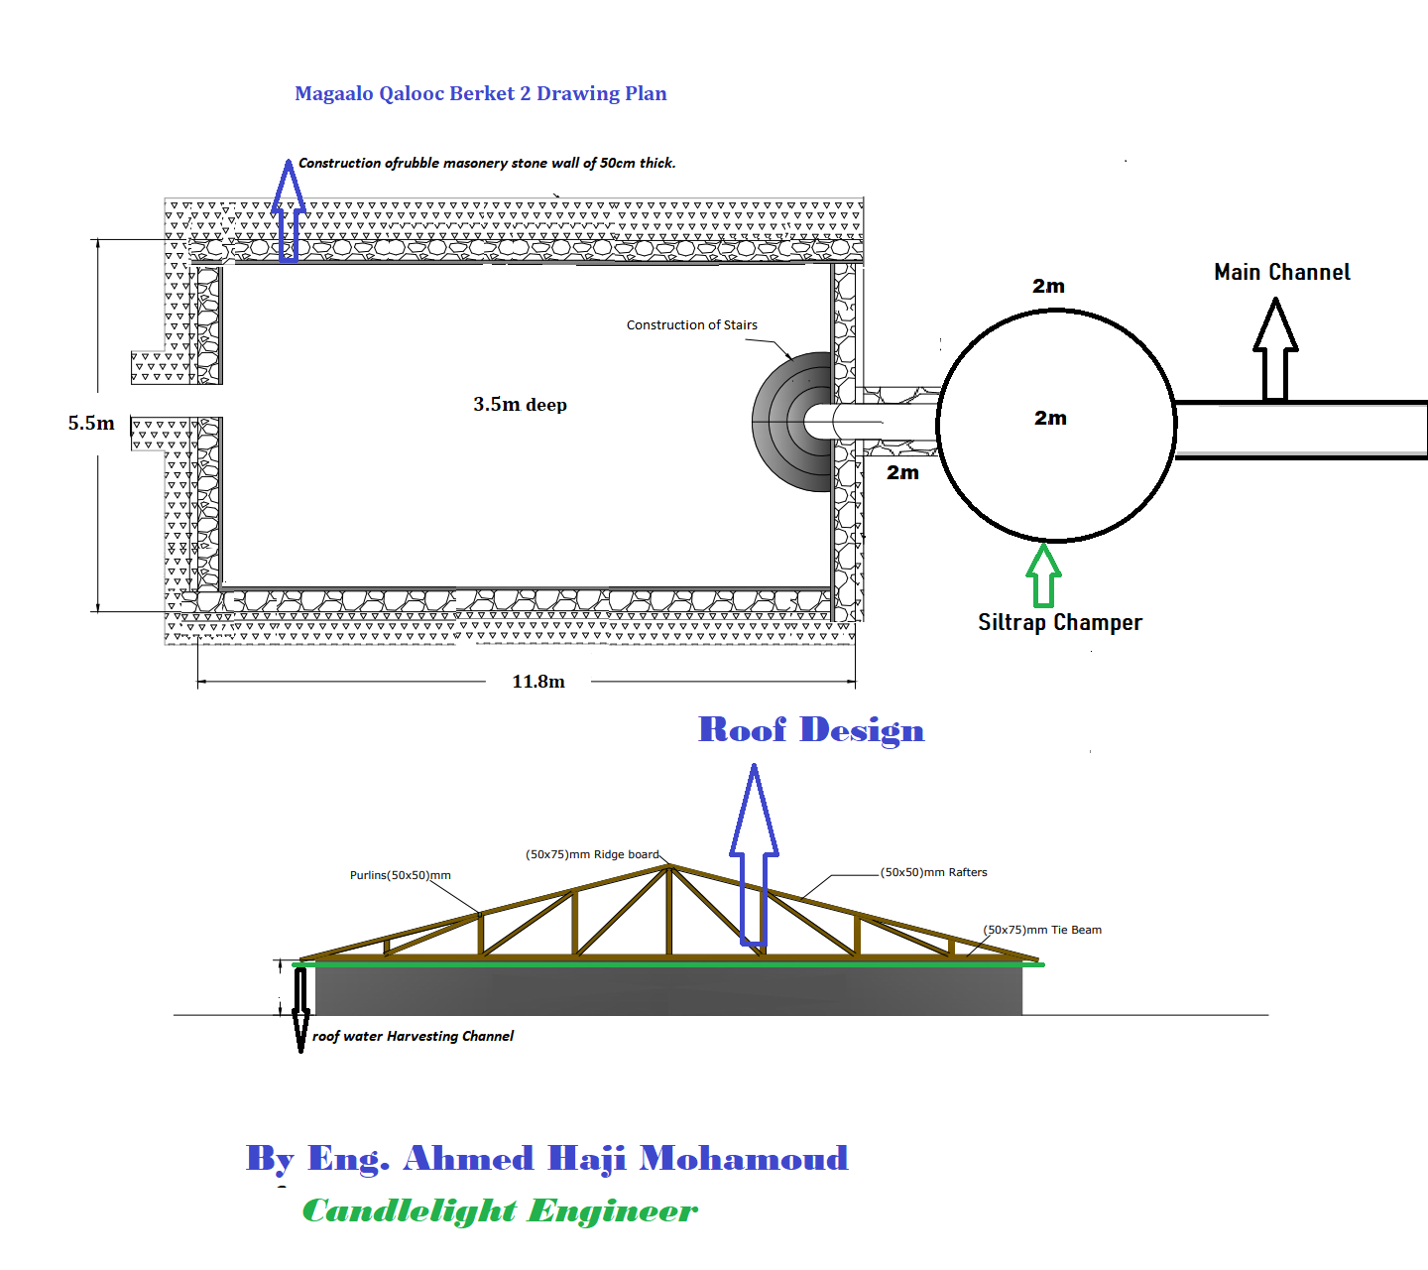

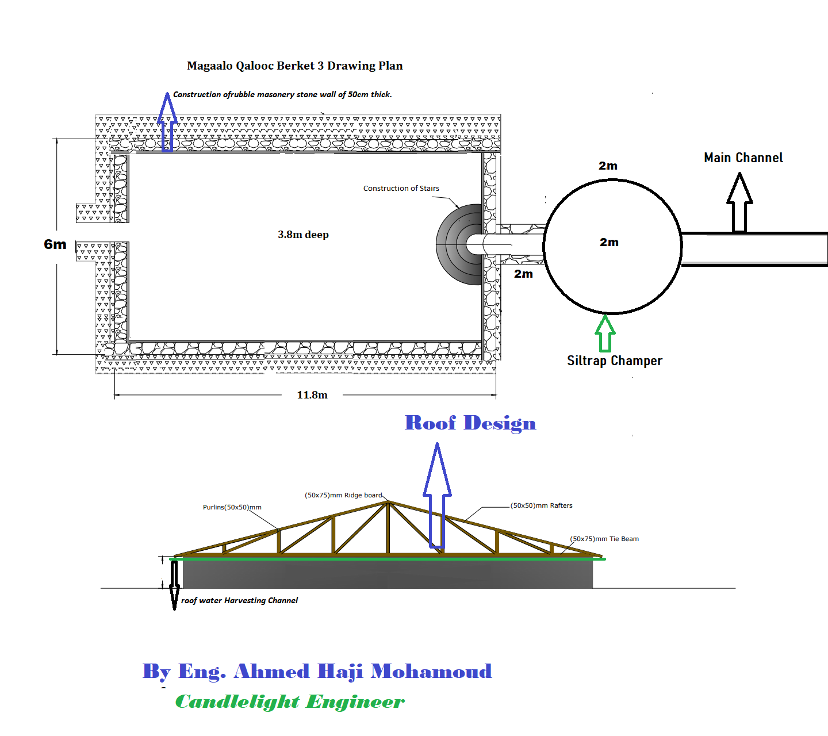

Appendix C: SUPPLIER QUESTIONNAIRE

ALL Suppliers and Subcontractors to complete Sections 1-6 and the declaration.
Suppliers providing branded products and services, rental vehicles and construction projects
to also complete section 7 and 8.

 | 1 A) Company Profile
 | Name of Company
 | Name of Candlelight staff member you have contact with; if any. (Name, Department, Location)
 | Registered Office address
 | Ordering Address (if different)
 | Payment Address (if different)
 | Telephone Number
 | Email
 | Website
Company Registration number
(Please attach a copy of the certificate)
 | Year established
 | Please state your position in the supply chain e.g. Agent, Manufacturer, Service Provider, Importer, Trader
 | Please specify the product/service being supplied to Candlelight
 | Do your goods or services carry the Candlelight brand?
Company turnover in trading currency
(please attach recent financial statement)
 | Turnover of the part of the business that would serve Candlelight
 | Location of other operational sites (national and international), their functions and approximate numbers of employees where Candlelight goods or services could be positioned
 | 1 B) Total Number of Workers
 |  |  | Men (%) | Women (%) | Total
 | Permanent Workers
 | Temporary directly employed workers
 | Agency indirectly employed workers
 | Homeworkers/outworkers
 | Management
 | Is your company committed to achieving the labour, environmental and business integrity standards in Candlelight’s Ethical and Environmental Policy |  |  |  | Yes
 |  |  |  |  | No
 | 2) Health & Safety
 | Is there anyone designated as being responsible for Health and Safety issues in your company? | Yes/ No. Give details

3) Management Systems and Policies
Do you have or are you working towards any of the following ethical/environmental, legal and technical management standards (add more fields if necessary) |  |  |  | ISO9001 - Quality
 |  |  |  | ISO14001 - Environment
 |  |  |  | ISO26000 - Social Responsibility
 |  |  |  | SA8000 - Labour standards
 |  |  |  | Other
Confirm which policies your company has in place. Please attach these: |  |  |  | Quality
 |  |  |  | Health & Safety
 |  |  |  | Environmental Management
 |  |  |  | Labour Standards
 |  |  |  | Equal Opportunities
 |  |  |  | Training & Development
 |  |  |  | Other
4) Ethical (Labour) Standards
Do you ensure your company meets worker related legislation? (e.g wages, hours, health & safety) Please share what you have in place to support this. | Yes/No. Give details.
5) Environmental Standards
Do you ensure that your company meets all required local laws/regulations covering the environment? Please share what you have in place to support this. | Yes/No. Give details.
Do you have an environmental policy in place? Please attach |  |  |  |  |  |  |  |  | Yes
 |  |  |  |  |  |  |  |  | No
6) Experience & Subcontracting
Please provide details of 3 customers/clients for whom you have completed contracts for in the last 3 years, willing to provide a reference. If available, attach reference letters.
 | Reference 1 |  |  | Reference 2 |  |  | Reference 3
Customer/Organisation
Contact name
Telephone No
Date awarded contract
Contract scope and details
Please detail what experience you have with dealing with International Non-Governmental Organisations (INGO): If yes, please provide details about the scope of contract and the INGO name.
If you supply services to Candlelight, do you subcontract/outsource services?
If yes, please share name and contact details of the sub-contractors and the type of service provided.
Please complete Sections 7 and 8 IF providing branded products or services, rental vehicles or construction projects
7) Pay & Hours
What is the national minimum wage (per hour)?
What is the lowest hourly pay in your company?
What deductions taken from worker's wages e.g. pension, tax?
If yes, how much are the charges and what are they for?
What are the normal weekly working hours for employees?
Do workers have at least 1 day off in 7? |  |  |  |  |  |  |  | Yes
 |  |  |  |  |  |  |  | No
What is the average overtime worked each month
What is the minimum age of worker your company would hire?
Explain how you ensure workers are not hired below the minimum age requirement
Were any health and safety risk assessments carried out in the last year? |  |  |  |  |  |  |  | Yes
 |  |  |  |  |  |  |  | No
8) Worker Management Communications
How do you ensure employees are aware of their rights? |  |  | Written Contracts
 |  |  | Staff notice boards
 |  |  | Intranet
 |  |  | Employee Handbook
 |  |  | Other
What forms of representation are used? |  |  | Union
 |  |  | Employees share ownership
 |  |  | Elected Health & Safety Committee
 |  |  | Workers co-operative
 |  |  | Works Council
 |  |  | Staff Association
 |  |  | Other
Do any workers belong to a Trade Union |  |  |  |  |  |  |  | Yes
 |  |  |  |  |  |  |  | No
If yes, please provide the name/s of the Union/s
Declaration (to be completed by Senior Authorised Manager. Please insert electronic signature or type name): I confirm that all the information given is accurate. For and on behalf of the supplier :

Name : |  | Position :
Date : |  | Signature :

For Candlelight use only - Risk Rated by
NB There are some industries Candlelight has run campaigns on to highlight the harm they can cause to poor communities. If your company, or any parent or subsidiary, has any involvement with the production or sales of weapons, pharmaceuticals, infant formula or pesticides; or with the Finance industry please tell your Candlelight contact.
Name : |  | Position :
Date : |  | Risks :

Appendix D: Assets Equipment list

S# | Brand and make | Model | Registration number | Year of manufacture

Appendix E: Reference

S# | Name | Address | E-mail | Phone # | Contract Person | Value of Business done in one year

Appendix F: Supplier Declaration Form

Note: This Supplier Declaration Form, including your certification by signature, is part of the qualification procedure for suppliers and service providers of Candlelight. If you do not fully complete this form, you may be disqualified from the tender.

1 Supplier information
By signing the certification at the end of this Supplier Declaration Form, you confirm that all information submitted in sections 1.1 and 1.2 below is true and complete.

1.1 Information about your business
Please provide the following information about your business and attach a copy of your company’s legal registration document.
Business name
Legal form
If the supplier is not a registered company, write “not registered.”
Year founded
Country where established
VAT or registration number
Bank details
Include the account holder’s name, bank name, IBAN, SWIFT code, and currency used.
Physical address, email address, and website
Sales and marketing contact
Range of services provided (company portfolio)
Other information

1.2 Information about your managing officials
Candlelight upholds high moral standards regarding the conduct of our employees, partners, suppliers, and other service providers. As discussed in part 2.2 below, one of these standards is a condemnation of terrorism and a commitment that no funds or other resources will be used to support terrorists or terrorist activities in any way. Not only is this standard an integral part of how we work, but it is also an expectation of our partners, institutional donors, and banks that we screen our suppliers and service providers against lists of known and suspected terrorists on a regular basis.
For this reason, we are required to collect certain information about the relevant decision makers of each supplier. In particular, we request information about your top 4 managing officials (e.g., executive board members, managing directors, or heads of department). Generally, these are the individuals listed on your company’s registration document. If your company has fewer than 4 managing officials, please provide details for all of your managing officials and let us know this fact when submitting the form.
The data collected below will only be used for comparison with freely accessible international sanctions lists published on the internet and will be protected in accordance with applicable data protection laws. If you have any questions about this requirement or about how your data will be processed or stored, please let us know.
Managing official 1
Full name
(given name followed by middle and surname)
Nationality
Address
(at a minimum, country of residence)
Gender (optional)
Birthdate | Date: | Month: | Year:
Managing official 2
Full name
(given name followed by middle and surname)
Nationality
Address
(at a minimum, country of residence)
Gender (optional)
Birthdate | Date: | Month: | Year:
Managing official 3
Full name
(given name followed by middle and surname)
Nationality
Address
(at a minimum, country of residence)
Gender (optional)
Birthdate | Date: | Month: | Year:
Managing official 4
Full name
(given name followed by middle and surname)
Nationality
Address
(at a minimum, country of residence)
Gender (optional)
Birthdate | Date: | Month: | Year:

2. Supplier ethical obligations

2.2 Basic values
All our suppliers are expected to act in accordance with the following principles:
- Suppliers must act with the highest standards of personal and professional conduct.
- Suppliers may not engage in religious or political activities when providing goods or services under a contract.
- Suppliers may not engage in discrimination of any kind, whether based on age, physical disability or attribute, nationality, ethnicity, gender, political views, union activity, religion, culture, language, sexual orientation, or any other distinguishing characteristic.
- Suppliers must should responsibility towards the health and safety of their staff and others.
- Suppliers may not engage in any type of sexual exploitation, abuse, or harassment.
- Suppliers may not act in ways that harm children and other vulnerable groups.
- Suppliers must handle personal data and other information in a responsible manner that complies with applicable data protection laws.
- Suppliers must use resources responsibly.
- Suppliers may not engage in any activities in support of terrorists, terrorism, or money laundering.
- Suppliers may not engage in corruption or fraud of any kind.
- Suppliers must avoid exploit their professional position or relationships for any personal gain or to benefit related parties and must avoid any situation that might present a perceived conflict of interest.
- Suppliers may not work under the influence of alcohol or drugs.
- Suppliers may not carry weapons while doing work for us.
- Suppliers have an obligation to report to us any concerns, suspicions, or knowledge of misconduct under the above principles.
By signing this Supplier Declaration Form, you explicitly agree to compliy with these principles.

2.3 Candlelight renounces all forms of terrorism and money laundering
Candlelight renounces all forms of terrorism and will never knowingly support, tolerate, or encourage terrorism or the activities of those who embrace terrorism or money laundering. Consistent with guidance issued by the United Nations Security Council and the European Union, Candlelight is firmly committed to the international fight against terrorism and, in particular, against the financing of terrorism. Accordingly, Candlelight screens its suppliers and their relevant decision makers against lists of known and suspected terrorists to ensure that none of its or its donor funds are used, directly or indirectly, to provide support to individuals or entities associated with terrorism or money laundering. By submitting an offer, suppliers and service providers agree to this screening process, including the obligation to provide the information required to conduct the screening (see parts 1.1 and 1.2 above).

3 Supplier declaration
We, _______________________________________ (name of supplier) hereby declare that
- all of the information submitted in parts 1.1 and 1.2 above is true and complete;
- we are not in bankruptcy proceedings, in judicial insolvency proceedings, or in liquidation, and we have not ceased our commercial activities and are not in a comparable situation by virtue of similar proceedings referred to in the national legal provisions;
- we have not received a sanction by legally binding judgment for reasons that bring into doubt our professional reliability;
- we comply with our duty to pay social insurance contributions, taxes, and other levies in accordance with the legal provisions of the jurisdiction in which we have our office, the jurisdiction of the consignee, and the jurisdiction where the contract is performed; we assure that we will comply with the legislation applicable and common standards in terms of wages, social legislation, and occupational safety and health;
- we have not received a legally binding sentence due to fraud, corruption, participation in a criminal association, or another act directed against the financial interests of another legal or natural person;
- no serious breaches of contract due to non-performance of our contractual obligations have been ascertained in connection with another contract or a contract awarded from any institutional donor involved in development cooperation, humanitarian assistance, or other public financing work (hereinafter “institutional donor”);
- we are providing you with all the information required to participate in a tender, and all information submitted in relation to this tender is true and complete;
- in respect of contracts that are ultimately paid for out of the funds of an institutional donor, no one has accused us of breach of contract due to gross violation of our contractual obligations;
- we have not been excluded as a contract partner by any institutional donor due to ethical issues;
- in the event we are chosen as the supplier for any project, we assure to Candlelight to any partner or institutional donor involved in the project, and to auditors engaged by either Candlelight or such partners or institutional donor that they will have reasonable access on demand to our business and accounting documents for the purpose of checks and audits;
- we respect basic social rights and condemn child labor;
- we understand that Candlelight will conduct a check to ensure that neither our company nor our top four managing officials appear on any lists of known or suspected terrorists issued by our institutional donors or the governments of which they are a part;
- we act in accordance with the values listed in part 2.2 above.

Name of supplier: | Official business stamp:
Name and title of owner or CEO: | Official business stamp:
Signature of owner or CEO: | Official business stamp:
Date: | Official business stamp:

