
TENDER DOCUMENT

(Supply and Delivery of Wheelchairs – Hargeisa)
Muslim Hands is an international relief and development non-government charitable organization established in 1993. Muslim Hands intends to invite Tenders from technically strong and registered Companies to provide services as per bid data
About the Project:
This project seeks to improve mobility, dignity, and social inclusion for 42 individuals with disabilities from poor households through the distribution of two-wheeler and three-wheeler wheelchairs. Persons with disabilities in low-income communities face multiple challenges including limited mobility, social isolation, and restricted access to education, healthcare, and livelihood opportunities. Poverty further compounds these difficulties, as families often cannot afford assistive devices or specialized care. Many beneficiaries rely on relatives for even the simplest daily tasks, leading to dependency and reduced quality of life.
By providing wheelchairs tailored to the beneficiaries’ needs, the project addresses these barriers by enhancing independence, restoring confidence, and opening pathways for greater participation in community life. The two-wheeler and three-wheeler models ensure both flexibility and stability, enabling recipients to move freely, pursue education, access health services, and engage in income-generating activities. Ultimately, the initiative aims to reduce vulnerability and promote equality by empowering people with disabilities to live more self-reliant and dignified lives.
Location Details
Details of items | Quantities | Delivery Point | Bid Validity
2 and 3-wheeler wheelchairs (detailed description refer bid data sheet) | 42 | Hargeisa | 30 Days

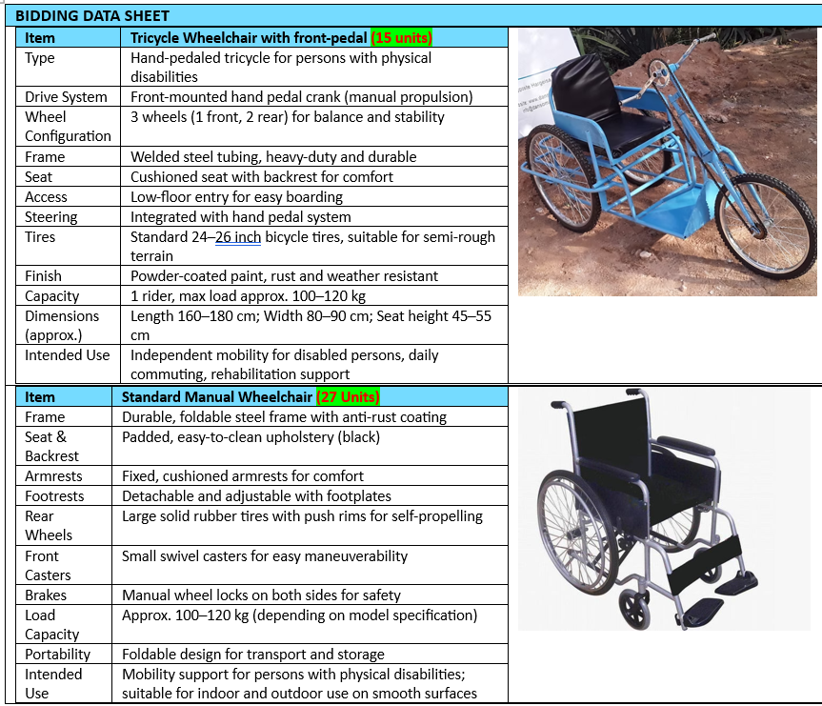

- SCOPE:
The successful vendor will be responsible for supplying 27 two-wheeler wheelchairs and 15 three-wheeler wheelchairs that are durable, safe, and suitable for local conditions. The equipment must be new, user-friendly, and capable of supporting long-term daily use.
The vendor will also ensure the secure delivery of all wheelchairs to the designated distribution location in Hargeisa. Proper packaging must be used to protect the equipment during transport, and delivery should occur within the agreed timeline. Upon delivery, the items will be jointly inspected by the vendor and the procurement committee to ensure quality and compliance with specifications.
All wheelchairs must meet basic international standards for mobility and should not come with any manufacturing defects. The vendor is required to provide delivery notes, certificates, item specs, and invoices for verification upon completion of delivery.
- LANGUAGE:
Muslim Hands requires the working language accepted within the relevant country, however translated versions into the working language of the relevant country will be considered. In this case English is required.
- QUALIFYING AND CONDITION;
The main criteria for admission to the tender are as follows:
a) Duly registered under applicable laws and authorities
c) Provision of evidence of financial soundness.
d) Provision of evidence of technical soundness and Previous relevant Experience,
f) Good track-record and references from previous clients
g) Good team composition

- TENDER BASIS:
- All Tender Documents must be completed in full; otherwise the application will be disqualified.
- All Applicants will receive identical documents: No applicant should add, omit, or change any item, term or condition in original papers.
- If Applicants have any additional request and conditions, this shall be stipulated in a separate letter accompanying the bid.
- Each bid shall be valid for the period of 30-days from its date of submission.
- Bids shall be made in writing calculated in USD only and clearly stated on the appropriate forms.
- The price schedule must include all information requested, including origin of materials.
- The applicant shall attach a detailed timetable for carrying out the works and propose ways and means to realize the works.
- Muslim Hands will not be liable for any damage to the applicant person or property in the event that something should occur.
- Muslim Hands strongly recommend that all applicants take extra precaution when visiting/delivering supplies to a project site.

- PAYMENTS:
Payment will be made according to the agreed payment schedule, upon satisfactory delivery of the supplies or completion of services, and submission of a technical test report (where applicable), at the location specified in the tender documents/invitation to tender.
- PERFORMANCE STANDARDS:
The work must be undertaken in accordance with all relevant rules, regulations and statutes currently in force in Somaliland.
- ELIGIBILITY OF APPLICANTS:
Applicants cannot apply if they:
- Are bankrupt or in the process of going bankrupt.
- Have been convicted for an offense concerning professional conduct.
- Have been guilty of grave professional misconduct (proven by any means which the contracting authorities can justify).
- Have not fulfilled obligations related to payment of taxes.
- Are guilty of serious misinterpretation in supplying information.
- Are in situations of conflict of interest (with prior relationship to project or family or business relationship to parties on Muslim Hands).
- Were declared at serious fault of implementation owing to a breach of their contractual obligations

- BID EVALUATION:
The Tender Committee will check the tenders to ensure that they contain no amendment to the terms or any other (calculation) errors. To assist in the examination, evaluation and comparison of bids, the Tender Committee may, at its discretion, request clarification from the Muslim Hands staff or consultant.

Technical Evaluation: The offers will first be evaluated on technical merits. The technical evaluation assesses the capacity of the company on the basis of submitted technical documents.
Financial Evaluation: The financial evaluation subject to the technical evaluation is based on the cost of assignment given in the tender.
Other Evaluations: After ranking companies according to financial and technical criteria, the Tender Committee may take into account other criteria, including, but not limited to record of past performance, integrity, samples and reputation within the community and other info provided.
The Supplier are advised to send Tender Documents to the email address provided.

- SELECTION OF TENDER;
Selection of the successful applicant will be based on the ranking of companies according to technical and financial criteria, as well as any other criteria suggested by the Tender Committee. Based on this the Tender Committee will then make a recommendation.

- ACCEPTANCE OF SUCCESSFUL TENDER:
Taking into consideration the recommendation of the Tender Committee, Muslim Hands SO will make the final choice of the awarded firm. (Muslim Hands) will then send a letter of acceptance to the successful applicant. After submitted documentation from the selected firm has been verified, the firm will then be presented to sign the contract for the stated amount. Any amendment to the awarded tender will be documented as an “Annex” to the contract and will be determined by (Muslim Hands SO)

- TECHNICAL PROPOSAL

SN. | Description | Detail | Comments
 | Project ID
 | Name of the Supplier
 | Physical Address
 | Type of Business
 | License # / Permit  Attach License | License Category | License Expire Date
 | Past Experience (in Years)
 | Company Profile with Relevant Experience  Technical  You may attach company profile | Name of orgs you’ve worked with in similar projects, your team composition and technical capabilities etc. (no more than 15 Pages) | As attachment
 | Implementation Strategy (Assignment Timetable) | (as Attachment no more than 500 words) | As attachment
 | Bank Statement | (Past 6 months as attachment)
 | Name of contact person within organization to whom all correspondences shall be addressed Cell #, e-mail etc
 | Name, designation and legal status of person authorized to enter into negotiation and sign any form or agreement
 | Disclosure of relationship with any employee of the firm within Muslim Hands

- FINANCIAL PROPOSAL
Financial Proposal
Name of the Supplier:
SN | Description | Unit | Quantity | Unit Price | Total
Total Cost

Name: Date: ____/______/_______

Supplier Stamp:
Company Quotations might be attached separately (optional)
BID CONDITIONS AND TERMS:
- The successful bidder is responsible for payment of taxes and transportation expenses, therefore this should be considered while submitting the tender.
- Preference will be given to bidders possessing relevant past work experience who have carried out a variety of foot item delivery assignments.
- Tender committee reserves the right to cancel/reject any or all offers without assigning any reason.
- Supplier must provide all details or otherwise mention within the tender document, incomplete proposals may result in cancellation.
- Payment will be made on satisfactory delivery of supplies / completion of work through bank account.
- Copies of tax clearance accompany the tenders.
- Tender committee reserves the right to alter the quantity, if required.
- An agreement will be signed with successful bidder(s) for timely supply of appropriate quality items and method of payment. Failure to meet the conditions of the agreement will result in cancellation of the agreement at the risk and cost of the supplier.
- In case the supplies are delayed, (Muslim Hands) will impose a penalty of 1% per day of the total amount of contract on the delay work and on low quality.
- Payment will be made in subsequent installments depending on the activity and delivery methods.
- (Muslim Hands) reserves the right to forfeit the contract in case of breach of the agreement.
- Tender Offers must be valid for minimum 30 days after the tender opening.
- Tender publication does not constitute any commitment on part of (Muslim Hands) unless a written agreement is signed by both parties.
- The prices should be quoted on the letter head of the company/firm in the given format and all other supporting documents should be attached with it.
- Lowest price; quality, capacity of the vendor, delivery time and previous relevant experience are all important criterion.

Other Tender Instructions
Tender Document
Tender document can be downloaded from the link or requested through email with tender subject line
Tel: 857749 Email: procurement@so.mhworldwide.org Subject line: Supply and Delivery Wheelchairs
Submission Deadline:
The last date for submission of bids (Technical & Financial) is The deadline for submitting Application is 2nd Oct 2025. Any tender documents received later than this date will not be considered.

