PROJECT NAME: CLIMATE-RESILIENT WASH AND LIVELIHOODS PACKAGE FOR RESILIENT SOMALI LANDSCAPES
PROJECT NO: SOM1065
From: Welthungerhilfe
Airport Road, next to Djibouti Consulate
Hargeisa, Somaliland
Phone: +252-2-567153/ 567154

Ref: RFT 390998 - SOM1065/2025/020

DATE: 04-04-2025

QUOTATION FOR SUPPLY OF ALUMUNIUM/STEEL MILK CONTAINERS
SPR REFERENCE NO: 65179

Submission Date
Company Name
Address
Tel/Mobile
Official Email

Your company is cordially invited by the Office of Welthungerhilfe to submit a firm offer for the following prosopis tools

NO | ITEM | UNIT | QTY | UNIT PRICE ($) | TOTAL ($)
 | BILL OF MATERIALS
1 | Aluminum/steel milk container 5 Liters | pcs | 282
2 | Milk cup 0.5 Liters MOVKZACV Stainless Steel Measuring Cup Milk Frothing Jug with Scale (size:5000ml) | pcs | 282
3 | Pot Aluminum 6 Quart Heavy Duty 6 mm Thick | pcs | 282
4 | Plastic Sieve Filter | pcs | 282
Total |  |  |  |  | $

Note: the related photos can be found on the next page (2) for your reference.

Delivery Period _____________________________ Validity of the Offer_____________________________

The Delivery location is Welthungerhilfe Burco Office

Photos for the required aluminum/steel milk containers
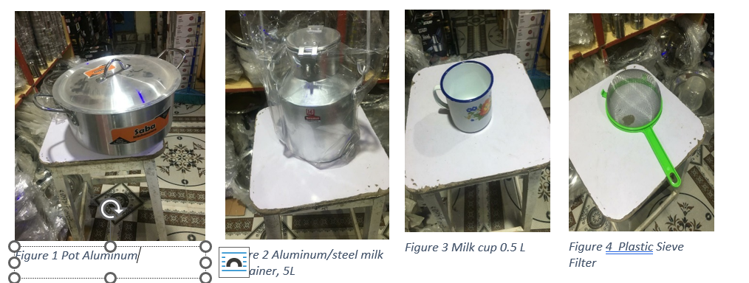

Requirements for Compliance:
- Ensure timely submission of your quotation by the specified deadline, which is on 19th April, 2025 at 11:59 pm.
- Companies failing to submit their quotations by this deadline will not be considered.
- All quotation documents must be submitted to our e-tender portal via the below link:
Public RFT - Invitation to Tender: Supply of Aluminum/steel Milk Containers_ Buroa Office

- Supplier declaration Annex-2 form signed, stamped.
- Please include a copy of your commercial license and tax clearance certificate with the bid documents for verification.
- Ensure that you submit all mandatory documents as requested in the tender invitation document
- Complete the unit and total price columns in the quotation form accurately.

