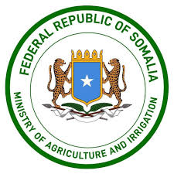

Federal Government of Somalia
Ministry of Agriculture and Irrigation (MoAI)

PUBLIC ADVERT
INVITATION TO BID
REF NO: FGS/GOODS/MOAI/0022/2025
Provision of Purchase of (One) Brand new Rice Combine Harvester with (One) Direct Seed Rice Planter.
- Background

The Ministry of Agriculture and Irrigation (MoAI) of the Federal Republic of Somalia is implementing its National Mechanization and Technology Adoption Program to enhance agricultural productivity, reduce labor intensity, and improve farmers’ access to modern agricultural equipment. As part of this effort, the Ministry invites qualified and reputable suppliers to submit bids for the supply, delivery, installation, and commissioning of a Rice Combine Harvester and a Direct Seeded Rice (DSR) Planter. This procurement forms a key component of the Ministry’s commitment to modernizing Somalia’s agricultural sector and promoting the adoption of efficient, climate-smart production technologies.
- Scope of Work
The selected supplier shall be responsible for:
- Supply of Machinery
  - One (1) Combine Harvester
  - One (1) Direct Seeded Rice (DSR) Planter
- Delivery and Transportation
  - Transport the machinery to the designated MoAI HQ, Mogadishu.
  - Transport the machinery from Mogadishu to Jowhar District as the second delivery phase.
  - Ensure safe handling, loading and unloading processes.
- Installation, Testing, and Commissioning
  - Assemble machinery (if required).
  - Conduct full operational testing.
  - Ensure machinery is ready for field use.

- Training
  - Provide hands-on training for MoAI technicians, operators, and selected farmers on:
    - Operation
    - Routine maintenance
    - Safety protocols

Technical Specifications
Rice Combine Harvester  - Structure: Self-propelled combine harvester  - Engine: 100 HP diesel engine  - Cutting Width: 2.0 – 2.5 meters  - Threshing System: Axial flow or tangential  - Feeding capacity: 6 kg/s  - Fuel Tank Capacity: 80 liters  - Efficiency: 0.8 hectares/hour  - Features:  - Adjustable reel height  - Straw management system  - Operator canopy  - Mud-friendly tires/tracks suitable for paddy fields  - Safety features (fire extinguisher, lights, seat belt) | 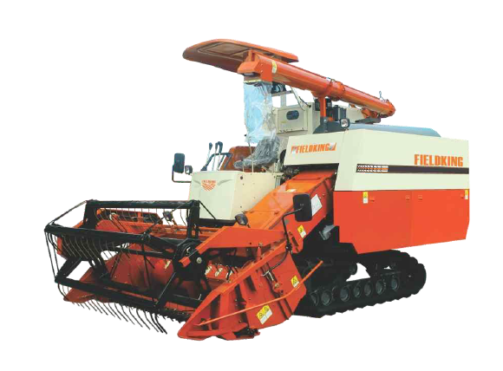
Direct Seeded Rice (DSR) Planter  - Structure: Tractor-mounted or self-propelled DSR planter  - Working Width: Minimum 6–8 rows  - Row Spacing: Adjustable (20–25 cm)  - Seed Metering: Precise seed-rate control  - Field Capacity: 0.5 hectares/hour  - Hopper Capacity: 20 kg  - Suitable for: Sandy loam and clay loam paddy soils  - Features:  - Low soil disturbance  - Depth adjustment mechanism  - Calibration tools  - Corrosion-resistant frame | 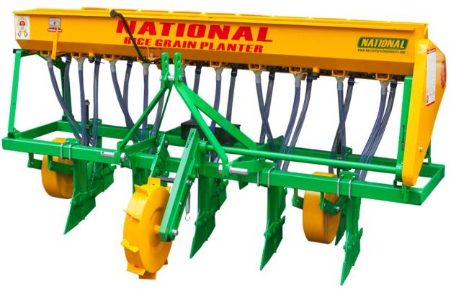
- After-Sales Service
  - Provide at least 12 months warranty on all machinery.
  - Guarantee availability of spare parts.
  - Provide periodic technical support during the warranty period
- Deliverables
The supplier shall deliver:
- Rice Combine Harvester (1 unit)
- DSR Rice Planter (1 unit)
- Operation and Maintenance Manuals
- Warranty Certificates
- Training report for operators and technicians
- Commissioning and handover report
- Requirements for Tender Documents and Guideline
- Tender reference number
- Tender envelop should be sealed.
- The tender envelop must be stamped
- BOQ/RFQ to be stamped and signed with Work Schedule/work plan
Interested suppliers must provide:
- Valid Registration certificate
- At least 3 years’ experience in supplying agricultural machinery
- Company Profile with detailed physically verifiable contact address
- Bank statements for the last six months.
- Certificate confirming payment of tax
- Evidence of Past Experience in similar work e.g., signed Contract/PO
- Ability to provide after-sales service and spare parts within Somalia
- Manufacturer authorization letter (if applicable)
- How to apply
All interested and eligible Contractors/suppliers with sound capacity and relevant experience in similar work are here by invited to collect tender documents from the Ministry of Agriculture and Irrigation, Mogadishu, KM4 Junction, Hodan District.

The deadline for submitting bids is 07/12/2025 at 4:00 pm and any tender or documents received later than 07/12/2025 4:00 pm will not be accepted.
The sealed envelopes should be dropped at TENDER BOX in Ministry of Agriculture and Irrigation, Mogadishu, KM4 Junction, Hodan District.

