

GOVERNMENT OF SOMALILAND
Ministry of Planning and National Development

Specific Procurement Notice

Request for Bids

(One-Envelope Bidding Process)

Country: Government of Somaliland
Name of Project: Somali Water for Rural Resilience (SWRR), or “Barwaaqo” Project
Contract Title: Construction of Office of the Ministry of Environment and Climate Change in Hargeisa.
Grant No: P177627
RFB Reference No: SO-MOPND-SL-365137-CW-RFB

- The Ministry of Planning and National Development (MoPND) of the Somaliland has, through the Government of Somaliland, received financing from the World Bank toward the cost of the Water for Rural Resilience Project (Barwaaqo) Project, and intends to apply part of the proceeds toward payments under the Contract for Construction of MoECC Offices under Barwaaqo Implementing Line Ministry office in Hargeisa. For this contract, the Borrower shall process the payments using the Direct Payment disbursement method, as defined in the World Bank’s Disbursement Guidelines for Investment Project Financing, except for those payments, which the contract provides to be made through letter of credit.
- The Ministry of Planning and National Development now invites sealed Bids from eligible Bidders for Construction of MoECC Offices under Barwaaqo Implementing Line Ministry office in Hargeisa.

- Bidding will be conducted through National Competitive Procurement using Request for Bids (RFB) as specified in the World Bank’s “Procurement Regulations for IPF Borrowers” dated July 2016 and revised in November 2017, August 2018 and November 2020 (“Procurement Regulations”), and is open to all eligible Bidders as defined in the Procurement Regulations. In addition, please refer to paragraphs 3.14 setting forth the World Bank’s policy on conflict of interest.

Interested eligible Bidders may obtain further information from Barwaaqo Office, Ministry of Planning, and National Development HQ, Hargeisa District, Somaliland Email: barwaaqopiu.procurement@gmail.com and copy Mohamoud.qawdhan2@gmail.com and inspect the bidding documents during office hours 09:00 to 15:00 hours Hargeisa local time from Saturday to Thursday exclusive of public holidays at the address given below.
- A complete set of bidding documents in English may be obtained by interested eligible bidders upon the submission of a written application to the e-mail address above.

- Bids must be delivered to the address below on or before 13:00 Hrs. Hargeisa time on 5th May, 2024. Electronic Bidding will NOT be permitted. Late Bids will be rejected. Bids will be publicly opened in the presence of the Bidders’ designated representatives and anyone who chooses to attend at the address below on 13:00 Hrs. Hargeisa time on 5th May, 2024.

- All Bids must be accompanied by a BID-SECURING DECLARATION using the form included in Section IV, Bidding Forms.

- “Attention is drawn to the Procurement Regulations requiring the Borrower to disclose information on the successful bidder’s beneficial ownership, as part of the Contract Award Notice, using the Beneficial Ownership Disclosure Form as included in the bidding document.”]

- The address(es) referred to above is:
Barwaaqo Office
Ministry of Planning and National Development
Floor/ Room number: 2nd floor
Email: barwaaqopiu.procurement@gmail.com and copy Mohamoud.qawdhan2@gmail.com
City: Hargeisa
State: Maroodi-jeex Region
Country: Government of Somaliland

Government of Somaliland
Ministry of Planning and National Development

Request for Bids
(One-Envelope Bidding Process)

Procurement of:

- Construction of MoECC Offices under Barwaaqo Implementing Line Ministry office in Hargeisa.
_____________________________
Country: Government of Somaliland
Name of Project: Somali Water for Rural Resilience, or “Barwaaqo” Project
- Contract Title: Construction of MoECC Offices under Barwaaqo Implementing Line Ministry office in Hargeisa.

Grant No: P177627
RFB Reference No: SO-MOPND-SL-365137-CW-RFB
Issued on: Saturday, 6th April, 2024

Standard Procurement Document

Table of Contents

PART 1 – Bidding Procedures 3

Section I - Instructions to Bidders 5

Section II - Bid Data Sheet (BDS) 37

Section III - Evaluation and Qualification Criteria 45

Section IV - Bidding Forms 60

Section V - Eligible Countries 121

Section VI - Fraud and Corruption 123

PART 2 – Works’ Requirements 127

Section VII - Works’ Requirements 129

PART 3 – Conditions of Contract and Contract Forms 239

Section VIII - General Conditions of Contract 240

Section IX - Particular Conditions of Contract 277

Section X - Contract Forms 285

PART 1 – Bidding Procedures

Section I - Instructions to Bidders

Contents

A. General 8

1. Scope of Bid 8

2. Source of Funds 8

3. Fraud and Corruption 9

4. Eligible Bidders 9

5. Eligible Materials, Equipment and Services 12

B. Contents of Bidding Document 12

6. Sections of Bidding Document 12

7. Clarification of Bidding Document, Site Visit, Pre-Bid Meeting 13

8. Amendment of Bidding Document 14

C. Preparation of Bids 15

9. Cost of Bidding 15

10. Language of Bid 15

11. Documents Comprising the Bid 15

12. Letter of Bid and Schedules 16

13. Alternative Bids 16

14. Bid Prices and Discounts 17

15. Currencies of Bid and Payment 18

16. Documents Comprising the Technical Proposal 18

17. Documents Establishing the Eligibility and Qualifications of the Bidder 18

18. Period of Validity of Bids 18

19. Bid Security 19

20. Format and Signing of Bid 21

D. Submission and Opening of Bids 22

21. Sealing and Marking of Bids 22

22. Deadline for Submission of Bids 22

23. Late Bids 23

24. Withdrawal, Substitution, and Modification of Bids 23

25. Bid Opening 23

E. Evaluation and Comparison of Bids 25

26. Confidentiality 25

27. Clarification of Bids 25

28. Deviations, Reservations, and Omissions 26

29. Determination of Responsiveness 26

30. Nonmaterial Nonconformities 27

31. Correction of Arithmetical Errors 27

32. Conversion to Single Currency 27

33. Margin of Preference 28

34. Subcontractors 28

35. Evaluation of Bids 28

36. Comparison of Bids 29

37. Abnormally Low Bids 29

38. Unbalanced or Front Loaded Bids 30

39. Qualification of the Bidder 30

40. Most Advantageous Bid 31

41. Employer’s Right to Accept Any Bid, and to Reject Any or All Bids 31

42. Standstill Period 31

43. Notification of Intention to Award 31

F. Award of Contract 32

44. Award Criteria 32

45. Notification of Award 32

46. Debriefing by the Employer 33

47. Signing of Contract 34

48. Performance Security 34

49. Adjudicator 34

50. Procurement Related Complaint 35

Section I - Instructions to Bidders
General
- Scope of Bid | - In connection with the Specific Procurement Notice - Request for Bids (RFB), specified in the Bid Data Sheet (BDS), the Employer, as specified in the BDS, issues this bidding document for the provision of Works as specified in Section VII, Works’ Requirements. The name, identification and number of lots (contracts) of this RFB are specified in the BDS.
  - Throughout this bidding document:
(a) the term “in writing” means communicated in written form (e.g. by mail, e-mail, and fax, including if specified in the BDS, distributed or received through the electronic-procurement system used by the Employer) with proof of receipt;
(b) if the context so requires, “singular” means “plural” and vice versa;
(c) “Day” means calendar day, unless otherwise specified as “Business Day”. A Business Day is any day that is an official working day of the Borrower. It excludes the Borrower’s official public holidays; and
(d) “ESHS” means environmental, social (including sexual exploitation and abuse (SEA) and gender-based violence (GBV)), health and safety.
- Source of Funds | - The Borrower or Recipient (hereinafter called “Borrower”) specified in the BDS has received or has applied for financing (hereinafter called “funds”) from the International Bank for Reconstruction and Development or the International Development Association (hereinafter called “the Bank”) in an amount specified in the BDS, toward the project named in the BDS. The Borrower intends to apply a portion of the funds to eligible payments under the contract(s) for which this bidding document is issued.
 | - Payment by the Bank will be made only at the request of the Borrower and upon approval by the Bank, and will be subject, in all respects, to the terms and conditions of the Loan (or other financing) Agreement. The Loan (or other financing) Agreement prohibits a withdrawal from the loan account for the purpose of any payment to persons or entities, or for any import of goods, equipment, plant, or materials, if such payment or import is prohibited by a decision of the United Nations Security Council taken under Chapter VII of the Charter of the United Nations. No party other than the Borrower shall derive any rights from the Loan (or other financing) Agreement or have any claim to the proceeds of the Loan (or other financing).
- Fraud and Corruption | - The Bank requires compliance with the Bank’s Anti-Corruption Guidelines and its prevailing sanctions policies and procedures as set forth in the WBG’s Sanctions Framework, as set forth in Section VI.  - In further pursuance of this policy, bidders shall permit and shall cause their agents (where declared or not), subcontractors, subconsultants, service providers, suppliers, and their personnel, to permit the Bank to inspect all accounts, records and other documents relating to any initial selection process, prequalification process, bid submission, proposal submission, and contract performance (in the case of award), and to have them audited by auditors appointed by the Bank.
- Eligible Bidders | - A Bidder may be a firm that is a private entity, or a state-owned enterprise or institution, subject to ITB 4.6, or any combination of them in the form of a joint venture (JV), under an existing agreement, or with the intent to enter into such an agreement supported by a letter of intent. In the case of a joint venture, all members shall be jointly and severally liable for the execution of the entire Contract in accordance with the Contract terms. The JV shall nominate a Representative who shall have the authority to conduct all business for and on behalf of any and all the members of the JV during the Bidding process and, in the event the JV is awarded the Contract, during contract execution. Unless specified in the BDS, there is no limit on the number of members in a JV.
  - A Bidder shall not have a conflict of interest. All Bidders found to have a conflict of interest shall be disqualified. A Bidder may be considered to have a conflict of interest for the purpose of this Bidding process, if the Bidder:
    - directly or indirectly controls, is controlled by or is under common control with another Bidder; or
    - receives or has received any direct or indirect subsidy from another Bidder; or
    - has the same legal representative as another Bidder; or
    - has a relationship with another Bidder, directly or through common third parties, that puts it in a position to influence the Bid of another Bidder, or influence the decisions of the Employer regarding this bidding process; or
    - or any of its affiliates participated as a consultant in the preparation of the design or technical specifications of the works that are the subject of the Bid; or
    - or any of its affiliates has been hired (or is proposed to be hired) by the Employer or Borrower as Project Manager for the Contract implementation;
    - would be providing goods, works, or non-consulting services resulting from or directly related to consulting services for the preparation or implementation of the project specified in the BDS ITB 2.1 that it provided or were provided by any affiliate that directly or indirectly controls, is controlled by, or is under common control with that firm;
    - has a close business or family relationship with a professional staff of the Borrower (or of the project implementing agency, or of a recipient of a part of the loan) who: (i) are directly or indirectly involved in the preparation of the bidding document or specifications of the contract, and/or the Bid evaluation process of such contract; or (ii) would be involved in the implementation or supervision of such contract unless the conflict stemming from such relationship has been resolved in a manner acceptable to the Bank throughout the procurement process and execution of the contract.
 | - A firm that is a Bidder (either individually or as a JV member) shall not participate in more than one Bid, except for permitted alternative Bids. This includes participation as a Subcontractor in other Bids. Such participation shall result in the disqualification of all Bids in which the firm is involved. A firm that is not a Bidder or a JV member may participate as a subcontractor in more than one Bid.
 | - A Bidder may have the nationality of any country, subject to the restrictions pursuant to ITB 4.8. A Bidder shall be deemed to have the nationality of a country if the Bidder is constituted, incorporated or registered in and operates in conformity with the provisions of the laws of that country, as evidenced by its articles of incorporation (or equivalent documents of constitution or association) and its registration documents, as the case may be. This criterion also shall apply to the determination of the nationality of proposed subcontractors or subconsultants for any part of the Contract including related Services.
 | - A Bidder that has been sanctioned by the Bank, pursuant to the Bank’s Anti-Corruption Guidelines, in accordance with its prevailing sanctions policies and procedures as set forth in the WBG’s Sanctions Framework as described in Section VI paragraph 2.2 d., shall be ineligible to be prequalified for, initially selected for, bid for, propose for, or be awarded a Bank-financed contract or benefit from a Bank-financed contract, financially or otherwise, during such period of time as the Bank shall have determined. The list of debarred firms and individuals is available at the electronic address specified in the BDS.
 | - Bidders that are state-owned enterprises or institutions in the Employer’s Country may be eligible to compete and be awarded a Contract(s) only if they can establish, in a manner acceptable to the Bank, that they (i) are legally and financially autonomous (ii) operate under commercial law, and (iii) are not under supervision of the Employer.
 | - A Bidder shall not be under suspension from Bidding by the Employer as the result of the operation of a Bid–Securing or Proposal-Securing Declaration.
  - Firms and individuals may be ineligible if so indicated in Section V and (a) as a matter of law or official regulations, the Borrower’s country prohibits commercial relations with that country, provided that the Bank is satisfied that such exclusion does not preclude effective competition for the supply of goods or the contracting of works or services required; or (b) by an act of compliance with a decision of the United Nations Security Council taken under Chapter VII of the Charter of the United Nations, the Borrower’s country prohibits any import of goods or contracting of works or services from that country, or any payments to any country, person, or entity in that country. When the Works are implemented across jurisdictional boundaries (and more than one country is a Borrower, and is involved in the procurement), then exclusion of a firm or individual on the basis of ITB 4.8 (a) above by any country may be applied to that procurement across other countries involved, if the Bank and the Borrowers involved in the procurement agree.
  - A Bidder shall provide such documentary evidence of eligibility satisfactory to the Employer, as the Employer shall reasonably request.
  - A firm that is under a sanction of debarment by the Borrower from being awarded a contract is eligible to participate in this procurement, unless the Bank, at the Borrower’s request, is satisfied that the debarment;
  - relates to fraud or corruption, and
  - followed a judicial or administrative proceeding that afforded the firm adequate due process.
- Eligible Materials, Equipment and Services | - The materials, equipment and services to be supplied under the Contract and financed by the Bank may have their origin in any country subject to the restrictions specified in Section V, Eligible Countries, and all expenditures under the Contract will not contravene such restrictions. At the Employer’s request, Bidders may be required to provide evidence of the origin of materials, equipment and services.
Contents of Bidding Document
- Sections of Bidding Document | - The bidding document consists of Parts 1, 2, and 3, which include all the sections specified below, and which should be read in conjunction with any Addenda issued in accordance with ITB 8.  PART 1 Bidding Procedures  - Section I - Instructions to Bidders (ITB)  - Section II - Bid Data Sheet (BDS)  - Section III - Evaluation and Qualification Criteria  - Section IV - Bidding Forms  - Section V - Eligible Countries  - Section VI - Fraud and Corruption  PART 2 Works’ Requirements  - Section VII - Works’ Requirements  PART 3 Conditions of Contract and Contract Forms  - Section VIII - General Conditions of Contract (GCC)  - Section IX - Particular Conditions of Contract (PCC)  - Section X - Contract Forms
 | - The Specific Procurement Notice - Request for Bids (RFB) issued by the Employer is not part of this bidding document.
 | - Unless obtained directly from the Employer, the Employer is not responsible for the completeness of the bidding document, responses to requests for clarification, the minutes of the pre-Bid meeting (if any), or Addenda to the bidding document in accordance with ITB 8. In case of any contradiction, documents obtained directly from the Employer shall prevail.
 | - The Bidder is expected to examine all instructions, forms, terms, and specifications in the bidding document and to furnish with its Bid all information and documentation as is required by the bidding document.
- Clarification of Bidding Document, Site Visit, Pre-Bid Meeting | - A Bidder requiring any clarification of the bidding document shall contact the Employer in writing at the Employer’s address specified in the BDS or raise its inquiries during the pre-Bid meeting if provided for in accordance with ITB 7.4. The Employer will respond in writing to any request for clarification, provided that such request is received prior to the deadline for submission of Bids within a period specified in the BDS. The Employer shall forward copies of its response to all Bidders who have acquired the bidding document in accordance with ITB 6.3, including a description of the inquiry but without identifying its source. If so specified in the BDS, the Employer shall also promptly publish its response at the web page identified in the BDS. Should the clarification result in changes to the essential elements of the bidding document, the Employer shall amend the bidding document following the procedure under ITB 8 and ITB 22.2.
 | - The Bidder is advised to visit and examine the Site of Works and its surroundings and obtain for itself on its own responsibility all information that may be necessary for preparing the bid and entering into a contract for construction of the Works. The costs of visiting the Site shall be at the Bidder’s own expense.
 | - The Bidder and any of its personnel or agents will be granted permission by the Employer to enter upon its premises and lands for the purpose of such visit, but only upon the express condition that the Bidder, its personnel, and agents will release and indemnify the Employer and its personnel and agents from and against all liability in respect thereof, and will be responsible for death or personal injury, loss of or damage to property, and any other loss, damage, costs, and expenses incurred as a result of the inspection.
 | - If so specified in the BDS, the Bidder’s designated representative is invited to attend a pre-Bid meeting and/or a Site of Works visit. The purpose of the meeting will be to clarify issues and to answer questions on any matter that may be raised at that stage.
 | - The Bidder is requested, to submit any questions in writing, to reach the Employer not later than one week before the meeting.
 | - Minutes of the pre-Bid meeting, if applicable, including the text of the questions asked by Bidders, without identifying the source, and the responses given, together with any responses prepared after the meeting, will be transmitted promptly to all Bidders who have acquired the bidding document in accordance with ITB 6.3 Any modification to the bidding document that may become necessary as a result of the pre-Bid meeting shall be made by the Employer exclusively through the issue of an addendum pursuant to ITB 8 and not through the minutes of the pre-Bid meeting. Nonattendance at the pre-Bid meeting will not be a cause for disqualification of a Bidder.
- Amendment of Bidding Document | - At any time prior to the deadline for submission of bids, the Employer may amend the bidding document by issuing addenda.
 | - Any addendum issued shall be part of the bidding document and shall be communicated in writing to all who have obtained the bidding document from the Employer in accordance with ITB 6. The Employer shall also promptly publish the addendum on the Employer’s web page in accordance with ITB 7.1.
 | - To give prospective Bidders reasonable time in which to take an addendum into account in preparing their Bids, the Employer may, at its discretion, extend the deadline for the submission of Bids, pursuant to ITB 22.2.
Preparation of Bids
- Cost of Bidding | - The Bidder shall bear all costs associated with the preparation and submission of its Bid, and the Employer shall in no case be responsible or liable for those costs, regardless of the conduct or outcome of the Bidding process.
- Language of Bid | - The Bid, as well as all correspondence and documents relating to the Bid exchanged by the Bidder and the Employer, shall be written in the language specified in the BDS. Supporting documents and printed literature that are part of the Bid may be in another language provided they are accompanied by an accurate translation of the relevant passages in the language specified in the BDS, in which case, for purposes of interpretation of the Bid, such translation shall govern.
- Documents Comprising the Bid | - The Bid shall comprise the following:  - Letter of Bid prepared in accordance with ITB 12;  - Bill of Quantities or Activity Schedule: completed in accordance with ITB 12 and ITB 14, as specified in the BDS;  - Bid Security or Bid-Securing Declaration, in accordance with ITB 19.1;  - Alternative Bid, if permissible, in accordance with ITB 13;  - Authorization: written confirmation authorizing the signatory of the Bid to commit the Bidder, in accordance with ITB 20.3;  - Bidder’s Eligibility: documentary evidence in accordance with ITB 17 establishing the Bidder’s eligibility to Bid;  - Qualifications: documentary evidence in accordance with ITB 17 establishing the Bidder’s qualifications to perform the contract if its Bid is accepted;  - Conformity: a technical proposal in accordance with ITB 16;  - any other document required in the BDS.  - In addition to the requirements under ITB 11.1, Bids submitted by a JV shall include a copy of the Joint Venture Agreement entered into by all members. Alternatively, a letter of intent to execute a Joint Venture Agreement in the event of a successful bid shall be signed by all members and submitted with the Bid, together with a copy of the proposed Agreement.  - The Bidder shall furnish in the Letter of Bid information on commissions and gratuities, if any, paid or to be paid to agents or any other party relating to this Bid.
- Letter of Bid and Schedules | - The Letter of Bid and Schedules shall be prepared using the relevant forms furnished in Section IV, Bidding Forms. The forms must be completed without any alterations to the text, and no substitutes shall be accepted except as provided under ITB 20.3. All blank spaces shall be filled in with the information requested.
- Alternative Bids | - Unless otherwise specified in the BDS, alternative Bids shall not be considered.
 | - When alternative times for completion are explicitly invited, a statement to that effect will be included in the BDS and the method of evaluating different alternative times for completion will be described in Section III, Evaluation and Qualification Criteria.
 | - Except as provided under ITB 13.4 below, Bidders wishing to offer technical alternatives to the requirements of the bidding document must first price the Employer’s design as described in the bidding document and shall further provide all information necessary for a complete evaluation of the alternative by the Employer, including drawings, design calculations, technical specifications, breakdown of prices, and proposed construction methodology and other relevant details. Only the technical alternatives, if any, of the Bidder with the Most Advantageous Bid conforming to the basic technical requirements shall be considered by the Employer.
 | - When specified in the BDS, Bidders are permitted to submit alternative technical solutions for specified parts of the Works. Such parts will be identified in the BDS and described in Section VII, Works’ Requirements. The method for their evaluation will be stipulated in Section III, Evaluation and Qualification Criteria.
- Bid Prices and Discounts | - The prices and discounts quoted by the Bidder in the Letter of Bid and in the Activity Schedule or Bill of Quantities shall conform to the requirements specified below.
 | - The Bidder shall submit a Bid for the whole of the Works described in ITB 1.1 by filling in prices for all items of the Works, as identified in Section IV. Bidding Forms. In case of admeasurement contracts, the Bidder shall fill in rates and prices for all items of the Works described in the Bill of Quantities. Items against which no rate or price is entered by the Bidder will not be paid for by the Employer when executed and shall be deemed covered by the rates for other items and prices in the Bill of Quantities.
 | - The price to be quoted in the Letter of Bid, in accordance with ITB 12.1, shall be the total price of the Bid, excluding any discounts offered.
 | - The Bidder shall quote any discounts and indicate the methodology for their application in the Letter of Bid in accordance with ITB 12.1.
  - Unless otherwise specified in the BDS and the Conditions of Contract, the prices quoted by the Bidder shall be fixed. If the prices quoted by the Bidder are subject to adjustment during the performance of the Contract in accordance with the provisions of the Conditions of Contract, the Bidder shall furnish the indices and weightings for the price adjustment formulae in the Schedule of Adjustment Data in Section IV- Bidding Forms and the Employer may require the Bidder to justify its proposed indices and weightings.
  - If so specified in ITB 1.1, Bids are invited for individual lots (contracts) or for any combination of lots (packages). Bidders wishing to offer discounts for the award of more than one Contract shall specify in their Bid the price reductions applicable to each package, or alternatively, to individual Contracts within the package. Discounts shall be submitted in accordance with ITB 14.4, provided the Bids for all lots (contracts) are opened at the same time.
 | - All duties, taxes, and other levies payable by the Contractor under the Contract, or for any other cause, as of the date 28 days prior to the deadline for submission of Bids, shall be included in the rates and prices and the total Bid price submitted by the Bidder.
- Currencies of Bid and Payment | - The currency(ies) of the Bid and the currency(ies) of payments shall be the same and shall be as specified in the BDS.
 | - Bidders may be required by the Employer to justify, to the Employer’s satisfaction, their local and foreign currency requirements, and to substantiate that the amounts included in the unit rates and prices and shown in the Schedule of Adjustment Data are reasonable, in which case a detailed breakdown of the foreign currency requirements shall be provided by Bidders.
- Documents Comprising the Technical Proposal | - The Bidder shall furnish a technical proposal including a statement of work methods, equipment, personnel, schedule and any other information as stipulated in Section IV, Bidding Forms, in sufficient detail to demonstrate the adequacy of the Bidders’ proposal to meet the work’s requirements and the completion time.
- Documents Establishing the Eligibility and Qualifications of the Bidder | - To establish Bidder’s eligibility in accordance with ITB 4, Bidders shall complete the Letter of Bid, included in Section IV, Bidding Forms.  - In accordance with Section III, Evaluation and Qualification Criteria, to establish its qualifications to perform the Contract, the Bidder shall provide the information requested in the corresponding information sheets included in Section IV, Bidding Forms.
 | - If a margin of preference applies as specified in accordance with ITB 33.1, domestic Bidders, individually or in joint ventures, applying for eligibility for domestic preference shall supply all information required to satisfy the criteria for eligibility specified in accordance with ITB 33.1.
- Period of Validity of Bids | - Bids shall remain valid for the Bid Validity period specified in the BDS. The Bid Validity period starts from the date fixed for the Bid submission deadline (as prescribed by the Employer in accordance with ITB 22.1). A Bid valid for a shorter period shall be rejected by the Employer as non-responsive.
 | - In exceptional circumstances, prior to the expiration of the Bid validity period, the Employer may request Bidders to extend the period of validity of their Bids. The request and the responses shall be made in writing. If a Bid Security is requested in accordance with ITB 19, it shall also be extended for twenty-eight (28) days beyond the deadline of the extended validity period. A Bidder may refuse the request without forfeiting its Bid Security. A Bidder granting the request shall not be required or permitted to modify its Bid, except as provided in ITB 18.3.
 | - If the award is delayed by a period exceeding fifty-six (56) days beyond the expiry of the initial Bid validity period, the Contract price shall be determined as follows:
    - in the case of fixed price contracts, the Contract price shall be the Bid price adjusted by the factor specified in the BDS;
    - in the case of adjustable price contracts, no adjustment shall be made; or
    - in any case, Bid evaluation shall be based on the Bid price without taking into consideration the applicable correction from those indicated above.
- Bid Security | - The Bidder shall furnish as part of its Bid, either a Bid-Securing Declaration or a Bid Security as specified in the BDS, in original form and, in the case of a Bid Security, in the amount and currency specified in the BDS.
 | - A Bid Securing Declaration shall use the form included in Section IV, Bidding Forms.
  - If a Bid Security is specified pursuant to ITB 19.1, the Bid Security shall be a demand guarantee in any of the following forms at the Bidder’s option:
    - an unconditional guarantee issued by a bank or non-bank financial institution (such as an insurance, bonding or surety company);
    - an irrevocable letter of credit;
    - a cashier’s or certified check; or
    - another security specified in the BDS,
from a reputable source from an eligible country. If an unconditional guarantee is issued by a non-bank financial institution located outside the Employer’s Country, the issuing non-bank financial institution shall have a correspondent financial institution located in the Employer’s Country to make it enforceable, unless the Employer has agreed in writing, prior to Bid submission, that a correspondent financial institution is not required. In the case of a bank guarantee, the Bid Security shall be submitted either using the Bid Security Form included in Section IV, Bidding Forms, or in another substantially similar format approved by the Employer prior to Bid submission. The Bid Security shall be valid for twenty-eight (28) days beyond the original validity period of the Bid, or beyond any period of extension if requested under ITB 18.2.
 | - If a Bid Security or Bid Securing Declaration is specified pursuant to ITB 19.1, any Bid not accompanied by a substantially responsive Bid Security or Bid-Securing Declaration shall be rejected by the Employer as non-responsive.
 | - If a Bid Security is specified pursuant to ITB 19.1, the Bid Security of unsuccessful Bidders shall be returned as promptly as possible upon the successful Bidder’s signing the Contract and furnishing the Performance Security and if required in the BDS, the Environmental, Social, Health and Safety (ESHS) Performance Security pursuant to ITB 48.
 | - The Bid Security of the successful Bidder shall be returned as promptly as possible once the successful Bidder has signed the Contract and furnished the required Performance Security. and if required in the BDS, the Environmental, Social, Health and Safety (ESHS) Performance Security.
  - The Bid Security may be forfeited or the Bid-Securing Declaration executed:
- if a Bidder withdraws its Bid during the period of Bid validity specified by the Bidder on the Letter of Bid, or any extension thereto provided by the Bidder; or
- if the successful Bidder fails to:

sign the Contract in accordance with ITB 47; or

furnish a Performance Security and if required in the BDS, the Environmental, Social, Health and Safety (ESHS) Performance Security in accordance with ITB 48.
 | - The Bid Security or the Bid-Securing Declaration of a JV shall be in the name of the JV that submits the Bid. If the JV has not been constituted into a legally enforceable JV, at the time of Bidding, the Bid Security or the Bid-Securing Declaration shall be in the names of all future members as named in the letter of intent mentioned in ITB 4.1 and ITB 11.2.
  - If a Bid Security is not required in the BDS, pursuant to ITB 19.1, and;
- if a Bidder withdraws its Bid during the period of Bid validity specified by the Bidder on the Letter of Bid; or
- if the successful Bidder fails to: sign the Contract in accordance with ITB 47, or furnish a Performance Security and if required in the BDS, the Environmental, Social, Health and Safety (ESHS) Performance Security in accordance with ITB 48;
the Borrower may, if provided for in the BDS, declare the Bidder ineligible to be awarded a contract by the Employer for a period of time stated in the BDS.
- Format and Signing of Bid | - The Bidder shall prepare one original of the documents comprising the Bid as described in ITB 11 and clearly mark it “Original”. Alternative Bids, if permitted in accordance with ITB 13, shall be clearly marked “Alternative”. In addition, the Bidder shall submit copies of the Bid in the number specified in the BDS, and clearly mark each of them “Copy.” In the event of any discrepancy between the original and the copies, the original shall prevail.
 | - Bidders shall mark as “CONFIDENTIAL” information in their Bids which is confidential to their business. This may include proprietary information, trade secrets, or commercial or financially sensitive information.
 | - The original and all copies of the Bid shall be typed or written in indelible ink and shall be signed by a person duly authorized to sign on behalf of the Bidder. This authorization shall consist of a written confirmation as specified in the BDS and shall be attached to the Bid. The name and position held by each person signing the authorization must be typed or printed below the signature. All pages of the Bid where entries or amendments have been made shall be signed or initialed by the person signing the Bid.
  - In case the Bidder is a JV, the Bid shall be signed by an authorized representative of the JV on behalf of the JV, and so as to be legally binding on all the members as evidenced by a power of attorney signed by their legally authorized representatives.
  - Any interlineations, erasures, or overwriting shall be valid only if they are signed or initialed by the person signing the Bid.
Submission and Opening of Bids
- Sealing and Marking of Bids | - The Bidder shall deliver the Bid in a single, sealed envelope (one-envelope Bidding process). Within the single envelope the Bidder shall place the following separate, sealed envelopes:  - in an envelope marked “Original”, all documents comprising the Bid, as described in ITB 11; and  - in an envelope marked “Copies”, all required copies of the Bid; and  - if alternative Bids are permitted in accordance with ITB 13, and if relevant:  - in an envelope marked “ Original - Alternative Bid”, the alternative Bid; and  - in the enveloped marked “Copies – Alternative Bid” all required copies of the alternative Bid.
  - The inner and outer envelopes shall:
    - bear the name and address of the Bidder;
    - be addressed to the Employer in accordance with ITB 22.1;
    - bear the specific identification of this Bidding process specified in accordance with BDS 1.1; and
    - bear a warning not to open before the time and date for Bid opening.
 | - If all envelopes are not sealed and marked as required, the Employer will assume no responsibility for the misplacement or premature opening of the Bid.
- Deadline for Submission of Bids | - Bids must be received by the Employer at the address and no later than the date and time specified in the BDS. When so specified in the BDS, Bidders shall have NO option of submitting their Bids electronically. Bidders submitting Bids electronically will not be accepted as specified in the BDS.
 | - The Employer may, at its discretion, extend the deadline for the submission of Bids by amending the bidding document in accordance with ITB 8, in which case all rights and obligations of the Employer and Bidders previously subject to the deadline shall thereafter be subject to the deadline as extended.
- Late Bids | - The Employer shall not consider any Bid that arrives after the deadline for submission of Bids, in accordance with ITB 22. Any Bid received by the Employer after the deadline for submission of Bids shall be declared late, rejected, and returned unopened to the Bidder.
- Withdrawal, Substitution, and Modification of Bids | - A Bidder may withdraw, substitute, or modify its Bid after it has been submitted by sending a written notice, duly signed by an authorized representative, and shall include a copy of the authorization in accordance with ITB 20.3, (except that withdrawal notices do not require copies). The corresponding substitution or modification of the Bid must accompany the respective written notice. All notices must be:  (a) prepared and submitted in accordance with ITB 20 and ITB 21 (except that withdrawal notices do not require copies), and in addition, the respective envelopes shall be clearly marked “Withdrawal,” “Substitution,” “Modification”; and  (b) received by the Employer prior to the deadline prescribed for submission of Bids, in accordance with ITB 22.
 | - Bids requested to be withdrawn in accordance with ITB 24.1 shall be returned unopened to the Bidders.
 | - No Bid may be withdrawn, substituted, or modified in the interval between the deadline for submission of Bids and the expiration of the period of Bid validity specified by the Bidder on the Letter of Bid or any extension thereof.
- Bid Opening | - Except in the cases specified in ITB 23 and ITB 24.2, the Employer shall publicly open and read out in accordance with this ITB, all Bids received by the deadline, at the date, time and place specified in the BDS, in the presence of Bidders’ designated representatives and anyone who chooses to attend. All Bidders, or their representatives and any interested party may attend a public opening. Any specific electronic Bid opening procedures required if electronic bidding is permitted in accordance with ITB 22.1, shall be as specified in the BDS.
  - First, envelopes marked “Withdrawal” shall be opened and read out and the envelope with the corresponding Bid shall not be opened, but returned to the Bidder. No Bid withdrawal shall be permitted unless the corresponding withdrawal notice contains a valid authorization to request the withdrawal and is read out at Bid opening.
  - Next, envelopes marked “Substitution” shall be opened and read out and exchanged with the corresponding Bid being substituted, and the substituted Bid shall not be opened, but returned to the Bidder. No Bid substitution shall be permitted unless the corresponding substitution notice contains a valid authorization to request the substitution and is read out at Bid opening.
  - Next, envelopes marked “Modification” shall be opened and read out with the corresponding Bid. No Bid modification shall be permitted unless the corresponding modification notice contains a valid authorization to request the modification and is read out at bid opening.
  - Next, all remaining envelopes shall be opened one at a time, reading out: the name of the Bidder and whether there is a modification; the total Bid Price, per lot (contract) if applicable, including any discounts and alternative Bids; the presence or absence of a Bid Security, or Bid Securing Declaration, if required; and any other details as the Employer may consider appropriate.
  - Only Bids, alternative Bids and discounts that are opened and read out at Bid opening shall be considered further for evaluation. The Letter of Bid and the priced Schedules are to be initialed by representatives of the Employer attending Bid opening in the manner specified in the BDS.
  - The Employer shall neither discuss the merits of any Bid nor reject any Bid (except for late Bids, in accordance with ITB 23.1).
  - The Employer shall prepare a record of the Bid opening that shall include, as a minimum:
- the name of the Bidder and whether there is a withdrawal, substitution, or modification;
- the Bid Price, per lot (contract) if applicable, including any discounts;
- the presence or absence of a Bid Security or Bid-Securing Declaration, if one was required; and
- any alternative Bids.
  - The Bidders’ representatives who are present shall be requested to sign the record. The omission of a Bidder’s signature on the record shall not invalidate the contents and effect of the record. A copy of the record shall be distributed to all Bidders.
Evaluation and Comparison of Bids
- Confidentiality | - Information relating to the evaluation of Bids and recommendation of contract award, shall not be disclosed to Bidders or any other persons not officially concerned with the Bidding process until information on Intention to Award the Contract is transmitted to all Bidders in accordance with ITB 43.
 | - Any effort by a Bidder to influence the Employer in the evaluation of the Bids or Contract award decisions may result in the rejection of its Bid.
 | - Notwithstanding ITB 26.2, from the time of Bid opening to the time of Contract award, if a Bidder wishes to contact the Employer on any matter related to the Bidding process, it shall do so in writing.
- Clarification of Bids | - To assist in the examination, evaluation, and comparison of the Bids, and qualification of the Bidders, the Employer may, at its discretion, ask any Bidder for a clarification of its Bid given a reasonable time for a response. Any clarification submitted by a Bidder that is not in response to a request by the Employer shall not be considered. The Employer’s request for clarification and the response shall be in writing. No change, including any voluntary increase or decrease in the prices or substance of the Bid shall be sought, offered, or permitted, except to confirm the correction of arithmetic errors discovered by the Employer in the evaluation of the Bids, in accordance with ITB 31.
 | - If a Bidder does not provide clarifications of its Bid by the date and time set in the Employer’s request for clarification, its Bid may be rejected.
- Deviations, Reservations, and Omissions | - During the evaluation of Bids, the following definitions apply:  (a) “Deviation” is a departure from the requirements specified in the bidding document;  (b) “Reservation” is the setting of limiting conditions or withholding from complete acceptance of the requirements specified in the bidding document; and  (c) “Omission” is the failure to submit part or all of the information or documentation required in the bidding document.
- Determination of Responsiveness | - The Employer’s determination of a Bid’s responsiveness is to be based on the contents of the Bid itself, as defined in ITB 11.
  - A substantially responsive Bid is one that meets the requirements of the bidding document without material deviation, reservation, or omission. A material deviation, reservation, or omission is one that:
(a) if accepted, would:

(i) affect in any substantial way the scope, quality, or performance of the Works specified in the Contract; or

(ii) limit in any substantial way, inconsistent with the bidding document, the Employer’s rights or the Bidder’s obligations under the proposed Contract; or
(b) if rectified, would unfairly affect the competitive position of other Bidders presenting substantially responsive Bids.
 | - The Employer shall examine the technical aspects of the Bid submitted in accordance with ITB 16, in particular, to confirm that all requirements of Section VII, Works’ Requirements have been met without any material deviation, reservation or omission.
 | - If a Bid is not substantially responsive to the requirements of the bidding document, it shall be rejected by the Employer and may not subsequently be made responsive by correction of the material deviation, reservation, or omission.
- Nonmaterial Nonconformities | - Provided that a Bid is substantially responsive, the Employer may waive any nonconformities in the Bid.
 | - Provided that a Bid is substantially responsive, the Employer may request that the Bidder submit the necessary information or documentation, within a reasonable period of time, to rectify nonmaterial nonconformities in the Bid related to documentation requirements. Requesting information or documentation on such nonconformities shall not be related to any aspect of the price of the Bid. Failure of the Bidder to comply with the request may result in the rejection of its Bid.
 | - Provided that a Bid is substantially responsive, the Employer shall rectify quantifiable nonmaterial nonconformities related to the Bid Price. To this effect, the Bid Price shall be adjusted, for comparison purposes only, to reflect the price of a missing or nonconforming item or component in the manner specified in the BDS.
- Correction of Arithmetical Errors | - Provided that the Bid is substantially responsive, the Employer shall correct arithmetical errors on the following basis:  (a) only for admeasurement contracts, if there is a discrepancy between the unit price and the total price that is obtained by multiplying the unit price and quantity, the unit price shall prevail and the total price shall be corrected, unless in the opinion of the Employer there is an obvious misplacement of the decimal point in the unit price, in which case the total price as quoted shall govern and the unit price shall be corrected;  (b) if there is an error in a total corresponding to the addition or subtraction of subtotals, the subtotals shall prevail and the total shall be corrected; and  (c) if there is a discrepancy between words and figures, the amount in words shall prevail, unless the amount expressed in words is related to an arithmetic error, in which case the amount in figures shall prevail subject to (a) and (b) above.
 | - Bidders shall be requested to accept correction of arithmetical errors. Failure to accept the correction in accordance with ITB 31.1, shall result in the rejection of the Bid.
- Conversion to Single Currency | - For evaluation and comparison purposes, the currency(ies) of the Bid shall be converted into a single currency as specified in the BDS.
- Margin of Preference | - Unless otherwise specified in the BDS, a margin of preference for domestic Bidders shall not apply.
- Subcontractors | - Unless otherwise stated in the BDS, the Employer does not intend to execute any specific elements of the Works by subcontractors selected in advance by the Employer, Financial Parts  - The subcontractor’s qualifications shall not be used by the Bidder to qualify for the Works unless their specialized parts of the Works were previously designated by the Employer in the BDS as can be met by subcontractors referred to hereafter as ‘Specialized Subcontractors’, in which case, the qualifications of the Specialized Subcontractors proposed by the Bidder may be added to the qualifications.  - Bidders may propose subcontracting up to the percentage of total value of contracts or the volume of works as specified in the BDS. Subcontractors proposed by the Bidder shall be fully qualified for their parts of the Works.
- Evaluation of Bids | - The Employer shall use the criteria and methodologies listed in this ITB and Section III, Evaluation and Qualification criteria. No other evaluation criteria or methodologies shall be permitted. By applying the criteria and methodologies the Employer shall determine the Most Advantageous Bid. This is the Bid of the Bidder that meets the Qualification Criteria and whose Bid has been determined to be:  - substantially responsive to the bidding document; and  - the lowest evaluated cost.
  - To evaluate a Bid, the Employer shall consider the following:
- the Bid price, excluding Provisional Sums and the provision, if any, for contingencies in the Summary Bill of Quantities for admeasurement contracts, but including Daywork items, where priced competitively;
- price adjustment for correction of arithmetic errors in accordance with ITB 31.1;
- price adjustment due to discounts offered in accordance with ITB 14.4;
- converting the amount resulting from applying (a) to (c) above, if relevant, to a single currency in accordance with ITB 32;
- price adjustment for nonconformities in accordance with ITB 30.3; and
- the additional evaluation factors are specified in Section III, Evaluation and Qualification Criteria.
 | - The estimated effect of the price adjustment provisions of the Conditions of Contract, applied over the period of execution of the Contract, shall not be taken into account in Bid evaluation.
 | - If this bidding document allows Bidders to quote separate prices for different lots (contracts), the methodology to determine the lowest evaluated cost of the contract combinations, including any discounts offered in the Letter of Bid, is specified in Section III, Evaluation and Qualification Criteria.
- Comparison of Bids | - The Employer shall compare the evaluated costs of all substantially responsive Bids established in accordance with ITB 35.2 to determine the Bid that has the lowest evaluated cost.
- Abnormally Low Bids | - An Abnormally Low Bid is one where the Bid price, in combination with other constituent elements of the Bid, appears unreasonably low to the extent that the Bid price raises material concerns as to the capability of the Bidder to perform the Contract for the offered Bid price.  - In the event of identification of a potentially Abnormally Low Bid, the Employer shall seek written clarifications from the Bidder, including detailed price analyses of its Bid price in relation to the subject matter of the contract, scope, proposed methodology, schedule, allocation of risks and responsibilities and any other requirements of the bidding document.  - After evaluation of the price analyses, in the event that the Employer determines that the Bidder has failed to demonstrate its capability to perform the Contract for the offered Bid Price, the Employer shall reject the Bid.
- Unbalanced or Front Loaded Bids | - If the Bid for an admeasurement contract, which results in the lowest evaluated cost is, in the Employer’s opinion, seriously unbalanced or, front loaded, the Employer may require the Bidder to provide written clarifications. Clarifications may include detailed price analyses to demonstrate the consistency of the Bid priceas with the scope of works, proposed methodology, schedule and any other requirements of the bidding document.  - After the evaluation of the information and detailed price analyses presented by the Bidder, the Employer may as appropriate:  - accept the Bid; or  - require that the amount of the Performance Security be increased at the expense of the Bidder to a level not exceeding 20% of the Contract Price; or  - reject the Bid.
- Qualification of the Bidder | - The Employer shall determine to its satisfaction whether the eligible Bidder that is selected as having submitted the lowest evaluated cost and substantially responsive Bid meets the qualifying criteria specified in Section III, Evaluation and Qualification Criteria.
 | - The determination shall be based upon an examination of the documentary evidence of the Bidder’s qualifications submitted by the Bidder, pursuant to ITB 17. The determination shall not take into consideration the qualifications of other firms such as the Bidder’s subsidiaries, parent entities, affiliates, subcontractors (other than Specialized Subcontractors if permitted in the bidding document), or any other firm(s) different from the Bidder.
 | - An affirmative determination of qualification shall be a prerequisite for award of the Contract to the Bidder. A negative determination shall result in disqualification of the Bid, in which event the Employer shall proceed to the substantially responsive Bid which offers the next lowest evaluated cost to make a similar determination of that Bidder’s qualifications to perform satisfactorily.
- Most Advantageous Bid | - Having compared the evaluated costs of Bids, the Employer shall determine the Most Advantageous Bid. The Most Advantageous Bid is the Bid of the Bidder that meets the Qualification Criteria and whose Bid has been determined to be:  - substantially responsive to the bidding document; and  - the lowest evaluated cost.
- Employer’s Right to Accept Any Bid, and to Reject Any or All Bids | - The Employer reserves the right to accept or reject any Bid, and to annul the Bidding process and reject all Bids at any time prior to Contract Award, without thereby incurring any liability to Bidders. In case of annulment, all Bids submitted and specifically, Bid securities, shall be promptly returned to the Bidders.
- Standstill Period | - The Contract shall not be awarded earlier than the expiry of the Standstill Period. The Standstill Period shall be ten (10) Business Days unless extended in accordance with ITB 46. The Standstill Period commences the day after the date the Employer has transmitted to each Bidder the Notification of Intention to Award the Contract. Where only one Bid is submitted, or if this contract is in response to an emergency situation recognized by the Bank, the Standstill Period shall not apply.
- Notification of Intention to Award | - The Employer shall send to each Bidder the Notification of Intention to Award the Contract to the successful Bidder. The Notification of Intention to Award shall contain, at a minimum, the following information:  - the name and address of the Bidder submitting the successful Bid;  - the Contract price of the successful Bid;  - the names of all Bidders who submitted Bids, and their Bid prices as readout, and as evaluated;  - a statement of the reason(s) the Bid (of the unsuccessful Bidder to whom the notification is addressed) was unsuccessful, unless the price information in c) above already reveals the reason;  - the expiry date of the Standstill Period;  - instructions on how to request a debriefing and/or submit a complaint during the standstill period.
Award of Contract
- Award Criteria | - Subject to ITB 41, the Employer shall award the Contract to the successful Bidder. This is the Bidder whose Bid has been determined to be the Most Advantageous Bid as specified in ITB 40.
- Notification of Award | - Prior to the expiration of the Bid Validity Period and upon expiry of the Standstill Period, specified in ITB 42.1 or any extension thereof, and, upon satisfactorily addressing any complaint that has been filed within the Standstill Period, the Employer shall notify the successful Bidder, in writing, that its Bid has been accepted. The notification of award (hereinafter and in the Conditions of Contract and Contract Forms called the “Letter of Acceptance”) shall specify the sum that the Employer will pay the Contractor in consideration of the execution of the contract (hereinafter and in the Conditions of Contract and Contract Forms called “the Contract Price”).  - Within ten (10) Business Days after the date of transmission of the Letter of Acceptance, the Employer shall publish the Contract Award Notice which shall contain, at a minimum, the following information:  - name and address of the Employer;  - name and reference number of the contract being awarded, and the selection method used;  - names of all Bidders that submitted Bids, and their Bid prices as read out at Bid opening, and as evaluated;  - names of all Bidders whose Bids were rejected either as nonresponsive or as not meeting qualification criteria, or were not evaluated, with the reasons therefor;  - the name of the successful Bidder, the final total contract price, the contract duration and a summary of its scope; and  - successful Bidder’s Beneficial Ownership Disclosure Form, if specified in BDS ITB 47.1.
 | - The Contract Award Notice shall be published on the Employer’s website with free access if available, or in at least one newspaper of national circulation in the Employer’s Country, or in the official gazette. The Employer shall also publish the contract award notice in UNDB online.
 | - Until a formal contract is prepared and executed, the Letter of Acceptance shall constitute a binding Contract.
- Debriefing by the Employer | - On receipt of the Employer’s Notification of Intention to Award referred to in ITB 43.1, an unsuccessful Bidder has three (3) Business Days to make a written request to the Employer for a debriefing. The Employer shall provide a debriefing to all unsuccessful Bidders whose request is received within this deadline.
 | - Where a request for debriefing is received within the deadline, the Employer shall provide a debriefing within five (5) Business Days, unless the Employer decides, for justifiable reasons, to provide the debriefing outside this timeframe. In that case, the standstill period shall automatically be extended until five (5) Business Days after such debriefing is provided. If more than one debriefing is so delayed, the standstill period shall not end earlier than five (5) Business Days after the last debriefing takes place. The Employer shall promptly inform, by the quickest means available, all Bidders of the extended standstill period
 | - Where a request for debriefing is received by the Employer later than the three (3)-Business Day deadline, the Employer should provide the debriefing as soon as practicable, and normally no later than fifteen (15) Business Days from the date of publication of Public Notice of Award of contract. Requests for debriefing received outside the three (3)-day deadline shall not lead to extension of the standstill period.
 | - Debriefings of unsuccessful Bidders may be done in writing or verbally. The Bidder shall bear their own costs of attending such a debriefing meeting.
- Signing of Contract | - The Employer shall send to the successful Bidder the Letter of Acceptance including the Contract Agreement, and, if specified in the BDS, a request to submit the Beneficial Ownership Disclosure Form providing additional information on its beneficial ownership. The Beneficial Ownership Disclosure Form, if so requested, shall be submitted within eight (8) Business Days of receiving this request.
 | - The successful Bidder shall sign, date and return to the Employer, the Contract Agreement within twenty-eight (28) days of its receipt.
- Performance Security | - Within twenty-eight (28) days of the receipt of the Letter of Acceptance from the Employer, the successful Bidder shall furnish the Performance Security and, if required in the BDS, the Environmental, Social, Health and Safety (ESHS) Performance Security in accordance with the General Conditions of Contract, subject to ITB 38.2 (b), using for that purpose the Performance Security and ESHS Performance Security Forms included in Section X, Contract Forms, or another form acceptable to the Employer. If the Performance Security furnished by the successful Bidder is in the form of a bond, it shall be issued by a bonding or insurance company that has been determined by the successful Bidder to be acceptable to the Employer. A foreign institution providing a bond shall have a correspondent financial institution located in the Employer’s Country, unless the Employer has agreed in writing that a correspondent financial institution is not required.
 | - Failure of the successful Bidder to submit the above-mentioned Performance Security and, if required in the BDS, the Environmental, Social, Health and Safety (ESHS) Performance Security, or to sign the Contract Agreement shall constitute sufficient grounds for the annulment of the award and forfeiture of the Bid Security. In that event the Employer may award the Contract to the Bidder offering the next Most Advantageous Bid.
- Adjudicator | - The Employer proposes the person named in the BDS to be appointed as Adjudicator under the Contract, at the hourly fee specified in the BDS, plus reimbursable expenses. If the Bidder disagrees with this proposal, the Bidder should so state in his Bid. If, in the Letter of Acceptance, the Employer does not agree on the appointment of the Adjudicator, the Employer will request the Appointing Authority designated in the Particular Conditions of Contract (PCC) pursuant to Clause 23.1 of the General Conditions of Contract (GCC), to appoint the Adjudicator.
- Procurement Related Complaint | - The procedures for making a Procurement-related Complaint are as specified in the BDS.

Section II - Bid Data Sheet (BDS)
The following specific data for the Works to be procured shall complement, supplement, or amend the provisions in the Instructions to Bidders (ITB). Whenever there is a conflict, the provisions herein shall prevail over those in ITB.

ITB Reference | A. General
ITB 1.1 | The number of the Invitation for Bids is: SO-MOPND-SL-365137-CW-RFB  The Employer is: Ministry of Planning and National Development  The reference number of the Request for Bids (RFB) is: SO-MOPND-SL-365137-CW-RFB  The name of the RFB is: Construction of MoECC Offices under Barwaaqo Implementing Line Ministry office in Hargeisa.  The number and identification of lots (contracts) comprising this RFB is: One lot
ITB 2.1 | The Borrower is: GOVERNMENT OF SOMALILAND  Loan or Financing Agreement amount: USD 19 Million.  The name of the Project is: ‘Barwaaqo’ Somali Water For Rural Resilience Project
ITB 4.1 | Maximum number of members in the Joint Venture (JV) shall be: TWO
ITB 4.5 | A list of debarred firms and individuals is available on the Bank’s external website: http://www.worldbank.org/debarr.
B. Contents of Bidding Document
ITB 7.1 | For Clarification of Bid purposes only, the Employer’s address is:  Attention: Mohamoud Mohamed Abdilahi  Project Coordinator  Somaliland Barwaaqo Office  Ministry of Planning and National Development.  Floor/ Room number: 2nd floor  City: Hargeisa  Country: Somaliland  Electronic mail address: barwaaqopiu.procurement@gmail.com and copy Mohamoud.qawdhan2@gmail.com
ITB 7.1 | Requests for clarification should be received by the Employer no later than: Fourteen (14) days before the Bid submission
ITB 7.1 | Web page: (www.somalijobs.com )
ITB 7.4 | A Pre-Bid meeting: NA
C. Preparation of Bids
ITB 10.1 | The language of the Bid is: ENGLISH.  Bidders shall not submit Bids in more than one language.  All correspondence exchange shall be in ENGLISH language.  Language for translation of supporting documents and printed literature is ENGLISH.
ITB 11.1 (b) | The following schedules shall be submitted with the Bid: The Priced Bill Quantities.
ITB 11.1 (i) | The Bidder shall submit the following additional documents in its Bid:  Code of Conduct (ESHS)  The Bidder shall submit its Code of Conduct that will apply to its employees and subcontractors, to ensure compliance with its Environmental, Social, Health and Safety (ESHS) obligations under the contract.  A satisfactory code of conduct will contain obligations and expectations for behavior for all Contractor’s Personnel project staff (including sub-contractors and day workers) that are suitable to address the following issues, as a minimum. Additional obligations may be added to respond to particular concerns of the region, the location and the project sector or to specific project requirements. The code of conduct shall contain a statement that the term “child” / “children” means any person(s) under the age of 15 years for non-hazardous work and 18 years for hazardous work.  The issues to be addressed include:  - Compliance with applicable laws, rules, and regulations  - Compliance with applicable health and safety requirements to protect the local community, the Employer’s Personnel, and the Contractor’s Personnel  - Interactions with the local community(ies), members of the local community (ies), and any affected person(s) (for example to convey an attitude of respect, including to their culture and traditions)  - Sexual exploitation and abuse and sexual harassment  - Violence, including other acts of gender-based violence  - Protection of children (including prohibitions against any form of sexual activity or abuse, or otherwise unacceptable behavior towards children, limiting interactions with children, and ensuring their safety in project areas)  - Non retaliation against workers who report violations of the Code, if that report is made in good faith.  In addition, the Bidder shall detail how this Code of Conduct will be implemented. This will include: how it will be introduced into conditions of employment/engagement, what training will be provided, how it will be monitored and how the Contractor proposes to deal with any breaches.  The Contractor shall be required to implement the agreed Code of Conduct and should have a non-retaliation policy against workers who report violations to the code of conduct.  In addition, the Bidder shall detail how this Code of Conduct will be implemented. This will include: how it will be introduced into conditions of employment/engagement, what training will be provided, how it will be monitored and how the Contractor proposes to deal with any breaches.  The Contractor shall be required to implement the agreed Code of Conduct.  Management Strategies and Implementation Plans (MSIP) to manage the (ESHS) risks  The Bidder shall submit Management Strategies and Implementation Plans (MSIP) to manage the following key Environmental, Social, Health and Safety (ESHS) risks.  -Traffic Management Plan to ensure safety of local communities from construction traffic;  -Construction Waste management plan, which will be included in the programme of execution of the Construction works;  -Strategy for obtaining Consents/Permits prior to the start of relevant works such as opening a quarry or borrow pit;  -Labor and working conditions (such as prevention of child labor, occupational health and safety measures, employment of host community members, IDPs, female workers and other vulnerable groups as unskilled workforce);  -Measures to address security risks (such as protection of workers and sites);  -Community engagement including grievance redress;  -Gender-based violence (GBV) Action Plan to articulate key risks, prevention and mitigation measures, provisions for accountability and response should cases arise, and communications and training requirements to be conducted by the Contractor.  The Contractor shall be required to submit for approval, and subsequently implement, the Contractor’s Environment and Social Management Plan (C-ESMP), in accordance with the Particular Conditions of Contract Sub-Clause 16.2, that includes the agreed Management Strategies and Implementation Plans some of which have been listed below.  mobilization strategy.  strategy for obtaining consents/permits.  traffic management plan.  strategy for marking and respecting work site boundaries.  strategy to be employed to reinstate borrow pits and quarries
ITB 13.1 | Alternative Bids SHALL NOT BE considered.
ITB 13.2 | Alternative times for completion SHALL NOT BE permitted.
ITB 13.4 | Alternative technical solutions shall be permitted for the following parts of the Works: Not Applicable
ITB 14.5 | The prices quoted by the Bidder SHALL NOT BE subject to adjustment during the performance of the Contract.
ITB 15.1 | The price shall be quoted by the Bidder in: US Dollars Only.
ITB 18.1 | The Bid validity period shall be ONE HUNDRED AND NINETEEN (119) days.
ITB 18.3 (a) | The Bid price shall be adjusted by the following factor(s): Not Applicable
ITB 19.1 | A Bid-Securing Declaration SHALL BE required.
ITB 19.3 (d) | Other types of acceptable securities:  Not Applicable
ITB 19.9 | If the Bidder performs any of the actions prescribed in ITB 19.9 (a) or (b) of this provision, the Borrower will declare the Bidder ineligible to be awarded contracts by the Employer for a period of two (2) years.
ITB 20.1 | In addition to the original of the Bid, the number of copies is: THREE (3) COPIES.
ITB 20.3 | The written confirmation of authorization to sign on behalf of the Bidder shall consist of:  Power of Attorney for the signatory to sign the Bid in case the Bid is not signed by the Chief Executive/Managing Director or the owner of the company.
D. Submission and Opening of Bids
ITB 22.1 | For Bid submission purposes only, the Employer’s address is:  Attention: Mohamoud Mohamed Abdilahi  Project Coordinator  Somaliland Barwaaqo Office  Ministry of Planning and National Development.  Floor/ Room number: 2nd floor  City: Hargeisa  Country: Somaliland  The deadline for Bid submission is:  - Date: Sunday, 5th May, 2024 Time: 13:00 Hrs. Hargeisa Time  Bidders SHALL NOT have the option of submitting their Bids electronically.
ITB 25.1 | The Bid opening shall take place at: MoPND Headquarter in Hargeisa, Somaliland.  Street Address: Opposite to Minstry of Interior Headquarter  Floor/ Room number: Meeting Hall at MoPND Office,  City: Hargeisa  Country: Somaliland  - Date: Sunday, 5th May, 2024  Time: 13:00 Hrs. Hargeisa Time
ITB 25.6 | The Letter of Bid and Priced Schedules shall be initialed by FOUR AUTHORIZED REPRESENTATIVES of the Employer conducting Bid opening.  Each Bid shall be initialed by All Four representatives and shall be numbered, any modification to the unit or total price shall be initialed by All the Representatives of the Employer,
E. Evaluation and Comparison of Bids
ITB 30.3 | The adjustment shall be based on the HIGHEST price of the item or component as quoted in other substantially responsive Bids. If the price of the item or component cannot be derived from the price of other substantially responsive Bids, the Employer shall use its best estimate.
ITB 32.1 | N/A
ITB 33.1 | A margin of domestic preference SHALL NOT apply.
ITB 34.1 | At this time the Employer DOES NOT INTEND to execute certain specific parts of the Works by subcontractors selected in advance.
ITB 34.2 | The parts of the Works for which the Employer permits Bidders to propose Specialized Subcontractors are designated as follows:  - Not Applicable
ITB 34.3 | Contractor’s proposed subcontracting: Maximum percentage of subcontracting permitted is: 20% of the total contract amount.  Bidders planning to subcontract more than 10% of total volume of work shall specify, in the Letter of Bid, the activity (ies) or parts of the Works to be subcontracted along with complete details of the subcontractors and their qualification and experience.
F. Award of Contract
ITB 47.1 | The successful Bidder SHALL submit the Beneficial Ownership Disclosure Form.
ITB 48.1 and 48.2 | The successful Bidder shall be required to submit an Environmental, Social, Health and Safety (ESHS) Performance Security.  Not Applicable
ITB 50.1 | The procedures for making a Procurement-related Complaint are detailed in the “Procurement Regulations for IPF Borrowers (Annex III).” If a Bidder wishes to make a Procurement-related Complaint, the Bidder shall submit its complaint following these procedures, In Writing (by the quickest means available, such as by email or fax), to:  For the attention: Mohamud MohamedAbdilahi  Title/position: Barwaaqo Project Coordinator  Purchaser: Ministry of Planning and National Development  Email address: barwaaqopiu.procurement@gmail.com  In summary, a Procurement-related Complaint may challenge any of the following:  - the terms of the Bidding Documents; and  - the Employer’s decision to award the contract.

Section III - Evaluation and Qualification Criteria

This section contains all the criteria that the Employer shall use to evaluate Bids and qualify Bidders through post-qualification. No other factors, methods or criteria shall be used other than specified in this bidding document. The Bidder shall provide all the information requested in the forms included in Section IV, Bidding Forms.

Table of Criteria

1. Margin of Preference 47

2. Evaluation 47

3. Qualification 48

4. Key Personnel 56

5. Equipment 59

- Margin of Preference

‘Not Applicable’
- Evaluation
In addition to the criteria listed in ITB 35.2 (a) – (e) the following criteria shall apply:
2.1 Adequacy of Technical Proposal

Evaluation of the Bidder's Technical Proposal will include an assessment of the Bidder's technical capacity to mobilize key equipment and personnel for the contract consistent with its proposal regarding work methods, scheduling, and material sourcing in sufficient detail and fully in accordance with the requirements stipulated in Section VII, Works’ Requirements.
2.2 Multiple Contracts

“Not Applicable”
2.3 Alternative Completion Times
“Not Applicable”

2.4 Sustainable procurement
“Not Applicable”

2.5 Alternative Technical Solutions for specified parts of Works

“Not Applicable”

2.6 Specialized Subcontractors

“Not Applicable”

- Qualification
Eligibility and Qualification Criteria |  |  | Compliance Requirements |  |  |  | Documentation
No. | Subject | Requirement | Single Entity | Joint Venture (existing or intended) |  |  | Submission Requirements
 |  |  |  | All members Combined | Each Member | At least one Member | Submission Requirements
1. Eligibility
1.1 | Nationality | Nationality in accordance with ITB 4.4 | Must meet requirement | Must meet requirement | Must meet requirement | N/A | Forms ELI – 1.1 and 1.2, with attachments
1.2 | Conflict of Interest | No conflicts of interest in accordance with ITB 4.2 | Must meet requirement | Must meet requirement | Must meet requirement | N/A | Letter of Bid
1.3 | Bank Eligibility | Not having been declared ineligible by the Bank, as described in ITB 4.5. | Must meet requirement | Must meet requirement | Must meet requirement | N/A | Letter of Bid
1.4 | State-owned enterprise or institution of the Borrower country | Meets conditions of ITB 4.6 | Must meet requirement | Must meet requirement | Must meet requirement | N/A | Forms ELI – 1.1 and 1.2, with attachments
1.5 | United Nations resolution or Borrower’s country law | Not having been excluded as a result of prohibition in the Borrower’s country laws or official regulations against commercial relations with the Bidder’s country, or by an act of compliance with UN Security Council resolution, both in accordance with ITB 4.8 and Section V. | Must meet requirement | Must meet requirement | Must meet requirement | N/A | Forms ELI – 1.1 and 1.2, with attachments
2. Historical Contract Non-Performance
2.1 | History of Non-Performing Contracts | Non-performance of a contract did not occur as a result of contractor default since 1st January 2022 | Must meet requirement^{1 & 2} | Must meet requirements | Must meet requirement | N/A | Form CON-2
2.2 | Suspension Based on Execution of Bid /Proposal Securing Declaration by the Employer or withdrawal of the Bid within Bid validity period | Not under suspension based on execution of a Bid/Proposal Securing Declaration pursuant to ITB 4.7 or withdrawal of the Bid pursuant ITB 19.9 | Must meet requirement | Must meet requirement | Must meet requirement | N/A | Letter of Bid
2.3 | Pending Litigation | Bidder’s financial position and prospective long term profitability sound according to criteria established in 3.1 below and assuming that all pending litigation will be resolved against the Bidder | Must meet requirement | N/A | Must meet requirement | N/A | Form CON – 2
2.4 | Litigation History | No consistent history of court/arbitral award decisions against the Bidder since 1st January 2022 | Must meet requirement | Must meet requirement | Must meet requirement | N/A | Form CON – 2
2.5 | Declaration: Environmental, Social, Health, and Safety (ESHS) past performance | Declare any civil work contracts that have been suspended or terminated and/or performance security called by an employer for reasons related to the non-compliance of any environmental, or social (including sexual exploitation and abuse (SEA) and gender based violence (GBV)), or health or safety requirements or safeguard in the past five years. | Must make the declaration. Where there are Specialized Sub-contractor/s, the Specialized Sub-contractor/s must also make the declaration. | N/A | Each must make the declaration. Where there are Specialized Sub-contractor/s, the Specialized Sub-contractor/s must also make the declaration. | N/A | Form CON-3 ESHS Performance Declaration
3. Financial Situation and Performance
3.1 | Financial Capabilities | (i) The Bidder shall demonstrate that it has access to, or has available, liquid assets, unencumbered real assets, lines of credit, and other financial means (independent of any contractual advance payment) sufficient to meet the construction cash flow requirements estimated as US$ 56.666.66 for the subject contract(s) net of the Bidder’s other commitments | Must meet requirement | Must meet Requirement | N/A | 80% | Form FIN – 3.1, with attachments
 |  | (ii) The Bidders shall also demonstrate, to the satisfaction of the Employer, that it has adequate sources of finance to meet the cash flow requirements on works currently in progress and for future contract commitments. | Must meet requirement | Must meet requirement | N/A | N/A
 |  | (iii) The audited balance sheets or, if not required by the laws of the Bidder’s country, other financial statements acceptable to the Employer, for the last Three (3) years shall be submitted and must demonstrate the current soundness of the Bidder’s financial position and indicate its prospective long-term profitability. | Must meet requirement | N/A | Must meet requirement | Mus meet the requirement
3.2 | Average Annual Construction Turnover | Minimum average annual construction turnover of US$ 680,000.00, calculated as total certified payments received for contracts in progress and/or completed within the last Three (3) years, divided by Three (3) years | Must meet requirement | Must meet requirement | Must meet 30%, of the requirement | Must meet 90%, of the requirement | Form FIN – 3.2
4. Experience
4.1 (a) | General Construction Experience | Experience under construction contracts in the role of prime contractor, JV member, subcontractor, or management contractor for at least the last Three (3) years, starting 1st January 2022. | Must meet requirement | N/A | Must meet requirement | N/A | Form EXP – 4.1
4.2 (a) | Specific Construction & Contract Management Experience | (i) A minimum number of Two similar contracts specified below that have been satisfactorily and substantially completed as a prime contractor, joint venture member , management contractor or sub-contractor6 between 1st January 2022 and bid submission deadline:  The similarity of the contracts shall be based on the following: construction of offices | Must meet requirement | Must meet requirement | N/A | N/A | Form EXP 4.2(a)
4.2 (b) |  | For the above and any other contracts [substantially completed and under implementation] as prime contractor, joint venture member, or sub-contractor between 1st January 2022 and Application submission deadline, a minimum construction experience in the following key activities successfully completed:  Construction of offices | Must meet requirements | Must meet requirements | N/A | N/A | Form EXP – 4.2 (b)

- Key Personnel
The Bidder must demonstrate that it will have a suitably qualified (and in adequate numbers) minimum Key Personnel, as described in the table below, that are required to perform the Contract.
The Bidder shall provide details of the Key Personnel and such other Key Personnel that the Bidder considers appropriate, together with their academic qualifications and work experience. The Bidder shall complete the relevant Forms in Section IV, Bidding Forms.
The Contractor shall require the Employer’s consent to substitute or replace the Key
Personnel (reference the Particular Conditions of Contract 9.1).
Key Personnel

Expert | Minimum Qualifications | Quantity
Project Manager: | Minimum Bachelor degree in Project management or Civil Studies, or similar advanced degree from an internationally recognized tertiary institution; a post-graduate qualification in project management or construction related studies will be an advantage; At least ten (10) years professional experience in construction project management; Two (2) years’ experience managing health construction projects; Proficiency in MS Word, MS Xcel are expected; written and verbal abilities in English is required and Somali or  Arabic are an added advantage.
Supervising Engineer: | Minimum Engineering or relevant field of study, or equivalent diplomas/certifications with additional experience taken into consideration in lieu of university study; minimum seven (7) years onsite construction experience as site manager or equivalent role; experience working on health sector projects an added advantage; Proficiency in MS Word, MS Xcel are expected; ability to travel within regional Somaliland a non-negotiable; written

 | and verbal abilities in English is required and Somali or Arabic are an added advantage.
Electrical Engineer/Electrician | Minimum B.A (Electrical) having minimum 10 years of experience or Diploma (Electrical) having minimum 15 years’ experience; experience with electrical works of a similar nature a must; must have satisfactorily completed 3 similar projects in past 10 years in electrician capacity. ability to certify electrical test results; written and verbal abilities in Somali/Arabic required, English is an added advantage.
Mechanical Engineer/plumber | Minimum B.A (Mechanical) having 7 years of experience or Diploma (Mechanical) having 10 years’ experience; must have satisfactorily completed 3 similar projects in past 5 years in plumbing/mechanical capacity; experience with plumbing works of a similar nature a must; ability to certify plumbing test results; written and verbal abilities in Somali/Arabic required English is an added advantage
Skilled / Specialist Foreman | Will need at minimum 3 x Skilled and experienced Foreman/Labourers in the following areas; Must all have minimum 5 years’ experience working as a specialist in the below mentioned area; proof of working on at least 3 similar projects completing the below specialist task  - Tiler  - Painter  - Concreter and/or Bricklayer  - Electrician  - Plumber
Plant Operator | For all plant equipment, an operator will be needed. Must have proof of licences and experience in operating the necessary equipment.
Environmental and Social Risk Manager Man | University Degree, Experience of 3 of working in a construction firm in a similar role and experience in preparation of environmental monitoring reports, enforcement of ESMP requirements. Experience of managing construction workforce. Experience in handling and managing project grievances related to the works contracts. Experience in preparing, incidents reports and investigation of incidents. Experience of preparation and enforcement of Cod of Conducts.
Structural Engineer | Minimum B.A. (Structural) having minimum 10 years of experience; experience with structural works of a similar nature a must; Must have satisfactorily completed 3 similar projects in past 10 years in Structural Engineer capacity. ability to certify structural test results; written and verbal abilities in Somali/Arabic required, English is an added advantage.

- Equipment

The Bidder must demonstrate that it will have access to the key Contractor’s equipment listed hereafter:

No | Equipment Type and Characteristics | Minimum Number Required
1 | Excavator
2 | Truck
3 | Mixer Machine
4 | Vibrator Machine
5 | Other construction tools
6 | Safety Equipment (Personal)
7 | First Aid Box
8 | Gas Cutter
9 | Welding Machine
10 | Grinding Machine
11 | Crane
12 | Concrete pump

The Bidder shall provide further details of proposed items of equipment using the relevant Form in Section IV.

Section IV - Bidding Forms
Table of Forms

Letter of Bid 62

Schedules 66

Bill of Quantities 66

2. Schedule of Payment Currencies 80

3. Schedule(s) of Adjustment Data 81

Forms of Bid Security-Not Used 82

Form of Bid-Securing Declaration 83

Technical Proposal 85

Technical Proposal Forms 85

Equipment 90

Site Organization 92

Method Statement 93

Mobilization Schedule 94

Construction Schedule 95

ESHS Management Strategies and Implementation Plans 96

Code of Conduct: Environmental, Social, Health and Safety (ESHS) 97

OTHERS (CASH FLOW) 98

Bidder’s Qualification 99

Form ELI -1.1: Bidder Information Form 100

Form ELI -1.2: Information Form for JV Bidders 102

Form CON – 2: Historical Contract Non-Performance, Pending Litigation and Litigation History 103

Form CON – 3: Environmental, Social, Health, and Safety 106

Form CCC: Current Contract Commitments / Works in Progress 108

Form FIN – 3.1: Financial Situation and Performance 109

Form FIN - 3.2: Average Annual Construction Turnover 112

Form FIN - 3.3: Financial Resources 113

Form EXP - 4.1: General Construction Experience 114

Form EXP - 4.2(a): Specific Construction and Contract Management Experience 116

Form EXP - 4.2(b): Construction Experience in Key Activities 118

Letter of Bid
INSTRUCTIONS TO BIDDERS: DELETE THIS BOX ONCE YOU HAVE COMPLETED THE DOCUMENT

The Bidder must prepare this Letter of Bid on stationery with its letterhead clearly showing the Bidder’s complete name and business address.

Note: All italicized text is to help Bidders in preparing this form.

Date of this Bid submission: [insert date (as day, month and year) of Bid submission]
RFB No.: [insert number of RFB process]
Alternative No.: [insert identification No. if this is a Bid for an alternative]

To: [insert complete name of Employer]

- No reservations: We have examined and have no reservations to the bidding document, including Addenda issued in accordance with ITB 8;
- Eligibility: We meet the eligibility requirements and have no conflict of interest in accordance with ITB 4;
- Bid-Securing Declaration: We have not been suspended nor declared ineligible by the Employer based on execution of a Bid-Securing Declaration or Proposal-Securing Declaration in the Employer’s Country in accordance with ITB 4.7;
- Conformity: We offer to execute in conformity with the bidding document the following Works: [insert a brief description of the Works]__________________________________
- Bid Price: The total price of our Bid, excluding any discounts offered in item (f) below is: [Insert one of the options below as appropriate]
[Option 1, in case of one lot:] Total price is: [insert the total price of the Bid in words and figures, indicating the various amounts and the respective currencies];
Or
[Option 2, in case of multiple lots:] (a) Total price of each lot [insert the total price of each lot in words and figures, indicating the various amounts and the respective currencies]; and (b) Total price of all lots (sum of all lots) [insert the total price of all lots in words and figures, indicating the various amounts and the respective currencies];
- Discounts: The discounts offered and the methodology for their application are:
(i) The discounts offered are: [Specify in detail each discount offered.]
(ii) The exact method of calculations to determine the net price after application of discounts is shown below: [Specify in detail the method that shall be used to apply the discounts];
- Bid Validity Period: Our Bid shall be valid for a period specified in BDS ITB 18.1 of days from the date fixed for the Bid submission deadline in accordance with the bidding document, and it shall remain binding upon us and may be accepted at any time before the expiration of that period;
- Performance Security: If our Bid is accepted, we commit to obtain a performance security [and an Environmental, Social, Health and Safety (ESHS) Performance Security, Delete if not applicable] in accordance with the bidding document;
- One Bid Per Bidder: We are not submitting any other Bid(s) as an individual Bidder or as a subcontractor, and we are not participating in any other Bid(s) as a Joint Venture member, and meet the requirements of ITB 4.3, other than alternative Bids submitted in accordance with ITB 13;
- Suspension and Debarment: We, along with any of our subcontractors, suppliers, consultants, manufacturers, or service providers for any part of the contract, are not subject to, and not controlled by any entity or individual that is subject to, a temporary suspension or a debarment imposed by the World Bank Group or a debarment imposed by the World Bank Group in accordance with the Agreement for Mutual Enforcement of Debarment Decisions between the World Bank and other development banks. Further, we are not ineligible under the Employer’s Country laws or official regulations or pursuant to a decision of the United Nations Security Council;
- State-owned enterprise or institution: [select the appropriate option and delete the other] [We are not a state-owned enterprise or institution] / [We are a state-owned enterprise or institution but meet the requirements of ITB 4.6];
- Commissions, gratuities and fees: We have paid, or will pay the following commissions, gratuities, or fees with respect to the Bidding process or execution of the Contract: [insert complete name of each Recipient, its full address, the reason for which each commission or gratuity was paid and the amount and currency of each such commission or gratuity]

Name of Recipient | Address | Reason | Amount

(If none has been paid or is to be paid, indicate “none.”)

- Binding Contract: We understand that this Bid, together with your written acceptance thereof included in your Letter of Acceptance, shall constitute a binding contract between us, until a formal contract is prepared and executed;
- Not Bound to Accept: We understand that you are not bound to accept the lowest evaluated cost Bid, the Most Advantageous Bid or any other Bid that you may receive; and
- Fraud and Corruption: We hereby certify that we have taken steps to ensure that no person acting for us or on our behalf engages in any type of Fraud and Corruption; and
- Adjudicator: We accept the appointment of [insert name proposed in Bid Data Sheet] as the Adjudicator.

[or]

We do not accept the appointment of [insert name proposed in Bid Data Sheet] as the Adjudicator, and propose instead that [insert name] be appointed as Adjudicator, whose daily fees and biographical data are attached.

Name of the Bidder: *[insert complete name of person signing the Bid]

Name of the person duly authorized to sign the Bid on behalf of the Bidder:**[insert complete name of person duly authorized to sign the Bid]

Title of the person signing the Bid: [insert complete title of the person signing the Bid]

Signature of the person named above: [insert signature of person whose name and capacity are shown above]

Date signed [insert date of signing] day of [insert month], [insert year]

*: In the case of the Bid submitted by joint venture specify the name of the Joint Venture as Bidder
**: Person signing the Bid shall have the power of attorney given by the Bidder to be attached with the Bid

Schedules
Bill of Quantities
PREAMBLE TO BILL OF QUANTITIES

GENERAL
The nature of this contract is measured unit price contract and the Bill of Quantities (BOQ) shall reflect this fact unless otherwise stated.
Bill of Quantities for the Construction of MoECC Offices under Barwaaqo Implementing Line Ministry office in Hargeisa.
BOQ shall be read and construed in conjunction with other Contract Documents.
General directions and description of work and material given in the Technical Specification are not necessarily repeated in the Bill of Quantities. The Specifications forms an integral part of the Bill of Quantities.
The Bidder is obliged to check the number of the pages of the Bill of Quantities and should any be found missing or duplicated or the figures or writing indistinct, the Bidder must notify the Employer/Project Manager at once and have the matter rectified before the Bid is submitted. No liability whatsoever will be accepted in respect of any claim for errors in the Bidder’s offer resulting from failure to comply with the afore-going.
The Bidder is deemed to have visited the site and fully acquainted himself as to the location of each of the construction works to be carried out and to all conditions which may affect the performance of the works, including but not limited to:
- Access to each of the buildings to be constructed.
- Access for the plant, equipment and materials.
- Surface conditions.
- Restrictions applicable to working in the project area.
- All safety regulations and employer site safety procedures.
- All Somaliland regulations.
The Bidder is also deemed to have surveyed the actual condition of the site and made his own assessment of the type and extent of the works prior to submitting his offer.

2. QUANTITIES
Notwithstanding that practical care was exercised in preparing the BOQ, but all quantities given herein shall be deemed to be estimated quantities of the work to be done but they are not to be taken as actual and correct quantities of the work to be executed and they are not to absolve the contractor of his obligations under the Contract. They are not to be taken as guarantee that the actual quantities increase or decrease, and any claim whatsoever submitted for cost or extra expenses incurred from such increase or decrease will not be accepted by Employer/Project Manager except where else stipulated in the Contract.

3. MATERIALS
All materials used are to be of the best new available and subject to the Employer/Project Manager approval, and of durable nature, guaranteed, not liable to any base exchange and manufactured according to applicable BS, ASTM or DIN Standards. Execution also is subject to approval of Employer/Project Manager and shall be the best available common practice in engineering codes at the time of execution.
Items that contain materials or products of special make with names of manufacturers are to be taken as samples of what will be required. Subject to the Employer/Project Manager approval, the Contractor may, at his discretion, offer similar products of other make if the equivalent quality of the specified materials is guaranteed. In this case, the Contractor shall submit a description and/or drawings showing all technical conditions, characteristics, make, type and address of Manufacturer … etc., of the materials offered as alternatives.

4. PRICES AND CURRENCY
The prices given, by the Contract, here under in the BOQ shall be in United States Dollars and shall not be exchangeable with other foreign currencies. Furthermore, inflation and escalation or changes whatsoever shall not be subject of claim later on.
The Unit Prices entered against the various items in the following Bill of Quantities include all operations for execution, completion and maintenance of the various items of the works finished completely in every respect till the final acceptance as specified or described in the Bid Documents, with or without modifications, either by way of additions or deductions, or alterations as may be offered in writing during the progress of the works, and include, without being limited to, all matters and things particularly referred to in the Bid Documents.
The Unit Price shall cover all costs of every kind whatsoever including, without being limited to, all charges for additional site installations, relocation, supervision, labour, transportation and supply of materials; the provision, maintenance, use and efficient repair of all plant, equipment and appliance of every kind, the construction and maintenance of all temporary works, the performance of all services and the fulfillment of all obligations and responsibilities herein defined.
The Bidder shall be deemed to have fully considered all the conditions, obligations, and requirements of the Bid Documents before entering the respective unit price against the various items of the Bill of Quantities.
The Unit Prices given here under the BOQ shall also include erection, installation, fixing, and re-fixing of all elements. These prices shall also include taxes, visa for labor, gate passes, accommodations for the Contractor’s staff and labors, all required insurance and work permits, guarantees, bonds etc. and all requirements necessary to have the work maintained until its final handing over.
The Unit Prices given here under in the Bill of Quantities for this work shall also include overheads, risks, profit etc. and all other financial matters to have all these civil works completed.
The works, materials or activities listed in the following shall always be considered as auxiliary works to be included in the Unit Prices bid for any item in the Bill of Quantities:
- Any measurement for execution and payment of the works, including the provision of measuring instruments, gauges, setting out marks, marking paint and relevant tools, labor, etc., the maintenance and preservation of gauges and setting-out marks during the execution of the works.
- Provision of small tackle tools or any other equipment required for the execution of the works.
- Supply of consumable for the Contractor’s equipment.
- Removal of all contamination (refuse, debris, building rubbish and the like) arising from or in connection with the Contractor’s work.
- Protection of the executed works and of the items made available for execution of the works from damage, fire, inclement weather, vandalism, and theft etc., to the time of final acceptance.
- Transportation of all materials and structural components from the storage places on site to the points of use and return transportation, if required.
- Submitting and transporting any samples required.
- Carrying out tests on materials and works, etc., that is required by the Project Manager.
- Fuel and lubricants for operation of Contractor’s equipment.
- All safety precautions and measures for safeguarding labor as well as securing surrounding areas.
- Lighting of the work site.

5. RIGHTS OF EMPLOYER
The following rights are reserved to the Employer:
- To omit individual items mentioned in the Schedule of Prices if not required in the opinion of the Employer and/or to replace them should it be more advantageous to execute them in another way.
- To order execution of alternative or provisional items as if they were main items.
- To order execution of additional works as well as alternatives of works, always in conformity with the conditions outlined in the Contract.
Any order and/or delivery of material or equipment by the Contractor for performance of the works may only be based on instructions and/or approved execution drawings by the Employer/Project Manager.
All equipment and materials for installation and finishing works to be incorporated in this contract shall prior to ordering and/or delivery by the Contractor, be approved by the Employer/Engineer both in respect of quality and type as well as of quantity.

6. SITE ACCESS AND STORAGE
The Bidder shall visit the site and ascertain the location of required access onto the site and the location of allowance for complying with the requirements and for the reinstatement to original condition of all affected public/private structures outside the RROW and areas used or disturbed by the Contractor to the satisfaction of the Project Manager.

7. SITE INSTALLATION
All costs of labor, works, provisions, materials and equipment for Site Installations required by the Contractor and stipulated in the Bid Documents shall be included in the various unit prices of the Bill of Quantities. No extra payment will be allowed by the Employer for any of these activities.

Bill of Quantities for the Section of Construction of Construction of MoECC Offices under Barwaaqo Implementing Line Ministry office in Hargeisa.

    - These Bills of Quantities shall be read in conjunction with the Instructions to Bidders, Conditions of Contract, Technical Specifications and the Drawings.

    - Payment for Construction works shall be made in relation to the work items satisfactorily completed in conformity with the Specifications, as measured by the Contractor and verified by the Project Manager, and valued at the unit rates and prices stated in the priced Bill of Quantities for Works.

    - The unit rates and prices bid in the priced Bill of Quantities shall, except insofar as is otherwise provided under the Contract, include all plant, equipment, labor, supervision, materials, erection, maintenance, insurance, profit, taxes and duties, together with all general risks, liabilities and obligations set out or implied in the Contract. Unit rates and prices shall also include the cost of mobilization and demobilization of the Contractor engineering design services, and measures needed to prevent or mitigate environmental impacts and safety measures.

    - The unit rates and prices shall be quoted entirely in the specified currency only.

    - A quantity, unit rate or price shall only be entered against those work items considered necessary to attain the required Service Levels and sustain such Service Levels thereafter through execution of maintenance services that are provided for separately.

    - General directions and descriptions of work and materials are not repeated or summarized in the Bill of Quantities. References to the relevant sections of the Contract documentation shall be made before entering rates or prices against each item in the Bill of Quantities.

    - The method of measurement of completed work for payment shall be in accordance with the measurement and payment provisions of the relevant section of the Specifications.
    - Arithmetical errors discovered prior to award of the Contract will be corrected by the Employer pursuant to the Instructions to Bidders.
    - Provisional Sums included and so designated in the Bill of Quantities shall be expended in whole or in part at the direction and discretion of the Project Manager.
    - Authorized" "Directed" or "Approved" shall mean the authority, direction or approval of the Project Manager.
    - Unless otherwise stated, all measurements shall be net taken on the finished work carried out in accordance with the details shown on the drawings or instructed, with no allowance for extra cuts or fills, waste or additional thickness necessary to obtain the minimum finished thickness or dimensions required in this contract. Any work performed in excess of the requirements of the plans and Specifications will not be paid for, unless ordered in writing by the Project Manager.
    - Units of Measurement and Abbreviations used herein shall have the following meanings:

Unit | Abbreviation | Unit | Abbreviation
cubic meter  hectare  hour  kilogram  kilometre  lump sum  prime cost  meter  metric ton  (1,000kg) | m³ or cu m  ha  hr  kg  Km  LSum.  PC Sum  m  t | litre  millimetre  month  number  provisional sum  square meter  square millimetre  vehicle  week | L  mm  mth  No.  Prov Sum  m² or sq m  mm² or sq mm  Veh

BILL OF QUANTITIES
CONSTRUCTION OF MINISTRY ENVIRONMENT AND CLIMATE CHANGE
- EXCAVATION WORKS

SQ.No | Description of Works | Unit | Quantity | Rate | Amount
A | Excavation Works
G.N | All excavation for foundation works shall not exceed a depth of 1m, the ground has sufficient strength as the soil is granular sand with slight silt (less than 35%). All excavated materials shall be removed from the site and dumped at  contractors own dump site.
1 | Site clearance and removal of the vegetation, the cleared material shall be  cleared of the site and dumped at contractor’s own dump site | Lsum | 129.6
2 | Excavation for foundation trenches, the depth of the excavation shall be set to  0.5m, the width of the excavation shall not exceed 45cm. | m3 | 62.21
4 | Excavation for footings of columns, the sizing of the footings are as follows but  the depth of the excavation is kept uniform through. | m3 | 150.53
5 | Excavation for 10 numbers of champers connecting the kitchen, toilets and  bathrooms to the two sewage pits dug to the front of the house, the chamers are of 0.8m x 0.8m x 0.75m average. | m3 | 0.00
6 | Excavation for two sewage pits in the back yard of the office, the pits shall have cross-sectional area of 1.5m x 1m and their excavated depth shall not exceed  6m. | m3 | 27.00
8 | Total for Excavation works
1 | Provision, placement, compacting and leveling of selected engineering filling under the foundation footings and tie beams. The compaction of the filling shall be done under watering. | m3 | 63.56
2 | Provision, placement, compaction of engineering fill for flooring concrete on  grade, the engineering fill shall be compacted in layers not exceed 20cm thickness. | m3 | 25.92

3 | Provision, placement and compacting natural river bed stones in sewage pits up  to a height of 4.5m, this is done so that the walls of the sewage pit do not cave in when exposed to mositure and overburden pressure | m3 | 13.50
B | Total for filling works
C | Total Costing of Excavation and Filling Works

B. CONCRETE FOR FOUNDATION WORKS.
SQ.No | Description of Works | Unit | Quantity | Rate | Amount
A | Lean Concrete for Foundation Works
1 | Lean concrete of 5cm thickness placed in areas to receive reinforced concrete works such as footings and tie beams | m3 | 7.76
2 | lean concrete covers for champers of 5cm thickness, 10 in number | m3 | 2.50
3 | Provision, construction of natural stone foundation of 0.4m width and 1m depth. The stones shall be laid in cement sand motar of 1:3 mix. | m3 | 43.2
4 | Provision, mixing, placing and curing lean concrete of 10cm thickness  for the for slab. The concrete shall be o f mix 1:2:4 | m3 | 86.4
B | Foundation Reinforced Cement Concrete Works
1 | RCC works for footings, the footings shall be reinforced with  T16@150mm c/c in both directions top and bottom, the cover around the reinforement shall be maintained throughout at 4cm. | m3 | 62.10
2 | Rcc works for tie beams at footing level, the tie beam shall be of  450mm thickness and 400mm width, the beams shall be reinforced wih 3T16 top and bottom with links of T8@150mm c/c. The cover to the reinforcement shall be maintained at 4.5 cm all around. | m3 | 17.28
3 | Provision, cutting and placement of water proofing membrane around  the foundation and the lean concrete slab deck | m2 | 184.79
4 | Total Costing for Lean & Reinforced Concrete foundation works

SQ.No | Description of Works | Unit | Quantity | Rate | Amount
C | Ground Columns, Beams and Slabs
1 | Rcc works for ground floor columns, the columns are of 250mm x 400mm in cross-section and 4.4m height of which 3m will be the floor height, the columns are reinforced with 8T20, and links of T10@150mm c/c for the first 1m height and the last 1m height of the columns, the mid 1m the  links shall be spaced at 200mm c/c | m3 | 18.48
2 | Rcc works for ground floor beams, the beams are of 250mm width and 600mm depth, of which 150mm will be casted with the slab. The beams shall be reinforced with 3T16 top and bottom with T8@150mm c/c.  Concrete cover to reinforcement maintained at 4.5cm all around. | m3 | 16.00
3 | Rcc works for lintel beams of the ground floor, the lintel beams shall be reinforced with 2T12 top and bottom. Cover to reinforcement  maintained at 3cm all around. | m3 | 45.00
4 | Ground floor slab deck of 150mm thickness, and reinforced with T12@150mm c/c, concrete cover shall be maintained at 3cm all around | m3 | 74.25
D | First Floor Columns, Beams and slabs.
1 | Rcc works for first floor concrete columns of 250mm x 400mm the height of the columns shall be 4m. The colums are reinforced with 8T16 and Links of T8@150mm from the first the last 1m height of the column, the mid 1m the links shall be spaced at 200mm c/c | m3 | 6.72

2 | Rcc works for first floor concrete beams of 250mm x 600mm, the beams shall be reinforced with 3T16 Top and Bottom, links of T8@150mm c/c and concrete cover of 4.5cm all around. | m3 | 19.94
3 | Sub Total of Rcc Works
1 | Rcc works for first floor concrete lintel beams of 200mm x 200mm, the beams shall be reinforced with 2T12 Top and Bottom, links of T8@150mm  c/c and concrete cover of 4.5cm all around. | m3 | 3.77
2 | Rcc works for first floor concrete slab150mm thickness, the slab shall be  reinforced with T12@150mm c/c In both directions bottom only | m3 | 24.60
4 | Rcc Works for roofing
1 | Ring beam for the parapet wall, the beam shall be of 200mm x 200mm and reinforced with 2T12 Top and bottom, the links shall be of  T6@150mm c/c. | m3 | 4.62
2 | Column stumps of 1m tall | m3 | 1.60
3 | Sub Total of Lean and Rcc Concreting Works
4 | Total Costing of Concrete Works

C. GROUND FLOOR, FIRST FLOOR AND ROOF WALL WORKS
SQ.No | Description of Works | Unit | Quantity | Rate | Amount
A | Ground Floor Wall Works
1 | Provision, placement, alignment and leveling of 20cm thick hollow block walls, the blocks shall be laid in cement sand mortar of mix 1:3. | m2 | 586.78
2 | Exterior plastering of walls with cement sand mortar of mix 1:3, the plastering thickness shall not exceed 2.5cm and shall be laid in 2 coats. Work inclusive of all leveling and aligning works | m2 | 334.16
3 | Interior plastering of walls with cement sand mortar of mix 1:4, the plaster thickness shall not exceed 2.5cm. Work inclusive of all leveling and aligning works | m2 | 943.78
4 | Provision, application and smooth render finishing of stucco on interior plaster finished walls, the stucco shall be applied as a single coat to even out the plastering works. | m2 | 943.78
5 | Provision, application and smooth render finishing of lime on exterior walls of the building. The lime coating on the exterior walls shall be done in two coats. | m2 | 334.16
6 | Provision, application and painting with interior walls with oil-based distemper coating, the painting works shall be done in two layers | m2 | 943.78
7 | Provision, application and painting the exterior walls with water based distemper, this shall be applied in two coats of painting, the color of choice is with the client | m2 | 334.16

8 | Subtotal of Ground floor wall work
SQ.No | Description of Works | Unit | Quantity | Rate | Amount
B | First Floor Wall Works
1 | Provision, placement, alignment and leveling of 20cm thick hollow block walls, the blocks shall be laid in cement sand mortar of mix 1:3. | m2 | 565.828
2 | Exterior plastering of walls with cement sand mortar of mix 1:3, the plastering thickness shall not exceed 2.5cm and shall be laid in 2 coats. Work inclusive of all leveling and aligning works | m2 | 267.328
3 | Interior plastering of walls with cement sand mortar of mix 1:4, the plaster thickness shall not exceed 2.5cm. Work inclusive of all leveling and aligning works | m2 | 892.224
4 | Provision, application and smooth render finishing of stucco on interior plaster finished walls, the stucco shall be applied as a single coat to even out the plastering works. | m2 | 892.224
5 | Provision, application and smooth render finishing of lime on exterior walls of the building. The lime coating on the exterior walls shall be done in two coats. | m2 | 267.328
6 | Provision, application and painting with interior walls with oil-based distemper coating, the painting works shall be done in two layers | m2 | 892.224
7 | Provision, application and painting the exterior walls with water-based distemper, this shall be applied in two coats of painting, the color of choice is with the client | m2 | 267.328

8 | Subtotal of First floor wall work

SQ.No | Description of Works | Unit | Quantity | Rate | Amount
C | Roof Wall Works
1 | Provision, placement, construction of 2 bedroom and room staircase 1.2m high parapet wall, the wall shall be of 200mm thickness and laid in cement sand | m2 | 291.68
2 | Exterior plastering of walls with cement sand motor of mix 1:3, the plastering thickness shall not exceed 2.5cm and shall be laid in 2 coats. Work inclusive of all leveling and aligning works | m2 | 152.56
3 | Interior plastering of walls with cement sand motor of mix 1:4, the plaster thickness shall not exceed 2.5cm. Work inclusive of all leveling and aligning works | m2 | 152.68
4 | Provision, application and smooth render finishing of lime on exterior walls of the building. The lime coating on the exterior walls shall be done in two coats. | m2 | 244.288
5 | Subtotal for roofing walls
D | Total Walling costing

D. ELECTRICAL AND PLUMBING FINISHING WORKS
NB | Work Description | Unit | Qty | Unit Pirce | Amount
E | Electrical Works
1 | Provision and installation of electrical wiring for the house, service quarters, and boundary Wall (Lights of Boundary wall will be space at ever 12m) | Lsum
F | Plumbing Works
1 | Provision and Installation of White chine Euro Type Sitting with Flash Tank in Bathrooms and of the House, | No's | 10
2 | Provision and Installation of 2 white chine Euro Type hand wash basins in all bathrooms, along with all their faucets | No's | 10
3 | Provision and installation of showers with shower trays in all bathrooms | No's | 10
4 | Provision and installation of Faucet by the toilets along with hose and head for washing | No,s | 10
5 | Provision and installation of Squatting toilets for the outside toilet | No,s | 10
6 | Construction of 9 champers for collection of waste from kitchen and toilets | No,s | 10
7 | Provision of 2 plastic tanks with each 10-barrel capacity | m3 | 5
8 | Total Electrical and plumbing work

E. FINSHING
SQ.No | Description of Works | Unit | Quantity | Rate | Amount
G | Ground Floor Tiles
1 | Provision, placement and leveling for tiles for bathrooms the tiles will be of 30cm x 30cm x 2.3-3mm thickness, the tiles have to be laid in cement sand motor of mix 1:4. | m2 | 18
2 | Provision, placement and leveling wall tiles of full wall height for the kitchen, bathrooms on the ground floor. The tiles are white ceramic tiles of 30cm x 20 cm x 3mm the, laid in cement sand motor of mix 1:4 | m2 | 167.58
3 | Provision, placement, laying ceramic for tiles of 40cm x 40cm x 3mm thus, the tiles will be laid in cement sand motor mix of 1:4. | m2 | 441.83
4 | Provision, placement, laying interlock tiles for outdoor, the tiles will be laid in sand. | m2 | 263.625
H | Ground Floor Doors and Windows
1 | Provision, fabrication and installation of doors of the following dimensions in the ground floor.
2 | D-Type, this is for the main entrance in to the building, | No's | 2
3 | D2-Type, these are doors is sliding door and panels will be installed in the Offices | No's | 8
4 | D2-Type, these are of 0.80 m x 2.10 m and will be installed in the inside bathrooms | No's | 6
6 | Provision. Fabrication and installation of wins and vents of the following specifications in the ground floor.
7 | Window of 2 m x 2 m for the offices. | No's | 2
8 | Windows of 0.6 m x 3 m, these will be provided for front view of building. | No's | 24
9 | Vents of 0.6m x 0.6m for bathrooms | No's | 4
10 | Total of Ground Floor Tiles, Windows and Doors

SQ.No | Description of Works | Unit | Quantity | Rate | Amount
K | First Floor Tiles
1 | Provision, placement and leveling for tiles for bathrooms the tiles will be of 30cm x 30cm x 2.3-3mm thickness, the  tiles have to be laid in cement sand motor of mix 1:4. | m2 | 26.06
2 | Provision, placement and leveling wall tiles of full wall height for the kitchen, bathrooms on the ground floor. The tiles are white ceramic tiles of 30cm x 20 cm x 3mm thk, laid in cement sand motor of mix 1:4 | m2 | 228.38
3 | Provision, placement, laying ceramic for tiles of 40cm x 40cm x 3mm thus, the tiles will be laid in cement sand motor mix of 1:4. | m2 | 403.294
L | First Floor Doors and Windows
1 | Provision, fabrication and installation of doors of the following dimensions in the ground floor.
2 | D1-Type, these are of 0.90 m x 2.10 m and will be installed in the offices | No's | 9
4 | D2-Type, these are of 0.80 m x 2.10 m and will be installed in the inside bathrooms | No's | 10
5 | D3-Type, these are sliding door of 2 m x 2.10 m and will be installed in the balcony | No's | 5
6 | Provision. Fabrication and installation of wins and vents of the following specifications in the ground floor.
7 | Window of 2 m x 2 m for the offices. | No's | 2
8 | Windows of 0.6 m x 3 m, these will be provided for front view of building. | No's | 17
9 | Vents of 0.6m x 0.6m for bathrooms | No's | 7
10 | Total of First Floor Tiles, Windows and Doors

SQ.No | Description of Works | Unit | Quantity | Rate | Amount
M | Roof Floor Tiles
1 | Provision, placement, laying ceramic for tiles of 40cm x 40cm x 3mm thks, the tiles will be laid in cement sand mortar mix of 1:4. | m2 | 59.66
2 | Provision, placement, laying water proof for roof floor. | m2 | 600.1
L | Roof Floor Doors and Windows
1 | Provision, fabrication and installation of doors of the following dimensions in the ground floor.
3 | D2-Type, these are of 0.90 m x 2.10 m and will be installed in the rooms | No's | 3
6 | Provision. Fabrication and installation of wins and vents of the following specifications in the ground floor.
8 | Windows of 1.2 m x 1.5m, these will be provided for all rooms. | No's | 4.75
9 | Vents and sun light windows in open area of top roof of 0.6m x 1m | No's | 7.6
10 | Total of Roof Floor Tiles, Windows and Doors
10 | Total of Tiles, Windows and Doors

F. GRAND SUMMARY
Sq.No | Description of Works | Total Cost (USD $)
A | EXCAVATION WORKS
B | CONCRETE FOR FOUNDATION WORKS
C | GROUND FLOOR, FIRST FLOOR AND ROOF WALL WORKS
D | ELECTRICAL AND PLUMBING FINISHING WORKS
E | FINSHING
5 | Contracting project Cost

Signature and stamp of the bidder…………………………………………………………

2. Schedule of Payment Currencies

Not applicable

- Schedule(s) of Adjustment Data

Not Applicable

Forms of Bid Security

Not Applicable

Form of Bid-Securing Declaration

Date: [insert date (as day, month and year)]
RFB No.: [insert number of Bidding process]
Alternative No.: [insert identification No if this is a Bid for an alternative]

To: [insert complete name of Employer]
We, the undersigned, declare that:
We understand that, according to your conditions, bids must be supported by a Bid-Securing Declaration.
We accept that we will automatically be suspended from being eligible for bidding or submitting proposals in any contract with the Employer for the period of time of 2 years starting on the date of notification by the Employer, if we are in breach of our obligation(s) under the bid conditions, because we:
(a) have withdrawn our Bid during the period of Bid validity specified in the Letter of Bid; or
(b) having been notified of the acceptance of our Bid by the Employer during the period of bid validity, (i) fail or refuse to execute the Contract, if required, or (ii) fail or refuse to furnish the Performance Security and, if required, the Environmental, Social, Health and Safety (ESHS) Performance Security, in accordance with the ITB.
We understand this Bid-Securing Declaration shall expire if we are not the successful Bidder, upon the earlier of (i) our receipt of your notification to us of the name of the successful Bidder; or (ii) twenty-eight days after the expiration of our Bid.
Name of the Bidder* [insert complete name of person signing the Bid]
Name of the person duly authorized to sign the Bid on behalf of the Bidder** [insert complete name of person duly authorized to sign the Bid]
Title of the person signing the Bid [insert complete title of the person signing the Bid]
Signature of the person named above [insert signature of person whose name and capacity are shown above]
Date signed _[insert date of signing] day of [insert month], [insert year]
*: In the case of the Bid submitted by joint venture specify the name of the Joint Venture as Bidder
**: Person signing the Bid shall have the power of attorney given by the Bidder to be attached with the Bid [Note: In case of a Joint Venture, the Bid-Securing Declaration must be in the name of all members to the Joint Venture that submits the Bid.]
Technical Proposal
Technical Proposal Forms

PER-1: Key Personnel Schedule

PER-2: Resume and Declaration Key Personnel and Qualification of Key Personnel Schedule

- Equipment

- Site Organization

- Method Statement

- Mobilization Schedule

- Construction Schedule (Bar-Chart/S-Curve)

- ESHS Management Strategies and Implementation Plans

- Code of Conduct (ESHS)

- Others

Form PER -1

Key Personnel
Schedule

Bidders should provide the names and details of the suitably qualified Key Personnel to perform the Contract. The data on their experience should be supplied using the Form PER-2 below for each candidate.

Key Personnel
1. | Title of position:
 | Name of candidate:
 | Duration of appointment: | [insert the whole period (start and end dates) for which this position will be engaged]
 | Time commitment: for this position: | [insert the number of days/week/months/ that has been scheduled for this position]
 | Expected time schedule for this position: | [insert the expected time schedule for this position (e.g. attach high level Gantt chart]
2. | Title of position: [Environmental Specialist]
 | Name of candidate:
 | Duration of appointment: | [insert the whole period (start and end dates) for which this position will be engaged]
 | Time commitment: for this position: | [insert the number of days/week/months/ that has been scheduled for this position]
 | Expected time schedule for this position: | [insert the expected time schedule for this position (e.g. attach high level Gantt chart]
3. | Title of position: [Health and Safety Specialist]
 | Name of candidate:
 | Duration of appointment: | [insert the whole period (start and end dates) for which this position will be engaged]
 | Time commitment: for this position: | [insert the number of days/week/months/ that has been scheduled for this position]
 | Expected time schedule for this position: | [insert the expected time schedule for this position (e.g. attach high level Gantt chart]
4. | Title of position: [Social Specialist]
 | Name of candidate:
 | Duration of appointment: | [insert the whole period (start and end dates) for which this position will be engaged]
 | Time commitment: for this position: | [insert the number of days/week/months/ that has been scheduled for this position]
 | Expected time schedule for this position: | [insert the expected time schedule for this position (e.g. attach high level Gantt chart]
5. | Title of position: [insert title]
 | Name of candidate
 | Duration of appointment: | [insert the whole period (start and end dates) for which this position will be engaged]
 | Time commitment: for this position: | [insert the number of days/week/months/ that has been scheduled for this position]
 | Expected time schedule for this position: | [insert the expected time schedule for this position (e.g. attach high level Gantt chart]

Form PER-2:
Resume and Declaration
Key Personnel

Name of Bidder

Position [#1]: [title of position from Form PER-1]

Personnel information | Name: | Date of birth:
 | Address: | E-mail:
 | Professional qualifications:
 | Academic qualifications:
 | Language proficiency: [language and levels of speaking, reading and writing skills]
Details
 | Address of employer:
 | Telephone: | Contact (manager / personnel officer):
 | Fax:
 | Job title: | Years with present employer:
Summarize professional experience in reverse chronological order. Indicate particular technical and managerial experience relevant to the project.
Project | Role | Duration of involvement | Relevant experience
[main project details] | [role and responsibilities on the project] | [time in role] | [describe the experience relevant to this position]

Declaration

I, the undersigned Key Personnel, certify that to the best of my knowledge and belief, the information contained in this Form PER-2 correctly describes myself, my qualifications and my experience.
I confirm that I am available as certified in the following table and throughout the expected time schedule for this position as provided in the Bid:
Commitment | Details
Commitment to duration of contract: | [insert period (start and end dates) for which this Key Personnel is available to work on this contract]
Time commitment: | [insert the number of days/week/months/ that this Key Personnel will be engaged]

I understand that any misrepresentation or omission in this Form may:
- be taken into consideration during Bid evaluation;
- my disqualification from participating in the Bid;
- my dismissal from the contract.

Name of Key Personnel: [insert name]
Signature: __________________________________________________________
Date: (day month year): _______________________________________________

Countersignature of authorized representative of the Bidder:
Signature: ________________________________________________________
Date: (day month year): __________________________________
Equipment
The Bidder shall provide adequate information to demonstrate clearly that it has the capability to meet the requirements for the key equipment listed in Section III (Evaluation and Qualification Criteria). A separate Form shall be prepared for each item of equipment listed, or for alternative equipment proposed by the Bidder. The Bidder shall provide all the information requested below, to the extent possible. Fields with asterisk (*) shall be used for evaluation.

Type of Equipment*

Equipment Information | Name of manufacturer, | Model and power rating
 | Capacity* | Year of manufacture*
Current Status | Current location
 | Details of current commitments
Source | Indicate source of the equipment  o Owned o Rented o Leased o Specially manufactured

The following information shall be provided only for equipment not owned by the Bidder.

Owner | Name of owner
 | Address of owner
 | Telephone | Contact name and title
 | Fax | Telex
Agreements | Details of rental / lease / manufacture agreements specific to the project

Site Organization
[insert Site Organization information]

Method Statement
[insert Method Statement]

Mobilization Schedule
[insert Mobilization Schedule]

Construction Schedule
[insert Construction Schedule]

ESHS Management Strategies and Implementation Plans

(ESHS-MSIP)

The Bidder shall submit comprehensive and concise Environmental, Social, Health and Safety Management Strategies and Implementation Plans (ESHS-MSIP) as required by ITB 11.1 (i) of the Bid Data Sheet. These strategies and plans shall describe in detail the actions, materials, equipment, management processes etc. that will be implemented by the Contractor, and its subcontractors.

In developing these strategies and plans, the Bidder shall have regard to the ESHS provisions of the contract including those as may be more fully described in the Works Requirements in Section VII.

Code of Conduct: Environmental, Social, Health and Safety (ESHS)

The Bidder shall submit the Code of Conduct that will apply to the Contractor’s employees and subcontractors as required by ITB 11.1 (i) of the Bid Data Sheet. The Code of Conduct shall ensure compliance with the ESHS provisions of the contract, including those as may be more fully described in the Works Requirements in Section VII.

In addition, the Bidder shall submit an outline of how this Code of Conduct will be implemented. This will include: how it will be introduced into conditions of employment/engagement, what training will be provided, how it will be monitored and how the Contractor proposes to deal with any breaches.

OTHERS (CASH FLOW)

Contract Name :
Location :

CASH FLOW BY QUARTER AND PAYMENT SCHEDULE
PARTICULARS | % WT | 1ST QUARTER | 2ND QUARTER | 3RD QUARTER | 4TH QUARTER
ACCOMPLISHMENTS (%)
CASH FLOW (US$)
CUMULATIVE ACCOMPLISHMENT ()
CUMULATIVE CASH FLOW (US$)

Bidder’s Qualification
To establish its qualifications to perform the contract in accordance with Section III (Evaluation and Qualification Criteria) the Bidder shall provide the information requested in the corresponding Information Sheets included here under

Form ELI -1.1: Bidder Information Form
Date: _________________
RFB No. and title: _________________
Page __________of _______________pages

Bidder's name

In case of Joint Venture (JV), name of each member:

Bidder's actual or intended country of registration:
[indicate country of Constitution]
Bidder's actual or intended year of incorporation:
Bidder's legal address [in country of registration]:

Bidder's authorized representative information
Name: _____________________________________
Address: ___________________________________
Telephone/Fax numbers: _______________________
E-mail address: ______________________________
1. Attached are copies of original documents of
Articles of Incorporation (or equivalent documents of constitution or association), and/or documents of registration of the legal entity named above, in accordance with ITB 4.4.
In case of JV, letter of intent to form JV or JV agreement, in accordance with ITB 4.1.
In case of state-owned enterprise or institution, in accordance with ITB 4.6 documents establishing:
- Legal and financial autonomy
- Operation under commercial law
- Establishing that the Bidder is not under the supervision of the Employer
2. Included are the organizational chart, a list of Board of Directors, and the beneficial ownership. [If required under BDS ITB 47.1, the successful Bidder shall provide additional information on beneficial ownership, using the Beneficial Ownership Disclosure Form.]

Form ELI -1.2: Information Form for JV Bidders
(to be completed for each member of Joint Venture)
Date: _______________
RFB No. and title: __________________
Page _______________ of ____________ pages

Bidder’s Joint Venture name:

JV member’s name:

JV member’s country of registration:

JV member’s year of constitution:

JV member’s legal address in country of constitution:

JV member’s authorized representative information
Name: ____________________________________
Address: __________________________________
Telephone/Fax numbers: _____________________
E-mail address: _____________________________
1. Attached are copies of original documents of
Articles of Incorporation (or equivalent documents of constitution or association), and/or registration documents of the legal entity named above, in accordance with ITB 4.4.
In case of a state-owned enterprise or institution, documents establishing legal and financial autonomy, operation in accordance with commercial law, and is not under the supervision of the Employer, in accordance with ITB 4.6.
2. Included are the organizational chart, a list of Board of Directors, and the beneficial ownership. [If required under BDS ITB 47.1, the successful Bidder shall provide additional information on beneficial ownership for each JV member using the Beneficial Ownership Disclosure Form.]

Form CON – 2: Historical Contract Non-Performance, Pending Litigation and Litigation History
Bidder’s Name: ________________
Date: ______________________
Joint Venture Member’s Name_________________________
RFB No. and title: ___________________________
Page _______________of ______________pages

Non-Performed Contracts in accordance with Section III, Evaluation and Qualification Criteria
Contract non-performance did not occur since 1st January [insert year] specified in Section III, Evaluation and Qualification Criteria, Sub-Factor 2.1.
Contract(s) not performed since 1st January [insert year] specified in Section III, Evaluation and Qualification Criteria, requirement 2.1
Year | Non- performed portion of contract | Contract Identification | Total Contract Amount (current value, currency, exchange rate and US$ equivalent)
[insert year] | [insert amount and percentage] | Contract Identification: [indicate complete contract name/ number, and any other identification]  Name of Employer: [insert full name]  Address of Employer: [insert street/city/country]  Reason(s) for nonperformance: [indicate main reason(s)] | [insert amount]
Pending Litigation, in accordance with Section III, Evaluation and Qualification Criteria
No pending litigation in accordance with Section III, Evaluation and Qualification Criteria, Sub-Factor 2.3.
Pending litigation in accordance with Section III, Evaluation and Qualification Criteria, Sub-Factor 2.3 as indicated below.

Year of dispute |  | Amount in dispute (currency) |  | Contract Identification | Total Contract Amount (currency), USD Equivalent (exchange rate)
Contract Identification: _________
Name of Employer: ____________
Address of Employer: __________
Matter in dispute: ______________
Party who initiated the dispute: ____
Status of dispute: ___________
Contract Identification:
Name of Employer:
Address of Employer:
Matter in dispute:
Party who initiated the dispute:
Status of dispute:
Litigation History in accordance with Section III, Evaluation and Qualification Criteria
No Litigation History in accordance with Section III, Evaluation and Qualification Criteria, Sub-Factor 2.4.
Litigation History in accordance with Section III, Evaluation and Qualification Criteria, Sub-Factor 2.4 as indicated below.
Year of award | Outcome as percentage of Net Worth |  | Contract Identification |  | Total Contract Amount (currency), USD Equivalent (exchange rate)
[insert year] | [insert percentage] |  | Contract Identification: [indicate complete contract name, number, and any other identification]  Name of Employer: [insert full name]  Address of Employer: [insert street/city/country]  Matter in dispute: [indicate main issues in dispute]  Party who initiated the dispute: [indicate “Employer” or “Contractor”]  Reason(s) for Litigation and award decision [indicate main reason(s)] |  | [insert amount]

Form CON – 3: Environmental, Social, Health, and Safety
Performance Declaration
[The following table shall be filled in for the Bidder, each member of a Joint Venture and each Specialized Subcontractor]

Bidder’s Name: [insert full name]
Date: [insert day, month, year]
Joint Venture Member’s or Specialized Subcontractor’s Name: [insert full name]
RFB No. and title: [insert RFB number and title]
Page [insert page number] of [insert total number] pages
Environmental, Social, Health, and Safety Performance Declaration
in accordance with Section III, Qualification Criteria, and Requirements
No suspension or termination of contract: An employer has not suspended or terminated a contract and/or called the performance security for a contract for reasons related to Environmental, Social, Health, or Safety (ESHS) performance since the date specified in Section III, Qualification Criteria, and Requirements, Sub-Factor 2.5.
Declaration of suspension or termination of contract: The following contract(s) has/have been suspended or terminated and/or Performance Security called by an employer(s) for reasons related to Environmental, Social, Health, or Safety (ESHS) performance since the date specified in Section III, Qualification Criteria, and Requirements, Sub-Factor 2.5. Details are described below:
Year | Suspended or terminated portion of contract | Contract Identification | Total Contract Amount (current value, currency, exchange rate and US$ equivalent)
[insert year] | [insert amount and percentage] | Contract Identification: [indicate complete contract name/ number, and any other identification]  Name of Employer: [insert full name]  Address of Employer: [insert street/city/country]  Reason(s) for suspension or termination: [indicate main reason(s) e.g. for GBV/ SEA breaches] | [insert amount]
[insert year] | [insert amount and percentage] | Contract Identification: [indicate complete contract name/ number, and any other identification]  Name of Employer: [insert full name]  Address of Employer: [insert street/city/country]  Reason(s) for suspension or termination: [indicate main reason(s)] | [insert amount]
… | … | [list all applicable contracts] | …
Performance Security called by an employer(s) for reasons related to ESHS performance
Year | Contract Identification |  | Total Contract Amount (current value, currency, exchange rate and US$ equivalent)
[insert year] | Contract Identification: [indicate complete contract name/ number, and any other identification]  Name of Employer: [insert full name]  Address of Employer: [insert street/city/country]  Reason(s) for calling of performance security: [indicate main reason(s) e.g. for GBV/ SEA breaches] |  | [insert amount]

Form CCC: Current Contract Commitments / Works in Progress

Bidders and each member of a JV should provide information on their current commitments on all contracts that have been awarded, or for which a letter of intent or acceptance has been received, or for contracts approaching completion, but for which an unqualified, full completion certificate has yet to be issued.

Name of contract | Employer, contact address/tel/fax | Value of outstanding work (current US$ equivalent) | Estimated completion date | Average monthly invoicing over last six months  (US$/month)
1.

2.

3.

4.

5.

etc.

Form FIN – 3.1: Financial Situation and Performance
Bidder’s Name: ________________
Date: ______________________
Joint Venture Member’s Name_________________________
RFB No. and title: ___________________________
Page _______________of ______________pages
1. Financial data
Type of Financial information in  (currency) | Historic information for previous _________years,  ______________  (amount in currency, currency, exchange rate, USD equivalent)
 |  | Year 2020 | Year 2021 | Year 2022
Statement of Financial Position (Information from Balance Sheet)
Total Assets (TA)
Total Liabilities (TL)
Total Equity/Net Worth (NW)
Current Assets (CA)
Current Liabilities (CL)
Working Capital (WC)
Information from Income Statement
Total Revenue (TR)
Profits Before Taxes (PBT)
Cash Flow Information
Cash Flow from Operating Activities

2. Sources of Finance

Specify sources of finance to meet the cash flow requirements on works currently in progress and for future contract commitments.

No. | Source of finance | Amount (US$ equivalent)
1
2
3

3. Financial documents

The Bidder and its parties shall provide copies of financial statements for _________ years pursuant Section III, Evaluation and Qualifications Criteria, Sub-factor 3.2. The financial statements shall:

(a) reflect the financial situation of the Bidder or in case of JV member , and not an affiliated entity (such as parent company or group member).

(b) be independently audited or certified in accordance with local legislation.

(c) be complete, including all notes to the financial statements.

(d) correspond to accounting periods already completed and audited.

Attached are copies of financial statements for the ____________years required above; and complying with the requirements

Form FIN - 3.2: Average Annual Construction Turnover
Bidder’s Name: ________________
Date: ______________________
Joint Venture Member’s Name_________________________
RFB No. and title: ___________________________
Page _______________of ______________pages

 |  | Annual turnover data (construction only)
Year | Amount  Currency |  | Exchange rate | USD equivalent
[indicate year] | [insert amount and indicate currency]
Average Annual Construction Turnover *
* See Section III, Evaluation and Qualification Criteria, Sub-Factor 3.2.

Form FIN - 3.3: Financial Resources

Specify proposed sources of financing, such as liquid assets, unencumbered real assets, lines of credit, and other financial means, net of current commitments, available to meet the total construction cash flow demands of the subject contract or contracts as specified in Section III, Evaluation and Qualification Criteria.
Source of financing | Amount (US$ equivalent)
1.

2.

3.

4.

Form EXP - 4.1: General Construction Experience

Bidder’s Name: ________________
Date: ______________________
Joint Venture Member’s Name_________________________
RFB No. and title: ___________________________
Page _______________of ______________pages

Starting  Year | Ending  Year | Contract Identification | Role of  Bidder
Contract name: ____________________
Brief Description of the Works performed by the
Bidder: _____________________________
Amount of contract: ___________________
Name of Employer: ____________________
Address: _____________________________
Contract name: _________________________
Brief Description of the Works performed by the
Bidder: _____________________________
Amount of contract: ___________________
Name of Employer: ___________________
Address: _________________________
Contract name: ________________________
Brief Description of the Works performed by the
Bidder: __________________________
Amount of contract: ___________________
Name of Employer: ___________________
Address: _________________________

Form EXP - 4.2(a): Specific Construction and Contract Management Experience
Bidder’s Name: ________________
Date: ______________________
Joint Venture Member’s Name_________________________
RFB No. and title: ___________________________
Page _______________of ______________pages
Similar Contract No. | Information
Contract Identification
Award date
Completion date
Role in Contract | Prime Contractor |  | Member in JV | Management Contractor | Sub-contractor
Total Contract Amount |  |  |  | US$ *
If member in a JV or subcontractor, specify participation in total Contract amount |  |  |  | *
Employer's Name:
Address:
Telephone/fax number
E-mail:
Form EXP - 4.2(a) (cont.)
Specific Construction and Contract Management Experience (cont.)

Similar Contract No. | Information
Description of the similarity in accordance with Sub-Factor 4.2(a) of Section III:
1. Amount
2. Physical size of required works items
3. Complexity
4. Methods/Technology
5. Construction rate for key activities
6. Other Characteristics
Form EXP - 4.2(b): Construction Experience in Key Activities
Bidder’s Name: ________________
Date: ______________________
Joint Venture Member’s Name_________________________
Subcontractor's Name (as per ITB 34.2 and 34.3): ________________
RFB No. and title: ___________________________
Page _______________of ______________pages
Subcontractor's Name (as per ITB 34.2 and 34.3): ________________
All subcontractors for key activities must complete the information in this form as per ITB 34.2 and 34.3 and Section III, Qualification Criteria and Requirements, Sub-Factor 4.2.

1. Key Activity No One: ________________________

 | Information
Contract Identification
Award date
Completion date
Role in Contract | Prime Contractor | Member in  JV |  | Management Contractor | Sub-contractor
Total Contract Amount |  |  |  | US$
Quantity (Volume, number or rate of production, as applicable) performed under the contract per year or part of the year | Total quantity in the contract  (i) |  | Percentage  participation  (ii) |  | Actual Quantity Performed  (i) x (ii)
Year 1
Year 2
Year 3
Year 4
Employer’s Name:
Address:
Telephone/fax number
E-mail:

Information
Employer’s Name:
Address:
Telephone/fax number
E-mail:
Information
Description of the key activities in accordance with Sub-Factor 4.2(b) of Section III:

2. Activity No. Two
3. …………………

Section V - Eligible Countries

Eligibility for the Provision of Goods, Works and Services in Bank-Financed Procurement

In reference to ITB 4.8, and 5.1, for the information of the Bidders, at the present time firms, goods and services from the following countries are excluded from this Bidding process:

Under ITB 4.8 (a) and 5.1 [“none”]
Under ITB 4.8 (b) and 5.1 [ “none”]

Section VI - Fraud and Corruption
(Section VI shall not be modified)

- Purpose
  - The Bank’s Anti-Corruption Guidelines and this annex apply with respect to procurement under Bank Investment Project Financing operations.
- Requirements
- The Bank requires that Borrowers (including beneficiaries of Bank financing); bidders (applicants/proposers), consultants, contractors and suppliers; any sub-contractors, sub-consultants, service providers or suppliers; any agents (whether declared or not); and any of their personnel, observe the highest standard of ethics during the procurement process, selection and contract execution of Bank-financed contracts, and refrain from Fraud and Corruption.

- To this end, the Bank:
- Defines, for the purposes of this provision, the terms set forth below as follows:
- “corrupt practice” is the offering, giving, receiving, or soliciting, directly or indirectly, of anything of value to influence improperly the actions of another party;
- “fraudulent practice” is any act or omission, including misrepresentation, that knowingly or recklessly misleads, or attempts to mislead, a party to obtain financial or other benefit or to avoid an obligation;
- “collusive practice” is an arrangement between two or more parties designed to achieve an improper purpose, including to influence improperly the actions of another party;
- “coercive practice” is impairing or harming, or threatening to impair or harm, directly or indirectly, any party or the property of the party to influence improperly the actions of a party;
- “obstructive practice” is:
- deliberately destroying, falsifying, altering, or concealing of evidence material to the investigation or making false statements to investigators in order to materially impede a Bank investigation into allegations of a corrupt, fraudulent, coercive, or collusive practice; and/or threatening, harassing, or intimidating any party to prevent it from disclosing its knowledge of matters relevant to the investigation or from pursuing the investigation; or
- acts intended to materially impede the exercise of the Bank’s inspection and audit rights provided for under paragraph 2.2 e. below.
- Rejects a proposal for award if the Bank determines that the firm or individual recommended for award, any of its personnel, or its agents, or its sub-consultants, sub-contractors, service providers, suppliers and/ or their employees, has, directly or indirectly, engaged in corrupt, fraudulent, collusive, coercive, or obstructive practices in competing for the contract in question;
- In addition to the legal remedies set out in the relevant Legal Agreement, may take other appropriate actions, including declaring mis procurement, if the Bank determines at any time that representatives of the Borrower or of a recipient of any part of the proceeds of the loan engaged in corrupt, fraudulent, collusive, coercive, or obstructive practices during the procurement process, selection and/or execution of the contract in question, without the Borrower having taken timely and appropriate action satisfactory to the Bank to address such practices when they occur, including by failing to inform the Bank in a timely manner at the time they knew of the practices;
- Pursuant to the Bank’s Anti- Corruption Guidelines and in accordance with the Bank’s prevailing sanctions policies and procedures, may sanction a firm or individual, either indefinitely or for a stated period of time, including by publicly declaring such firm or individual ineligible (i) to be awarded or otherwise benefit from a Bank-financed contract, financially or in any other manner; (ii) to be a nominated sub-contractor, consultant, manufacturer or supplier, or service provider of an otherwise eligible firm being awarded a Bank-financed contract; and (iii) to receive the proceeds of any loan made by the Bank or otherwise to participate further in the preparation or implementation of any Bank-financed project;
- Requires that a clause be included in bidding/request for proposals documents and in contracts financed by a Bank loan, requiring (i) bidders (applicants/proposers), consultants, contractors, and suppliers, and their sub-contractors, sub-consultants, service providers, suppliers, agents personnel, permit the Bank to inspect all accounts, records and other documents relating to the procurement process, selection and/or contract execution, and to have them audited by auditors appointed by the Bank.

PART 2 – Works’ Requirements

Section VII - Works’ Requirements

Table of Contents

Specifications 130

Environmental, social, health and safety requirements 225

Drawings 229

Supplementary Information 232

Specifications

GENERAL AND PARTICULAR SPECIFICATIONS. CIVIL WORKS.
1.0. PRELIMINARIES

GENERAL

    - Pre-Construction Work
The contract period begins on the day the Notice to Proceed is issued.
The Engineer and Contractor will carry out a joint condition-in survey using video or digital photographs to record the condition of the site upon handover to the Contractor. This will determine the state of the site that the Contractor must hand back upon completion of the works.
The Contractor will carry out a detailed site set out survey for the works.
The contractor may not proceed with on-site mobilization or construction works before the Engineer approves the following documentation that shall be covered in Program:
      - Condition-in Survey
      - Site Survey
      - Work Method Statement
      - Program of Works
      - Health and Safety Plan
      - Environmental Protection Plan
      - Schedule of Materials and Installed Equipment
A Pre-Construction Meeting will be held between the Engineer and the Contractor to review the above documentation. If the documentation is incomplete, the Contractor will have 3 calendar days to revise and resubmit the documentation for approval.
Site restrictions
Site security limitations: Comply with any restrictions on site area, access or working times advised by the Engineer.
Access: Access on to and within the site, use of the site for temporary works and constructional plant, including working and storage areas, location of offices, workshops, sheds, and parking, is restricted to the areas as agreed with the Engineer.
Occupied Areas of Site or Buildings
For the parts of the site designated as occupied areas in the Occupied Areas schedule: Allow
occupants to continue using the area for the required period. Make available safe access for occupants.
Arrange work to minimise nuisance to occupants and ensure their safety.
Protect occupants against weather, dust, dirt, water or other nuisance, by such means as temporary screens.

Protection of persons and property
Temporary works: Provide and maintain required barricades, guards, fencing, shoring, temporary roadways, footpaths, signs, lighting and traffic flagging.
Access ways, services: Do not obstruct or damage roadways and footpaths, drains and watercourses and other existing services in use on or adjacent to the site. Determine the location of such services. If damage occurs, immediately repair it at the Contractors cost.
Property: Do not damage property which is to remain on or adjacent to the site, including adjoining property encroaching onto the site. If damage occurs, immediately repair it at the Contractors cost.

Existing services
Attend to existing services as follows:
If the service is to be continued, repair, divert or relocate as required.
If the service is to be abandoned, cut and seal or disconnect, and make safe.
Submit proposals to the Engineer for action for existing services before starting this work. Minimise the number and duration of interruptions.

    - Construction Plant Access
Access route and site access point are as agreed with the Engineer.
Use of Existing Services
Existing services may be used as temporary services for the performance of the contract subject to approval by the Engineer.
Contractor’s Facilities and Work Practices
The Contractor is required to provide adequate toilet and washroom facilities for his staff. These facilities shall be kept clean and serviceable at all times.
The Contractor is required to provide adequate first aid equipment on-site, failure of which will result in an immediate ‘stop work’ order being issued. All costs and time delays resulting from any such ‘stop work’ order are entirely the Contractor's responsibility.
A site office will be established by the Contractor at the work site. The location of the site office will be identified by the Engineer to the Contractor. The office will have a complete set of the contract documents.
The Contractor is to maintain a safe, healthy and tidy worksite at all times and all work activities are to be performed with protective and safety equipment appropriate for the task. The Contractor is entirely responsible for workplace safety and unsafe work practices will be identified and recommendations made for revised work methods as appropriate.
The Contractor will be required to comply with the approved Health and Safety Plan

Project Signboards
Provide project-specific signboards and the following:
      - Location, size and wording as directed by Engineer.
      - Maintain in good condition for duration of the work.
      - Remove on completion.
Obtain approval before display of advertisements or provision of other signboards.
    - Building the Works Surveys
Setting out: Set out the works from the dimensioned drawings and/or as agreed on site. Check surveys: Check the set out regularly on site
Final survey: Confirm final set out of roads, services and buildings on the ‘as constructed’ drawings after Practical Completion

Survey marks
Definition: The term “survey mark” means a survey peg, bench mark, reference mark, signal, alignment, level mark or any other mark used or intended to be used for the purpose of setting out, checking or measuring the work.
Care of survey marks: Preserve and maintain the survey marks in their true positions. The Contractor shall check survey marks for consistency and if there are inconsistencies, the Contractor shall give written information to the Engineer with his proposed corrections. If the survey marks are damaged, the Contractor shall immediately advise the Engineer and rectify the damage.

Contractor's Representative The contractor must employ a suitably experienced engineer as the site Manager. This person must be on site during working hours, and fluent in English and technical
Terminology. The Contractor’s Site Manager will have the authority to make all decisions concerning the project on behalf of the Contractor.
Program of Work
The Contractor is to provide a construction baseline program with MS Project, or in a method acceptable by the Engineer, which has the following information:
Method Statement or (Work Breakdown Structure) Activity durations with start and finish dates
Periods within which various stages or parts of the work are to be executed. Time scale: Calendar Days
Site Meetings
Hold and attend weekly site meetings throughout the contract and ensure attendance of appropriate Subcontractors, the Site Manager and Engineer. The meeting schedule may be modified by the Engineer. The meeting will consider the following items:
      - Technical issues.
      - Commercial issues.
      - Program.
      - Quality of work. Items Supplied by Owner
Materials and other items identified ‘to be Supplied’ will be supplied free of charge to the Contractor
for installation in the execution of the works. Off-load and take delivery of them, inspect them for defects and then take care of them. If defects are found, advise. Return unused items to the owner.
    - Completion of the Works Final Cleaning
Before Practical Completion, clean throughout, including interior and exterior surfaces exposed to view. Clean carpeted and soft surfaces. Clean debris from the site, roofs, gutters and downpipes and drainage systems. Remove waste and surplus materials and dispose as directed.
Reinstatement
Before Practical Completion, clean and repair damage caused by installation or use of temporary work and restore existing facilities used during construction to original condition.
Adjoining Property
At practical completion, for properties described in the Adjoining Properties to be Recorded schedule inspect the properties with the Engineer and owners and occupants of the properties, recording any damage that has occurred since the pre-commencement inspection.
Post Construction Works
The Contractor will provide, where applicable, the following documentation after all site construction has been completed:
      - Warranty Statement
      - Material Test Certificates
      - As-Built Drawings
      - List of the Suppliers with their contact information
      - Spare materials, where applicable
      - A condition-out survey will be conducted with the Contractor and Engineer at which damages caused by the Contractor will be identified. The Engineer will determine if the Contractor is to make repairs or if the damage will be deducted from the Contractor’s final invoice.

Removal of plant

Within 10 working days after practical completion, remove temporary works and construction plant no longer required. Remove the balance before the end of the defects liability period.

    - Payment for the works Anticipated Progress Claims Schedule
The method of measurement and payment will be SMM7 – Standard Method of Measurement for Building Works (latest version). Any other method deemed appropriate may also be used.
The Contractor is to submit a schedule of anticipated progress claims which will be made throughout the contract. Submit a revised schedule with each progress claim.
    - Miscellaneous Compliance with the Law
The Contractor is responsible for compliance with all requirements of authorities. The owner, before entering into the contract, will have given the notices, paid the fees, and obtained the permits, approvals and other authorizations as necessary.

2 GENERAL REQUIREMENTS

G E N E R A L

    - CONTRACT DOCUMENTS Drawings
Large scale drawings take precedence over small scale drawings. Written or calculated dimensions take
precedence over scaled dimensions.
If there are any errors in dimensions, set out or size, immediately notify the Engineer. Schedule
The schedule forms part of the specification. Information in the schedule will take precedence over information in the specification.
Bill of Quantities
If there are any errors in description of items or omissions in the BOQ, immediately notify the Engineer.
If there are any items which are unclear or are not available within the project program, immediately notify the Engineer.
Services diagrammatic layouts
Layouts of service lines, plant and equipment shown on the drawings are diagrammatic only, except where figured dimensions are provided or calculable.
Before commencing work:

Obtain measurements and other necessary information. Coordinate the design and installation in conjunction with all trades.

Site Levels Spot levels and identified levels on drawings take precedence over contour lines and ground profile lines.

INSPECTION
Inspection Notification Schedule
The Contractor is to notify the Engineer when the items are ready for inspection. Notice
Minimum notice for inspections to be made on site is 24 hours for off-site personnel, 4 hours for onsite personnel.
If notice of inspection is required in respect of parts of the works that are to be concealed, advise when the inspection can be made before concealment.

    - SUBMISSIONS Samples
The Engineer must approve the laboratory used for testing. Submit nominated samples for approval of the Engineer.
If it is intended to incorporate samples into the works, submit proposals for approval. Only incorporate samples in the works which have been approved. Do not incorporate other samples.
Keep endorsed samples in good condition on site, until practical completion.
Shop Drawings
General: If required, submit dimensioned drawings showing details of the fabrication and installation of services and equipment, including relationship to building structure and other services, cable type and size, and marking details.
Diagrammatic layouts: Coordinate work shown diagrammatically in the contract documents, and submit dimensioned set-out drawings.

PRODUCTS
      - TESTS Notice
Give notice of time and place of nominated tests. Attendance
The Contractor is to carry out and attend all tests as instructed for by the Engineer. The independent approved testing laboratory shall perform the required tests and report results of all tests noting if the tested material passed or failed such tests and shall furnish copies to the Engineer.

      - MATERIALS AND COMPONENTS Consistency
For the whole quantity of each material or product use the same approved manufacturer or source and provide consistent type, size, quality and appearance.

Manufacturers’ or Suppliers’ Recommendations
Proprietary items: Select, if no selection is given, and transport, deliver, store, handle, protect, finish, adjust, prepare for use, and provide manufactured items in accordance with the current written recommendations and instructions of the manufacturer or supplier.
Proprietary systems/assemblies: Assemble, install or fix in accordance with the current written recommendations and instructions of the manufacturer or supplier.
Project modifications: Advise of activities that supplement, or are contrary to, manufacturers’ or suppliers’ written recommendations and instructions.
Proprietary Items Identification of a proprietary item does not necessarily imply exclusive preference for the tem so identified, but indicates the necessary properties of the item.

Alternatives: If alternatives are proposed, submit proposed alternatives and include samples, available technical information, reasons for proposed substitutions and cost. If necessary, provide an English translation. State if provision of proposed alternatives will necessitate alteration to other parts of the works and advise consequent costs.

EXECUTION
Use of explosives will not be permitted.
3 DEMOLITION

GENERAL
    - Interpretation Demolished materials classes
Salvaged for re-use: Demolished materials scheduled for re-use in the works. Salvaged for disposal: Demolished materials scheduled for re-use elsewhere.
Demolished for re-use: Non-scheduled demolished materials proposed by contractor for re-use in the works.
Demolished for removal: Other demolished materials.

    - Inspection Notice
Give sufficient notice so that inspection may be made of the following:
Adjacent structures before commencement of demolition. Propping of structures prior to demolition works.
Structure after stripping and removal of roof coverings and other external cladding. Underground structures after demolition above them.

PRODUCTS
      - Demolished Materials Demolished Materials
Ownership: Ownership of demolished materials is described in the Demolished Materials Classes table.
Demolished Materials Classes Table

Class | Ownership
Salvaged for reuse | Principal/Proprietor
Salvaged for disposal | Principal/Proprietor
Demolished for re-use | Principal/Proprietor
Demolished for removal | Contractor
Reuse: If it is proposed to reuse demolished materials in the works, submit proposals.
Removal: Remove from the site demolished materials which are the property of the contractor. Do not burn or bury on site.
Transit: Prevent spillage of demolishing materials in transit.

      - Protection Encroachment
Prevent the encroachment of demolished materials onto adjoining property, including public places.
Weather Protection
If walls or roofs are opened for alterations and additions or the surfaces of adjoining buildings are exposed, provide temporary covers to prevent water penetration. Provide covers to protect existing plant and equipment and materials intended for re-use.
Dust Protection
Provide dust-proof screens, bulkheads and covers to protect existing finishes and the immediate environment from dust and debris.

Security
If a wall or roof is opened for alterations and additions, provide security against unauthorized entry to the building.

      - Demolition Explosives
Do not use explosives in the demolition process.

      - Hazardous Materials General
General: The Engineer must immediately be notified of any Hazardous materials or conditions encountered by any communicable means possible.

Hazardous Materials
General: Hazardous materials or conditions include the following:

Asbestos or material containing asbestos. Flammable or explosive liquids or gases. Toxic, infective or contaminated materials. Radiation or radioactive materials.
Noxious or explosive chemicals. Tanks or other containers which have been used for storage of explosive, toxic, infective or contaminated substances.

      - Completion Notice of Completion
Give at least 3 working days’ notice of completion of demolition so that adjacent structures may be inspected following completion of demolition.
Make good any damage arising out of demolition work. Obtain written acceptance from the owner of each adjoining property of completeness and standard of making good.
Temporary Support
General: Clear away at completion of demolition.
SITE PREPARATION

GENERAL
      - Aims
Responsibilities The aim of this work section is to clear the site and put in place adequate environmental controls to allow the commencement of earthworks and/or building works.
      - Submissions Execution
Submit the methods and equipment proposed for the earthworks, including the following:
- Dewatering and groundwater control and disposal of surface water.

- Control of erosion and contamination of the site, surrounding areas and drainage systems.
- Dust control.
- Noise control.

EXECUTION
      - Existing Services
Maintain existing utilities that are to remain in service. Before excavating over or adjacent to existing utilities, notify Engineer to ensure protective work will be coordinated and performed in accordance with the requirements. If existing service lines, utilities and utility structures, which are to remain in service, are uncovered or encountered during these operations, safeguard and protect from damage.

Before commencing earthworks, locate and mark existing underground services in the areas which will be affected by the earthworks operations including clearing, excavating and trenching.
Within limits of excavation, remove existing piping, subsoil drainage systems, conduit, manholes and relocated items, which are to be abandoned. Plug open ends of utilities to remain with concrete.
Re-route existing subsoil drains which obstruct work around new construction, or incorporate them into new drainage systems.
      - Environmental Protection Dust Protection
Provide dust-proof screens, bulkheads and covers to protect existing finishes and the immediate environment from dust and debris.
Dewatering
Keep groundworks free of water. Provide and maintain slopes and drains on excavations and embankments to ensure free drainage. Place construction, including fill, masonry, concrete and services, on ground from which free water has been removed. Prevent water flow over freshly laid work.

      - Site Clearing Extent
Clear only the following site areas:
        - Areas to be occupied by works such as buildings, paving, excavation and landscaping.
        - Other areas designated to be cleared.
Contractor’s site areas: If not included within the areas specified above, clear generally only to the extent necessary for the performance of the works.

Disposal of materials
Remove cleared and grubbed material from the site.

3.2 EARTHWORK

GENERAL
      - Interpretation Description
Perform earthwork necessary to complete site clearing, excavating, filling, and grading, including preparation of sub-grade for building and structures, and in accordance with Contract Documents.
Definitions

For the purposes of this work section the definitions given below apply.
- Unauthorized Excavation: Removal of materials beyond indicated sub-grade elevations or dimensions without Engineer's authorization. No payment will be made for unauthorized excavation or remedial work.
- Authorized Additional Excavation: Removal of material authorized by Engineer based on determination by Testing Agency that the material is soil not capable of supporting design load, or otherwise unsuitable material.
- Bad ground: Ground unsuitable for the purposes of the works, including fill liable to subsidence, ground containing cavities, faults or fissures, ground contaminated by harmful substances and ground which is or becomes soft, wet or unstable.
- Line of influence: A line extending downward and outward from the bottom edge of a footing, slab or pavement and defining the extent of foundation material having influence on the stability or support of the footings, slab or pavement.
Project Conditions
Examine site, drawings, records of existing utilities and construction, record of test borings, and subsurface exploration report available. Records of test borings are for information only and are not guaranteed to represent all conditions that will be encountered.
      - Records of Measurement Excavation and Backfilling
Do not commence backfilling or place permanent works in the excavation until the following have been agreed and recorded:
        - Depths of excavations related to the datum.

        - Final plan dimensions of excavations.
Method of measurement: The volume excavated material will be calculated from the measurements given on the drawing. No allowance will be made for bulking.
Excavate the ground as found. No additional payment will be made for rock excavation, or over excavation. Over-excavation at footings shall be filled with concrete during footing placement.

      - Inspection Notice
Give sufficient written notice so that inspection may be made of the following:
        - Excavation completed to contract levels or founding material.
        - Filling completed to contract levels.

      - Tolerances Tolerances
Finish the surface to the required level, grade and shape within the following tolerances:
        - Under building slabs and load bearing elements: + 0, -40 mm.
        - Pavement sub grades; + 0, - 60 mm.

        - Other ground surfaces: ± 50 mm, provided the area will drain and matches adjacent construction where required.

PRODUCTS
      - Fill materials General
Fill material is to be inorganic, non-perishable material. Excluded materials:
        - Organic soils.
        - Materials contaminated through past site usage.
        - Silts or silt-like materials.
        - Fill containing wood, metal, plastic, boulders or other deleterious material.

Classifications for structural fill are based on the intended use of the fill, and defined as follows :( all subject to approval)
Class I structural fill - used as support for shallow foundations, paved areas, and slabs each with loadings of 3660 kgf/m2 or more, for storage tanks, truck turnarounds, and base course and sub-base course. The fill must not contain more than 15% clay (non-plastic).
Class II structural fill - used as support for shallow foundations, paved areas, and slabs each with a minimum loading of 2000 kgf/m2 and for parking areas, backfill around foundations, the construction of embankments, and for roadways pavement sub grades.
Class III non-structural fill - used in areas where installation of structures or equipment is not planned and in open areas where grading is only required to reach levels noted on the drawings.
Re-use of Material Recovered from Excavation
Re-use excavated material elsewhere on site if approved by the Engineer.

EXECUTION

      - Preparation
- Reference Points: Provide and maintain throughout construction, benchmarks and other reference points on and off site.
- Site Preparation: Clean areas within Contract Limit Lines as required.
- Remove existing concrete, masonry, rubble, and paving to a depth of at least 60 centimetres below sub- grade in paved and graded areas. In areas to be paved, spread levelling courses of crushed material acceptable to Engineer over surface of remaining rubble and compact with vibrating compactors. Provide additional crushed material and compact as required to produce a dense uniform surface. Lift thickness, measured before compaction, shall not exceed 20 centimetres. Refer to paragraphs FILLING for material and compaction requirements of the sub grade.

- Beneath areas where building slabs, walks and paving are supported on grade, excavate existing fill soils and loose, soft, or disturbed natural soils and replace with properly compacted fill per the recommendations of the Geotechnical Report.
- Fill above described areas to sub-grade with acceptable material as specified.

      - Removal of topsoil General
Topsoil is the upper portion of a soil, usually dark coloured and rich in organic material.
Where applicable, remove topsoil to all areas to be cut, areas to be filled, areas to be occupied by structures, pavements, embankments and the like.
The depth specified should be varied to suit the recommendations of the Engineer. Re-use of removed topsoil
Re-use removed topsoil elsewhere on site as directed by the Engineer.
      - Excavation Extent
Excavate over the site to give correct levels for construction, pavements, filling and landscaping.
Excavate for footings, pits and shafts, to the required sizes and depths. Confirm that bearing capacity is adequate.
Proof Rolling
Proof roll excavations for pavements, filling and non-spanning slabs on ground to determine the extent of any bad ground.

Disposal of Excess Excavated Material
- Do not remove the following material from site and dispose of legally:
  - Unsuitable excavated materials.
  - Excess excavated material.
  - Stripped topsoil which is not being stockpiled for future work, unless disposition on site is directed by Engineer.
- Do not burn material resulting from clearing and grubbing operations on site.

      - Bearing surfaces General
Provide flat bearing surfaces for load bearing elements including footings. Step to suit changes in levels. Make the steps to the appropriate courses if supporting masonry.

Reinstatement of excavation General
Where excavation is deeper than the required depth, fill and consolidate to the correct depth.

      - Supporting Excavations Provision of Supports
Provide temporary supports to all excavations greater than 1.8m deep. Confirm type of supports and level of protection required with the Engineer.
Removal of Supports
Remove temporary supports progressively as backfilling proceeds.

      - Preparation for filling General
Materials for fills shall be approved by Engineer.
Prepare the ground surface before placing fill (including topsoil fill), ground slabs or load bearing elements. Shape to assist drainage. Compact the ground exposed after stripping or excavation.
      - Placing Fill General
Layers: Place fill in maximum 15cm horizontal layers across the fill area. Mix: Place fill in a uniform mixture.
Protection: Protect the works from damage due to compaction operations. Where necessary, limit the size of compaction equipment or compact by hand. Commence compacting each layer at the structure and proceed away from it.

Compaction Requirements for Fill and Subgrade Compaction
Compact each layer of fill with acceptable equipment to achieve the following minimum percentages of maximum dry density at the moisture content specified in these Specifications. Class II and III fill shall be compacted to a minimum of 90% relative compaction (ASTM D1557); Class I fill must contain less than 15% clay (finer than 0.005 mm) and shall be compacted to 95% relative compaction (ASTM D1557). Compaction or consolidations by soaking or jetting with water are not acceptable alternative methods to utilization of mechanical equipment.
3.3 CONCRETE – GENERAL

3.3.1 GENERAL 3.3.2
      - Inspection
Notice
Give sufficient notice so that inspection may be made of the following:
Base or subgrade before covering.
Membrane or film underlay installed on the base.
Completed formwork, and reinforcement, cores, fixings and embedded items fixed in place. Surfaces or elements to be concealed in the final work before covering.
Commencement of concrete placing.

REFERENCES
ASTM – C33 Concrete
ASTM – C150 Portland Cement
ACI 318 - Building Code Requirements for Structural Concrete ASTM C494 - Chemical Admixtures for Concrete
ASTM C94 - Ready-Mixed Concrete
ACI 304 - Recommended Practice for Measuring, Mixing, Transporting and Placing Concrete. ACI 305 - Recommended Practice for Hot Weather Concreting.
ACI 306 - Recommended Practice for Cold Weather Concreting. ACI 301 - Specifications for Structural Concrete for Buildings.

Submissions
Submit mix designs for each concrete strength identifying all admixtures, mix ingredients and properties.

Products – Proposals
Curing compounds: If it is proposed to use a liquid membrane-forming curing compound submit certified test results for water retention.
Curing by the covering sheet method

      - Tests General
Perform tests of the type and frequency necessary to adequately control the materials and processes used
in the construction of the works and in conformance with the Concrete Tests Table.
Compliance Assessment Tests
Timing: Obtain materials samples at the time of delivery to the site.
Location: Sample from selected sample sites within designated uniform test lots, consisting of an area placed, or compacted or both in one day.
Flatness and Levelness of Floors
Floors shall be measured for levelness and flatness as indicated below. Measurements shall be made within 24 hrs after placement of the slab and shall be reported to the Engineer as soon as possibleand not later than 72 hrs after installation.
Where these tolerances are not met it shall be immediately be brought to the Engineer’s attention.

Testing of Concrete
Contractor’s Independent Testing/Inspection Laboratory shall perform following tests. Samples for testing shall be obtained in accordance with ASTM C172, and shall be taken from as close to point of placement as possible.
The specimens within each set shall be tested at the following ages in conformance with the Concrete Tests table.
- Compressive Strength Tests: Specimen type: A set of compression test specimens shall consist of six 200 x 200 x 200 mm cubes or six 150mm diameter x 300 mm high cylinders. Cast at least 1 set from each day's placing. Cast an additional set for each 38 m3, or fraction thereof, or not less than
one set for each 185 m2 of surface area for slabs and walls, of each strength of structural concrete. Date
cylinders, assign record number, and tag showing the location from which sample was taken. Also record slump test result of sample. Do not make more than 2 series of tests from any 1 location or batch of concrete.
- Test Cylinders: Samples will be made in accordance with ASTM C172. Cast cylinders according to ASTM C31; 24 hours later, store cylinders under moist curing conditions at about 21°C. Test according to ASTM C39 at 7 and 28 day ages. The remaining cylinder shall be kept in reserve in case tests are unsatisfactory.
- Control Test Cylinders: Cast a set of two or more cylinders for each day's placing of concrete for slabs supported on shoring. Place test cylinders on slabs represented by cylinders and cure the same as slabs. Test cylinders to determine proper times for removal of shores and re-shoring. A strength test shall be the average of the compressive strengths of 2 cylinders made from the same sample of concrete and tested at 28 days.
- Core Tests: If tests show the compressive strength of any concrete falls below the required minimum, additional testing of concrete which unsatisfactory tests represent may be required. Make core tests at approved locations according to ASTM C42. Fill core holes with drypack concrete of

strength required for concrete. Contractor shall bear cost of tests for below-strength concrete even if such tests indicate concrete has attained required minimum compressive strength, and all costs for required corrections.
- Discharge Slump Tests: Carry out slump tests at approximately one quarter and three quarter points of the load during discharge.
See section 3.1.2.7 for slump and water/cement ratios. Concrete Tests Table:
Samples | ASTM C172
Curing of Samples | ASTM C31
Cylinder or Cube Testing (see below) | ASTM C39,
Slump Determination | ASTM C143
Air Content (for mix design – test by concrete supplier) | ASTM C231 or C173

Conversion between Cube and Cylinder Strengths
The following matching values of cylinder and cube strengths convert between cylinder and cube strengths, employing linear interpolation for intermediate values and linear extrapolation for values outside the range.

Cylinder Strength |  | Cube Strength
MPa | Psi | MPa | Psi
12 | 1740 | 15 | 2175
16 | 2320 | 20 | 2900
20 | 2900 | 25 | 3625
25 | 3625 | 30 | 4350
30 | 4350 | 37 | 5365
35 | 5075 | 45 | 6525
50 | 7250 | 60 | 8700

PRODUCTS

      - Reinforcement
- Welded Wire Mesh: Welded plain cold-drawn steel wire fabric, ASTM A185, in flat sheets, not rolls. Welded wire fabric used in concrete paving shall have lapped splices made so that the overlap between the outermost cross wires of each fabric sheet is at least 50 mm.
- Reinforcing Bars: Deformed steel bars, ASTM A 615, Grade 60.
- Joint Dowel Bars: Plain steel bars, ASTM A 615, Grade 60. Provide each dowel in one piece, straight, cut accurately to length with ends square and free from burrs. Fix in locations as shown on the design drawings
All reinforcing shall be supported and wired together to prevent displacement by construction loads, or the placing of concrete, beyond the tolerances specified in ACI 301. Any tack or spot welding of reinforcement shall not be performed without approval from the Engineer.
Reinforcement shall be free of loose rust and of any other coating which may adversely affect the bond.
Splices in bar reinforcement shall be located and lapped as shown on the design drawings. Bars in lapped splices shall be in contact unless otherwise shown on the design drawings. Additional splices, if required,

shall be made only at locations, and in a manner approved by the Engineer. Welded splices shall not be used. All lap splices in bar reinforcement shall be fully in compliance with ACI
318-05.
Unless specifically indicated on the design drawings, splicing by means of proprietary mechanical splices shall not be used.
Concrete spacers, metal or plastic bar spacers i.e. chairs, shall be used for obtaining proper spacing of reinforcement from the bottom and sides of formwork.

Formwork
Construct forms according to ACI 347 "Recommended Practice for Concrete Formwork", and conforming to tolerances specified in ACI 301, "Specifications for Structural Concrete for Buildings"
Construct formwork to support concrete for full duration of critical curing period. Construct in a durable manner with sufficient props and fixings to ensure that the formwork remains in position at all times.

Materials: Use a formwork system and material so that there will not be any additional plastering required on concrete surfaces. Wooden planks shall not be used as formwork. Workmanship: Rigidly construct forms to prevent mortar leakage, sagging, displacement or bulging between studs. Use clean, sound, approved form material, coated with specified materials only, not oil. Provide backing on all plywood joints.
Formwork Erection and Removal: Conform to ACI 301 and ACI 347.
Cleanouts and Cleaning: Provide temporary openings in all wall forms and other vertical forms for cleaning and inspection. Clean forms and surfaces to receive concrete prior to placing.
Re-Use: Clean and recondition form material before re-use.
Form Removal: Do not remove concrete forms until concrete attains sufficient strength to support its own weight and all superimposed loads as determine by testing field cured concrete cylinders, but not sooner than specified in ACI 347, paragraph 3.6.2.3. Load supporting forms may be removed when concrete has attained 75% of required 28 day compressive strength, but no sooner than 10 days provided construction is re-shored.
- Re-shore structural members as specified below because of design requirements or construction conditions to permit successive construction.
- Remove formwork progressively so unbalanced loads are not imposed on the structure.
- Avoid damage concrete surfaces during form removal.
- Store reusable forms for exposed architectural concrete to prevent damage to contact surfaces.
- Remove formwork in same sequence as concrete placement to achieve similar concrete surface coloration.
- Re-shoring loads to the lower floors shall be consistent with the design loads specified on the
construction documents and with the acquired strength of the lower floors based on the time they have been allowed to cure before being loaded.

Re-shoring
- Minimum re-shoring shall consist of not less than half the full required shoring added under last placed floor over which full shoring is to be placed for the next floor above. Leave re-shoring in place for at least 10 days after the floor above is placed, but in no case remove re-shoring until next concrete placing has attained a compressive strength equal to 75% of that required for the 28 day age as determined by control test cylinders specified hereinafter.
- Record: Maintain a form and shoring removal record.

- Survey and Adjustment
Check forms before and during placement of concrete, using an instrument, and make corrections as work proceeds.

Cores, fixings and embedded items
- Where work of other sections require openings for passage of pipes, conduits, ducts, and other inserts in the concrete, obtain all dimensions and other information. All necessary pipe sleeves, anchors, or other required inserts shall be accurately installed as part of the work of other sections, according to following requirements
- Conduits or Pipes: Locate so as not to reduce strength of concrete. In no case place pipes, other than conduits, in a slab 108 mm thick or less. Conduit buried in a concrete slab shall not have an outside diameter greater than 1/3 the slab thickness nor be placed below the bottom reinforcing steel or over top reinforcing steel.
- Sleeves: Pipe sleeves may pass through slabs or walls if not exposed to rusting or other deterioration and are of uncoated or galvanized iron or steel. Provide sleeves of diameter large enough to pass any hub or coupling on pipe, including any insulation.
- Conduits: Conduits may be embedded in walls only if the outside diameter does not exceed 1/3 the wall thickness, are spaced no closer than 3 diameters on centers, and do not impair the strength of
the structure.
Inspection: Obtain inspection and approval of forms before placing structural concrete.
Adjoining elements
For adjoining elements to be fixed to or supported on the concrete, provide for the required fixings. If required, provide for temporary support of adjoining elements during construction of the concrete.

Protection
Grease threads. Protect embedded items against damage.
Compatibility: Ensure inserts, fixings and embedded items are compatible with each other, with the reinforcement and with the concrete mix to be used.
Corrosion: If in external or exposed locations, galvanize anchor bolts and embedded fixings.

Structural Integrity
Fix cores and embedded items to prevent movement during concrete placing. In locating cores, fixings and embedded items, reposition but do not cut reinforcement, and maintain cover to reinforcement.

Tolerances
Maximum deviation from correct positions:
Cores and embedded items generally: 10 mm.
Other fixing bolts: 3 mm.
      - Polymeric Film Underlay Location
Provide a vapour barrier under slabs on ground including integral ground beams and footings.

Installation
Lay over the base, lap joints at least 200 mm and seal the laps and penetrations with waterproof adhesive tape. Face the laps away from the direction of concrete pour. Patch or seal punctures or tears before pouring concrete. Cut back as required after concrete has gained strength and forms have been removed.

Base preparation
According to base type, as follows:
- Concrete working base: Remove projections above the plane surface, and loose material.

- Graded prepared subgrade: Blind with sufficient sand to create a smooth surface free from hard projections. Wet the sand just before laying the underlay.

Curing Products
Curing compounds: Liquid-Membrane Forming and Sealing Curing Compound: Comply with ASTM C309, Type I, Class A unless other type acceptable to Engineer. Moisture loss no more than
0.055 gr./sq. cm. when applied at 5 m2/litres. Obtain approval from the Engineer for all curing compounds prior to use.
Covering sheet materials: To be opaque polyethylene film, or burlap-polyethylene sheet, or equivalent material.

Concrete
Furnish ready-mixed concrete from an approved concrete batch plant. Conform to ASTM C94, except materials, testing, and mix designs as specified herein. Use transit mixer trucks equipped with automatic devices for recording number of revolutions of drum. Design mix to produce normal-weight concrete consisting of Portland cement, aggregate, water-reducing or high-range water-reducing admixture (super- plasticizer), air-entraining admixture, and water to produce the following properties:
- Compressive Strength: All concrete shall be C30 with a minimum cylindrical compressive strength of 25 N/mm2 (3625 psi) at 28 days.
- Slump: Adjust quantity of water so concrete at point and time of placing does not exceed the following slumps when tested according to ASTM C143. Use the minimum water necessary for workability required by part of structure being cast.
Slump Limit

Slump and Water/Cement Ratios
Part of Structure | Maximum Slump | Maximum Water  Cement Ratio
Footings, foundation walls, and mass concrete, not reinforced | 100 mm | 0.5
Slabs on grade, reinforced and non-reinforced | 100 mm | 0.45
Reinforced concrete over 200 mm thick | 100 mm | 0.5
Reinforced concrete 200 mm or less thick | 100 mm | 0.5
All other concrete | 100 mm | 0.5
If super-plastizers are used, slumps may be 180 mm for all concrete, with water-cement ratio unchanged or lower than slumps without admixture.

- Air Content: 5 to 8 percent.

Source Quality Control
Refer to the following paragraphs for specific procedures. Concrete materials which, by previous tests or actual service, have shown conformance may be used without testing when so approved by the Engineer. Approved testing Laboratory performs following conformance tests:
- Portland Cement: Furnish Mill Certificates, acceptable to the Engineer, showing conformance with requirements specified; otherwise, the Contractor’s approved independent testing/inspection laboratory shall test cement in accordance with ASTM C150.
- Aggregate for Normal Weight Concrete: Test the aggregate before and after concrete mix is designed and whenever character of aggregate varies or source of material is changed. Include a sieve analysis. Obtain samples of aggregates at the dry batching or ready-mix concrete plant in accordance with ASTM D75 and perform tests for the following properties:
- Lightweight Aggregates: Test the lightweight aggregates before mix is designed and whenever the character of aggregate varies or source is changed in accordance with ASTM C330. Include a sieve analysis and report on unit weights, deleterious substances, unburned or under-burned lumps, loss on ignition, soundness, and staining materials.

Materials
  - Portland cement: Cement shall conform to the requirements of ASTM specification C-150 Type 1 or similar approved standard for normal Portland cement as approved by Engineer.
Cement shall be free from any hardened lumps and foreign matter. It shall have a minimum of 90% of particles by weight passing the 75-micron sieve, an initial setting time in excess of 30 minutes and a final setting time of less than 7 hours.
Cement shall be stored in a waterproof shaded area. The cement stacks shall be placed at a minimum distance of 300mm from the walls. The damp proof floor shall be constructed by raising it minimum 300mm above the ground.

Aggregates:
    - Normal weight aggregates: ASTM C33.
    - Lightweight aggregates: ASTM C330, expanded shale type coarse aggregate, dry loose weight maximum 38 lbs. per cubic foot, maximum 9/16" size; all aggregate vacuum or thermally fully saturated for pumped concrete.

Admixtures
- Chemical (Water Reducing) Admixture: ASTM C494, Type A, D, or E. Only one brand. When used, are subject to approval of the ENGINEER, and must reduce the mixing water at least 10% without entraining air in excess of 2% by volume. If the water reducing agent entrains more than 2% air, the water reduction shall be at least 12 %, but in no case shall the water reducing agent entrain air in excess of 4 %.
- Air-entraining admix: ASTM C260.
- Super-Plasticizers (High Range Water Reducers): ASTM C494, Type F or G. Master Builders "Rheobuild", Euclid "Eucon 37" or equal, capable of producing concrete which can be placed at 8-11” slump without segregation, capable of maintaining slump within 50 mm of that initially mixed for 2 hours, and of maintaining concrete temperature within 2°F. from time of batching for 2 hours minimum.
- Concrete Waterproofing Admixure: Xypex Concentrate Admix C-1000 (standard set time) or C-
2000 (extended set time), or approved equal that shall be of the cementitious crystalline type that chemically controls and permanently fixes a non-soluble crystalline structure throughout the capillary voids of the concrete. Use of waterproofing admixture shall be at locations specified per the Architectural drawings or schedules and shall follow all manufacturer recommendations for quantity and preparation.

  - Water: From potable domestic source. Water must be tested in an approved laboratory and deemed suitable for concrete, plaster, etc.

Curing Materials:
- Liquid Curing compound: ASTM C309, Type I, Class B, W.R. Meadows 1100 Series, MasterBuilders "Mastercure W", or equal,
- Curing sheet: ASTM C171, non-staining white types.
- Evaporation retardant and finishing aid: Master Builders "Confilm", Euclid "Eucobar", or equal.

Vapor barrier:

At typical locations use under slab vapor/methane membrane barrier as specified in Section 03106.

Non-shrink grout:
    - Pre-package, non-metallic, non-gaseous when tested in accordance with A2STM C117, Grade C at fluid
(flow cone) consistency of 20- to 30- seconds. Grout shall attain 530 kg/m compressive strength in 28-
days at specified flow and shall not bleed. [Master Builders "Masterflow 928", Euclid Chemical Co. "Euco Hi-Flow Grout", L&M Construction Chemicals “Crystex”]
    - Epoxy grout where indicated: Multi-component, premeasured, fastcuring combination of thermosetting resins and inert fillers, [Master Builders "Ceilcote 648", Sikadur 42 Industrial Group-Pak by Sika Chemical Corporation, or Euclid "Euco High Strength Grout"].
  - Drypack: Field mixture of 1 part Portland cement to 2 parts fine aggregate mixed to a damp consistency such that a ball molded in the hands will stick together and hold its shape. At Contractor's option, the specified admixture may be added for increased workability at lower water/cement ratio. In lieu of field mixing, Contractor may use factory mixed drypack material, such as [Master Builders "SetGrout" or Euclid "Euco Dry Pack Grout"].
I. Expansion Joint Filler: Asphalt impregnated fiber or non-extruding foam type, conforming to ASTM D994 and D1751, or D1752.
- Construction Joint Materials: "[Key-Kold]" or "[Kwik-Joint]", of profiles indicated.
- Bonding Agent: "[Weld-Crete]", manufactured by, Master Builders "Concresive]", or equal.
- Integral Color Concrete: As specified in Section [03331]

Concrete Mix Designs
Contractor’s approved independent testing/inspection laboratory shall design c2oncrete mixes for
concrete requiring 28-day cylindrical compressive strength exceeding 25N/mm (3625 psi). Mix
designs shall be stamped and signed by the approved laboratory. Contractor shall bear all costs for concrete mix designs.
- Strength Requirements: Design mixes for structural concrete for minimum 28-day compressive strengths required by Drawings and Specifications. All mix designs for structural concrete shall be proportioned in accordance with Section 3.9 of ACI 301. If trial batches are used, the mix design shall be prepared by an independent testing laboratory and shall achieve an average compressive strength
85 kg/cm2 higher than the specifi2ed strength. This over-design shall be increased to 100 kg/cm2 when
concrete strengths over 350 kg/cm are used.

Physical Properties, Units | Test Method | Minimum Values
Sieve Analysis | ASTM C136
Organic Impurities | ASTM C40 | Fine Aggregate not darker than reference standard colour
Soundness | ASTM C88 | Loss after 5 cycles not more than 8% of coarse aggregate, nor more than 10% of fine aggregate
Abrasion | ASTM C131 | Weight loss not more than 10.5% after 100 revolutions, 42% after 500 revolutions
Deleterious materials | ASTM C33
Materials finer than No. 200 sieve | ASTM C117 | Not over 1% for gravel, 1.5% for crushed aggregate
Reactivity potential | ASTM C227, C289, C342 | Ratio of silica released to reduction in alkalinity not to exceed 1.0
Sand equivalent | ASTM D2419 | California sand equivalent values  operating range not below 71%

- Basis of Mix Designs: Design all mixes for workability and durability of concrete. Control mixes in accordance with ACI 301. Make adjustments in water/cement ratios as necessary for required concrete strengths at the Contractor's expense. Calcium chloride, thiocyanates or admixtures containing more than 0.05% chloride ions are not permitted.

- Maximum Aggregate Sizes: Not exceeding 3/4 of minimum clear space between bars and between bars and forms, nor larger than 1/5 of least dimensions between the forms. Design the mixes with 1" maximum size, except maximum 38 mm size for foundations and maximum 10 mm size at congested reinforcing or thin sections, when approved by the Owner’s Representative
- Lightweight Structural Concrete: Design for air-dry density of 1794 kg/m3 maximum. With each mix design, include test reports showing that concrete covered by the mix design meets shrinkage

Delivery, Storage, and Handling
- Deliver all materials in timely manner to ensure uninterrupted progress of the Work.
- Store materials by methods that prevent damage and permit ready access for inspection and identification.
Project Site Conditions
Do not place concrete during rain or adverse weather conditions without means to prevent all damage. Conform to requirements specified hereinafter whenever concrete placement is required during cold or hot weather.

On-Site Batch Mixed Concrete
On site batch mixed concrete shall be used only where designated and shall have characteristics and proportions of concrete ingredients conforming to those specified above.
Mixing time: Measure the mixing time after solid materials are in the mixer, provided that mixing
water is introduced before a quarter of the mixing time has elapsed. Increase mixing time if necessary to obtain the required uniformity and consistence of concrete. Do not overmix such that additions of water are needed.

Transport
Transport and discharge the concrete without segregation.
Elapsed delivery time: Discharge truck mixed concrete within a time (t hours) determined as follows, where T is the temperature of the concrete in degrees Celsius:
t = 2 - 0.05T.

EXECUTION
      - Preparation for Concrete Placing
- Remove all free water from forms before concrete is deposited. Remove hardened concrete, debris, and foreign materials from interior surfaces of forms, exposed reinforcing, and from surfaces of mixing and conveying equipment.
- Wet materials sufficiently to reduce adsorption and to help maintain concrete workability.
- Earth Subgrade: Dampen 24 hours before placing concrete, but do not muddy. Re-roll where necessary for smoothness and remove loose material.
- Gravel Fill: Compact disturbed gravel and bring to correct elevation.
- Sand Beds or Sub slab Drainage Fill: Re-compact disturbed material and bring to correct elevation
- Vapor Barrier: Install under interior floor slabs on grade. Lap joints 200 mm in the direction of concrete spreading and tape seal. Seal the joints at walls and around penetrations with tape.

- Screeds: Set screeds at walls and maximum 2.4 m centers between. Set to provide level floor. Check with an instrument level, transit, or laser during placing operation to maintain level floor.
- Screeds over Vapor Barrier: Use weighted pad or cradle type screeds and do not drive stakes through the vapor barrier. Check with an instrument level, transit, or laser.
- Metal Floor Decking: Verify that decking joints are sealed and there are no openings or voids that will permit concrete leakage.
- Expansion Joint Filler: Install where slabs abut buildings and elsewhere as indicated. Install full depth of concrete with top level with finished surface of concrete.

Conveying and Placing
Do not place concrete until sub base and forms have been checked for line and grade. Moisten sub base if required to provide a uniform dampened condition at time concrete is placed. Use placing methods which avoid segregation and loss of concrete, and which minimise plastic settlement. Maintain a generally vertical and plastic concrete edge at faces of a pour. Do not place concrete around manholes or other structures until they are at required finish elevation and alignment.
Place concrete by methods that prevent segregation of mix. Consolidate concrete along face of forms and adjacent to transverse joints with internal vibrator. Keep vibrator away from joint assemblies, reinforcement, or side forms. Use only square-faced shovels for hand-spreading. Do not use rakes. Consolidate with care to prevent dislocation of reinforcing, dowels, and joint devices.
Do not place concrete until the reinforcing steel, forms, or metal decking have been approved. Do not use aluminum tubes or any aluminum equipment for pumping concrete, nor allow concrete to free fall from its point of release at mixer, hoppers, tremies, or conveying equipment more than 1.5 m for concealed concrete and 1 m for exposed concrete. Deposit concrete so that the surface is kept level throughout, a minimum being permitted to flow from one portion to another. Place concrete in horizontal layers not more than 450 mm thick within 45 minutes after water is first added to the batch. Place concrete by methods that prevent segregation of materials.

Exception: When using super-plasticizers, the free fall, horizontal layer thickness and time limitations may be doubled.
Where new concrete is placed against or on old or existing concrete, apply bonding agent to properly prepared surface of old concrete prior to placement of new concrete.

Joints in Concrete
Locate joints only where approved, and obtain prior approval for points of stoppage of any pour.
Clean and roughen the surface of construction joints by removing the entire surface and exposing 6.5 mm amplitude of clean aggregate solidly embedded in mortar matrix by chipping, use of an approved surface retarder, or equal. Water and keep hardened concrete wet for not less than 24 hours and slush with portland cement slurry just before placing joining concrete. Cover horizontal surfaces of existing or previously placed and hardened concrete with a 50 mm thick layer of fresh concrete less
50% of coarse aggregate just before balance of concrete is placed.

Construction Joints
Location: Do not relocate or eliminate construction joints, or make construction joints not shown on the drawings. If emergency construction joints are made necessary by unforeseen interruptions to the concrete pour, consult Engineer and submit a report on the action taken.
Joint preparation: Roughen and clean the hardened concrete joint surface. Remove loose or soft material, free water, and foreign matter. Dampen the surface just before placing the fresh concrete and coat with a neat cement slurry.

Expansion joints
Conform to details and approved submittal. Control Joints
Provide for concrete slabs as indicated. At Contractor's option, "Soff-Cut" saw may be used to depth of 32
mm (1-1/4") immediately providing spalling or undercutting of the concrete does not occur, and in no case shall slab reinforcement be cut or damaged. Conventional saws shall be used as soon as possible without dislodging aggregate to ¼ slab thickness. Complete sawing of joints within 12 hours after finishing is completed. If early sawing causes undercutting or washing of the concrete, delay the sawing operation and repair the damaged areas. The saw cut shall not vary more than 13mm (1/2”) from the true joint alignment. Discontinue sawing if a crack develops ahead of a saw cut. Immediately after each joint is sawed, thoroughly clean the saw cut and adjacent concrete surface.
Respray surfaces treated with curing compound which are damaged during the sawing operations as soon as the water disappears. Protect joints in a manner to prevent the curing compound from entering the joints. Conform to approved submittal.

Compaction
Compact each layer of the concrete as placed with mechanical vibrators or equivalent equipment. Transmit vibration directly to concrete and in no case through the forms unless approved. Accomplish thorough compaction. Supplement by rodding or spading by hand adjacent to forms. Compact concrete into corners and angles of forms and around reinforcement and embedded fixtures. Re- compact deep sections with congestion due to reinforcing steel as required.
Layers: Place concrete in layers ≤ 300 mm thick, such that each succeeding layer is compacted before previous layer has taken initial set.
Use bonding agent at locations where fresh concrete is placed against hardened or partially hardened concrete surfaces.
Deposit and spread concrete in a continuous operation between transverse joints as far as possible.

Compact concrete using internal mechanical vibration of sufficient amplitude to produce noticeable vibrations at 300 mm radius. Insert vibrators into the concrete to the depth which will provide the best compaction, but not deeper than 50 mm above the surface of the sub base, and for a duration sufficient to produce satisfactory compaction, but not longer than 30 seconds in any one location.

Operation of Vibrators
Do not horizontally transport concrete in forms with vibrators nor allow vibrators to contact forms or reinforcing. Push vibrators vertically into the preceding layers that are still plastic and slowly withdraw, producing maximum obtainable density in concrete without creating voids or segregation. In no case disturb concrete that has partially set. Vibrate at intervals not exceeding two-thirds the effective
visible vibration diameter of the submerged vibrator. Avoid excessive vibration that causes segregation. Use and type of vibrators shall conform to ACI 309 "Recommended Practice for Consolidation of Concrete".
Do not allow vibrators to come into contact with partially hardened concrete, reinforcement or items including pipes and conduits embedded in concrete. Do not use vibrators to move concrete along the forms. Avoid over-vibration that may cause segregation.
Vertical elements: In vertical elements, limit the free fall of concrete to 1500 mm per 100 mm element thickness, up to a maximum free fall of 3000 mm, using enclosed vertical chutes or access hatches in forms.
Use bonding agent at locations where fresh concrete is placed against hardened or partially hardened concrete surfaces.
Deposit and spread concrete in a continuous operation between transverse joints as far as possible. If interrupted for more than 1/2 hour, place a construction joint.
Correction of Segregation
Before placing next layer of concrete, and at the top of last placement for vertical elements, remove concrete containing excess water or fine aggregate or showing deficiency of coarse aggregate and fill the space with compacted concrete of correct proportions.

Waterproof Membranes
Perform work adjacent to waterproof membranes to prevent damage to membranes. Arrange work so that membrane is left unprotected for minimum period of time, as approved. Prior to placing concrete, inspect the membrane and arrange for repair to all damage which may have occurred.

Rain
Do not expose concrete to rain before it has been placed and set.

Slabs
- Float Finish: Place, consolidate, strike off and level concrete slab to proper elevation. Use highway straightedge, bull float or as approved by the Engineer. Remove all bleed water. After the concrete has stiffened sufficiently to permit the operation, and water sheen has disappeared, the surface shall be floated, at least twice, to a uniform sandy texture.
- On-Grade Slabs: Generally locate joints on column lines, exact locations as directed or approved. Submit joint locations and pour sequence for review and approval.
- On-Grade Slab Construction and Contraction Joints: Use types as indicated at column lines or intermediate locations after
  - 3 days or
  - Until the concrete reaches an in-place compressive strength of 35 kg/cm2.

Curing Formed Concrete
Protect fresh concrete from premature drying and from excessively hot or cold temperatures. Maintain the concrete at a reasonably constant temperature with minimum moisture loss for the curing period.
Temperature: Maintain the concrete at a temperature above 5°C and below 32°C for at least 7 days.
Curing compound method: Spray the entire surface including edges using a mechanical sprayer, at a uniform application rate as per manufacturer’s specifications. Respray defective areas within 30 minutes. Respray within 3 hours after heavy rain. Apply as a continuous coating without visible breaks or pinholes.
Covering sheet method: Immediately after finishing operations cover concrete using damp hessian or cotton mats overlapped at least 150 mm and anchored against displacement by wind or other interference. Keep the mats continuously damp until covered by the covering sheet material. Repair tears and the like immediately.
Joint sawing: Sheet materials may be removed for the minimum distance and period to permit joint sawing, provided the concrete is kept moist by other means.
Moist curing method: Immediately after finishing operations keep the concrete surface continuously damp by spraying constantly with water, fog, or mist, using suitable spraying equipment. In cold weather, only steam is allowed for curing.
Do not use any type of finishing or curing materials or methods that interfere with the correct application or bonding of subsequent materials; verify exact requirements as they apply to all applicable materials.

Patching Formed Concrete
- Remove fins, projections, and offsets. Cut out rock pockets, honeycomb, and all other defects to sound concrete, with edges of cuts straight and back-beveled. Dampen cut-outs and edges, and scrub with neat Portland cement slurry just before patching, or apply an approved epoxy concrete adhesive.
- Saturate form tie holes with water and fill voids and patches with flush smooth finished mortar of same mix as concrete (less coarse aggregate), cure, and dry.

Grouting and Dry packing
- Install as indicated or required. Where grouting and drypacking is part of the work of other sections, it shall conform to the following requirements, as applicable.
- Drypacking: Mix materials thoroughly with minimum amount of water. Install drypack by forcing and rodding to fill voids and provide complete bearing under plates. Finish exposed surfaces smooth and cure with damp burlap or liquid curing compound.
- Non-Shrink Grouting:
Mixing: Mix the approved non-shrink grout material with sufficient water per manufacturer’s recommendations.
Application: Surfaces to receive the non-shrink grout shall be clean, and shall be moistened thoroughly immediately before placing the mortar. Before grouting, surfaces to be in contact shall be roughened and cleaned thoroughly, all loose particles shall be removed and the surface flushed thoroughly with neat cement grout immediately before the grouting mortar is placed. Place fluid grout from one side only and puddle, chain, or pump for complete filling of voids; do not remove the dams or forms until grout attains initial set. Finish exposed surfaces smooth, and cure as recommended by grout manufacturer.

Elapsed delivery time
General: Ensure that the elapsed time between the wetting of the mix and the discharge of the mix at the site is in conformance with the Elapsed delivery time table. Do not discharge below 10°C or above
32°C.

Elapsed Delivery Time Table (without admixtures)

Concrete temperature at time of discharge (°C) | Maximum elapsed time (hours)
10 – 24 | 2.00
Concrete temperature at time of discharge (°C) | Maximum elapsed time (hours)
24 – 27 | 1.50
27 – 30 | 1.00
30 – 32 | 0.75

Finishing
Immediately after placement and spreading and compaction of the plastic concrete, start finishing operations to achieve finish shown on the drawings.

Finishing Exposed Formed Concrete
Sack and patch as required to remove fins and correct errors.

Tolerances
Allowable Tolerances: Construct concrete conforming to the tolerances specified in ACI 117

COMPLETION
      - Protection
Keep traffic, including construction plant, off the pavement entirely during curing, and thereafter permit access only to necessary constructional plant vehicles until the pavement is at least 14 days old.

Traffic on pavement
General: Give notice before opening the pavement to traffic before the work is completed. Provide adequate means of protection.

BRICKWORK

    - GENERAL
      - Inspection Notice
Give sufficient notice so that inspection may be made of the following:
        - Set out of brickwork to lintels, arches and other architectural features.
        - Damp-proof courses, in position.
        - Lintels, in position.

PRODUCTS
      - Materials First Class Bricks
First Class Bricks shall be made from good brick earth free from saline deposits, and shall be sand molded. They shall be thoroughly burnt by coal without being vitrified, of uniform and good color, shall be regular

and uniform in size, shape and texture with sharp square edges and parallel faces. They must emit a clear metallic ringing sound when struck one against another. They shall be free from flaws, cracks, chips, stones, and nodules of lime or canker. A First Class Brick shall not absorb more than 1/6th of its weight of water after being soaked for one hour.
Second Class Bricks
Second Class Bricks shall be as well burnt as First Class or may be slightly over burnt but not vitrified, and must give a clear ringing sound when struck one against another. Slight irregularities in size, shape or color are acceptable provided irregular or uneven courses do not result. Second Class Bricks may have slight chips or flaws but must be free from lime or canker nodules. They shall not absorb more than 1/4th of their weight of water after being soaked for one hour.
General
Machine made pressed bricks shall be standard commercial products, locally manufactured unless specified. The Engineer prior to use in the Works shall approve the use of machine made pressed bricks.
Bricks not meeting the above requirements shall not be used in brickwork. Mortar Materials
Cement shall conform to the requirements of ASTM specification C-150 Type 1 or similar approved standard for normal Portland cement.
White cement: Iron salts content ≤ 1%.
Off-white cement: Iron salts content ≤ 2.5%.
Lime: Confirm source of Lime with Engineer to ensure highest quality Lime is used in the mortar. Protect from damage on site and store minimum 300mm above ground in waterproof storage facility.
Sand: Fine aggregate with a low clay content selected for grading, sharp and free from efflorescing salts. River or pit sand should be sharp, angular, hard, clean uncoated particles free from clay and organic impurities.

Water: Water to be used for the mixing of mortar should be clean and free from oil, acid, alkali, salts, organic materials or other substances that are harmful to the mortar mix.
Measurement of volume: Measure binders and sand by volume using buckets or boxes. Do not allow sand to bulk by absorption of water.
Mortar
Proportioning: Standard and ratio of mix for all mortar shall be M-400 (1:3), M-300 (1:4), M-250 (1:5) and M-200 (1:6).Provide minimum water.
      - Components Nailing blocks
Solid timber, or hollow timber box filled with earthen mortar. Timber unseasoned or thoroughly pre- wetted.
Steel components, including reinforcement
All steel components to be galvanised for maximum durability after incorporation into the structure.
Window and Door lintels
Lintels: Use steel, concrete or timber lintels in accordance with the manufacturers’ technical literature or conform to the Steel angle and T-lintels table.

Steel Angle and T-Lintels Table

Maximu m span (mm) | Wall height above ≤ 600 mm |  |  | Wall height above > 600 mm, ≤ 1800 mm
Maximu m span (mm) | Angle lintel size | T-Lintel dimensions: H x W x T (mm) | Bearing min. (mm) | Angle lintel size | T-Lintel dimensions: H x W x T (mm) | Bearing min. (mm)
1000 | Two 75 x 50 x 5  Unequal angles | 81 x 150 x 6 | 100 | Two 125 x 75 x 8  Unequal angles | 136 x 150 x 6 | 200
2000 | Two 100 x 75 x 6 Unequal angles | 136 x 150 x 6 | 150 | Two 150 x 90 x 8 Unequal angles | 156 x 150 x 6 | 200
2400 | Two 125 x 75 x 8  Unequal angles | 156 x 150 x 6 | 150 | Two 150 x 90 x 10  Unequal angles | 160 x 150 x 10 | 250
2800 | Two 150 x 90 x 8 Unequal angles | 158 x 150 x 8 | 200 | Two 150 x 100 x  10 Unequal angles | 210 x 200 x 10 | 300
3000 | Two 150 x 90 x 10  Unequal angles | 160 x 150 x 10 | 200 | Two 150 x 100 x  12 Unequal angles | 210 x 200 x 10 | 300

Timber Lintel

Size: Width of the wall and in conformance with the Timber Lintels Height table. Grade: Best quality of imported Russian timber or suitable approved local timber. Bearing: 300 mm (minimum).
Timber Lintels Height Table

Maximum span (mm) | Lintel height (mm)
1200 | 150
1800 | 150
2400 | 200
3000 | 250

Timber Fixing Plates
Size: 200 x 50 mm (minimum).

Holding-down Bolts
Type: 10 mm diameter threaded rod.
Termination: Horizontal 5 x 100 x 200 mm steel plate, weld-fixed, or with nuts. Depth of embedment:
Length (minimum): 450 mm.

EXECUTION
      - General
Construction of masonry brickwork shall not commence until the Engineer has accepted the footings on which it is to be placed.
Brickwork shall be built plumb, curved or battered as shown on the Drawings or as may be required, by skilled masons and properly supervised workmen. Bricks shall be clean and if necessary, they shall be scrubbed. Bricks shall be soaked in water for at least one hour before use.

Brick should be laid as indicated in drawings or schedules, or as specified by Engineer. All horizontal joints shall be parallel and level. Vertical joints in alternate courses shall come directly over one another. Joint thickness shall be 8mm and shall in no case exceed 12mm. The height of four courses including 4 bed joints shall rise 300mm. Set out brickwork with joints of uniform width and minimise cutting of masonry units.
Walls shall always be carried up regularly along their entire length unless otherwise directed by the Engineer. Bricks should be laid so that only full courses are used to avoid splitting bricks at beams, ledges, lintels.
Mortar Mix
Mortar mixing shall be done in a mechanical mixer unless the Engineer specifically permits hand mixing. If hand-mixing is done, the operation shall be carried out on a clean watertight platform and cement & sand shall be first mixed dry in the required proportion to obtain a uniform colour and then the mortar shall be mixed for at least two minutes after addition of water.
Cement Mortar shall be mixed in such quantities as can be used in the work within 30 minutes. Mortar, which has taken initial set, shall not be used, nor shall it be re-mixed with fresh mortar.
Preparing lime putty:
        - Using hydrated lime: Add lime to water in a clean container and stir to a thick creamy consistency. Leave undisturbed for at least 16 hours. Remove excess water and protect from drying out.
        - Using quicklime: Run to putty as soon as possible after receipt of quicklime. Partly fill clean container with water, add lime to half the height of the water, then stir and hoe ensuring that no lime remains exposed above the water. Continue stirring and hoeing for at least 5 minutes after all reaction has ceased, then sieve into a maturing bin. Leave undisturbed for at least 14 days. Protect from drying out.
Mortar proportions (cement: lime: sand): As defined on drawings.
Sand stockpile: Ensure sand is dry and stored undercover to avoid errors in volume batching during the mixing process.

Protection from Contamination
Protect masonry materials and components from ground moisture and contamination.

Building-In
Embedded items: Build in fixing blocks, brackets, lintels and accessories as the construction proceeds.
Steel door frames: Fill the backs of jambs and heads solid with mortar as the work proceeds.

Joining to Existing
If jointing to existing work is required, provide a straight joint. Do not tooth new masonry into existing work.

Chasing
Chasing of brickwork shall be to the Brickwork Chasing table and subject to the following limitations: Parallel chases on opposite faces of a wall shall not be closer than 600 mm to each other.

Brickwork Chasing Table
Brick thickness (mm) | Depth of chase (maximum mm)
More than 250 thick | 35
250 thick | 25
100 thick non load bearing walls only | 20

Joint Finish
Lay brickwork on a full bed of mortar. Fill perpendicular joints solid. Finish:
        - Externally: Tool to give a dense water-shedding finish for face brickwork or rake not more than 10mm to give a key for render finish.
        - Internally: If wall is to be plastered, rake not more than 10 mm to give a key.

      - Facework Cleaning
General: Clean progressively as the work proceeds to remove mortar smears, stains and discoloration.
      - Damp-proof courses Damp-proof Courses
Material: Embossed Polythene sheeting or bitumen membrane as approved by Engineer. Install sheeting at base of all walls to stop moisture rising up wall structures.
Location
Provide damp-proof courses as follows:
Walls built off slabs on ground: In the bottom course of the wall on top of the slab.
Walls adjoining infill floor slabs: In the course above the slab. Project 40 mm and dress down over the membrane turned up against the wall.
Installation
Lay in long lengths. Lap full width at angles and intersections and at least 150 mm at joints. Step as necessary, but not exceeding 2 courses per step. Sandwich damp-proof courses between mortar.

      - Control of movement Joints
Provide joints as follows: Expansion joints for brickwork:
        - Maximum length of continuous wall face: 8 m.
        - Closest joint location to external corner: 2.5m
        - Maximum vertical spacing: 8 m.
        - Width of control joint: ≥ 10 mm ≤ 20 mm.
        - Width of horizontal joint: ≥15 mm ≤ 20 mm.
Filler material: Provide compatible sealant and bond breaking backing materials which are non- staining to masonry.
Bond breaking materials: To be non-adhesive to sealant, or faced with a non-adhering material. Foamed materials: To be closed-cell or impregnated, not water-absorbing.
Joint filling:

        - Installation: Clean the joints thoroughly and insert an easily compressible backing material before sealing.
        - Sealant depth: Fill the joints with a gun-applied flexible sealant for a depth of at least two-thirds the joint width.

3.4 STONEWORK

GENERAL
      - Inspection Notice
Give sufficient notice so that inspection may be made of the following: The prepared stone sample range.
Lintels in position.
Damp proof courses in position.

PRODUCTS
3.4.2.1.1 Natural stone Stone Types
Sandstone defects: Minor shale laminates and minor concentrations of carbonaceous material (tea leaves) are acceptable in visible faces. Neither defect is acceptable in carved or moulded work.
Granite defects: Igneous stone (e.g. granite) obtained from quarry stone extracted in blocks sufficiently large to suit the project requirements, and containing no more than a small degree of microcracking.
Stone Selection
Grading: Select stone of the designated quality grade.
Matching: Within each grade, select stone for the best match of colour and pattern.
Source of Stone Supply
Ensure the stone quarry or supplier can provide all stone required for the project without the need to find alternative supplies.
3.4.2.2 MORTAR Mortar Materials
Cement shall conform to the requirements of ASTM specification C-150 Type 1 or similar approved standard for normal Portland cement.
White cement: Iron salts content ≤ 1%.
Off-white cement: Iron salts content ≤ 2.5%.
Mortar
Standard and ratio of mix for all mortar shall be M-400 (1:3), M-300 (1:4), M-250 (1:5) and M-200 (1:6).Provide minimum water.
Mortar Mix
Mortar mixing shall be done in a mechanical mixer unless the Engineer specifically permits hand mixing. If hand-mixing is done, the operation shall be carried out on a clean watertight platform and cement & sand shall be first mixed dry in the required proportion to obtain a uniform color and then the mortar shall be mixed for at least two minutes after addition of water.

EXECUTION
      - Workmanship Carving and Moulding
Achieve a clean sharp finish. Carry out all work identified on the drawings to the approval of the Engineer.
      - Laying Units Bedding
Remove dust and foreign material from the bedding surfaces. Water the face of the stone units so that full strength joints are achieved. Where possible, bed and joint the stone in one operation. Lay each stone on a full bed of mortar. Solidly fill and grout vertical joints as the work proceeds. Point up joints around flashings as necessary.
Natural Bed
Raking and Toothing
Raise advanced work no more than 1.5 m above the general level, and rake back. Do not tooth stonework for subsequent additions except where toothing is shown on the drawings.
Bonding
Bond the masonry so as to provide stability and monolithic structural action to the stonework assembly.

      - Stone foundations Stone Footings
Construct the footing course entirely of through stones, and if stepping is necessary, overlap the stepped courses at least 300 mm.

Subfloor Stone Foundation Walls Minimum foundation wall thicknesses:
Supporting masonry walls 100 mm thick: 300 mm. Supporting masonry walls 250 mm thick: 450 mm. Supporting masonry walls 370 mm thick: 600 mm.
Stone sizes:
Maximum height: 350 mm.
Minimum height: Generally 175 mm; through stones 300 mm. Bond pattern: Provide through stones as follows:
All stones in top and bottom courses. Elsewhere as header units.
Slab bearings: Provide continuous bearing at least 100 mm wide to the edge of suspended slabs.

      - Damp-Proof Courses Material
Material: Embossed Polyethylene sheeting. Install sheeting at base of all walls to stop moisture rising up wall structures.
Location
Provide damp-proof courses as follows:
Walls built off slabs on ground: In the bottom course of the wall on top of the slab.

Walls adjoining infill floor slabs: In the course above the slab. Project 40 mm and dress down over the membrane turned up against the wall.

Installation
Lay in long lengths. Lap full width at angles and intersections and at least 150 mm at joints. Step as necessary, but not exceeding 2 courses per step. Sandwich damp-proof courses between mortar.

      - Jointing and Pointing Joints
Size (mm): Not less than 3mm or more than 5mm for dimensioned stonework. Size may vary for non- dimensioned stonework from 10mm to 30mm. Joint size should not exceed this without approval of the Engineer.
Jointing material: Mortar with a strength less than the stonework.
Pointing material: Coloured mortar or mortar as above, refer to Schedule or drawings.
Sealant Jointing Preparation for Jointing
Immediately before jointing remove loose particles from the joint, using brushes or compressed air.
Sealant Application
Apply the sealant to dry joint surfaces. Do not apply the sealant in unsuitable weather conditions (e.g. when the ambient temperature is outside the range 5 – 50°C) or outside the recommended working time for the material or the primer.
Joint Finish
General: Produce a smooth, slightly concave surface using a tool designed for the purpose.

3.5 STRUCTURAL STEEL

GENERAL
Structural steel is that work defined in American Institute of Steel Construction (AISC) "Code of Standard Practice for Steel Buildings and Bridges" and as otherwise shown on drawings.
DELIVERY, STORAGE, AND HANDLING
- Deliver materials to site at such intervals to ensure uninterrupted progress of work.
- Deliver anchor bolts and anchorage devices, which are to be embedded in cast-in-place concrete or masonry, in ample time so that work will not be delayed.
- Store materials to permit easy access for inspection and identification. Keep steel members off ground by using pallets, platforms, or other supports. Protect steel members and packaged materials from corrosion and deterioration. If bolts and nuts become dry or rusty, clean and lubricate before use.
Do not store materials on structure in a manner that might cause distortion or damage to members or supporting structures. Repair or replace damaged materials or structures as directed.
PROJECT CONDITIONS
Field Measurements: Check actual locations of walls and other construction to which steel framing must fit, by accurate field measurements before fabrication; show recorded measurements on final shop drawings.

PRODUCTS
      - Materials
Metal Surfaces, General: For fabrication of work that will be exposed to view, use only materials that are smooth and free of surface blemishes including pitting, rust and scale seam marks, roller marks, rolled trade names, and roughness. Remove such blemishes by grinding, or by welding and grinding, prior to cleaning, treating, and applying surface finishes.

Fabrication
Shop Fabrication and Assembly:
Fabricate and assemble structural assemblies in shop to greatest extent possible. Fabricate items of structural steel in accordance with AISC Specifications and as indicated on final shop drawings. Provide camber in structural members where indicated.
- Properly mark and match-mark materials for field assembly. Fabricate for delivery sequence that will expedite erection and minimize field handling of materials.
- Where finishing is required, complete assembly, including welding of units, before start of finishing operations. Provide finish surfaces of members exposed in final structure free of markings, burrs, and other defects.

Shop Drawing

General:
Shop-paint structural steel, except those members or portions of members to be embedded in concrete or mortar. Paint embedded steel that is partially exposed on exposed portions and initial 2 inches (51 mm) of embedded areas only.
- Do not paint surfaces to be welded or high-strength bolted with friction-type connections.
- Do not paint surfaces scheduled to receive sprayed-on fireproofing.
- Apply 2 coats of paint to surfaces that are inaccessible after assembly or erection. Change color of second coat to distinguish it from first.

Painting:
Immediately after surface preparation, apply structural steel primer paint in accordance with manufacturer's instructions and at a rate to provide dry film thickness of not less than 3.0 mils. Use painting methods that result in full coverage of joints, corners, edges, and exposed surfaces.

Touch-Up Painting:
Immediately after erection, clean field welds, bolted connections, and abraded areas of shop paint. Apply paint to exposed areas using same material as used for shop painting.
Apply by brush or spray to provide minimum dry film thickness of 3.0 mils.
      - Completion Cleaning
On completion of framing remove debris from any gaps between members.
3.6 PLASTERING

GENERAL
      - Materials and components Accessories
Beads: To be metal proprietary sections manufactured to be fixed to backgrounds and/or embedded in the plaster to form and protect plaster edges and junctions.
Aggregates
Sand: To be fine, sharp, well-graded sand with a low clay content and free from efflorescing salts.

Bonding products
To be proprietary products manufactured for bonding cement-based plaster to solid backgrounds.
Cement
Cement shall conform to the requirements of ASTM specification C-150 Type 1 or similar approved standard for normal Portland cement.
Colouring Products
To be proprietary products manufactured for colouring cement plaster. Integral pigment proportion: 5% by mass of cement.
Curing Products
To be proprietary products manufactured for use with the plaster system.
Gypsum Plaster
To be a proprietary product containing calcium sulfate hemihydrate with additives to modify setting.
Lime
Confirm source of Lime with Engineer to ensure highest quality Lime is used in the mortar. Protect from damage on site and store minimum 300mm above ground in waterproof storage facility.

Mixes
Select a mix ratio to suit the application in conformity to the Mixes table.
Measurement: Measure binders and sand by volume using buckets or boxes. Do not allow sand to bulk by absorption of water.
Plaster mixing: Machine mix for greater than 3 minutes and less than 6 minutes.
Strength of successive coats: Ensure successive coats are no richer in binder than the coat to which they are applied.
Mixes Table

Mix type |  | Application | Upper and lower limits of proportions by volume
 |  | Application | Gypsum | Cement | Lime | Sand
Cement render coats in:  - Single or multi-coat systems with integral finishing treatments  - Base coats in multi- coat systems with cement or gypsum finishes | CRS | Dense and smooth concrete and masonry Thrown finishing treatments  Tiled finishes Gypsum finishes | -  - | 1  1 | 0  0.5 | 3  4.5
 | CRM | Clay or concrete masonry | -  - | 1  1 | 0.5 | 4.5  6
 | CRW | Lightweight concrete masonry and other weak backgrounds | -  - | 1  1 |  | 6  9
Cement finish coats | CRF | Cement renders base coats | -  - | 1  1 | 1 | 1.5  2
Lime felting finish | LF | Cement renders base coats |  |  | 1 | 3
Gypsum medium coats | GPM | Gypsum renders base coats | Ready-Mix
Gypsum finish coats | GPF | Gypsum renders finish coat | Ready-Mix

Movement Control Joint Products
To be proprietary products manufactured for use with the plastering system and to accommodate the anticipated movement of the backgrounds and/or the plaster.

Water
To be clean and free from any deleterious matter.
Stop beads: At all terminations of plaster and junctions with other materials or plaster systems.

Bonding Treatment
If bonding treatment is required, throw a wet mix onto the background as follows: Cement plaster: 1 part cement to 2 parts sand.
Gypsum plaster: 1 part gypsum to 2 parts sand.
Curing: Keep continuously moist for 5 days and allow to dry before applying plaster coats. Thickness: From greater than 3mm but less than 6 mm.

Embedded Items
If there are water pipes and other embedded items, sheath them to permit thermal movement. Ensure embedded items will have a suitable level of corrosion resistance prior to embedment.

Application
Plastering is to follow ASTM C842-05 standard for Application of Interior Gypsum Plaster.

Plastering
General: Provide plaster finishes as follows:
Resistant to impacts expected in use. Free of irregularities.
Consistent in texture and finish.
Firmly bonded to substrates for the expected life of the application. As a suitable substrate for the nominated final finish.
Base coats: Scratch-comb each base coat in two directions when it has stiffened.
A bonding agent is required before the application of Gypsum Plaster – Medium (GPM) on concrete surfaces.

Finishing Treatments
Steel trowel: To be a smooth dense surface by steel trowelling which is not glass-like and is free from shrinkage cracks and crazing.
Wood or plastic float: To be an even surface by wood or plastic floating the finish coat on application.

Incidental Work
Return plaster into reveals, beads, sills, recesses and niches. Plaster faces, ends, and soffits of projections in the background, such as string courses, sills, and other wall features. Trim around openings. Plaster exposed inside of built-in cupboards.

Joining-Up
If joining up is required, ensure joints will not be visible in the finished work after decoration.

Movement Control Joints
Provide movement control joints in the finish to coincide with movement joints in the background. Ensure that the joint in the background is not bridged during plastering.
Depth: Extend the joint right through the plaster and reinforcement to the background. Width: 3 mm, or the same width as the background joint, whichever is greater.
Damp-proof courses: Do not continue plaster across damp-proof courses.
V-joints: Provide V-joints, cut right through the plaster to the background, at the following locations: Abutments with metal door frames.
Abutments with other finishes.
Junctions between different backgrounds.
Plaster Thickness
Conform to the Plaster Thickness table Plaster Thickness Table

Plaster | Application | Upper limit of thickness (mm)
Plaster | Application | Single coat systems | Multi-coat systems
Plaster | Application | Single coat systems | Base coat(s) | Finish coat | System
Cement render base coats and cement finish | On clay and concrete brickwork and other backgrounds | 15 | 13 | 4 | 16
Gypsum Plaster | On smooth dense  Concrete | - | 10 | 4 | 13
Gypsum Plaster | On clay and concrete brickwork and other backgrounds | - | 13 | 4 | 16

Temperature
If the ambient temperature is less than 10ºC or more than 30ºC ensure that the temperature of mixes, backgrounds and reinforcement are, at the time of application, greater than 5ºC or less than 35ºC.
      - Tolerances General
Conform to the Tolerances table.

Tolerances Table

Property | Tolerance criteria: Permitted deviation (mm)
Features1: Verticality in 2000 mm | 3
Features: Horizontality in 2000 mm | 3
Soffits: Horizontality in 2000 mm | 5
Walls: Verticality in 2000 mm | 5
Walls: Flatness2 in 2000 mm | 4
1 Features: Conspicuous horizontal or vertical lines including external corners, parapets, reveals,
heads, sills, movement control joints and mouldings.
2 Flatness: Measured under a straightedge laid in any direction on a plane surface.
      - Completion Curing
General: Prevent premature or uneven drying out and protect from the sun and wind. Keeping moist: If a proprietary curing agent is not used, keep the plaster moist as follows:
Cementitious Base coats and single coat systems: Keep continuously moist for 2 days and allow to dry for 5 days before applying further plaster coats.
Cementitious finish coats: Keep continuously moist for 2 days.
PAINTING

GENERAL
      - Inspection Notice
Give sufficient notice so that inspection may be made of the substrate immediately before application of paint finishes.
Materials and Equipment ‘Not to be Painted’
Unless scheduled, specified, or required by the drawings to be painted, the following items do not require painting. These surfaces shall be left completely clean and free from droppings and accidentally applied material.
        - Non-ferrous metals, chrome plated metal, and stainless steel.
        - Finish Hardware.
        - Ceramic tile.
        - Floor finish materials.
        - Acoustic tile.
        - Equipment furnished with complete factory-applied finish, (except A.C. units) unless specifically noted on the drawings or specified herein to be painted.

Submissions
Prior to start of painting, submit three copies of a complete list of all materials, identified by manufacturer's name and product label or stock number, to the Engineer for approval. This list shall be in the form of a repetition of the paint finishes specified, with the addition of the specific product intended for each coat.
Clear Finish Coated Samples
Submit pieces of timber or timber veneer matching the timber to be used in the works, prepared and coated in accordance with the paint system.

Opaque Coated Samples
Provide approx. 600x600mm samples on representative substrates of each paint system showing surface preparation, colour, gloss level and texture.

PRODUCTS

      - Materials General
Thinners, vehicles, pigments, and other incidental materials intended to be combined with or used with factory-mixed products shall be of the types and kinds recommended by the paint manufacturer for the intended purpose. Include listing of such materials in the material list required hereinafter.
Deliver materials to the job in unopened containers bearing manufacturer's name and product designation corresponding to designation on material list.
      - Paints Combinations
Do not combine paints from different manufacturers in a paint system.

Delivery
Deliver paints to the site in the manufacturer’s labelled and unopened containers.

Tinting
Provide only products which are colour tinted by the manufacturer or supplier.

Putty
Non-timber substrates: Oil-based or polymeric based. Timber finishes: Lacquer or water based only.

EXECUTION
      - General
Store and mix paint materials in places as directed. Portions of the building used for paint storage and mixing shall be suitably safeguarded against stains, damage and defects. Take adequate precautions against fire hazard.
Mixing and thinning of prepared paints: In accordance with recommendations of manufacturer whose material is being altered, where necessary to produce satisfactory results.
Painting materials required for use on the project shall conform in all respects, with applicable air pollution control regulations.
      - Preparation Order of Work
Other trades: Before painting, complete the work of other trades as far as practicable within the area to be painted, except for installation of fittings and laying flooring materials.
Clear finishes: Complete clear timber finishes before commencing opaque paint finishes in the same area.
Acceptance of Surface
Inspect surfaces to be treated to effectively safeguard work of others and to preserve painted work free from damage of every nature.
All surfaces which are found to be unsuitable for application of paint finish, shall be properly prepared before painting is started. Application of the first coat of paint shall be construed as acceptance of the surface as satisfactory for application of painter's finish.
Report unsatisfactory conditions disclosed by inspections in writing for correction. Do not proceed with the work until such unsatisfactory conditions have been properly corrected.
Protection
Fixtures: Protect door furniture, switch plates, light fittings and other fixtures before starting to paint.

Adjacent surfaces: Protect adjacent finished surfaces liable to damage from painting operations.
Under no circumstances is the painter allowed to get paint on any surface which is not to be painted. The painter is required to protect all surfaces other than the one which is to be painted immediately, With coverings.
These include, but are not limited to: drop cloths, masking tape, plastic sheeting, and paper. No paint may be allowed on glass, stone, floors, stone walls, suspended ceilings, windows or any other surface which is not mean to be painted.
Cover well with drop cloths and do not use fixtures or finished building construction of any type for scaffolding or support of scaffolding.
Post signs immediately following application of paint. Exercise proper care to completely protect fixtures, and cabinets that will be installed before painting operations are complete.
In the event finish materials which require no painting should be accidentally splashed with paint or otherwise disfigured by unauthorized application of paint, and if the paint cannot be removed without damage to the material involved, then these materials shall be removed and replaced with new materials, and all costs incidental thereto shall be paid by the Contractor. Cleaning and removal of unauthorized paint or other such materials shall be accomplished with materials and procedures which are non-injurious to the surface, all as approved by the Architect.
After completion and acceptance of the painter's work in any area, the Contractor shall be responsible for provision and maintenance of such forms of protection that may be required to protect finished
work from damage from any cause prior to acceptance of the job by the Owner. Schedule the work, and exclude traffic and unauthorized personnel from finished areas, to the extent necessary to prevent damage.

“Wet paint” warning
Place notices conspicuously and do not remove them until paint is dry.
Restoration
Clean off marks, paint spots and stains progressively and restore damaged surfaces to their original condition. Touch up damaged decorative paintwork or misses only with the paint batch used in the original application.
Substrate preparation
Prepare substrates to receive the painting systems.
Cleaning: Clean down the substrate surface. Do not cause undue damage to the substrate or damage to, or contamination of, the surroundings.
Filling: Fill cracks and holes with fillers, sealants, putties or grouting cements as appropriate for the finishing system and substrate, and sand smooth.
Clear finish: Provide filler tinted to match the substrate.
Clear timber finish systems: Prepare the surface so that its attributes will show through the clear finish without blemishes, by methods which may involve the following:

Painting
Provide coating systems to substrates as follows and as scheduled:
- Consistent in colour, gloss level, texture and thickness.
- Free of runs, sags, blisters, or other discontinuities.
- Fully adhered.
- Resistant to expected impacts in use.
- Resistant to environmental degradation within the manufacturer’s stated life span.

Number of Coats
The number of coats specified is minimum that shall be applied. It is intended that paint finishes of even, uniform color, free from cloudy or mottled surfaces, be provided. The work shall be "spot- coated" or undercoated as necessary. Unless specified as one coat or two coat systems, each paint system consists of at least 3 coats comprising priming coat and 2 top coats.
Drying
Ensure that the moisture content of the substrate is at or below the recommended maximum level for the type of paint and the substrate material.

Paint application
Apply the first coat immediately after substrate preparation and before contamination of the substrate can occur. Apply subsequent coats after the manufacturer’s recommended drying period has elapsed.

Priming before fixing
Apply one coat of wood primer (2 coats to end grain) to the back of the following before fixing in position:
- Timber door and window frames.
- Bottoms of external doors.
- Associated trims and glazing beads.

Sanding
Clear finishes: Sand the sealer using the finest possible abrasive and avoid cutting through the colour. Take special care with round surfaces and edges.

Repair of Galvanizing
For galvanized surfaces which have been subsequently welded, prime the affected area.

SELECTIONS
      - Paint Systems

Paint System Description
This will be as approved by the Engineer and in accordance with manufacturer’s recommendations.

Colour Selection

This will be as agreed and approved by the Engineer.

GENERAL AND PARTICULAR SPECIFICATIONS. ELECTRICAL WORKS.

  - GENERAL

  - Materials

    - All materials required for the execution of Electrical works detailed in the drawings and specifications shall be provided by the contractor together with tools and equipment as necessary.

    - The quality of material shall be NEW and complying with details specified.

    - The contractor shall arrange for the proper storage of all materials until the works are completed and handed over to the Client.

    - The contractor shall supply materials for and carry out all builder’s work considered necessary to install the Distribution Boards, installation of cable trays, construction of manholes, excavation of trenches, cutting roadways and walls, laying pipe ducts for cabling and for reinstating all the disturbed surfaces.

    - All electrical fittings shall be of European quality and subject to Engineers approval prior to installation.

  - Interpretation of Scope of Work

    - The contractor must allow for all work as described in the drawings or specifications or as implied by the contract documents, for the safe, efficient and proper completion of the project.

    - All materials and workmanship shall comply with the
      - latest Edition of I.E.E Regulations, 17th edition BS 7671-2008,
      - BS 7430 – Earth requirements in electrical installations.
      - BS 6346 – for armoured Cables.
      - BS 196/1363 – for power outlets.
      - BS 6007 – for PVC non armoured cables.
      - BSEN60947-3 – for low voltage switch gear

    - The contractor shall quote prices that are inclusive of all consumables and transport to site as applicable in the bill of quantities attached.

2.0 PARTICULAR SPECIFICATIONS

- Medium Voltage Switchgear

  - Supply and install Distribution Boards in wall mounted recessed position as specified in the BOQ.
  - The Distributions Boards shall be industrial type as MEM, Schneider, Hager or equivalent & approved.
  - The DB shall have local isolator switches accessible without opening any cover or door of the DB.
  - The installation shall comply with schematic drawing.
  - Panel should have a terminal block for all incoming and outgoing cables. Appropriate sized copper cable glands shall be fitted on all armoured cables leaving the DB.
  - An Earth terminal block located inside the DB shall be bonded to the earth pit established as shown on drawings using an appropriately sized single green/yellow cable. All earth connections shall be from this terminal block.

- Earthing

    - Provide earth pit at Site. The earth resistance should not exceed 10 Ohms INDEPENDENTLY and should be to BS 7430. An Earth manhole with a concrete cover clearly labelled “EARTH” should be installed at the test point.
    - Bond the distribution boards to Earth pit using a 25 mm2 single core Copper conductor in yellow/green PVC sheath.
    - Lay and bond all extraneous metallic structures with a 25mm2 single core PVC sheathed copper cable or copper tape of similar cross-sectional area or above. The cable shall run in all ducts in the position shown on drawings.
    - Enclosures of all switchgear, isolators, etc. shall be bonded to the earth system.
    - Allow for obtaining proper earth readings by driving additional earth electrodes in the earth pit until acceptable readings are obtained.
    - All earthed equipment (on electrical circuits) should be capable of carrying the maximum fault current which can develop without creating a hazard to persons or property in the vicinity.
    - Entire earthing system and final readings to be approved by Engineer.

- Drawings
    - The Contractor shall produce working drawings as may be required and complying with all details specified.
    - On completion of works, the Contractor shall prepare “as-built” drawings with all details of circuits, cable routes, switchgear, conduit runs, etc. Cables shall be identified at each end and marked on drawings.
    - Two prints of “as-built” drawings sets shall be produced as well as one set of transparencies which shall be handed over on completion.

- Supervision
  - At all times the Contractor shall provide on site the services of a competent site foreman, who should be thoroughly familiar with scope of work being undertaken.
  - The foreman shall be conversant with all construction and safety procedures and will be well experienced in the relevant phases of work for which he is responsible.
  - In addition, the Contractor shall ensure that, at required intervals, all progress of site works is monitored by a suitably qualified and experienced Engineer.

- Phasing of Works
  - All works shall be phased out in a programme for approval by the Engineer/Employer.
  - The programme shall show in detail planned completion covering supply of cables, switchgear all materials and all other phases of the project. This shall be done for each item on the scope of works.

- Testing & Commissioning
  - The Contractor shall provide all tools, appliances and labour as required for testing and commissioning the facilities.
  - Procedure for testing and Pre-commissioning should comply with I.E.E. Regulations and subject to be witnessed by the engineer during commissioning.

These shall include:-
    - Verification of polarity.
    - Earth continuity conductance.
    - Insulation resistance (armoured cable).
    - Earth loop impedance.
    - Earth resistance.

For switchgear:-
- Ensure that enclosures are free from moisture, dust or foreign matter.
- Insulation resistance Test with 1000 volt “Megger” on Power cables.
- Check for loose connections and rectify as required.

- Finishing

  - Unless surface is galvanized all other steel should be paint treated as follows:-

- grit blasting and thoroughly rubbing down all surfaces to remove rust and scale
- using one coat of correct and approved primer.
- using 2 finishing coats of approved oil paint.
- total DFT 250 microns min.

  - Provide permanent labels on all isolators, MCCBs & MCBs. These labels shall identify the component and cross reference it on the “as-built” drawings. Confirm Font details with Engineer.
  - Prepare “as-built” drawings of entire installation providing all details as actually commissioned including any site variations.

- Test Readings

  - Supply two (2) sets of test readings to the Engineer.
  - Firmly place a test certificate for all measured readings on the main switch board.

- Commissioning and Handover
  - Clear site of all tools, debris, materials and equipment.
  - Carry out final commissioning in the presence of Engineer/Employer after obtaining approval on your test results during pre-commissioning as detailed above in these particular specifications.

GENERAL SPECIFICATION FOR PLUMBING, DRAINAGE &
FIREFIGHTING INSTALLATION

1.0. GENERAL REQUIREMENTS

  - Introduction

This specification details supply, installation and commissioning of plumbing, drainage, firefighting and water supply works.
The Sub-Contractor shall include for all appurtenances and appliances not necessarily called for in this specification or shown on the Contract Drawings but which are necessary for the completion and satisfactory functioning of the contract works.

If there is a difference between the requirements of this Specification and the Contract Drawings or lack of clarity in either specification or the Contract Drawings, the Contractor must clarify such differences with the Engineer before tendering. No claim
for extra payments shall be entertained from the Contractor due to failure to comply with this requirement.

  - Scope of Works
The Sub-Contract works shall comprise the supply and installation of supply, installation, testing and commissioning plumbing, drainage, firefighting and water supply works.

  - Regulations and Standards
The Contractor shall be responsible for ensuring compliance with all the governing regulations and in particular, his attention is drawn to the following specific codes and regulations:-

    - The Local Authority by-laws and regulations
    - B.S. 5572 - Code of practice for sanitary pipework
    - B.S. 8301 - Code of practice on building drainage
    - B.S. 6465 - Sanitary Appliances
    - B.S 5955 - Code of Practice for uPVC pipework
    - C.P. 310 - Water Supply
    - B.S. 6700: 1987 - Water supplies within buildings
    - The I.E.E Regulation

  - Materials and Standards
All equipment and materials shall be new, strong and of durable construction. All the items must meet the relevant quality standards and of reputable manufacture.

  - Builders Work
Holes, trenches and wall chase in building fabric to accommodate pipes, cable trays etc., together with concrete plinths for pumps, tanks etc. shall be carried out at no extra cost.

  - Water meters
These shall be to BS 5728 part I and I.S. 4064/1.
These shall have counter registration in cubic meters (or litres), and be able to register down to 1 litre of water volume. These shall be installed to the requirements of BS 5728 part 2 and to the approval of the local council.

  - WATER SUPPLY INSTALLATION
  - Galvanised Mild steel pipes
Tubing shall be galvanised mild steel to B.S. 1387, with tapered pipe thread to B.S 21:1985. These shall be medium gauges for general use and heavy gauge for underground use, with screwed and socketed joints and of approved manufacture. Tubes must be cleanly finished with smooth surfaces, free from defects and scales.

All pipes below ground are to be protected by coating with bitumen reinforced with glass fibre tissue, hessian cloth or other approved material.

Fittings shall be galvanised wrought steel to B.S 1740, with B.S. thread, or galvanised malleable cast iron to
B.S. 143 and 1256, of approved manufacture, for use with galvanised steel pipes to B.S. 1387. Castings must be smooth and free from blow holes, pittings and other defects.

Where flanged connections are used, these shall comply with B.S. 4504, welded or screwed .All flanges shall withstand a Nominal pressure of 1.6 Mpa (PN 16) and shall be of either grey cast iron or steel.

Flanged joints shall have gaskets complying with B.S. 4865 part 1 of 1972, for pressures upto 6.4 Mpa (64 bars).
Galvanising of pipes and fittings shall be to B.S. 729:1971

  - u.P.V.C. Cold Water Service Pipe System
Pipes shall comply in all respects with British Standard 3305:1968. Fittings shall comply in all respects with British Standard 4346 Part 1:1969 Pipes shall be supplied in plain-ended lengths.

The minimum acceptable wall thickness of pipe and fittings shall be as follows:

12mm nominal 1.7mm 40mm nominal 3.1 mm 20mm nominal 1.9mm 50mm nominal 3.9mm 25mm nominal 2.2mm 75mm nominal 5.7mm 30mm nominal 2.7mm 100mm nominal 7.3mm

The method of jointing to be employed for dimensions 40mm and smaller shall be that of solvent welding socket using the manufacturers approved solvent cement.
For dimensions 50mm and larger the method of jointing shall be with lock-ring integral socket and coupling. The grade of Polymer used for the pipe shall have a minimum softening point of 75 C and for the fittings a minimum softening point of 72C when tested by the ‘Vicat’ method 102J and a Tensile strength of Min. 45MN/m2 at 20 C as described in British Standard 2782:1975.
  - Valves, Taps and Ball-valves
    - Brass stop valves and draw-off taps (bibtaps, pillar taps combination taps etc) shall be to
B.S. 1010 Part 2:1973 or B.S. 5412; screw-down pattern, to comply to test pressure of 2.0 Mpa (20 Bars) and of approved manufacture.
    - Draw off taps shall be of metal body with chromium plated finish unless otherwise specified.
    - Copper alloy valves (gate, globe, stop and check valves) shall be to B.S. 5154 and tested to
B.S. 5146 Part 2; 1984. These shall be with screwed, flanged or capillary compression ends. Flanged check valves shall be to B.S. 5153:1974 as type Glenfield No. 5003. The body, door cover to be of meehanite cast iron with fun-metal seat to B.S, 1400.

    - Gate valves of sizes above 80mm shall be of cast iron wedge type to B.S. 5163:1974 as Glenfield R.S. No. 3500 series. These are of meehanite cast iron body to B.S. 1452 with rubber covered meehanite cast iron gate.
    - Brass draining taps to be screw down pattern to B.S. 2879:1980, type A (Bushed) unless otherwise specified.

    - Ball valves shall be of brass body and to B.S. 1212 Part 1:1953 piston type for low, medium or high

pressure (3.58 bars, 7.72 bars and 12.62 bars respectively) as directed and with provision for removable seats, supplied with copper floats to B.S. 1968:1953, or plastic floats to B.S. 2456., approximately marked.
  - Jointing of Water Supply Pipework
    - All joints must be air and water tight.
    - Compounds containing red-lead shall not be used in jointing water supply pipes.
    - Steel pipes shall be screwed together using an approved compound/proprietary thread tape. Exposed threads above ground shall be rust-proof painted using non-toxic bituminous paint while those to be buried shall be thickly coated with bitumen.
    - Joints of copper to steel pipes of less than 38mm diameter shall be by copper unions or union ferrules. Those of 38mm diameter and above shall be by screw, braze, or weld copper flange to copper pipe jointing to steel flange with copper allow bolts and nuts.
Before any joint is made, the pipes shall be hung in their supports and adjusted to ensure that the jointing faces are parallel and any falls which shall be required are achieved without springing the pipe.
Where falls are not shown on the drawings or stated elsewhere in the specification, pipework shall be installed parallel to the lines of the building and as close to the walls, ceilings, columns, etc., as is practicable.
    - All water systems shall be provided with sufficient drain points and automatic air vents to enable them to function correctly

  - Expansion Joints and Anchors
Where piping anchors are supplied, they shall be fixed to the main structure only. Details of all anchor design proposals shall be submitted to the Engineer for approval before erection commences.
When arranging piping it shall be ensured that no expansion movements are transmitted directly to connections and flanges on pumps or other items of plant.
Flexible joints shall be supplied to prevent vibrations and other movements being transmitted from pumps to the piping systems or vice versa.
  - Pipe Supports and Fixings
(a) General
These shall be manufactured to B.S. 3974.
All proposals for pipe supports shall be submitted to the Engineer for approval before any erection work commences.
  - Spacing for Pipe Supports
Pipe runs shall be secured by pipe clips connected to pipe hangers, wall brackets or trapeze type supports. ‘U’ bolts shall not be used as a substitute for pipe clips without the prior approval of the Engineer.
An approximate guide to the maximum permissible supports spacing in meters for steel and copper pipe and tube is given in the following table for horizontal runs.

Size  Nominal Bores | Copper Tube To B.S. 2871 | Steel Tube To  B.S. 1387
15mm | 1.25mm | 2.0m
20mm | 2.0m | 2.5m
25mm | 2.0m | 2.5m
32mm | 2.5m | 2.7m
40mm | 2.5m | 3.0m
50mm | 2.5m | 3.0m
65mm | 3.0m | 3.5m
80mm | 3.0m | 3.5m
100mm | 3.0m | 4.0m
125mm | 3.5m | 4.5m

150mm | 4.5m | 5.5m
The Support spacing for vertical runs shall not exceed one and half times the distances given for horizontal runs, or as given by the manufacturers.

  - Pipe Sleeves
Where pipes pass through concrete or block wall, pipe sleeves of galvanised steel tube shall be used; these shall be of sufficient sizes to give at least 3mm clearance around the pipe. The annular space shall be filled with bitumastic material and caulked at the ends.

  - Trench Excavation – Water Main
As described in B.S 8301 Clause 18 and the following:-

- The Contractor shall excavate the pipe trenches in the line to the depths indicated by the Engineer. Except where otherwise indicated on the drawings or directed by the Engineer, all pipes must have a minimum cover of 500mm over top of the barrel of the pipe when laid, plus or minus a tolerance of 75mm either way. All trenches shall be excavated in open cuttings.

- Where more than one pipe is to be laid parallel, then the clear width inside the timbering shall be at least 520mm in excess of the combined external diameters of the pipes.

- Any excavation below the specified depth, in error or otherwise, shall be refilled to the correct levels, at no extra cost, with mix 1:3:6 concrete or other approved material.

- If a mechanical excavator is used by the Contractor, he shall indemnify the Employer against all claims for damage which, in the opinion of the Engineer, may have been caused by the use of this plant. When a mechanical excavator issued the bottom 200mm of excavation shall be excavated by hand to ensure an even bed for the pipes.

  - Concrete Bedding, Haunching and Surround
Concrete bedding, haunching and surround shall be provided as necessary of where called for by the Engineer in accordance with the requirements laid down in B.S. 8301:1985 Clause 11.

  - Backfilling
Backfilling of trenches, shall be carried out in accordance with the methods described in B.S. 8301:1985 Clause 5.7.6.

  - Reinstatement of Surfaces
Following the final backfilling of all trenches and manhole surrounds, the surface of the excavated areas shall be fully reinstated to the approval of the Engineer.

Where the excavations have been carried out in public highways or other areas not forming part of the site, prices will be deemed to allow for all charges associated with the temporary and final reinstatement requirements of the Local Highway Authority.
No claims for extras in this respect will be accepted.

  - Lettering
The lettering for sluice valves, fire hydrants, air valves and washouts abbreviated SV, FH, AV and WO respectively shall be in accordance with the normal practice and as details shown on the drawings and colour coded as above with letters in white or black on the appropriate background colour.

  - Surface Boxes
Sluice valves, air valves and fire hydrants shall be covered with surface boxes in accordance with details as shown on the drawings. In roads and footpaths the boxes shall be laid flush with the surface.

  - Water Supply Pipework Testing
The whole of the water supply system shall be tested to the approval of the Engineer as follows:-

Plug-off valves of main service line and/or terminals in the section to be tested.
Fill pipes with drinking water and apply test pressure which shall be the maximum working pressure plus 50%, or as directed by the Engineer.
There must be no measurable loss of pressure at the end of one hour and system must be water tight. Open all taps and check for satisfactory rate of outflow.
Test all cisterns as directed, at pressure not less than the working pressure. Locate and
make good all defects and re-test to the satisfaction of the Engineer.

  - Testing – Mains Installation

- The test pressure shall be one and a half the maximum working pressure except where a pipe is manufactured from a material for which the relevant B.S. Specification designates a maximum test pressure as in the case of the cast or spun iron pipes, where the test pressures should not exceed 120, 180 and 240 metre/head for Clause B, C, or D pipes, respectively.

The test pressure shall be maintained by the pump for about one hour and if there is any leakage, it shall be measured by the quantity of water pumped into the main in that time.

- When a section of the main has been jointed, the ends shall be closed with caps, plugs, or flanges which must be strongly strutted against a solid surface to the satisfaction of the Engineer. The trench shall be properly backfilled and rammed as herein specified, and as shown on the drawings, for its whole length so as to cover the main to a depth of not less than 500mm, except at the joint places which shall be kept clear of all backfilling, if necessary by the use of timbering, so that each joint is left fully exposed for inspection. No backfilling of joints will be permitted before testing of each section.

The section shall then be filled with mains water, great care being taken to drive out all air through air valves ferrules or otherwise to the approval of the Engineer.

To determine the rate of leakage, the Contractor shall furnish a suitable hydraulic test pump, pressure gauge, connections and water meter or other appliance, for measuring the amount of water pumped.

If the leakage to be at a greater rate than that specified the Contractor shall re-excavate the trench where necessary and shall remake the joints and replace defective work until the leakage shall be reduced to the allowable amount.

- In carrying out the test for water tightness the Engineer only shall authorize the operation of all valves, but the Contractor shall provide all the necessary labor to assist in the opening and closing of the valves to the Engineer’s instruction, and he shall allow in his prices for all his expenses in connection with testing on completion.
The Engineer shall be the sole judge of water tightness.

  - Sterilization of Installation
After testing, all the water supply system shall be sterilized before taking into use, and after being opened up for any repairs.
Sterilizing shall be done in accordance with C.P. 310:1965 Clause 409, or as detailed below, to the
satisfaction of the Engineer.

    - Fill the whole system with drinking water and flash out.

    - Re-fill the system, adding sterilizing chemical gradually as the storage cistern fills. Use proprietary chemicals or bleaching powder at the rate of 0.15 kg per 1000 litres.

    - When the cistern is full, open the taps successively working away from the cistern, and closing each tap as the discharge begins to small chlorine.

    - Top up the cistern with water and the sterilizing chemical and leave still for 24 hours.

    - Empty system and flush-out thoroughly with clean water.
  - Clearance of the Site
The Contractor shall remove all surplus pipes, specials and other fittings from the site, upon completion of the works and prior to handing over. The site of works shall be levelled and all surplus excavation, debris, cut trees or bushes shall be carted to approve tip sites.

3.0. DRAINAGE SYSTEM MATERIALS AND WORKMANSHIP

  - Cast Iron Spigot and Socket Pipes
These shall conform to B.S. 416:1973 for above ground pipework and of approved manufacture. Castings must be sound and free from defects, and must ring clearly when struck with a light metal hammer. All pipes and fittings to be coated with tar or bitumen based solution suitable for tropical conditions by the manufacturer.

Jointing shall be by packing the joint space with a gasket of firmly caulked tarred yarn, then caulked with molten lead or fibrous lead yarn.

Cast iron socketed pipes shall generally be supported at every socket joint by means of either holder bats secured rigidly to the structure, or purpose made straps for attachment to rigid steel support brackets.

When holder bats are used, they shall conform to the requirements of B.S. 416.

Suitable anchors shall be provided at all changes of pipe direction, junctions and tees, to counteract the effect of end thrust loads.

All cast iron pipework, branches, tees, bends and other fittings shall be supplied complete with inspection covers for cleaning purposes. These inspection covers shall be included as part of the fittings and shall comply with the requirements of B.S. 146.

  - u.P.V.C. Soil and Water System
The pipes and fittings shall comply in all respects to B.S.S. 4514 and B.S 5255.
The minimum acceptable wall thickness of pipe and fittings will be as follows:- 32mm pipe 1.8mm
40mm pipe 1.9mm 50mm pipe 2.0mm 80mm pipe 3.20mm 100mm pipe 3.20mm 150mm pipe 3.30mm

The method of jointing to be employed shall be that of solvent welding using the manufacturers approved cement. Seal ring fittings shall be used where necessary to accommodate thermal movement, or the sockets of standard fittings shall be converted to seal ring joints by the addition of a seal ring adaptor.

The grade of Polymer used for the pipe shall have a minimum softening point of 82 deg. C and for the fittings a minimum softening point of 79 deg. C when tested by the ‘Vicat’ method 102D as described in British Standard 2782:1975.

The pipe and fittings shall be colour grey, to British Standard 5252:1976, 10.A.07 with the exception of water closet connections, which may be colour white.

The rubber seals for seal ring joint shall be of ‘W’ section and shall be to the material requirements of British Standard 2494:1976. Water closet connections shall be to the same British Standard.

Water boss connections when fitted to pipes shall consist of two parts with inner and outer flanges, solvent welded as a complete unit with inbuilt gradients for the waste pipes of 1.25 degrees. Where it is not possible to gain access to the bore of the soil pipe, self-locking bosses with integral clamping action may be used provided that the mating surfaces are suitable for and used with solvent weld cement.

Water boss connections to branch fittings as necessary shall be solvent welded to set positions of its branch fittings.
Alternative waste boss connections may be made using unequal junctions conforming to British Standard 4514:1969 with solvent weld joints conforming to the same.
Holderbats shall be made of mild steel protected from corrosion by galvanising. They shall have a two position fixing suitable for either acting as pipe support but allowing thermal movement or as a clamp fit on a fitting creating a fixed point. For optimum fit to pipe supports P.C.V packing pieces may be used.
Access shall be provided when necessary either by means of an integrally moulded door in an access fitting with an externally fitted rubber seal and secured with two galvanised bolts and nuts or alternatively two-piece clamp type door fitted into the pipe run. The system shall be as described in a ‘Product Handbook’ complying with the recommendations of B.S. 4940:1973.

3 3.3 u.P.V.C. Rainwater Fittings
All fittings shall be injection moulded and shall be compatible with pipes and gutters/
All gutters, pipes and fittings shall be colour grey to British Standard 5252:1976 10.A.07, or black or white.
4 3.4 u.P.V.C Underground Drainage System
The pipes and fittings shall comply in all respects to British Standard 4660:1973 and shall bear the British Standard Kite Mark.
Pipes shall be supplied win plain ended lengths.
The minimum acceptable wall thickness of pipe and fittings will be as follows:- 80mm pipe 2.25mm
110mm pipe 3.2mm
160mm pipe 4.10mm
80mm junction 3.2mm
110mm junction only 3.50mm socket 3.80mm body All
other fittings 3.20mm socket 3.40mm body
160mm all fittings 4.30mm socket 4.70mm body

The method of jointing to be employed shall be solvent weld or lip-seal socketed fittings

4.0 Waste Fitment Traps 4.11Standard Traps
These shall be generally of the same diameter and material as the waste outlets to which they are connected to or as specified on the drawings. All wastes shall comply to B.S. 3380.
Plastic traps shall be B.S. 3943, of approved manufacture. These and the uPVC pipe work must be supplied by the same manufacturer.

  - Drain Trenches
Excavation of trenches shall be made to such depths as shall be required to obtain proper falls and firm foundation. No permanent construction shall be commenced on any trench until the excavation has been approved by the Engineer. Where trenches have been excavated below the required depths they shall be re- filled to the correct level with Class “10” mass concrete (1:4:8 mix) for indoors and compacted granular or other approved fill for outdoors. Backfilling of the pipe trenches shall be by soft material free from stones and shall be watered and carefully tamped over and around the pipe concrete surround in 300mm layers until they are covered to a depth of 600mm. Subsequent filling is to be in 150mm layers, watered and rammed..

  - Sundries
Galvanised steel wire balloons shall be B.S. 416, table 22, of approved manufacture. Vent cowls, weathering slates and aprons for uPVC piping shall be supplied from the manufacture of the plastic pipework’s system.

Fixing of all pipework shall be by holder-bats, pipe-rings and fixing clips, screwed, nailed or bolted to the structure to manufacturer’s recommendations and to the Engineer’s approval.

  - Inspection and Testing
All apparatus and water for testing shall be provided by the Contractor.

Drainage pipework shall be tested as soon as practical after erection. Concealed pipework shall be tested to approval before enclosing.
Testing shall be carried out as follows:-
    - Carry out air-test as described in B.S. 5572, Clause 12.3.1.
    - Carry out water test as described in B.S. 5572, Clause 12.3.2.3.
    - Carry out performance tests as described in B.S. 5572 Clause 12.3.3.

Keep record of all tests carried out for inspection by the Engineer.

  - SANITARY APPLIANCES
  - General
All sanitary appliances shall be installed in accordance with the best standard of modern practice as described in B.S. 6465, and to the approval of the Engineer.
Protection.
Protection covers for the appliances etc. shall be retained during and after fixing as far as possible. None of the equipment for the Contract works shall be used for preparing or soaking materials for washing tools, disposing waste or for any other purpose for which they are not designed.

  - Fixing
All fixtures shall be fixed in accordance with the manufacturer’s recommendations and to the Engineer’s approval.

6.0 FIRE FIGHTING/PROTECTION INSTALLATION PORTABLE FIRE EXTINGUISHERS
The Contractor shall supply and install portable fire extinguishers as directed on site by the Engineer. These shall be containing an extinguishing medium of water, foam powder, carbon dioxide or halon, contained in a metal body, rechargeable or non-rechargeable as specified in the bill of quantities.
The units shall comply in all respects to B.S. 5423:1980 and B.S. 5306 Part 3, 1985.
Where fixed on the wall, an appropriate fixing method shall be used, with rawl plugs in the wall to ensure permanent fix.

Environmental, social, health and safety requirements

content for an Environmental and Social Policy {Statement)
The Works’ policy goal, as a minimum, should be stated to integrate environmental protection, occupational and community health and safety, gender, equality, child protection, vulnerable people (including those with disabilities), sexual harassment, gender-based violence (GBV), sexual exploitation and abuse (SEA), HIV/AIDS awareness and prevention and wide stakeholder engagement in the planning processes, programs, and activities of the parties involved in the execution of the Works. The Employer is advised to consult with the World Bank to agree the issues to be included which may also address: climate adaptation, land acquisition and resettlement, indigenous people, etc. The policy should set the frame for monitoring, continuously improving processes and activities and for reporting on the compliance with the policy.
The policy shall include a statement that, for the purpose of the policy and/or code of conduct, the term “child” / “children” means any person(s) under the age of 18 years.
The policy should, as far as possible, be brief but specific and explicit, and measurable, to enable reporting of compliance with the policy in accordance with the Particular Conditions of the Contract Sub-Clause 26.2 and Appendix B to the General Conditions of Contract.
As a minimum, the policy is set out to the commitments to:
- apply good international industry practice to protect and conserve the natural environment and to minimize unavoidable impacts;
- provide and maintain a healthy and safe work environment and safe systems of work;
- protect the health and safety of local communities and users, with particular concern for those who are disabled, elderly, or otherwise vulnerable;
- ensure that terms of employment and working conditions of all workers engaged in the Works meet the requirements of the ILO labour conventions to which the host country is a signatory;
- be intolerant of, and enforce disciplinary measures for illegal activities. To be intolerant of, and enforce disciplinary measures for GBV, inhumane treatment, sexual activity with children, and sexual harassment;
- incorporate a gender perspective and provide an enabling environment where women and men have equal opportunity to participate in, and benefit from, planning and development of the Works;
- work co-operatively, including with end users of the Works, relevant authorities, contractors and local communities;
- engage with and listen to affected persons and organisations and be responsive to their concerns, with special regard for vulnerable, disabled, and elderly people;
- provide an environment that fosters the exchange of information, views, and ideas that is free of any fear of retaliation, and protects whistleblowers;
- minimise the risk of HIV transmission and to mitigate the effects of HIV/AIDS associated with the execution of the Works;
The policy should be signed by the senior manager of the Employer. This is to signal the intent that it will be applied rigorously.
Minimum Content of ESHS requirements
The ESHS Plan will apply over the entire project life cycle, which is generally defined on four sequential phases: early works construction, construction, site restoration, and closure; and post-closure (DLP)

These strategies and plans shall will include the following:

Gender and youth participation

Health and safety

GBV/SEA prevention and management
- Engagement of labour
Minimum Requirements for the BIDDER’S Code of Conduct
A satisfactory code of conduct will contain obligations on all Contractor’s personnel (including sub-contractors and day workers) that are suitable to address the following issues, as a minimum. Additional obligations may be added to respond to particular concerns of the region, the location and the project sector or to specific project requirements. The code of conduct shall contain a statement that the term “child” / “children” means any person(s) under the age of 18 years.
The issues to be addressed include:
- Compliance with applicable laws, rules, and regulations
- Compliance with applicable health and safety requirements to protect the local community (including vulnerable and disadvantaged groups), the Employer’s and Project Manager’s personnel, and the Contractor’s personnel, including sub-contractors and day workers, (including wearing prescribed personal protective equipment, preventing avoidable accidents and a duty to report conditions or practices that pose a safety hazard or threaten the environment)
- The use of illegal substances
- Non-Discrimination in dealing with the local community (including vulnerable and disadvantaged groups), the Employer’s and Project Manager’s personnel, and the Contractor’s personnel, including sub-contractors and day workers (for example on the basis of family status, ethnicity, race, gender, religion, language, marital status, age, disability (physical and mental), sexual orientation, gender identity, political conviction or social, civic, or health status)
- Interactions with the local community(ies), members of the local community (ies), and any affected person(s) (for example to convey an attitude of respect, including to their culture and traditions)
- Sexual harassment (for example to prohibit use of language or behavior, in particular towards women and/or children, that is inappropriate, harassing, abusive, sexually provocative, demeaning or culturally inappropriate)
- Violence including sexual and/or gender-based violence (for example acts that inflict physical, mental or sexual harm or suffering, threats of such acts, coercion, and deprivation of liberty
- Exploitation including sexual exploitation and abuse (for example the prohibition of the exchange of money, employment, goods, or services for sex, including sexual favors or other forms of humiliating, degrading behavior, exploitative behavior or abuse of power)
- Protection of children (including prohibitions against sexual activity or abuse, or otherwise unacceptable behavior towards children, limiting interactions with children, and ensuring their safety in project areas)
- Sanitation requirements (for example, to ensure workers use specified sanitary facilities provided by their employer and not open areas)
- Avoidance of conflicts of interest (such that benefits, contracts, or employment, or any sort of preferential treatment or favors, are not provided to any person with whom there is a financial, family, or personal connection)
- Respecting reasonable work instructions (including regarding environmental and social norms)
- Protection and proper use of property (for example, to prohibit theft, carelessness or waste)
- Duty to report violations of this Code
- Non retaliation against workers who report violations of the Code, if that report is made in good faith.
The Code of Conduct should be written in plain language and signed by each worker to indicate that they have:
- received a copy of the code;
- had the code explained to them;
- acknowledged that adherence to this Code of Conduct is a condition of employment; and
- understood that violations of the Code can result in serious consequences, up to and including dismissal, or referral to legal authorities.

A copy of the code shall be displayed in a location easily accessible to the community and project affected people. It shall be provided in languages comprehensible to the local community, Contractor’s personnel (including sub-contractors and day workers), Employer’s and Project Manager’s personnel, and affected persons.

Payment for ESHS Requirements
Payment for the delivery of ESHS requirements shall be a subsidiary obligation of the Contractor covered under the prices quoted for other Bill of Quantity items or activities.
A provisional sum has been provided in the Bills of Quantities and a sum set aside for the Contractor’s compliance to additional ESHS outcomes beyond the requirement of the Contract.
.
DRAWINGS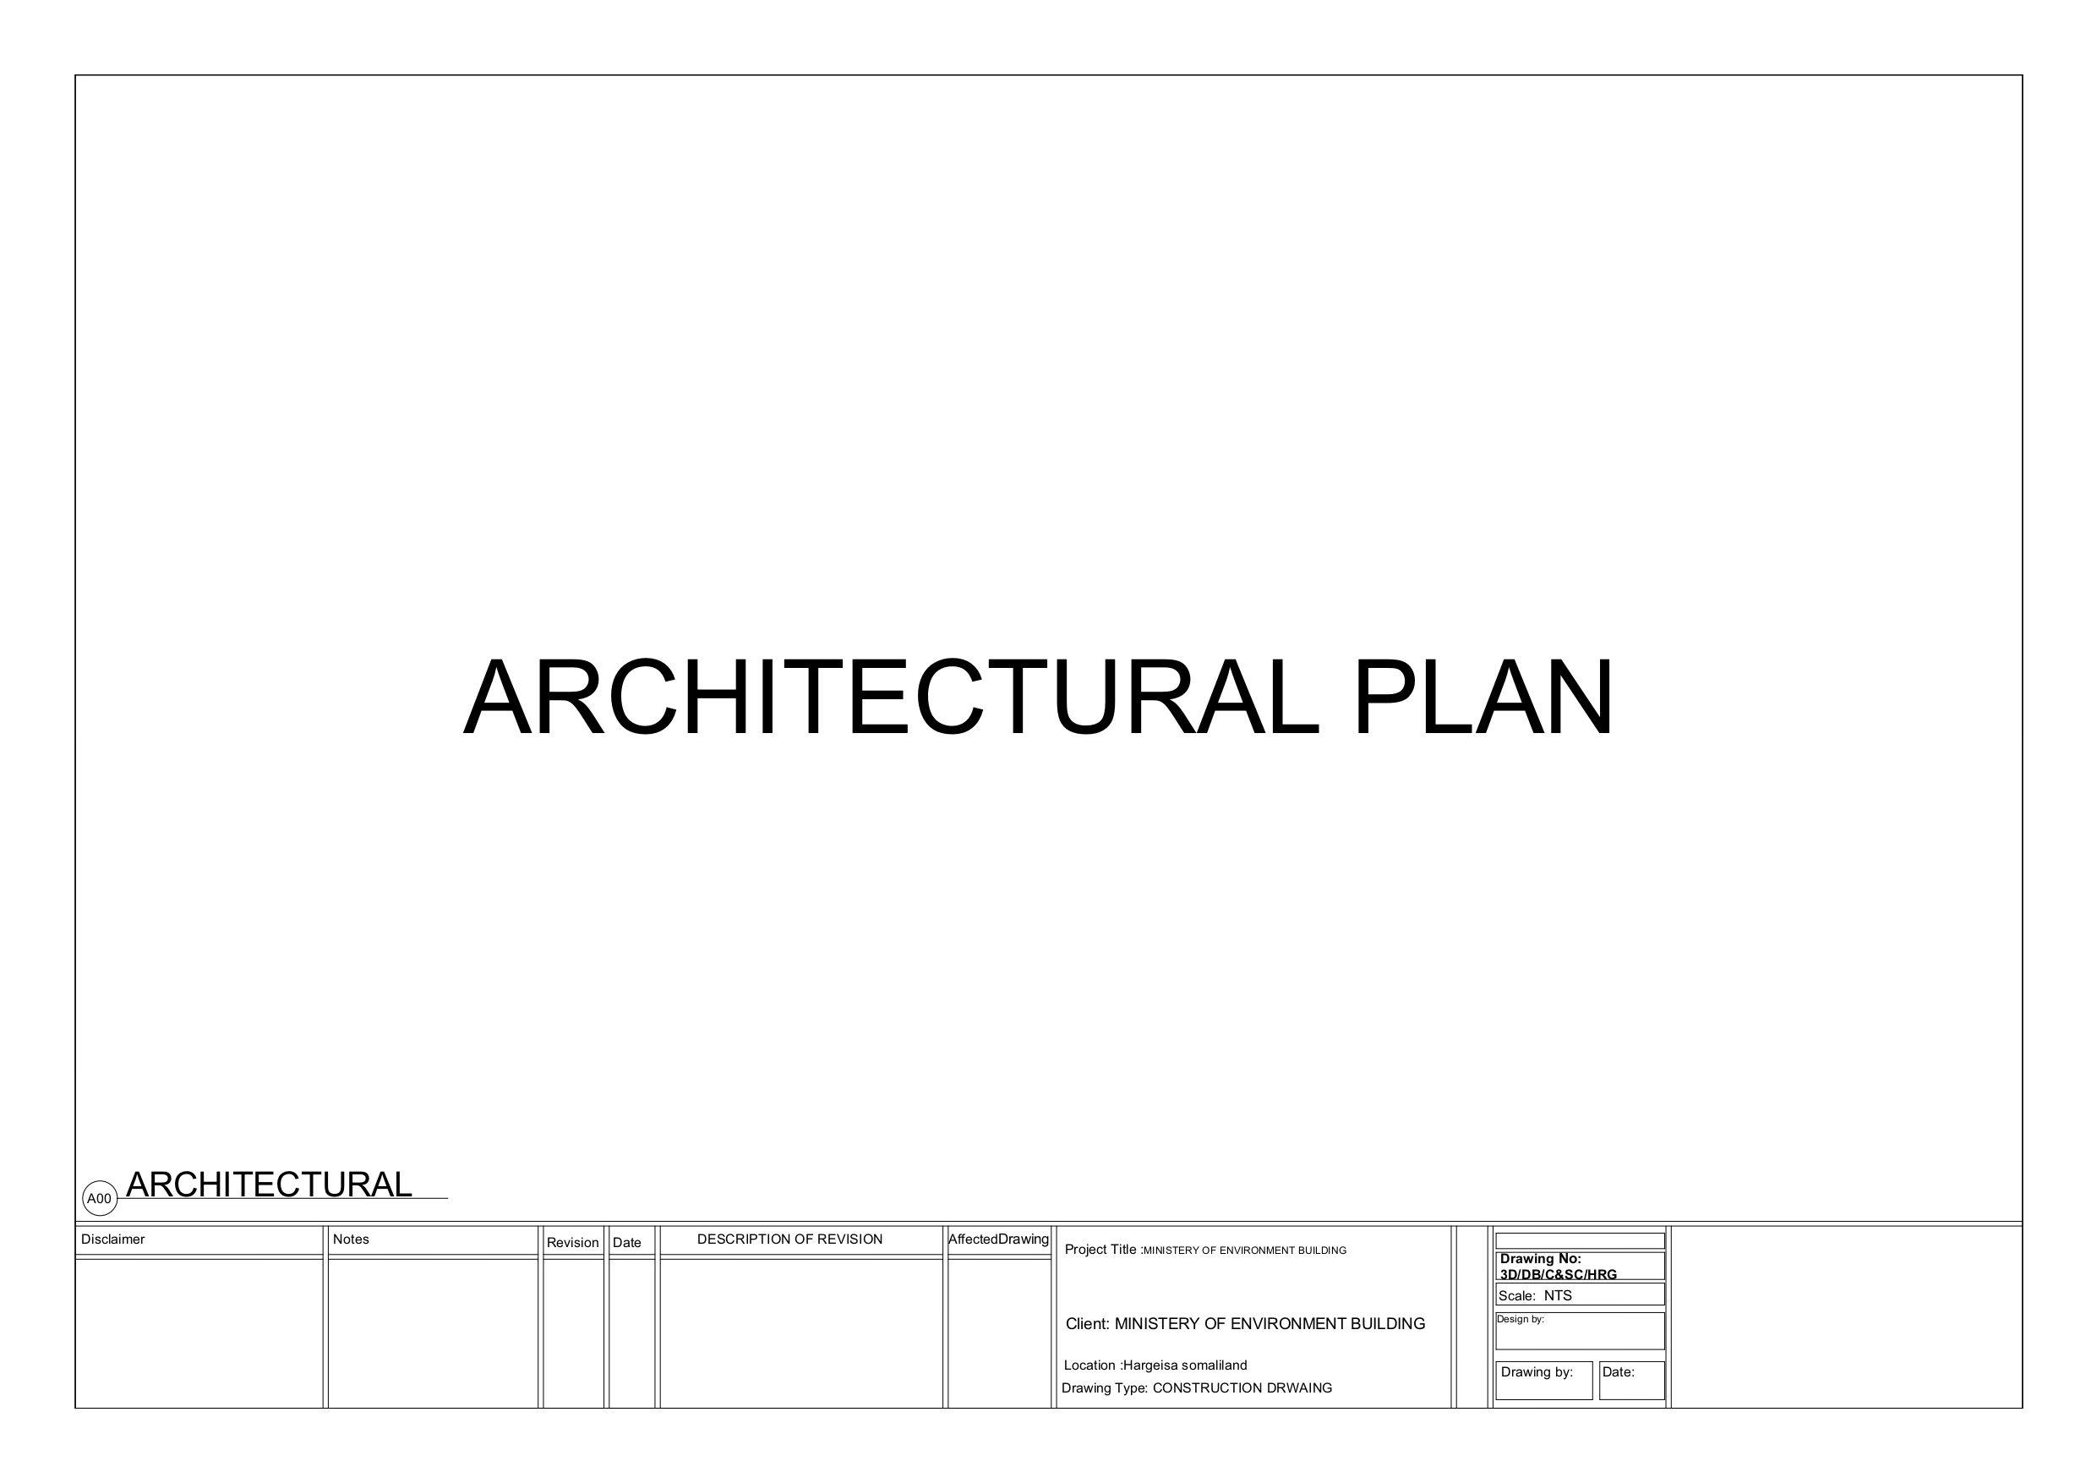
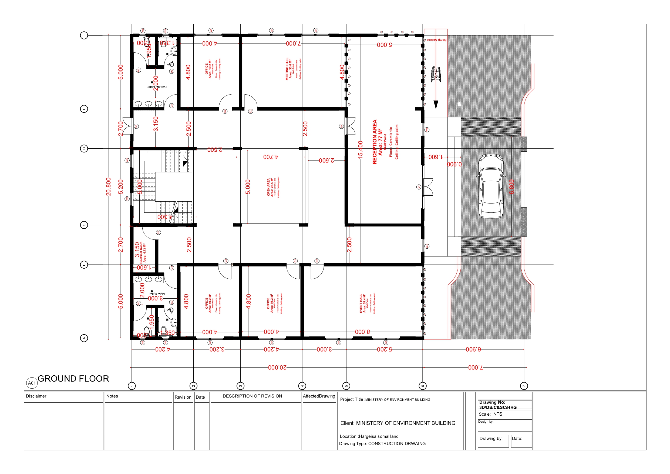
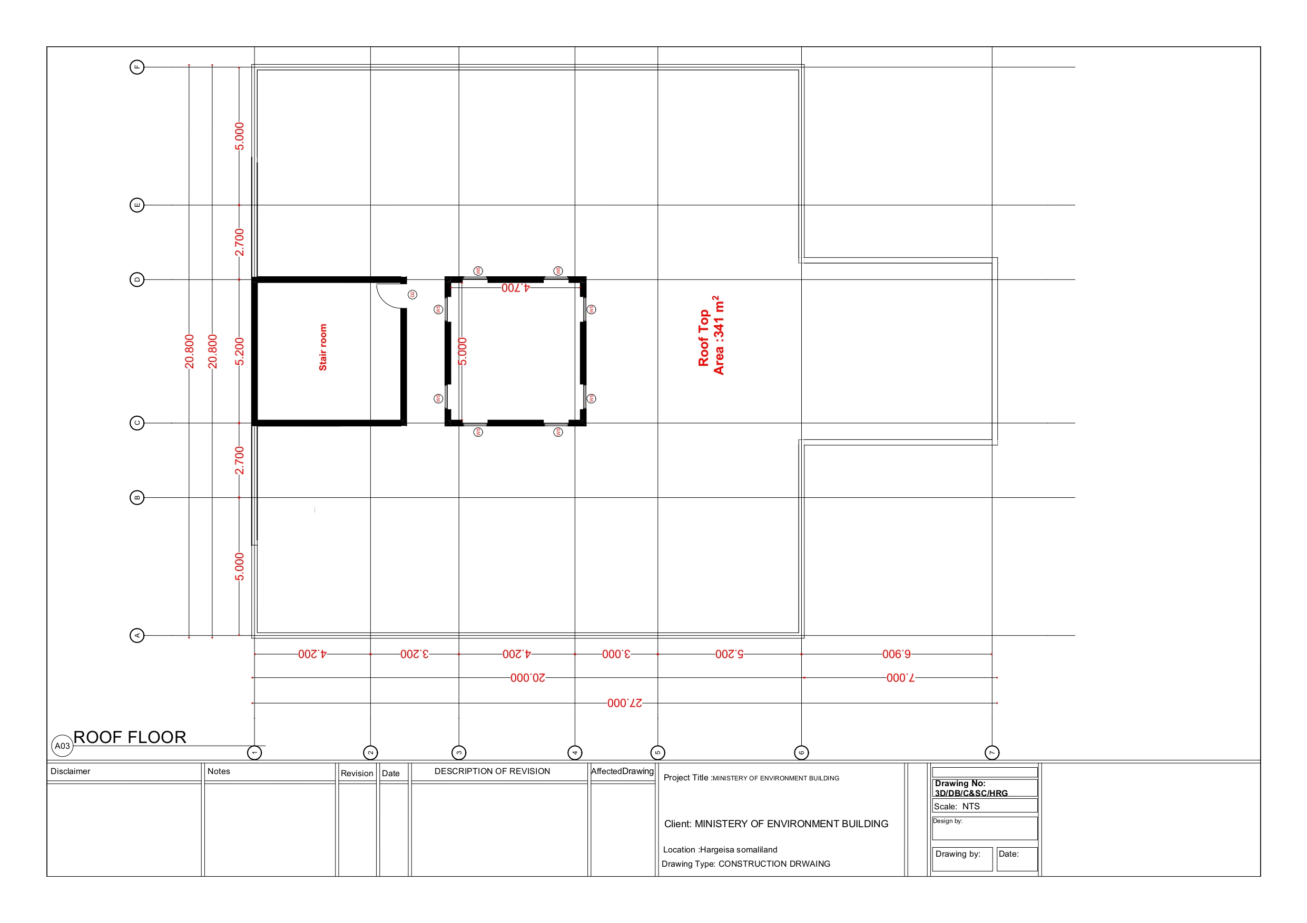
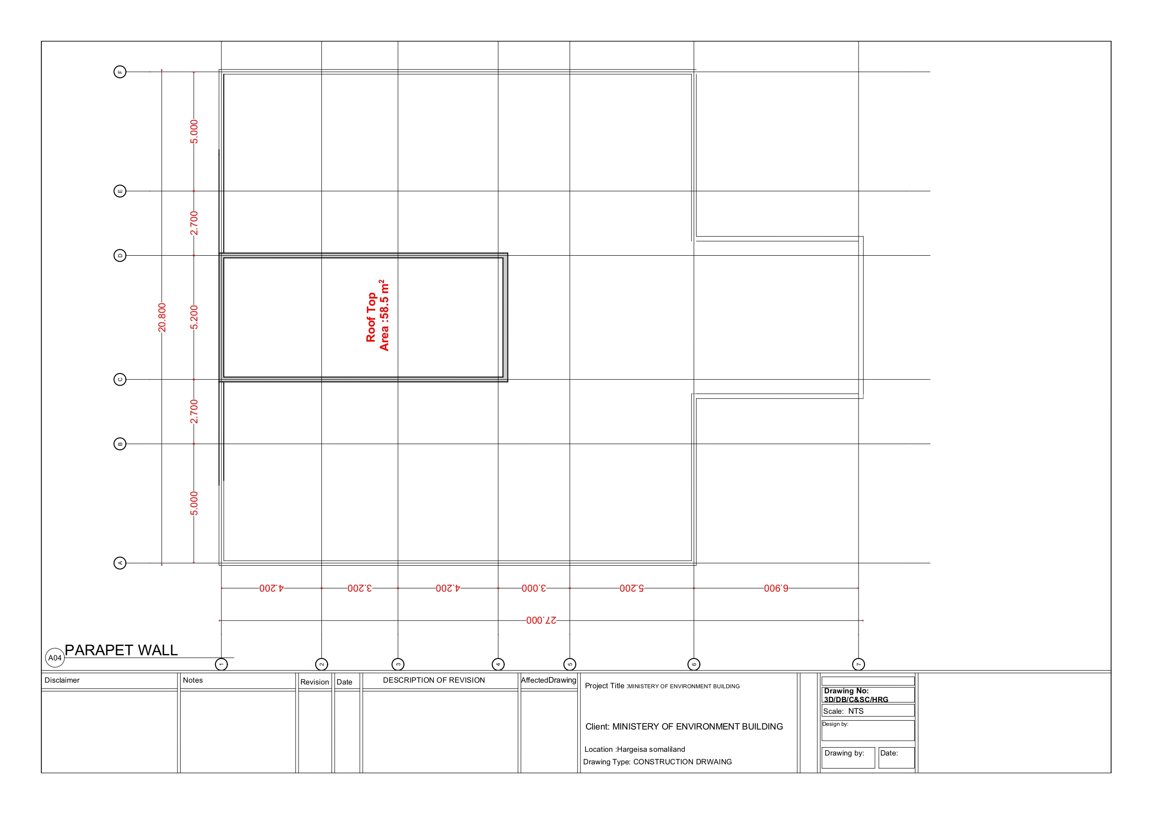
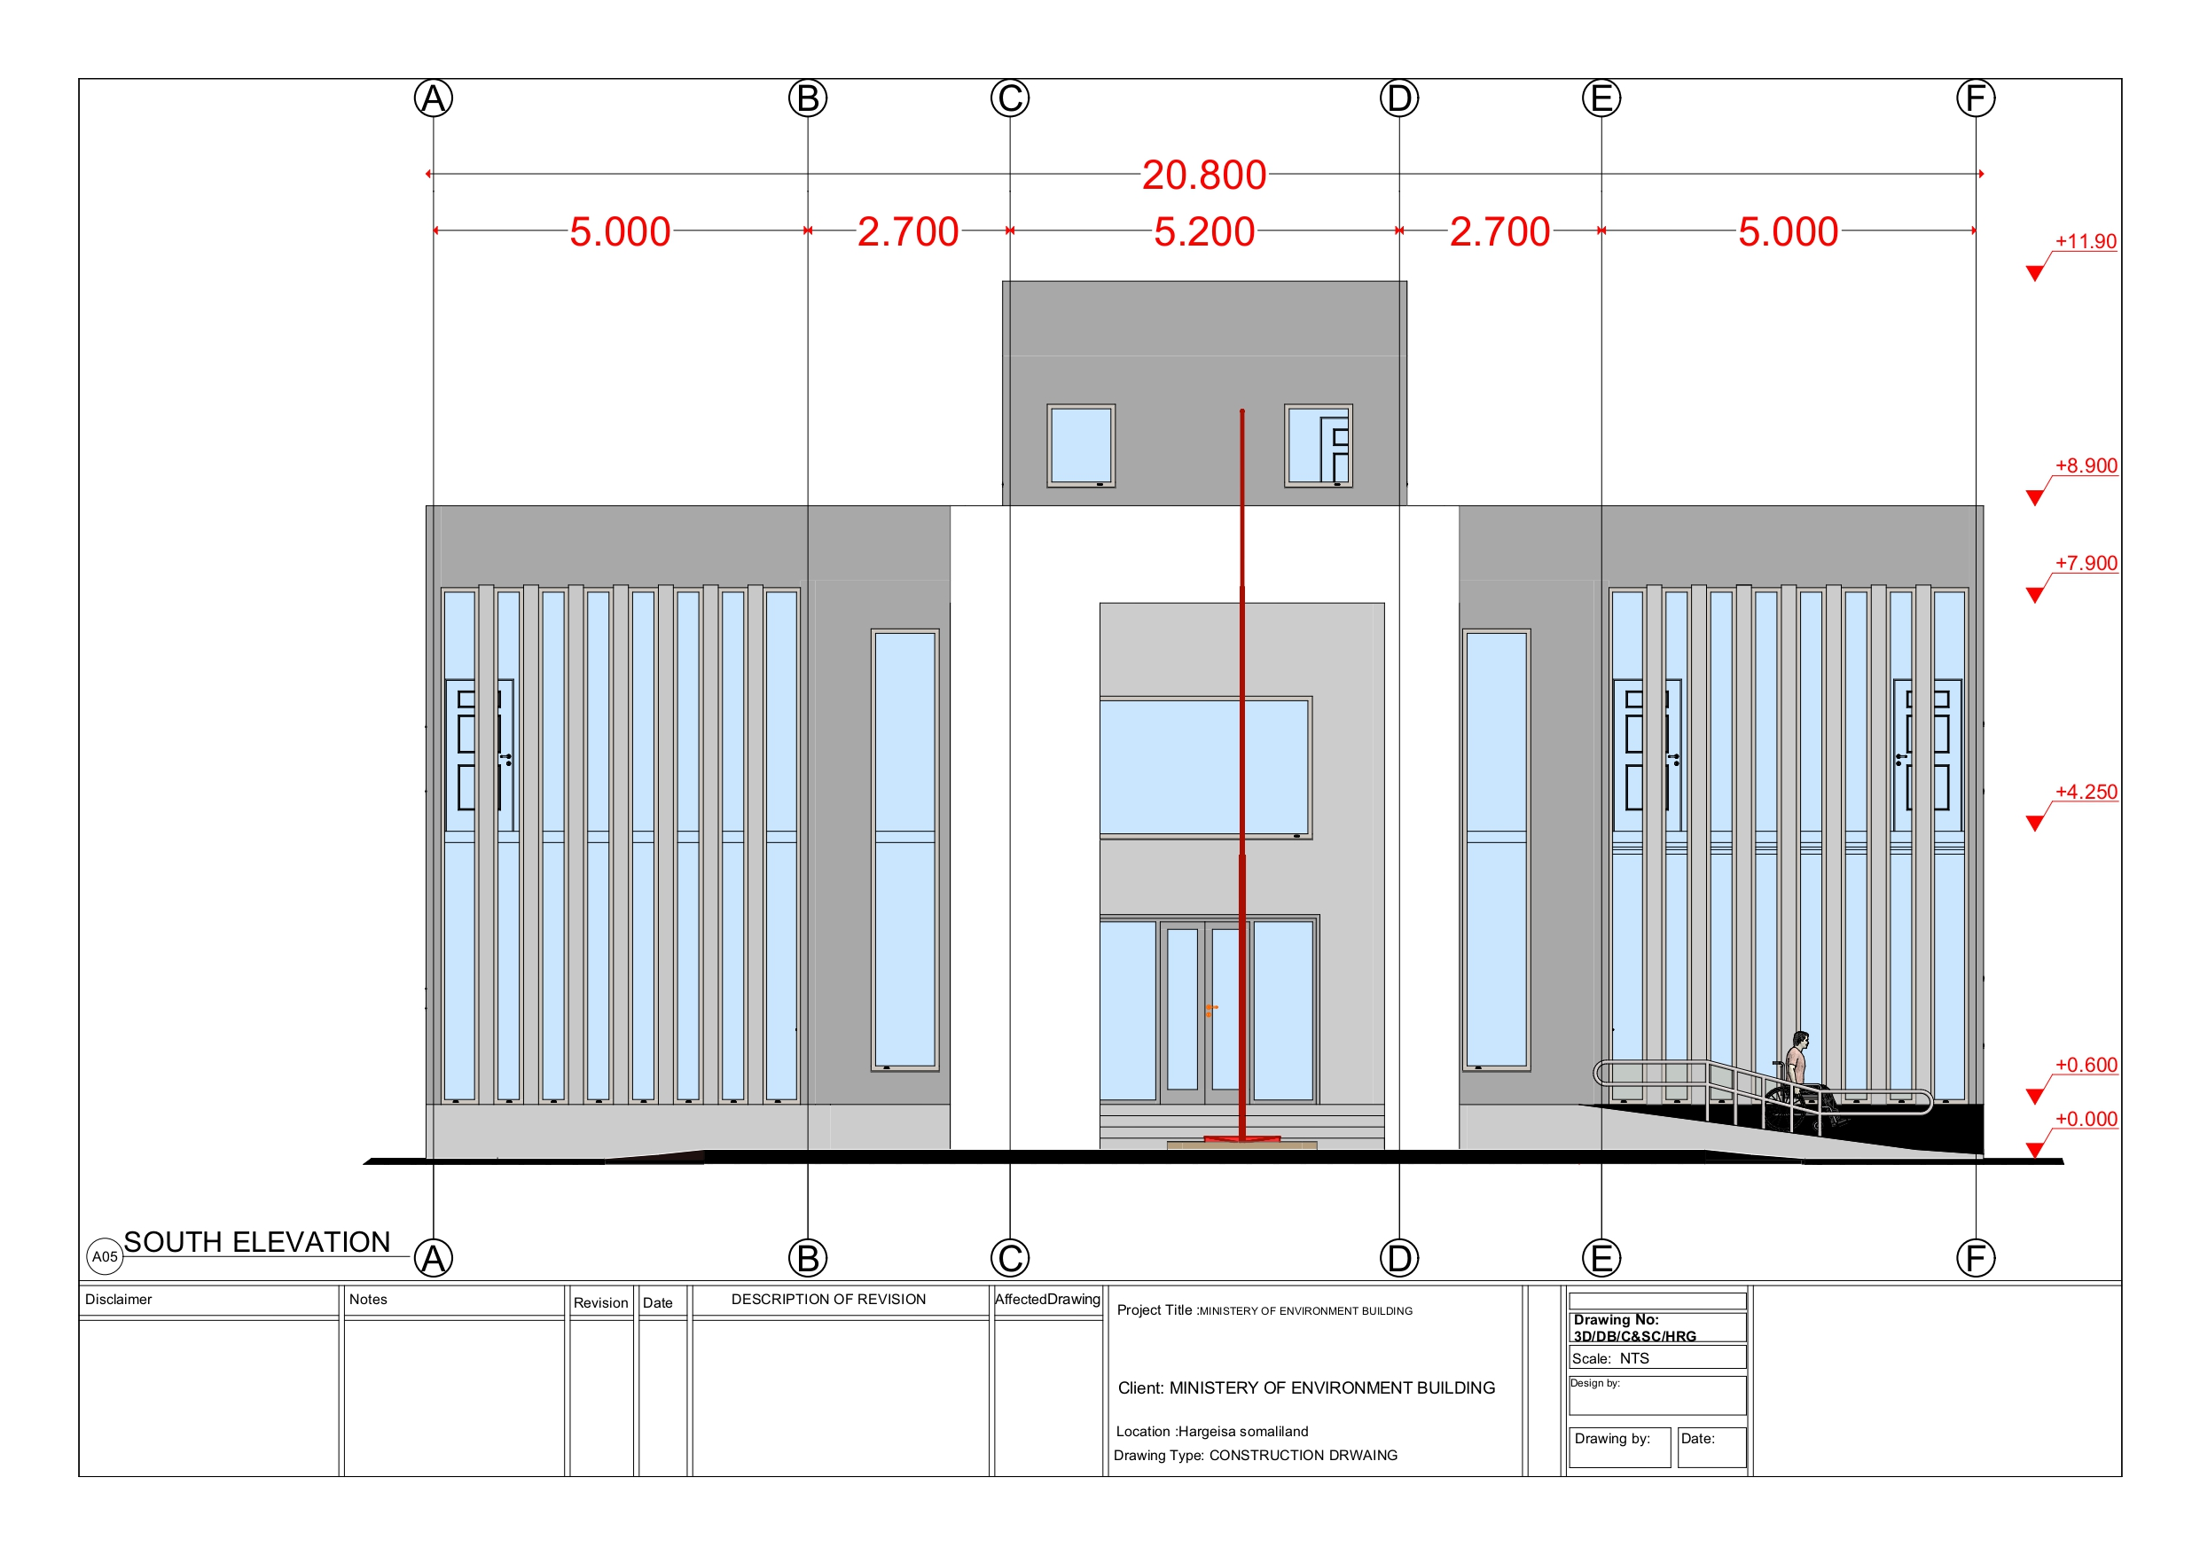
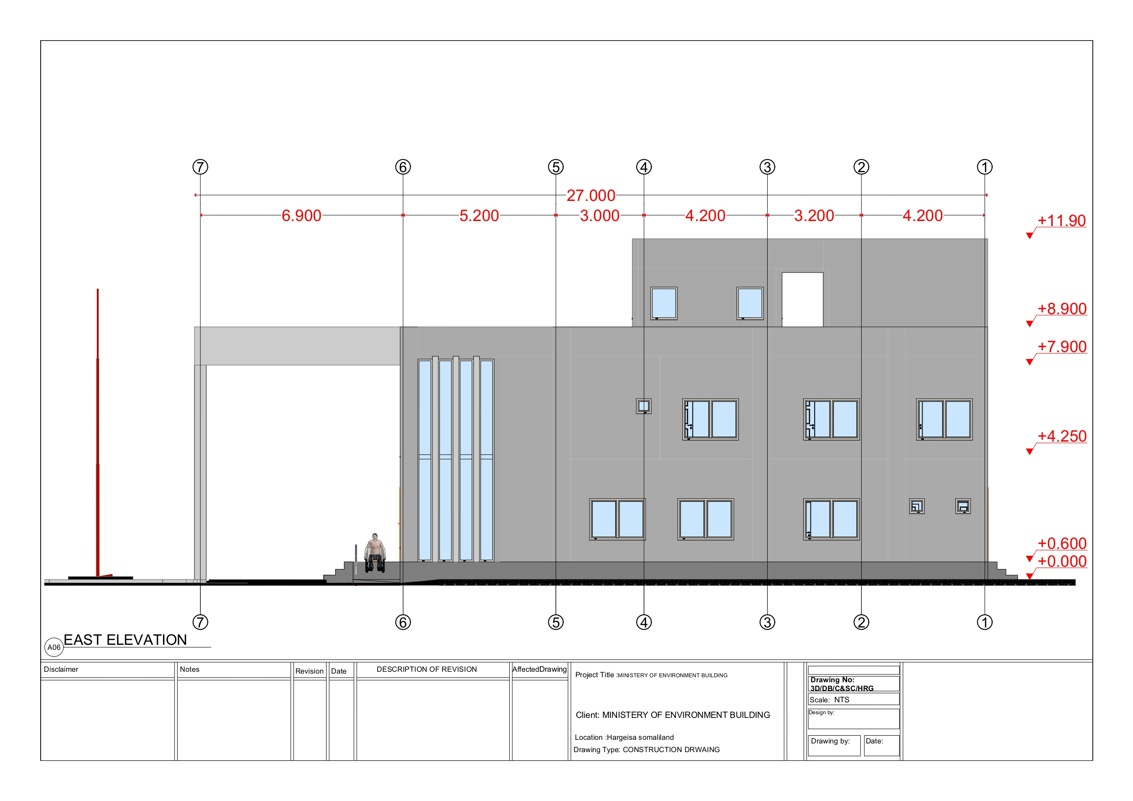
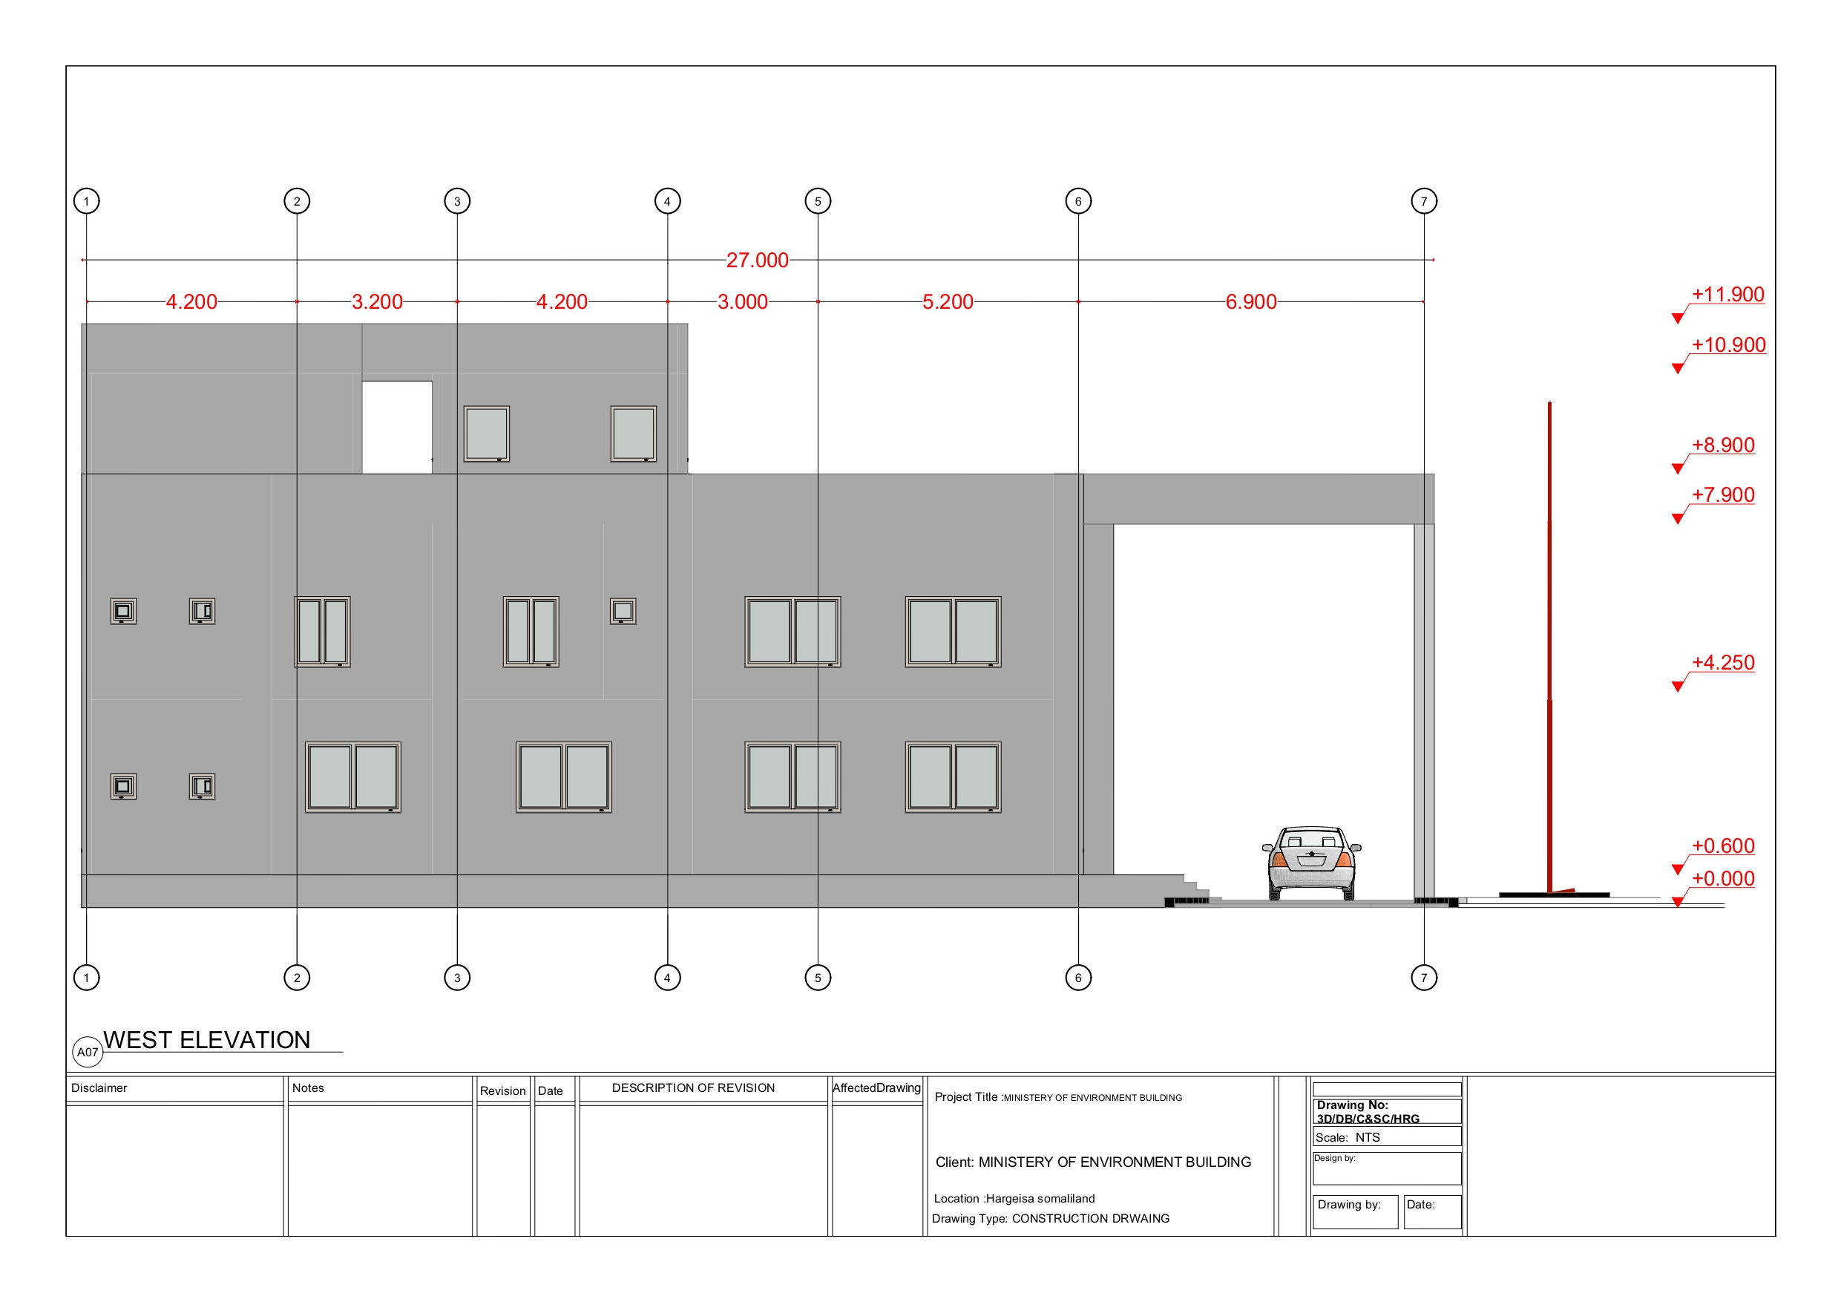
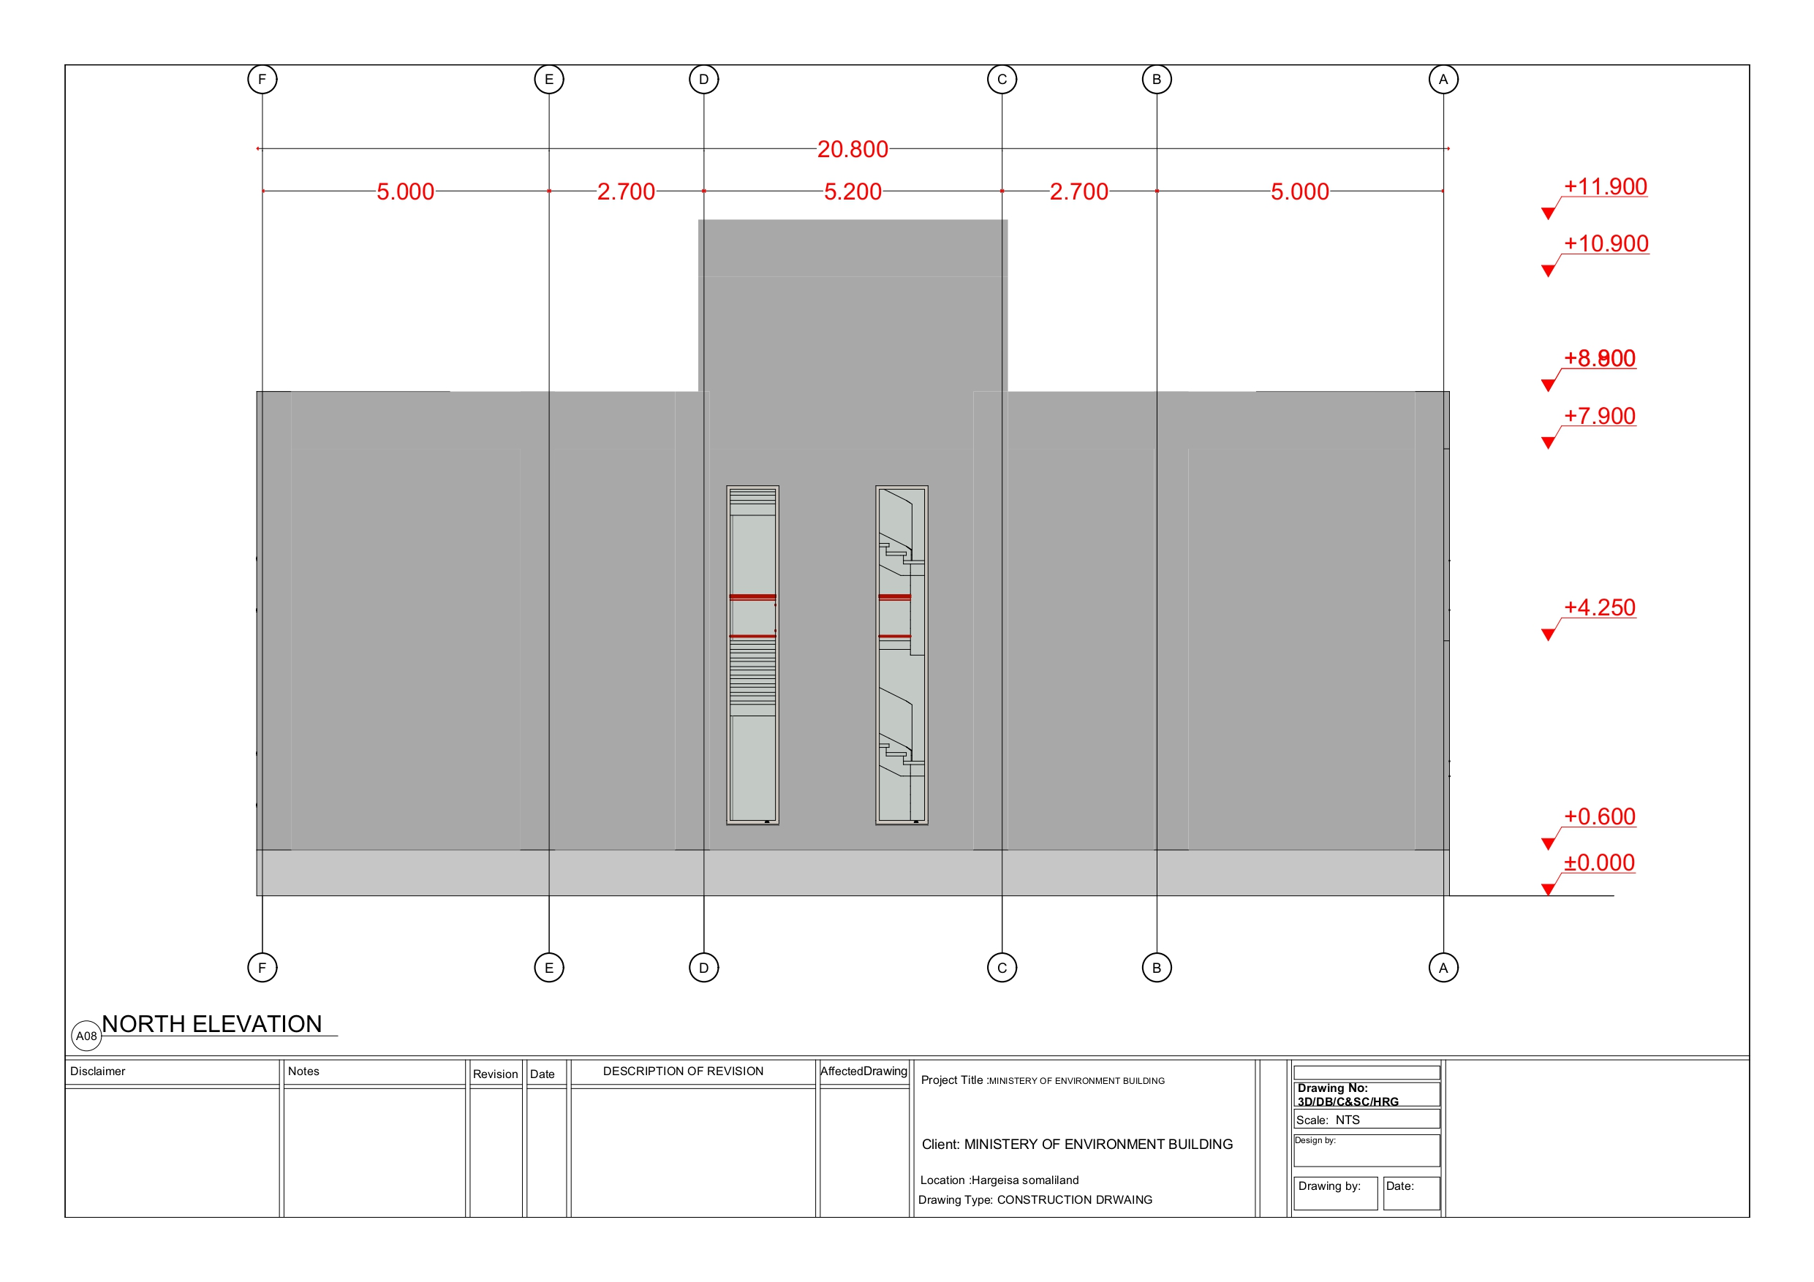
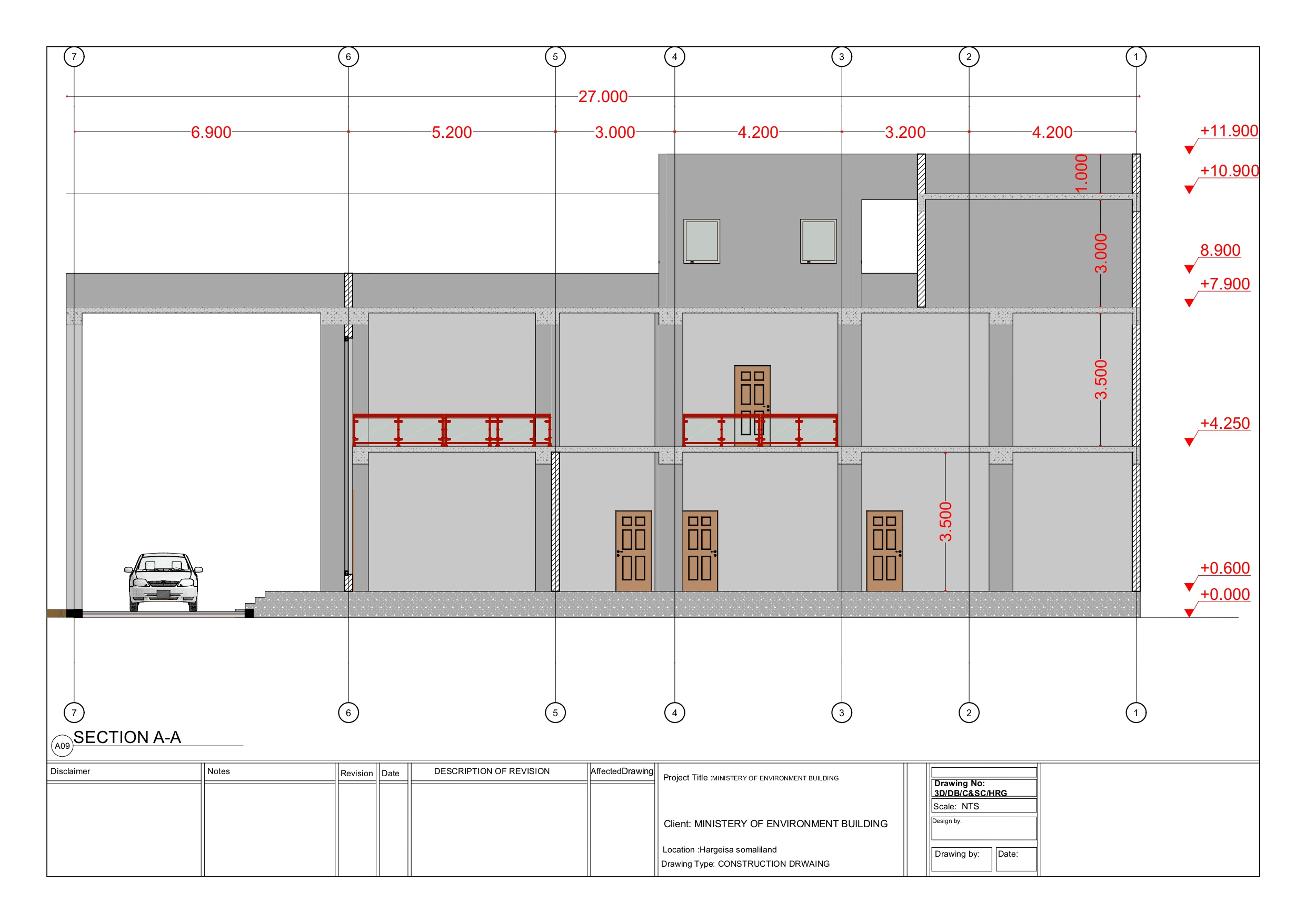
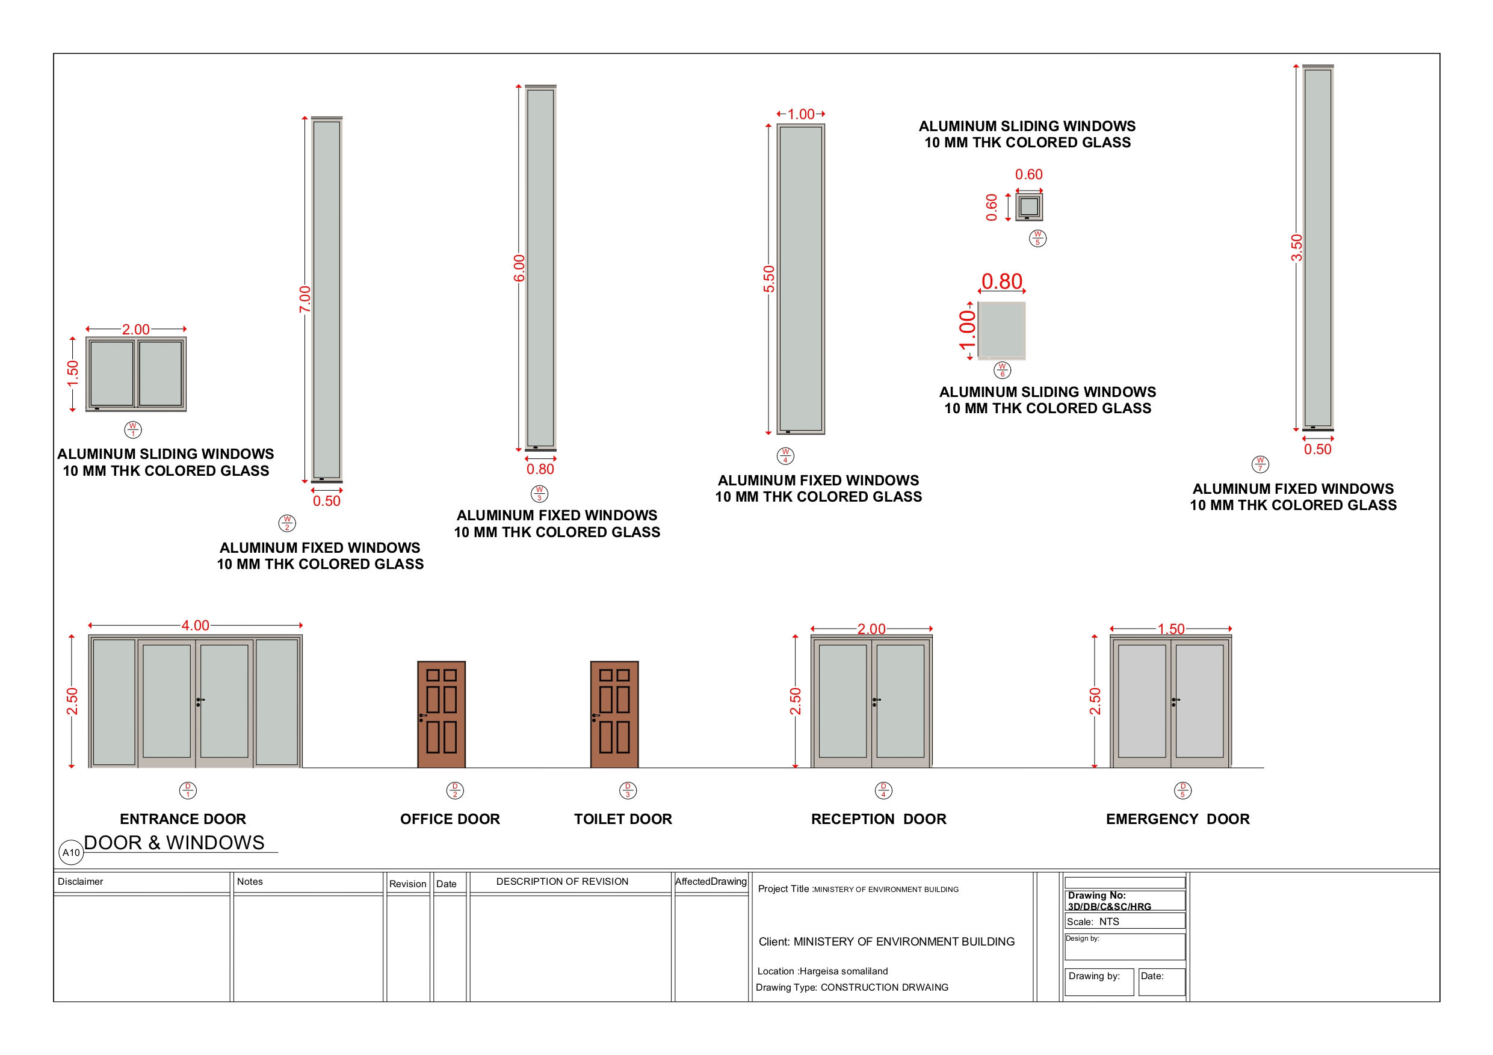
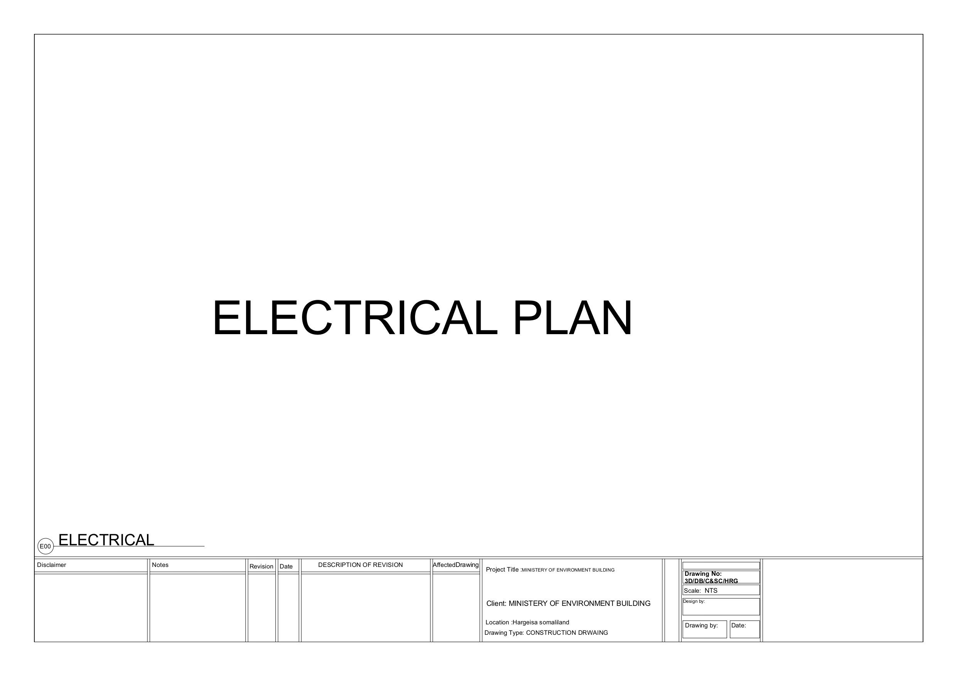
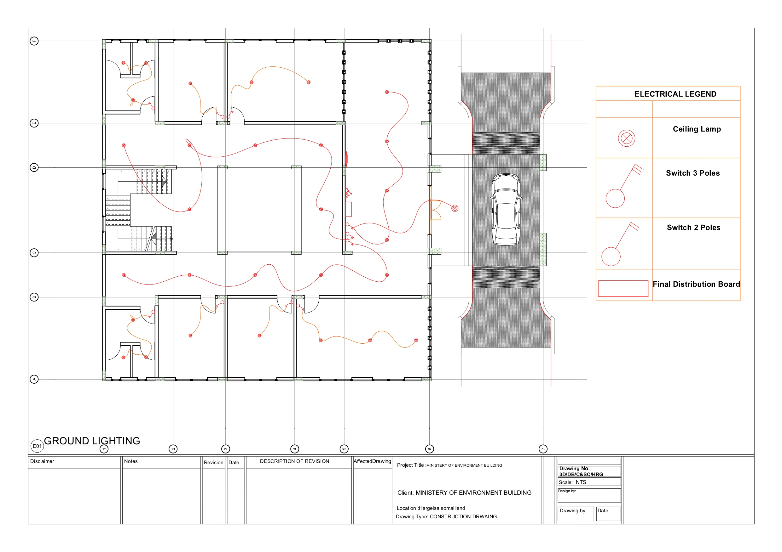
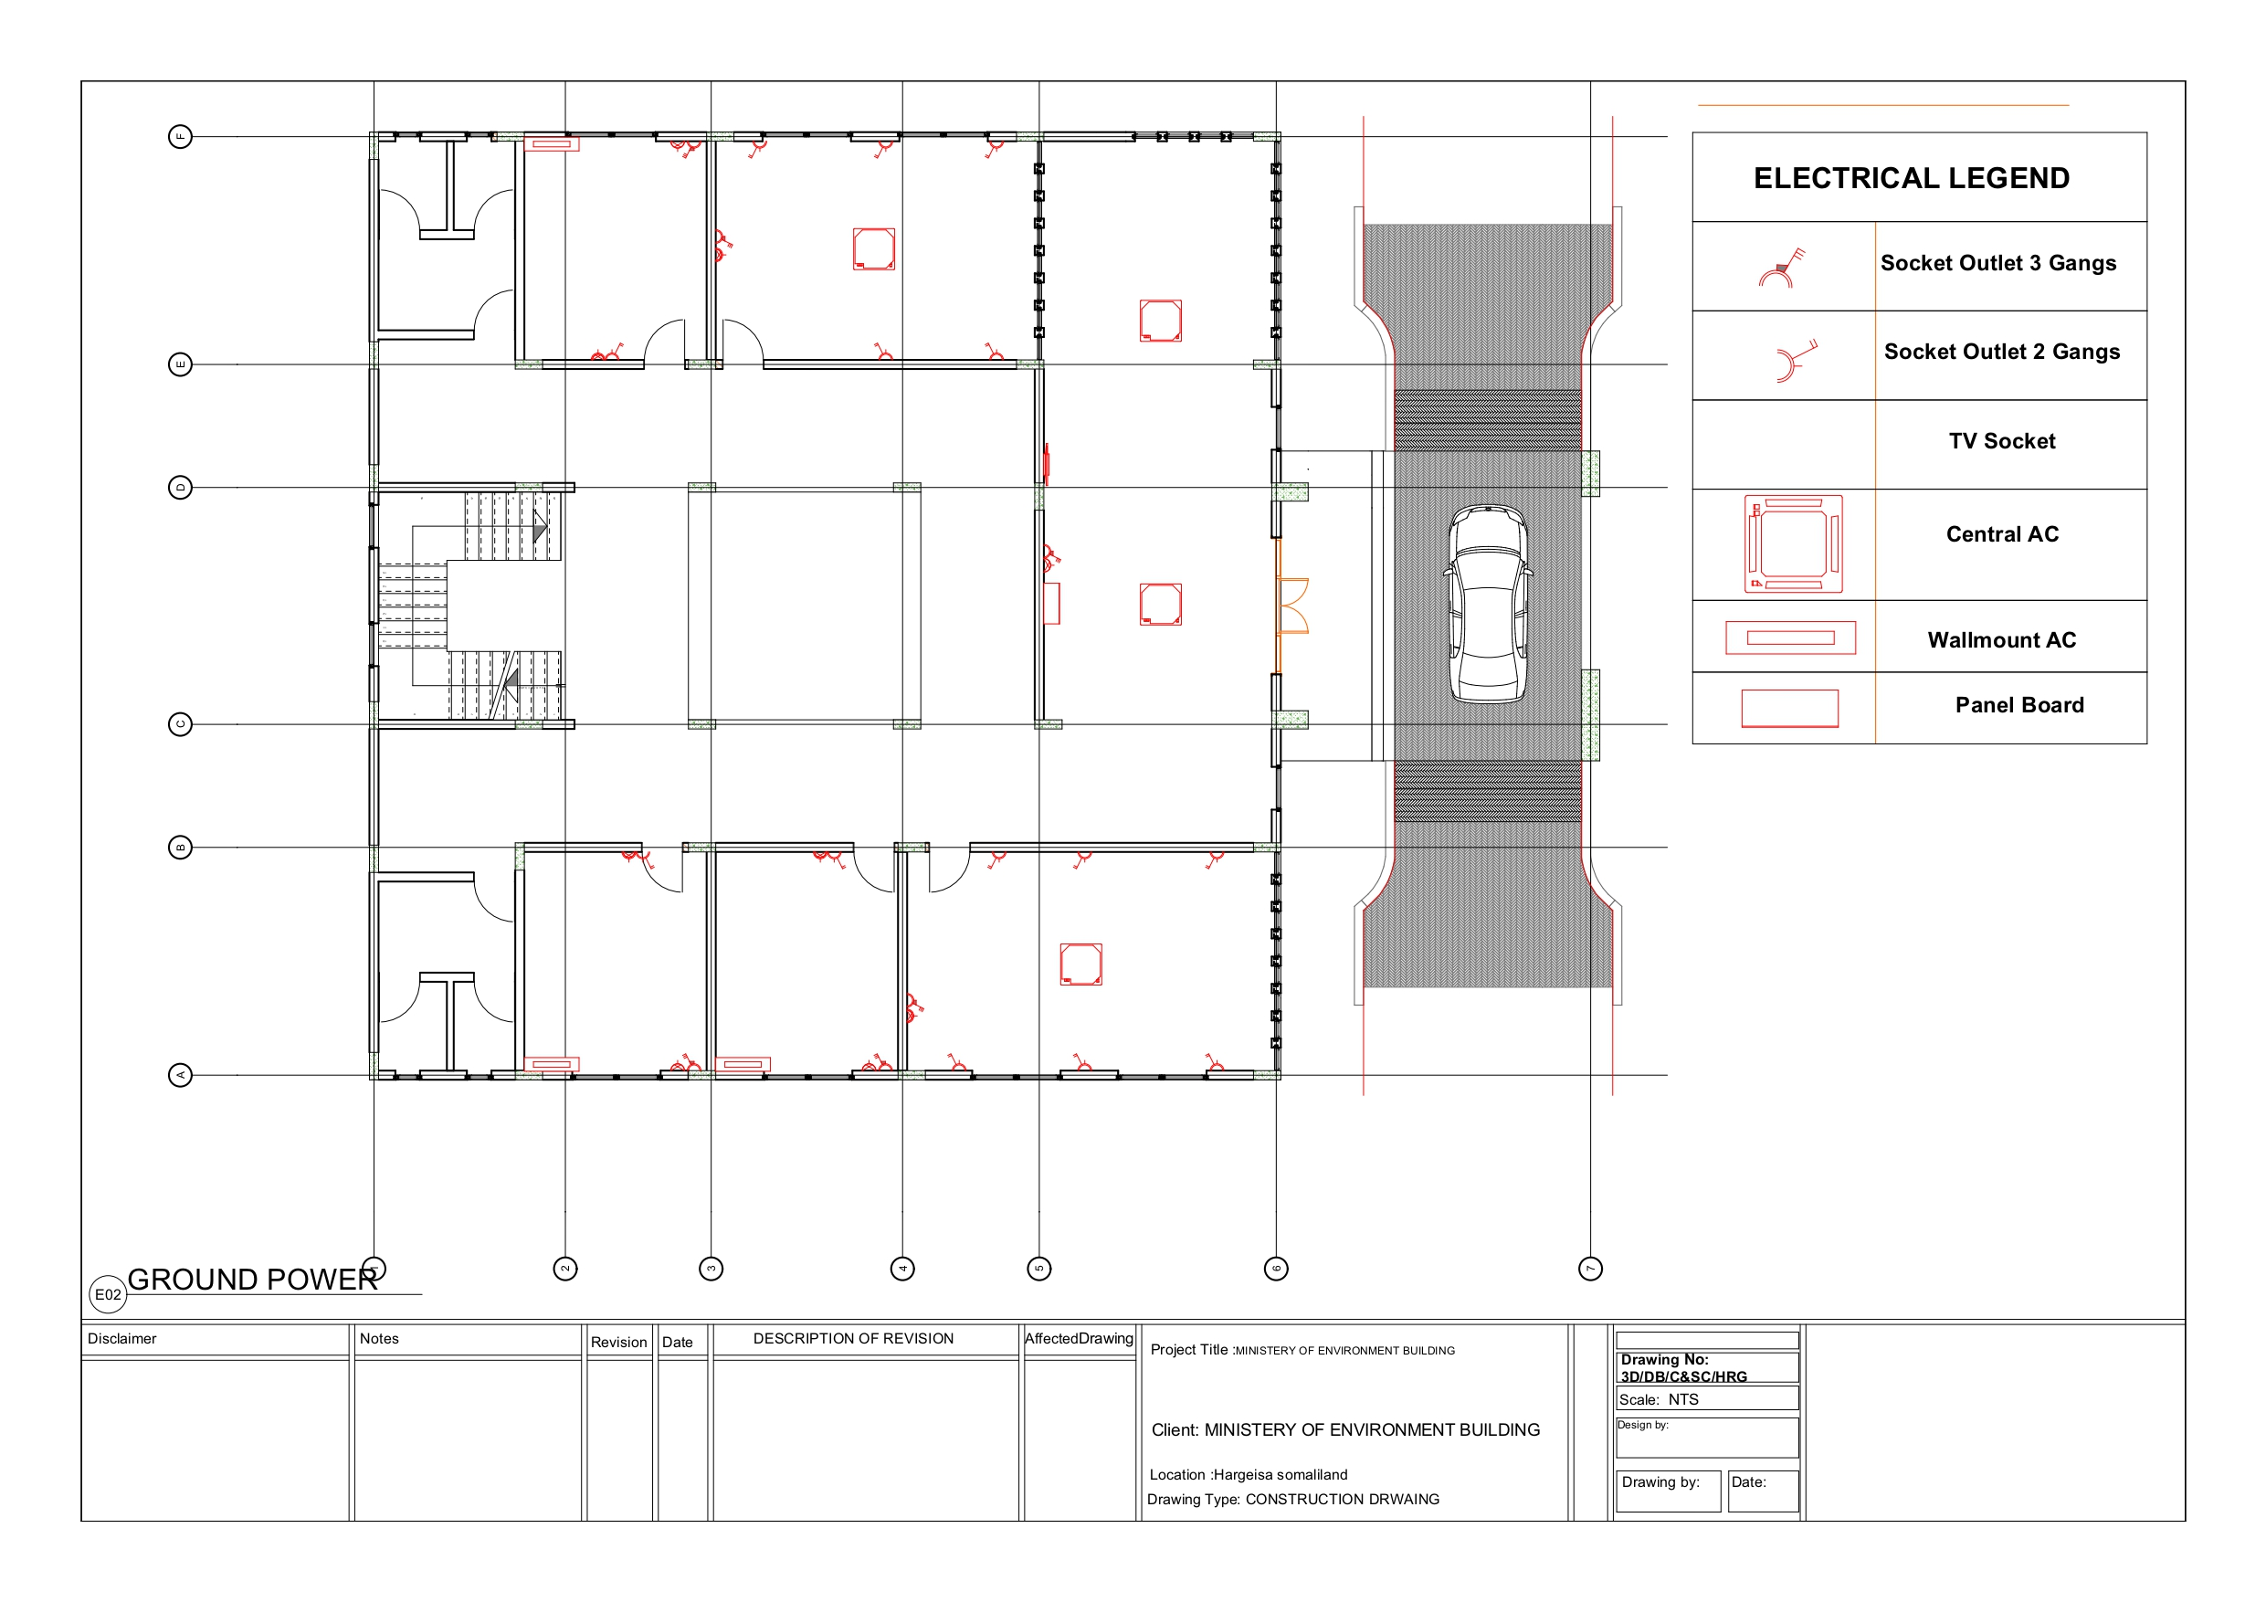
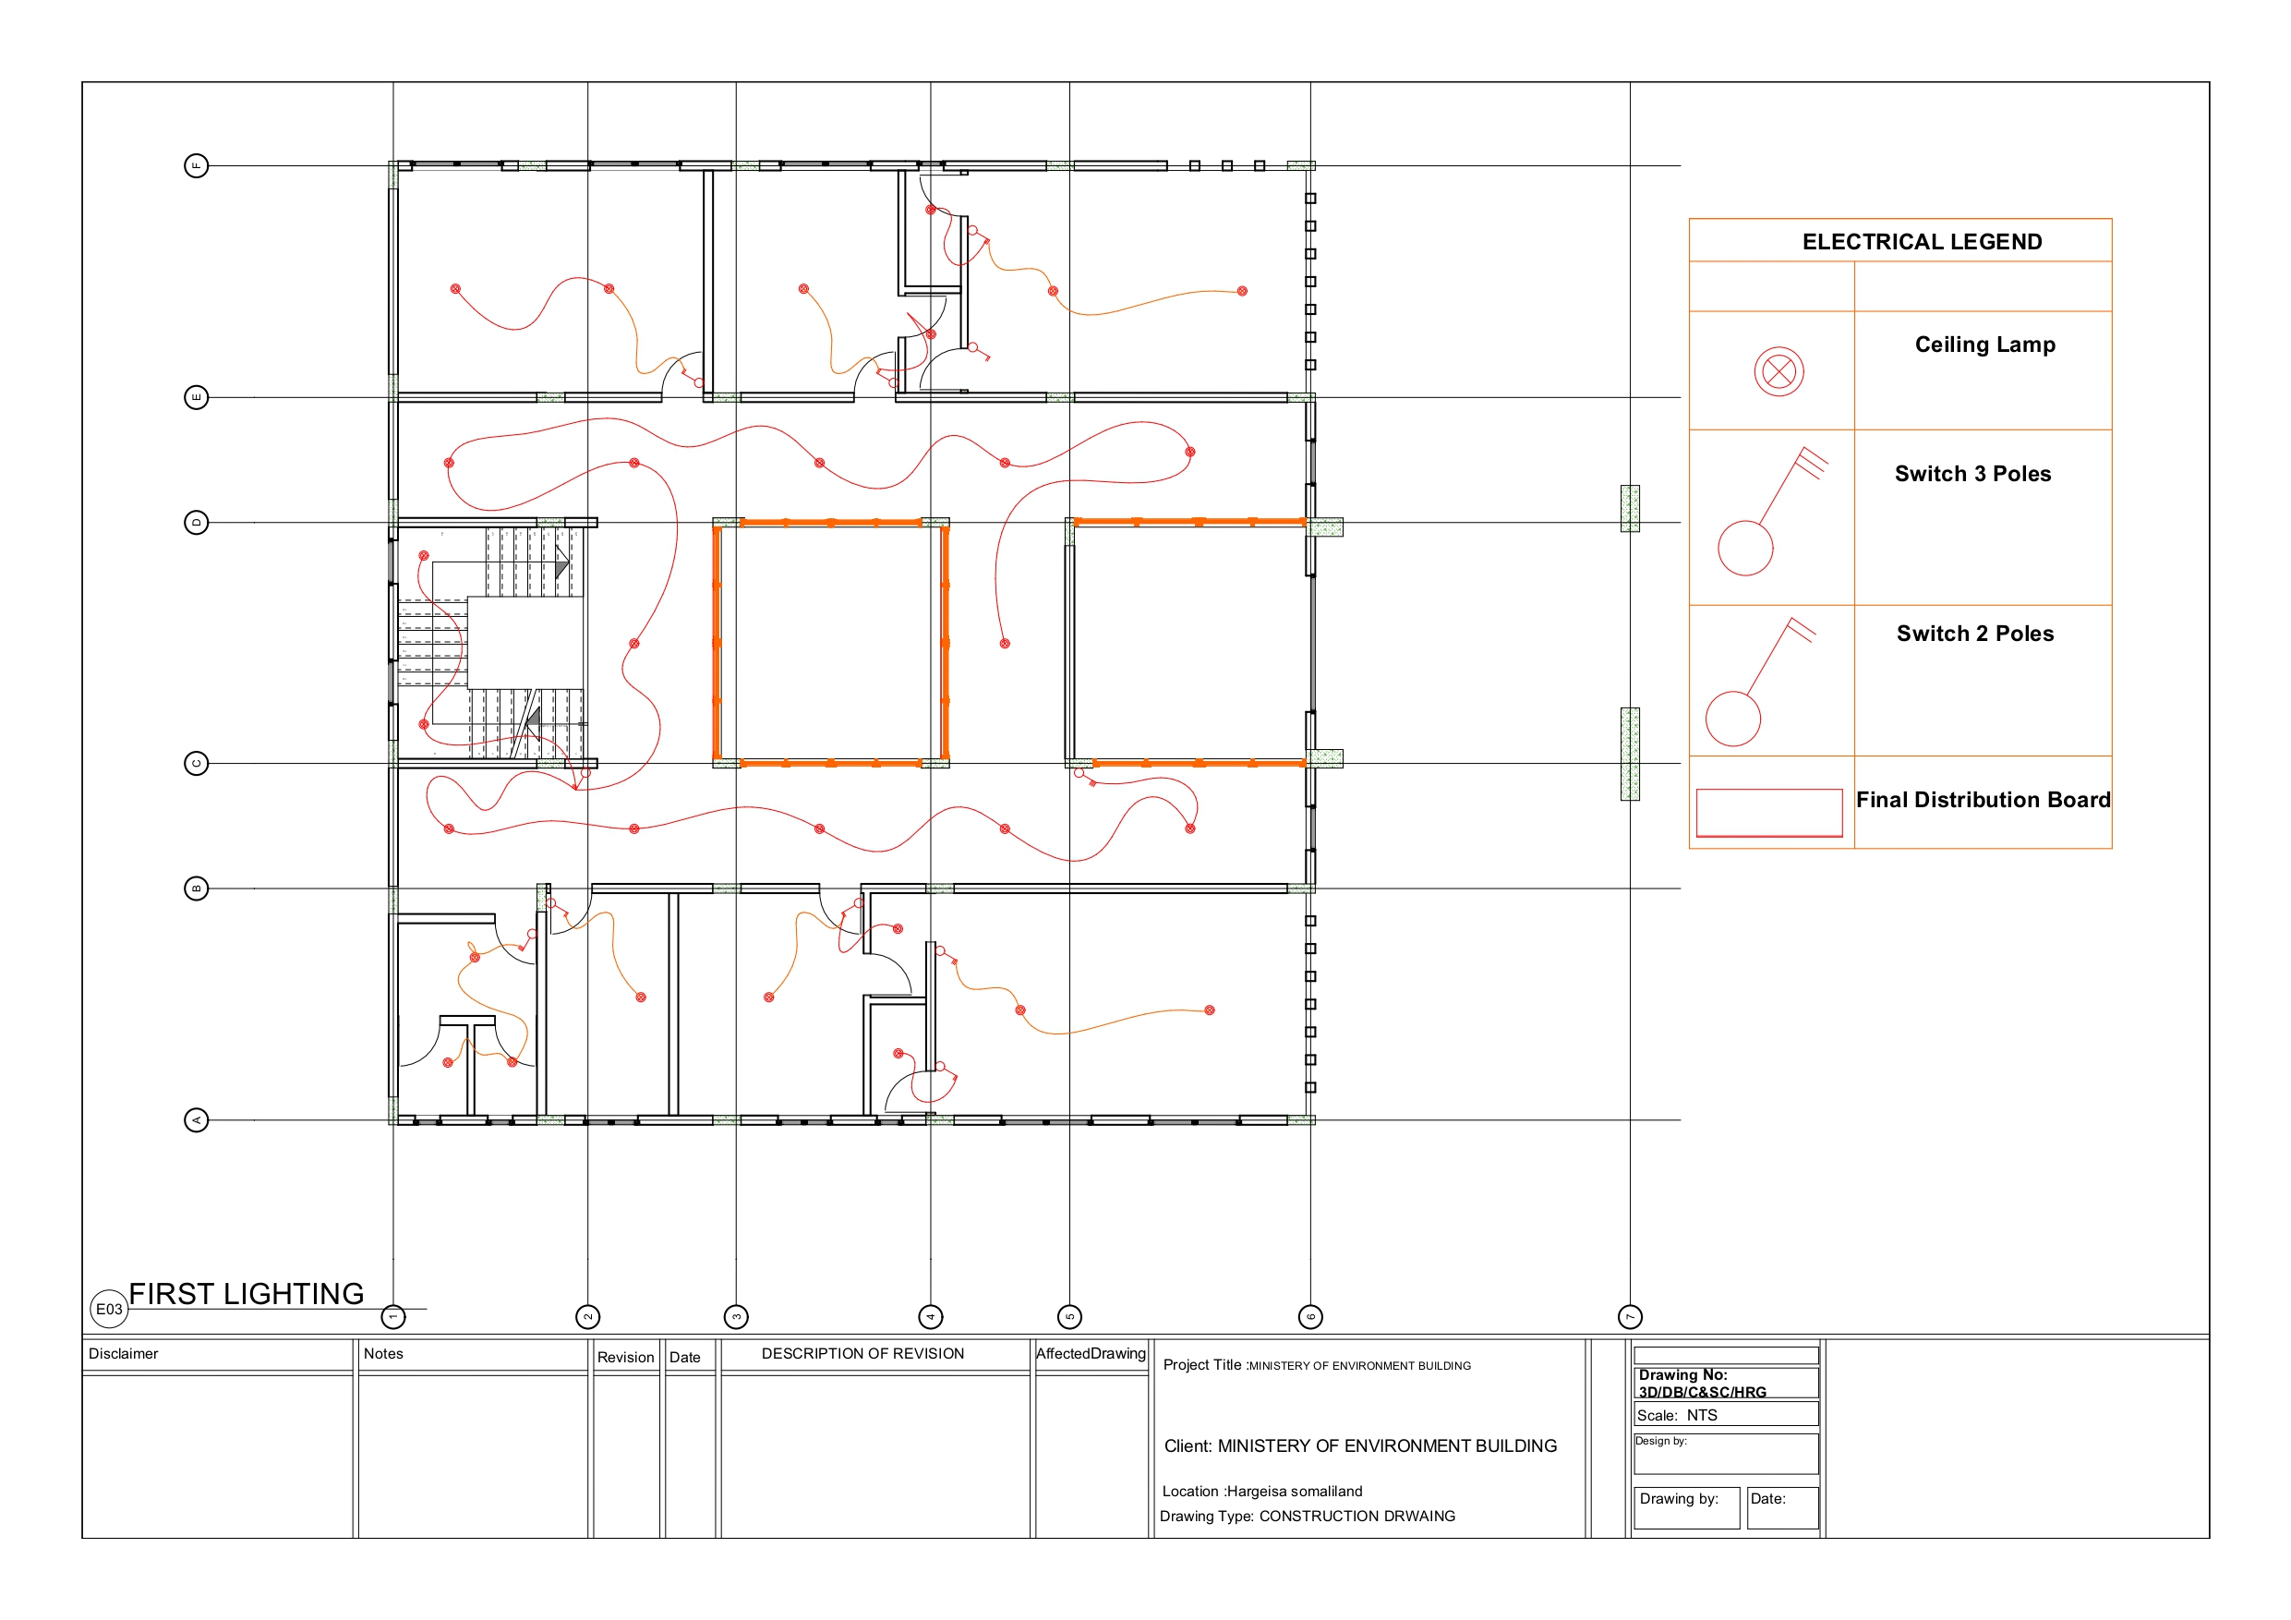
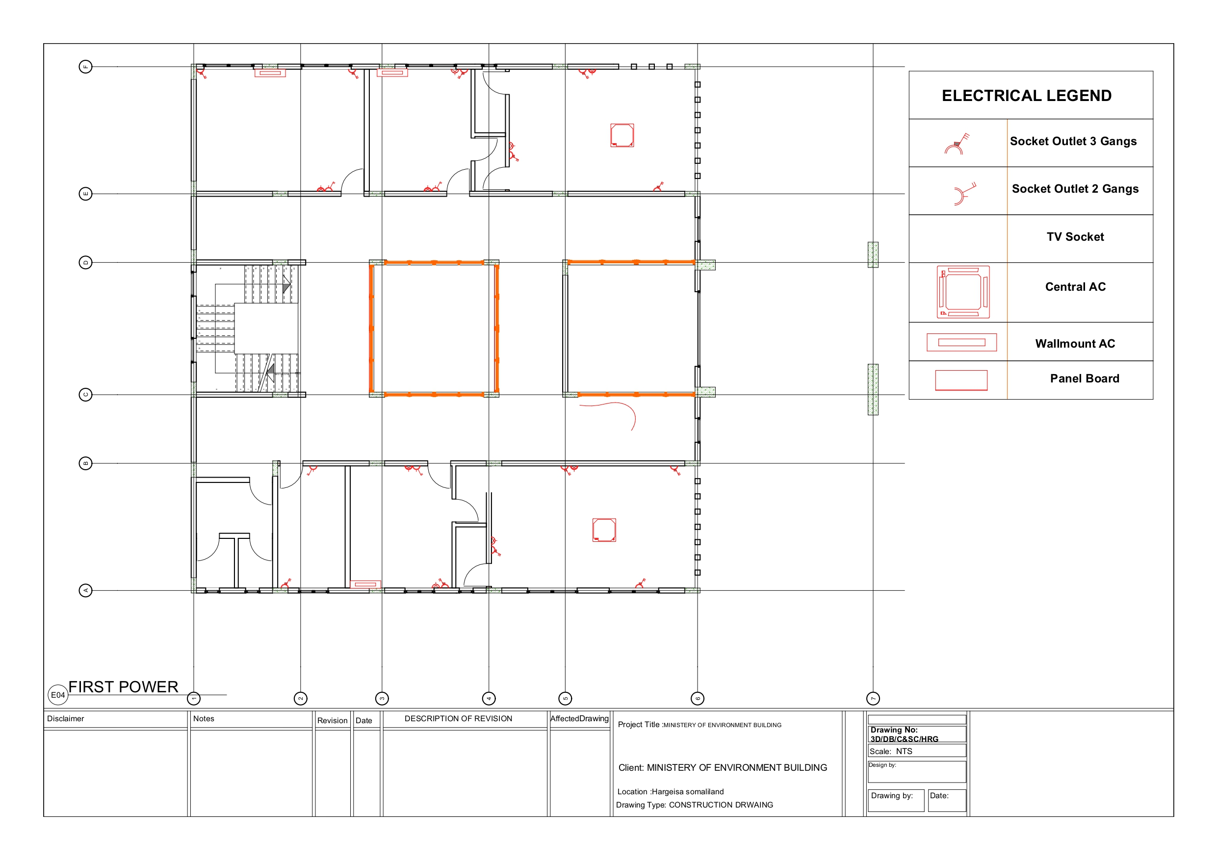
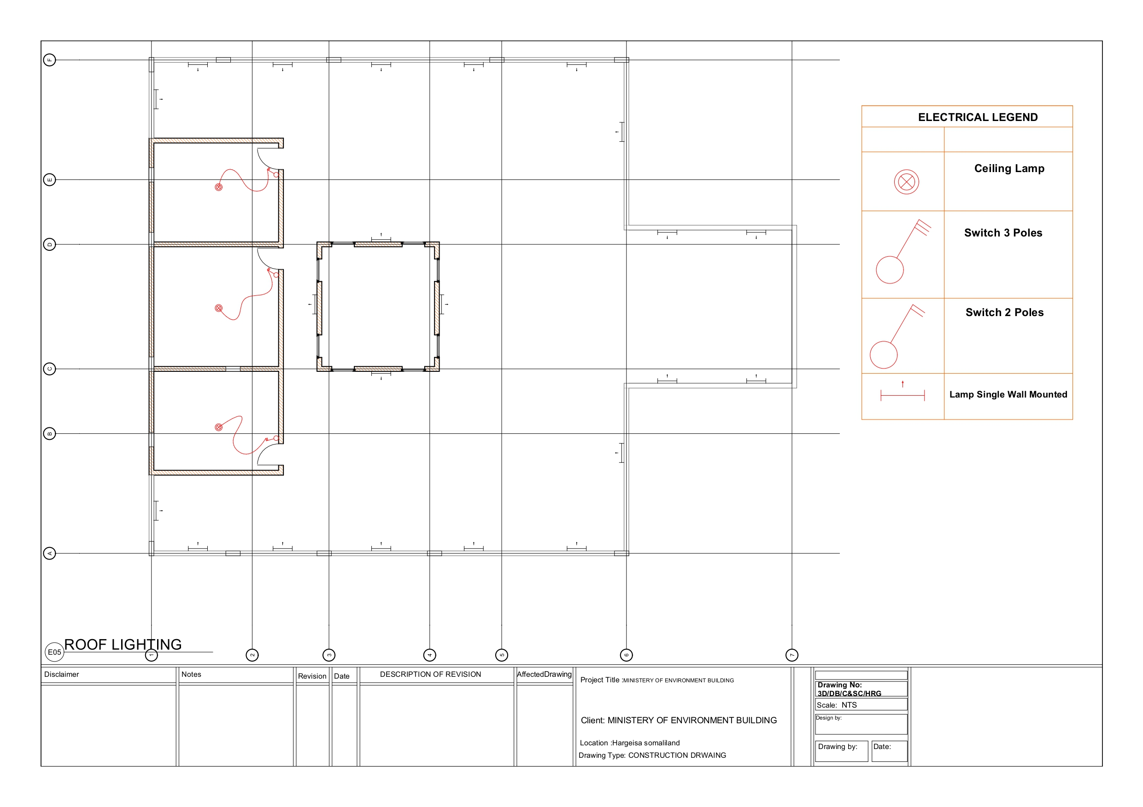
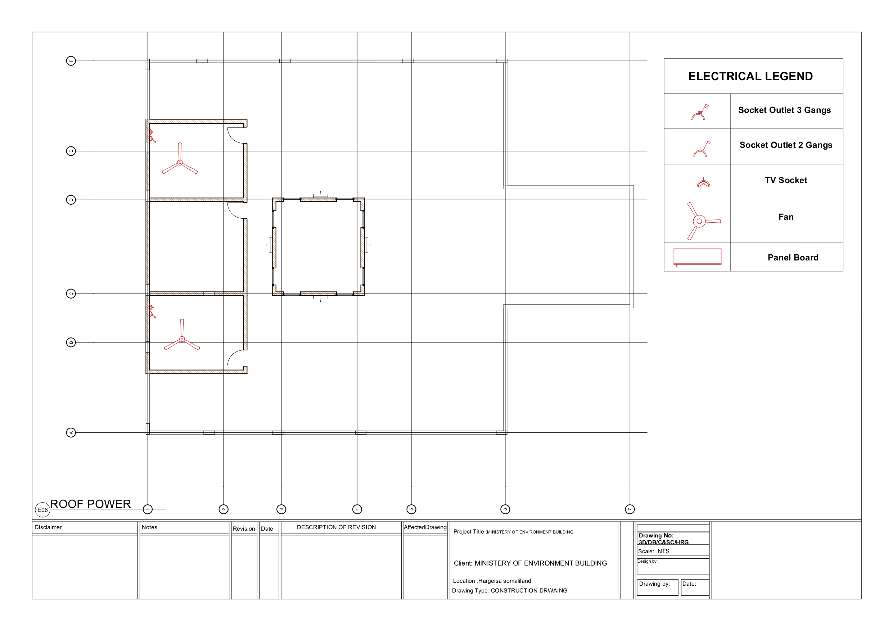
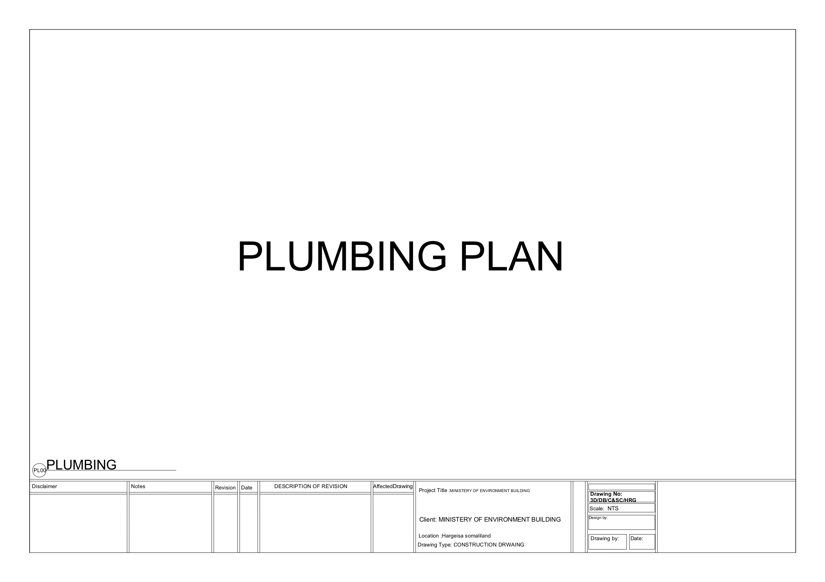
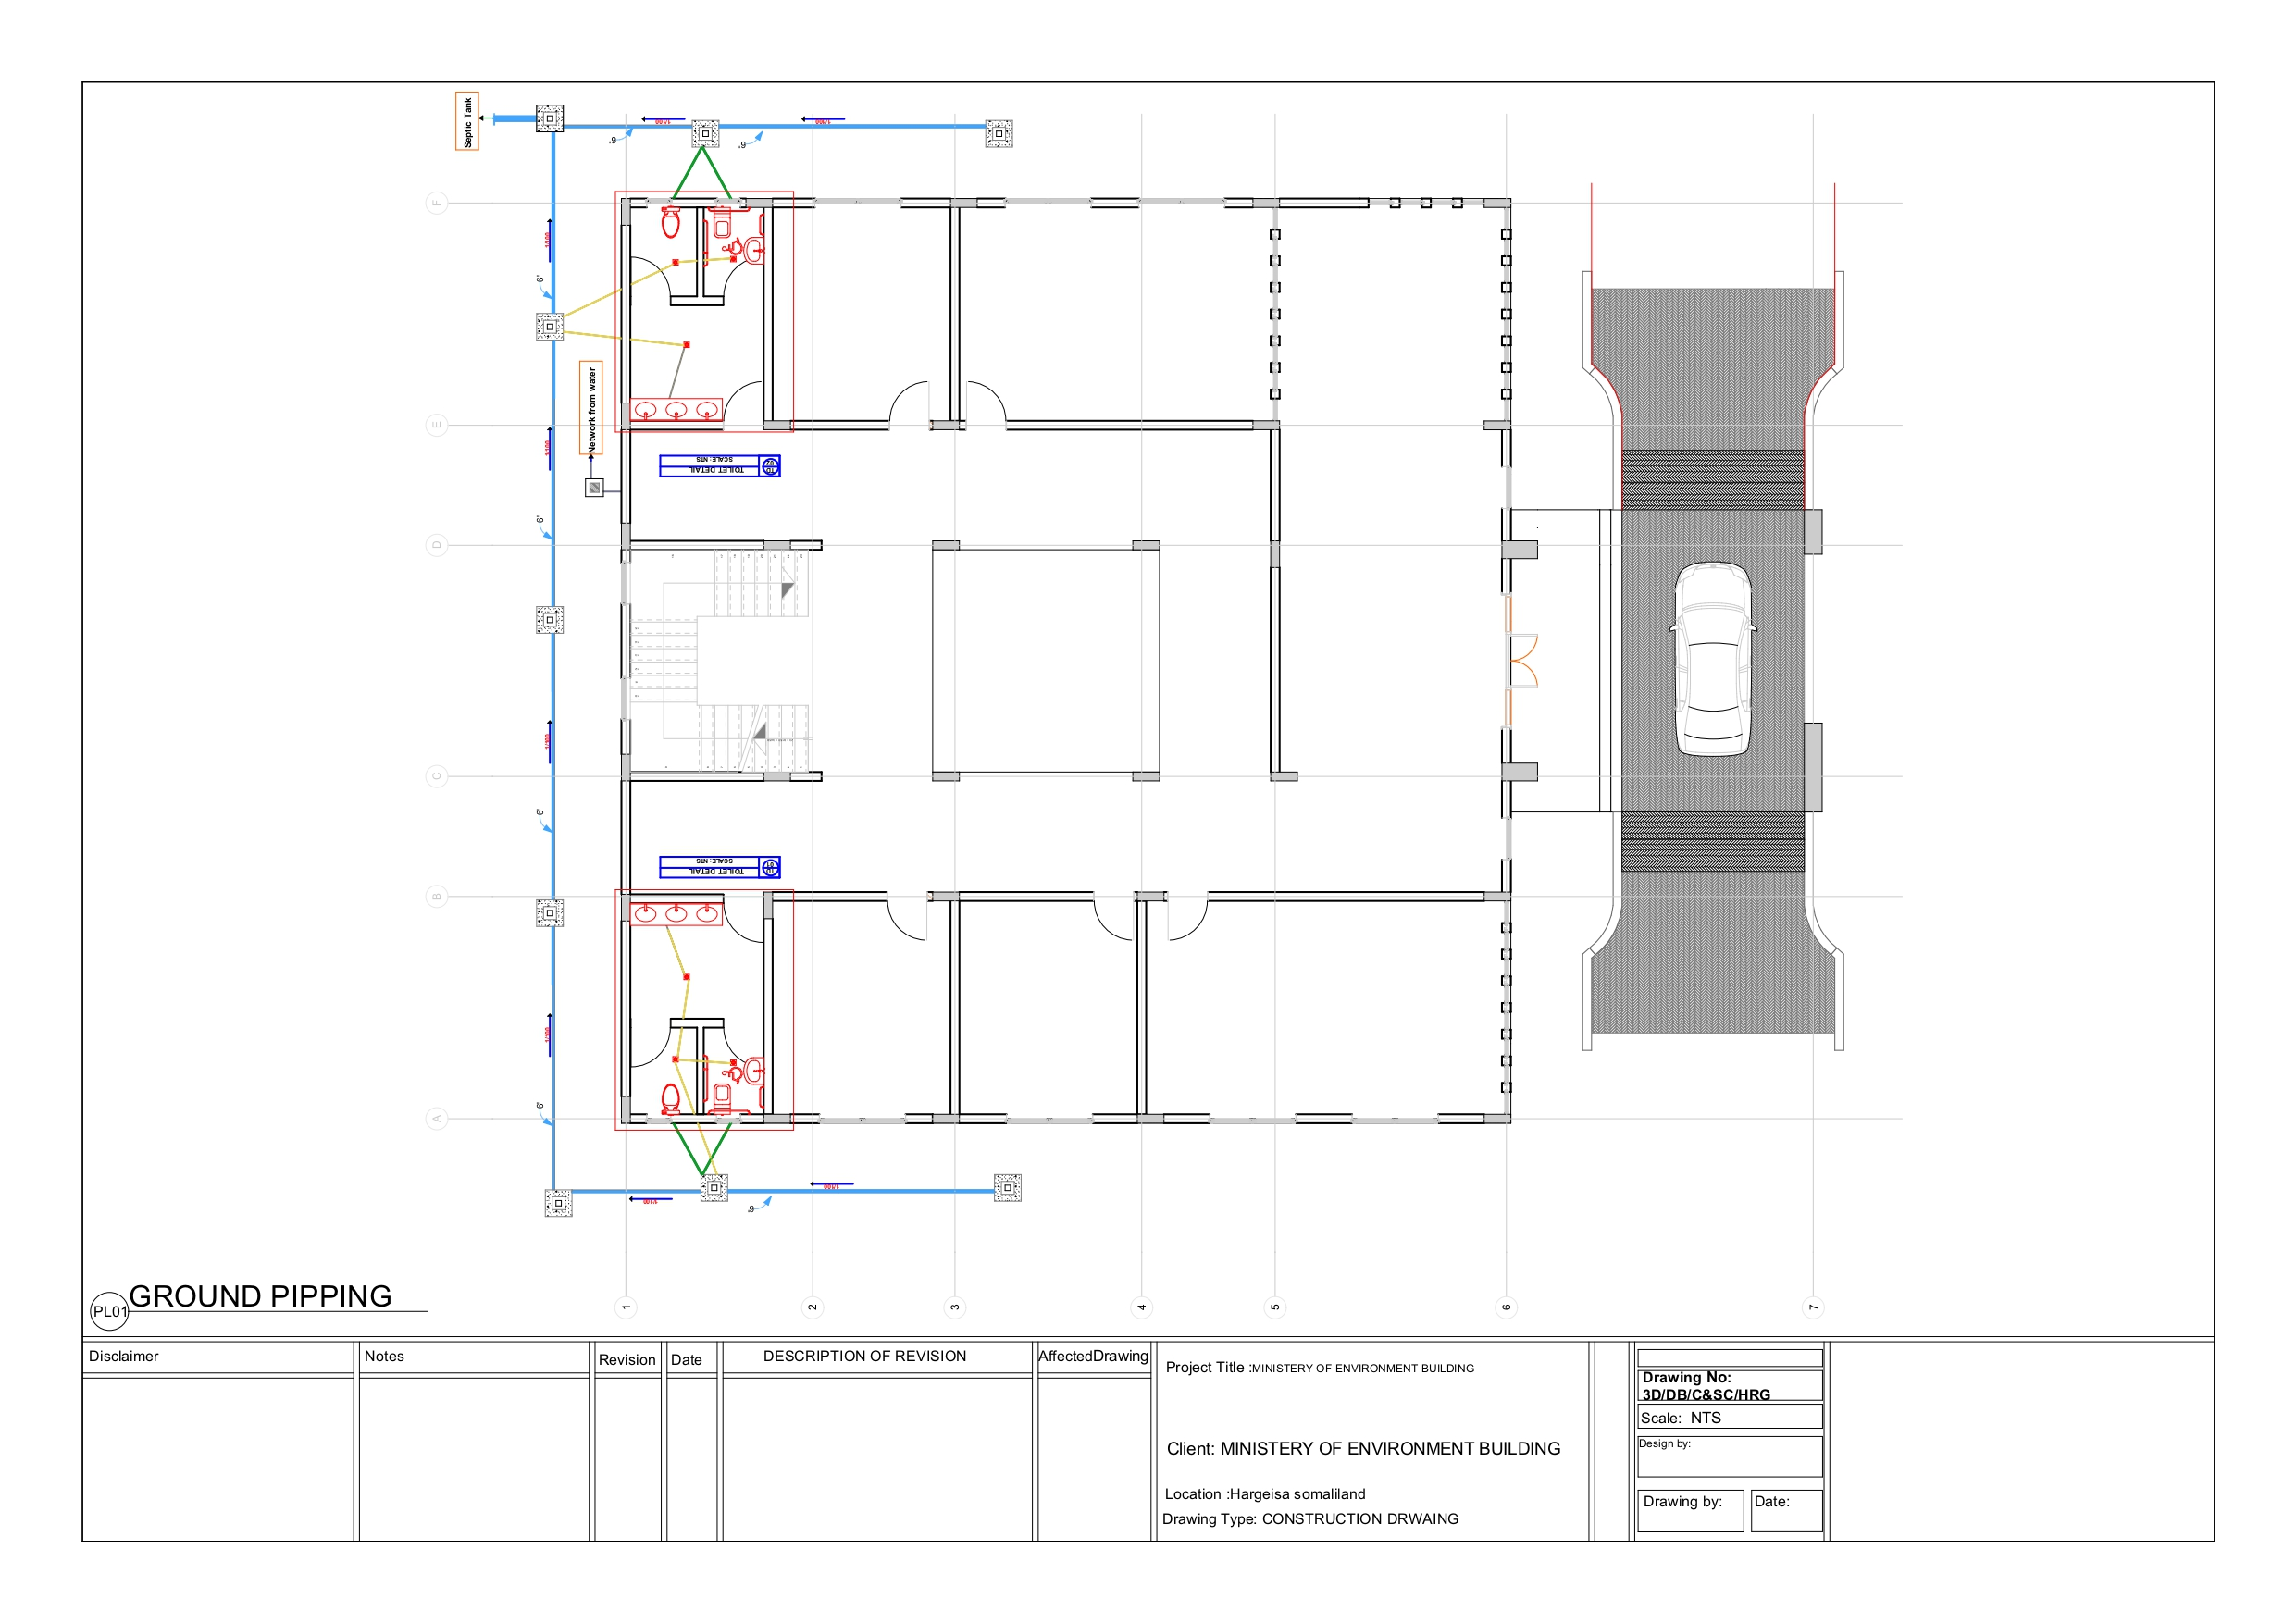
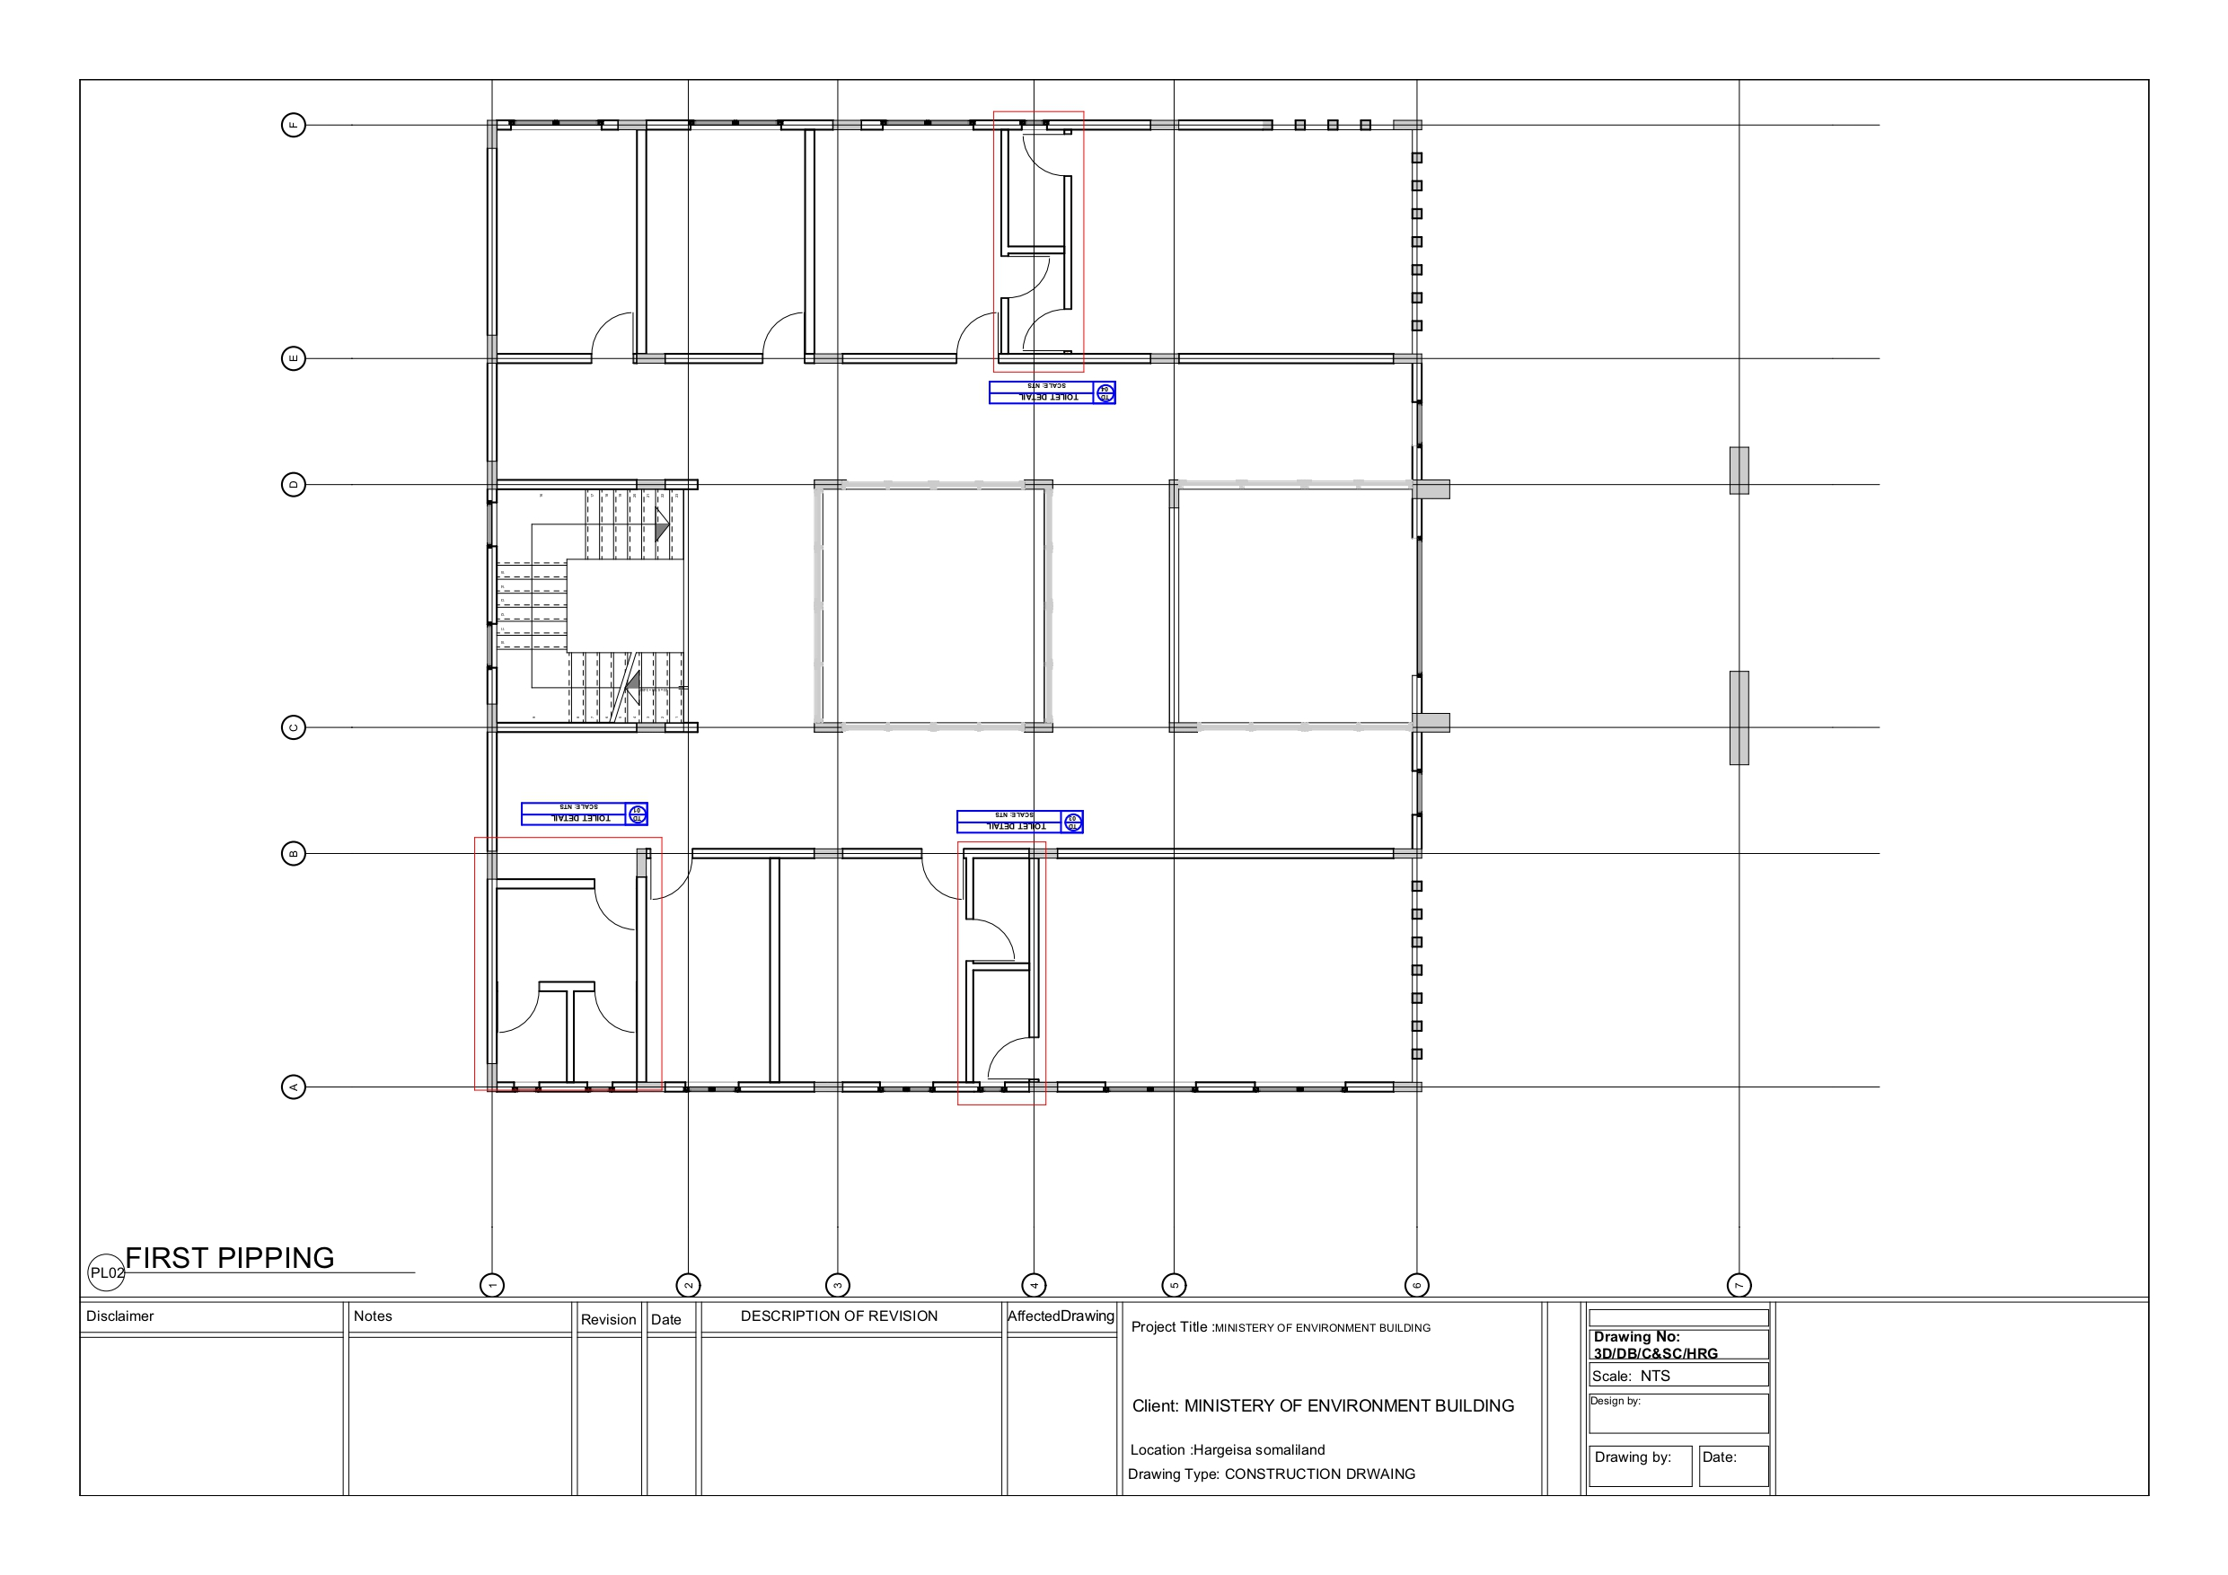
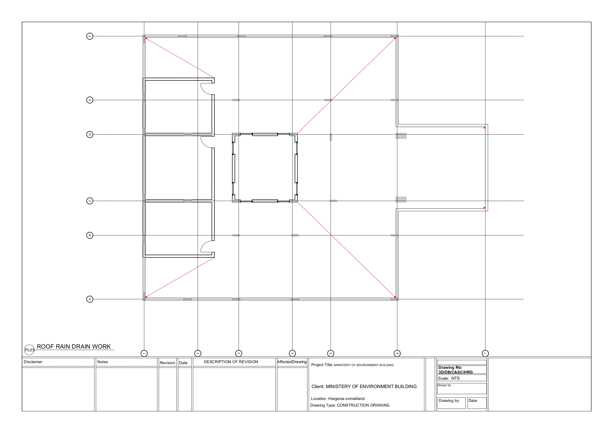
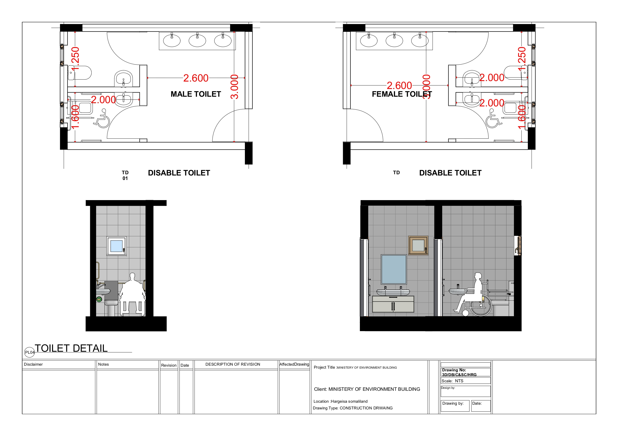

3D Design

Supplementary Information
Not Applicable

PART 3 – Conditions of Contract and Contract Forms

Section VIII - General Conditions of Contract

These General Conditions of Contract (GCC), read in conjunction with the Particular Conditions of Contract (PCC) and other documents listed therein, should be a complete document expressing fairly the rights and obligations of both parties.

These General Conditions of Contract have been developed on the basis of considerable international experience in the drafting and management of contracts, bearing in mind a trend in the construction industry towards simpler, more straightforward language.

The GCC can be used for both smaller admeasurement contracts and lump sum contracts.

Table of Clauses

A. General 244

1. Definitions 244

2. Interpretation 247

3. Language and Law 247

4. Project Manager’s Decisions 248

5. Delegation 248

6. Communications 248

7. Subcontracting 248

8. Other Contractors 248

9. Personnel and Equipment 249

10. Employer’s and Contractor’s Risks 249

11. Employer’s Risks 249

12. Contractor’s Risks 250

13. Insurance 250

14. Site Data 251

15. Contractor to Construct the Works 251

16. The Works to Be Completed by the Intended Completion Date 251

17. Approval by the Project Manager 251

18. Safety and Protection of the Environment 251

19. Discoveries 252

20. Possession of the Site 252

21. Access to the Site 252

22. Instructions, Inspections and Audits 252

23. Appointment of the Adjudicator 253

24. Procedure for Disputes 253

25. Fraud and Corruption 254

B. Time Control 254

26. Program 254

27. Extension of the Intended Completion Date 255

28. Acceleration 255

29. Delays Ordered by the Project Manager 255

30. Management Meetings 255

31. Early Warning 256

C. Quality Control 256

32. Identifying Defects 256

33. Tests 256

34. Correction of Defects 256

35. Uncorrected Defects 256

D. Cost Control 257

36. Contract Price 257

37. Changes in the Contract Price 257

38. Variations 257

39. Cash Flow Forecasts 259

40. Payment Certificates 259

41. Payments 260

42. Compensation Events 260

43. Tax 262

44. Currencies 262

45. Price Adjustment 262

46. Retention 263

47. Liquidated Damages 263

48. Bonus 264

49. Advance Payment 264

50. Securities 264

51. Dayworks 265

52. Cost of Repairs 265

E. Finishing the Contract 265

53. Completion 265

54. Taking Over 265

55. Final Account 265

56. Operating and Maintenance Manuals 266

57. Termination 266

58. Payment upon Termination 267

59. Property 267

60. Release from Performance 267

61. Suspension of Bank Loan or Credit 268

General Conditions of Contract
A. General
- Definitions | - Boldface type is used to identify defined terms.  - The Accepted Contract Amount means the amount accepted in the Letter of Acceptance for the execution and completion of the Works and the remedying of any defects.  - The Activity Schedule is a schedule of the activities comprising the construction, installation, testing, and commissioning of the Works in a lump sum contract. It includes a lump sum price for each activity, which is used for valuations and for assessing the effects of Variations and Compensation Events.  - The Adjudicator is the person appointed jointly by the Employer and the Contractor to resolve disputes in the first instance, as provided for in GCC 23.  - Bank means the financing institution named in the PCC.  - Bill of Quantities means the priced and completed Bill of Quantities forming part of the Bid.  - Compensation Events are those defined in GCC Clause 42 hereunder.  - The Completion Date is the date of completion of the Works as certified by the Project Manager, in accordance with GCC Sub-Clause 53.1.  - The Contract is the Contract between the Employer and the Contractor to execute, complete, and maintain the Works. It consists of the documents listed in GCC Sub-Clause 2.3 below.  - The Contractor is the party whose Bid to carry out the Works has been accepted by the Employer.  - The Contractor’s Bid is the completed bidding document submitted by the Contractor to the Employer.  - The Contract Price is the Accepted Contract Amount stated in the Letter of Acceptance and thereafter as adjusted in accordance with the Contract.  - Days are calendar days; months are calendar months.  - Dayworks are varied work inputs subject to payment on a time basis for the Contractor’s employees and Equipment, in addition to payments for associated Materials and Plant.  - A Defect is any part of the Works not completed in accordance with the Contract.  - The Defects Liability Certificate is the certificate issued by Project Manager upon correction of defects by the Contractor.  - The Defects Liability Period is the period named in the PCC pursuant to Sub-Clause 34.1 and calculated from the Completion Date.  - Drawings means the drawings of the Works, as included in the Contract, and any additional and modified drawings issued by (or on behalf of) the Employer in accordance with the Contract, include calculations and other information provided or approved by the Project Manager for the execution of the Contract.  - The Employer is the party who employs the Contractor to carry out the Works, as specified in the PCC.  - Equipment is the Contractor’s machinery and vehicles brought temporarily to the Site to construct the Works.  - “In writing” or “written” means hand-written, type-written, printed or electronically made, and resulting in a permanent record;  - The Initial Contract Price is the Contract Price listed in the Employer’s Letter of Acceptance.  - The Intended Completion Date is the date on which it is intended that the Contractor shall complete the Works. The Intended Completion Date is specified in the PCC. The Intended Completion Date may be revised only by the Project Manager by issuing an extension of time or an acceleration order.  - Materials are all supplies, including consumables, used by the Contractor for incorporation in the Works.  - Plant is any integral part of the Works that shall have a mechanical, electrical, chemical, or biological function.  - The Project Manager is the person named in the PCC (or any other competent person appointed by the Employer and notified to the Contractor, to act in replacement of the Project Manager) who is responsible for supervising the execution of the Works and administering the Contract.  - PCC means Particular Conditions of Contract.  - The Site is the area defined as such in the PCC.  - Site Investigation Reports are those that were included in the bidding document and are factual and interpretative reports about the surface and subsurface conditions at the Site.  - Specification means the Specification of the Works included in the Contract and any modification or addition made or approved by the Project Manager.  - The Start Date is given in the PCC. It is the latest date when the Contractor shall commence execution of the Works. It does not necessarily coincide with any of the Site Possession Dates.  - A Subcontractor is a person or corporate body who has a Contract with the Contractor to carry out a part of the work in the Contract, which includes work on the Site.  - Temporary Works are works designed, constructed, installed, and removed by the Contractor that are needed for construction or installation of the Works.  - A Variation is an instruction given by the Project Manager which varies the Works.  - The Works are what the Contract requires the Contractor to construct, install, and turn over to the Employer, as defined in the PCC.
- Interpretation | - In interpreting these GCC, words indicating one gender include all genders. Words indicating the singular also include the plural and words indicating the plural also include the singular. Headings have no significance. Words have their normal meaning under the language of the Contract unless specifically defined. The Project Manager shall provide instructions clarifying queries about these GCC.  - If sectional completion is specified in the PCC, references in the GCC to the Works, the Completion Date, and the Intended Completion Date apply to any Section of the Works (other than references to the Completion Date and Intended Completion Date for the whole of the Works).  - The documents forming the Contract shall be interpreted in the following order of priority:  - Agreement,  - Letter of Acceptance,  - Contractor’s Bid,  - Particular Conditions of Contract,  - General Conditions of Contract, including Appendices,  - Specifications,  - Drawings,  - Bill of Quantities, and  - any other document listed in the PCC as forming part of the Contract.
- Language and Law | - The language of the Contract and the law governing the Contract are stated in the PCC.  - Throughout the execution of the Contract, the Contractor shall comply with the import of goods and services prohibitions in the Employer’s Country when  (a) as a matter of law or official regulations, the Borrower’s country prohibits commercial relations with that country; or  (b) by an act of compliance with a decision of the United Nations Security Council taken under Chapter VII of the Charter of the United Nations, the Borrower’s Country prohibits any import of goods from that country or any payments to any country, person, or entity in that country.
- Project Manager’s Decisions | - Except where otherwise specifically stated, the Project Manager shall decide contractual matters between the Employer and the Contractor in the role representing the Employer.
- Delegation | - Otherwise specified in the PCC, the Project Manager may delegate any of his duties and responsibilities to other people, except to the Adjudicator, after notifying the Contractor, and may revoke any delegation after notifying the Contractor.
- Communications | - Communications between parties that are referred to in the Conditions shall be effective only when in writing. A notice shall be effective only when it is delivered.
- Subcontracting | - The Contractor may subcontract with the approval of the Project Manager, but may not assign the Contract without the approval of the Employer in writing. Subcontracting shall not alter the Contractor’s obligations.
- Other Contractors | - The Contractor shall cooperate and share the Site with other contractors, public authorities, utilities, and the Employer between the dates given in the Schedule of Other Contractors, as referred to in the PCC. The Contractor shall also provide facilities and services for them as described in the Schedule. The Employer may modify the Schedule of Other Contractors, and shall notify the Contractor of any such modification.
- Personnel and Equipment | - The Contractor shall employ the key personnel and use the equipment identified in its Bid, to carry out the Works or other personnel and equipment approved by the Project Manager. The Project Manager shall approve any proposed replacement of key personnel and equipment only if their relevant qualifications or characteristics are substantially equal to or better than those proposed in the Bid.  - If the Project Manager asks the Contractor to remove a person who is a member of the Contractor’s staff or work force, stating the reasons, the Contractor shall ensure that the person leaves the Site within seven days and has no further connection with the work in the Contract.  - If the Employer, Project Manager or Contractor determines, that any employee of the Contractor be determined to have engaged in Fraud and Corruption during the execution of the Works, then that employee shall be removed in accordance with Clause 9.2 above.
- Employer’s and Contractor’s Risks | - The Employer carries the risks which this Contract states are Employer’s risks, and the Contractor carries the risks which this Contract states are Contractor’s risks.
- Employer’s Risks | - From the Start Date until the Defects Liability Certificate has been issued, the following are Employer’s risks:  - The risk of personal injury, death, or loss of or damage to property (excluding the Works, Plant, Materials, and Equipment), which are due to  - use or occupation of the Site by the Works or for the purpose of the Works, which is the unavoidable result of the Works or  - negligence, breach of statutory duty, or interference with any legal right by the Employer or by any person employed by or contracted to him except the Contractor.  - The risk of damage to the Works, Plant, Materials, and Equipment to the extent that it is due to a fault of the Employer or in the Employer’s design, or due to war or radioactive contamination directly affecting the country where the Works are to be executed.  - From the Completion Date until the Defects Liability Certificate has been issued, the risk of loss of or damage to the Works, Plant, and Materials is an Employer’s risk except loss or damage due to  - a Defect which existed on the Completion Date,  - an event occurring before the Completion Date, which was not itself an Employer’s risk, or  - the activities of the Contractor on the Site after the Completion Date.
- Contractor’s Risks | 12.1 From the Starting Date until the Defects Liability Certificate has been issued, the risks of personal injury, death, and loss of or damage to property (including, without limitation, the Works, Plant, Materials, and Equipment) which are not Employer’s risks are Contractor’s risks.
- Insurance | - The Contractor shall provide, in the joint names of the Employer and the Contractor, insurance cover from the Start Date to the end of the Defects Liability Period, in the amounts and deductibles stated in the PCC for the following events which are due to the Contractor’s risks:  - loss of or damage to the Works, Plant, and Materials;  - loss of or damage to Equipment;  - loss of or damage to property (except the Works, Plant, Materials, and Equipment) in connection with the Contract; and  - personal injury or death.  - Policies and certificates for insurance shall be delivered by the Contractor to the Project Manager for the Project Manager’s approval before the Start Date. All such insurance shall provide for compensation to be payable in the types and proportions of currencies required to rectify the loss or damage incurred.  - If the Contractor does not provide any of the policies and certificates required, the Employer may effect the insurance which the Contractor should have provided and recover the premiums the Employer has paid from payments otherwise due to the Contractor or, if no payment is due, the payment of the premiums shall be a debt due.  - Alterations to the terms of an insurance shall not be made without the approval of the Project Manager.  - Both parties shall comply with any conditions of the insurance policies.
- Site Data | - The Contractor shall be deemed to have examined any Site Data referred to in the PCC, supplemented by any information available to the Contractor.
- Contractor to Construct the Works | - The Contractor shall construct and install the Works in accordance with the Specifications and Drawings.
- The Works to Be Completed by the Intended Completion Date | - The Contractor may commence execution of the Works on the Start Date and shall carry out the Works in accordance with the Program submitted by the Contractor, as updated with the approval of the Project Manager, and complete them by the Intended Completion Date.
- Approval by the Project Manager | - The Contractor shall submit Specifications and Drawings showing the proposed Temporary Works to the Project Manager, for his approval.  - The Contractor shall be responsible for design of Temporary Works.  - The Project Manager’s approval shall not alter the Contractor’s responsibility for design of the Temporary Works.  - The Contractor shall obtain approval of third parties to the design of the Temporary Works, where required.  - All Drawings prepared by the Contractor for the execution of the temporary or permanent Works, are subject to prior approval by the Project Manager before this use.
- Safety and Protection of the Environment | - The Contractor shall be responsible for the safety of all activities on the Site.  - The Contractor shall take all reasonable steps to protect the environment (both on and off the Site) and to limit damage and nuisance to people and property resulting from pollution, noise and other results of his operations.
- Discoveries | - Anything of historical or other interest or of significant value unexpectedly discovered on the Site shall be the property of the Employer. The Contractor shall notify the Project Manager of such discoveries and carry out the Project Manager’s instructions for dealing with them.
- Possession of the Site | - The Employer shall give possession of all parts of the Site to the Contractor. If possession of a part is not given by the date stated in the PCC, the Employer shall be deemed to have delayed the start of the relevant activities, and this shall be a Compensation Event.
- Access to the Site | - The Contractor shall allow the Project Manager and any person authorized by the Project Manager access to the Site and to any place where work in connection with the Contract is being carried out or is intended to be carried out.
- Instructions, Inspections and Audits | - The Contractor shall carry out all instructions of the Project Manager which comply with the applicable laws where the Site is located.  - The Contractor shall keep, and shall make all reasonable efforts to cause its Subcontractors and subconsultants to keep, accurate and systematic accounts and records in respect of the Works in such form and details as will clearly identify relevant time changes and costs.  - Pursuant to paragraph 2.2 e. of Appendix B to the General Conditions, the Contractor shall permit and shall cause its subcontractors and subconsultants to permit, the Bank and/or persons appointed by the Bank to inspect the Site and/or the accounts and records relating to the procurement process, selection and/or contract execution, and to have such accounts and records audited by auditors appointed by the Bank if requested by the Bank. The Contractor’s and its Subcontractors’ and subconsultants’ attention is drawn to Sub-Clause 25.1 (Fraud and Corruption) which provides, inter alia, that acts intended to materially impede the exercise of the Bank’s inspection and audit rights constitute a prohibited practice subject to contract termination (as well as to a determination of ineligibility pursuant to the Bank’s prevailing sanctions procedures).]
- Appointment of the Adjudicator | - The Adjudicator shall be appointed jointly by the Employer and the Contractor, at the time of the Employer’s issuance of the Letter of Acceptance. If, in the Letter of Acceptance, the Employer does not agree on the appointment of the Adjudicator, the Employer will request the Appointing Authority designated in the PCC, to appoint the Adjudicator within 14 days of receipt of such request.  - Should the Adjudicator resign or die, or should the Employer and the Contractor agree that the Adjudicator is not functioning in accordance with the provisions of the Contract, a new Adjudicator shall be jointly appointed by the Employer and the Contractor. In case of disagreement between the Employer and the Contractor, within 30 days, the Adjudicator shall be designated by the Appointing Authority designated in the PCC at the request of either party, within 14 days of receipt of such request.
- Procedure for Disputes | - If the Contractor believes that a decision taken by the Project Manager was either outside the authority given to the Project Manager by the Contract or that the decision was wrongly taken, the decision shall be referred to the Adjudicator within 14 days of the notification of the Project Manager’s decision.  - The Adjudicator shall give a decision in writing within 28 days of receipt of a notification of a dispute.  - The Adjudicator shall be paid by the hour at the rate specified in the PCC, together with reimbursable expenses of the types specified in the PCC, and the cost shall be divided equally between the Employer and the Contractor, whatever decision is reached by the Adjudicator. Either party may refer a decision of the Adjudicator to an Arbitrator within 28 days of the Adjudicator’s written decision. If neither party refers the dispute to arbitration within the above 28 days, the Adjudicator’s decision shall be final and binding.  - The arbitration shall be conducted in accordance with the arbitration procedures published by the institution named and in the place specified in the PCC.
- Fraud and Corruption | - The Bank requires compliance with the Bank’s Anti-Corruption Guidelines and its prevailing sanctions policies and procedures as set forth in the WBG’s Sanctions Framework, as set forth in Appendix A to the GCC.  - The Employer requires the Contractor to disclose any commissions or fees that may have been paid or are to be paid to agents or any other party with respect to the bidding process or execution of the Contract. The information disclosed must include at least the name and address of the agent or other party, the amount and currency, and the purpose of the commission, gratuity or fee.
B. Time Control
- Program | - Within the time stated in the PCC, after the date of the Letter of Acceptance, the Contractor shall submit to the Project Manager for approval a Program showing the general methods, arrangements, order, and timing for all the activities in the Works. In the case of a lump sum contract, the activities in the Program shall be consistent with those in the Activity Schedule.  - An update of the Program shall be a program showing the actual progress achieved on each activity and the effect of the progress achieved on the timing of the remaining work, including any changes to the sequence of the activities.  - The Contractor shall submit to the Project Manager for approval an updated Program at intervals no longer than the period stated in the PCC. If the Contractor does not submit an updated Program within this period, the Project Manager may withhold the amount stated in the PCC from the next payment certificate and continue to withhold this amount until the next payment after the date on which the overdue Program has been submitted. In the case of a lump sum contract, the Contractor shall provide an updated Activity Schedule within 14 days of being instructed to by the Project Manager.  - The Project Manager’s approval of the Program shall not alter the Contractor’s obligations. The Contractor may revise the Program and submit it to the Project Manager again at any time. A revised Program shall show the effect of Variations and Compensation Events.
- Extension of the Intended Completion Date | - The Project Manager shall extend the Intended Completion Date if a Compensation Event occurs or a Variation is issued which makes it impossible for Completion to be achieved by the Intended Completion Date without the Contractor taking steps to accelerate the remaining work, which would cause the Contractor to incur additional cost.  - The Project Manager shall decide whether and by how much to extend the Intended Completion Date within 21 days of the Contractor asking the Project Manager for a decision upon the effect of a Compensation Event or Variation and submitting full supporting information. If the Contractor has failed to give early warning of a delay or has failed to cooperate in dealing with a delay, the delay by this failure shall not be considered in assessing the new Intended Completion Date.
- Acceleration | - When the Employer wants the Contractor to finish before the Intended Completion Date, the Project Manager shall obtain priced proposals for achieving the necessary acceleration from the Contractor. If the Employer accepts these proposals, the Intended Completion Date shall be adjusted accordingly and confirmed by both the Employer and the Contractor.  - If the Contractor’s priced proposals for an acceleration are accepted by the Employer, they are incorporated in the Contract Price and treated as a Variation.
- Delays Ordered by the Project Manager | - The Project Manager may instruct the Contractor to delay the start or progress of any activity within the Works.
- Management Meetings | - Either the Project Manager or the Contractor may require the other to attend a management meeting. The business of a management meeting shall be to review the plans for remaining work and to deal with matters raised in accordance with the early warning procedure.  - The Project Manager shall record the business of management meetings and provide copies of the record to those attending the meeting and to the Employer. The responsibility of the parties for actions to be taken shall be decided by the Project Manager either at the management meeting or after the management meeting and stated in writing to all who attended the meeting.
- Early Warning | - The Contractor shall warn the Project Manager at the earliest opportunity of specific likely future events or circumstances that may adversely affect the quality of the work, increase the Contract Price, or delay the execution of the Works. The Project Manager may require the Contractor to provide an estimate of the expected effect of the future event or circumstance on the Contract Price and Completion Date. The estimate shall be provided by the Contractor as soon as reasonably possible.  - The Contractor shall cooperate with the Project Manager in making and considering proposals for how the effect of such an event or circumstance can be avoided or reduced by anyone involved in the work and in carrying out any resulting instruction of the Project Manager.
C. Quality Control
- Identifying Defects | - The Project Manager shall check the Contractor’s work and notify the Contractor of any Defects that are found. Such checking shall not affect the Contractor’s responsibilities. The Project Manager may instruct the Contractor to search for a Defect and to uncover and test any work that the Project Manager considers may have a Defect.
- Tests | - If the Project Manager instructs the Contractor to carry out a test not specified in the Specification to check whether any work has a Defect and the test shows that it does, the Contractor shall pay for the test and any samples. If there is no Defect, the test shall be a Compensation Event.
- Correction of Defects | - The Project Manager shall give notice to the Contractor of any Defects before the end of the Defects Liability Period, which begins at Completion, and is defined in the PCC. The Defects Liability Period shall be extended for as long as Defects remain to be corrected.  - Every time notice of a Defect is given, the Contractor shall correct the notified Defect within the length of time specified by the Project Manager’s notice.
- Uncorrected Defects | - If the Contractor has not corrected a Defect within the time specified in the Project Manager’s notice, the Project Manager shall assess the cost of having the Defect corrected, and the Contractor shall pay this amount.
D. Cost Control
- Contract Price | - The Bill of Quantities shall contain priced items for the Works to be performed by the Contractor. The Bill of Quantities is used to calculate the Contract Price. The Contractor will be paid for the quantity of the work accomplished at the rate in the Bill of Quantities for each item.
- Changes in the Contract Price | - If the final quantity of the work done differs from the quantity in the Bill of Quantities for the particular item by more than 25 percent, provided the change exceeds 1 percent of the Initial Contract Price, the Project Manager shall adjust the rate to allow for the change. The Project Manager shall not adjust rates from changes in quantities if thereby the Initial Contract Price is exceeded by more than 15 percent, except with the prior approval of the Employer.  - If requested by the Project Manager, the Contractor shall provide the Project Manager with a detailed cost breakdown of any rate in the Bill of Quantities.
- Variations | - All Variations shall be included in updated Programs produced by the Contractor.  - The Contractor shall provide the Project Manager with a quotation for carrying out the Variation when requested to do so by the Project Manager. The Project Manager shall assess the quotation, which shall be given within seven (7) days of the request or within any longer period stated by the Project Manager and before the Variation is ordered.  - If the Contractor’s quotation is unreasonable, the Project Manager may order the Variation and make a change to the Contract Price, which shall be based on the Project Manager’s own forecast of the effects of the Variation on the Contractor’s costs.  - If the Project Manager decides that the urgency of varying the work would prevent a quotation being given and considered without delaying the work, no quotation shall be given and the Variation shall be treated as a Compensation Event.  - The Contractor shall not be entitled to additional payment for costs that could have been avoided by giving early warning.  - If the work in the Variation corresponds to an item description in the Bill of Quantities and if, in the opinion of the Project Manager, the quantity of work above the limit stated in Sub-Clause 39.1 or the timing of its execution do not cause the cost per unit of quantity to change, the rate in the Bill of Quantities shall be used to calculate the value of the Variation. If the cost per unit of quantity changes, or if the nature or timing of the work in the Variation does not correspond with items in the Bill of Quantities, the quotation by the Contractor shall be in the form of new rates for the relevant items of work.
  - Value Engineering: The Contractor may prepare, at its own cost, a value engineering proposal at any time during the performance of the contract. The value engineering proposal shall, at a minimum, include the following;
(a) the proposed change(s), and a description of the difference to the existing contract requirements;
(b) a full cost/benefit analysis of the proposed change(s) including a description and estimate of costs (including life cycle costs) the Employer may incur in implementing the value engineering proposal; and
(c) a description of any effect(s) of the change on performance/functionality.
The Employer may accept the value engineering proposal if the proposal demonstrates benefits that:
(a) accelerate the contract completion period; or
(b) reduce the Contract Price or the life cycle costs to the Employer; or
(c) improve the quality, efficiency, safety or sustainability of the Facilities; or
(d) yield any other benefits to the Employer,
without compromising the functionality of the Works.
If the value engineering proposal is approved by the Employer and results in:
(a) a reduction of the Contract Price; the amount to be paid to the Contractor shall be the percentage specified in the PCC of the reduction in the Contract Price; or
(b) an increase in the Contract Price; but results in a reduction in life cycle costs due to any benefit described in (a) to (d) above, the amount to be paid to the Contractor shall be the full increase in the Contract Price.

- Cash Flow Forecasts | - When the Program, is updated, the Contractor shall provide the Project Manager with an updated cash flow forecast. The cash flow forecast shall include different currencies, as defined in the Contract, converted as necessary using the Contract exchange rates.
- Payment Certificates | - The Contractor shall submit to the Project Manager monthly statements of the estimated value of the work executed less the cumulative amount certified previously.  - The Project Manager shall check the Contractor’s monthly statement and certify the amount to be paid to the Contractor.  - The value of work executed shall be determined by the Project Manager.  - The value of work executed shall comprise the value of the quantities of work in the Bill of Quantities that have been completed.  - The value of work executed shall include the valuation of Variations and Compensation Events.  - The Project Manager may exclude any item certified in a previous certificate or reduce the proportion of any item previously certified in any certificate in the light of later information.
- Payments | - Payments shall be adjusted for deductions for advance payments and retention. The Employer shall pay the Contractor the amounts certified by the Project Manager within 28 days of the date of each certificate. If the Employer makes a late payment, the Contractor shall be paid interest on the late payment in the next payment. Interest shall be calculated from the date by which the payment should have been made up to the date when the late payment is made at the prevailing rate of interest for commercial borrowing for each of the currencies in which payments are made.  - If an amount certified is increased in a later certificate or as a result of an award by the Adjudicator or an Arbitrator, the Contractor shall be paid interest upon the delayed payment as set out in this clause. Interest shall be calculated from the date upon which the increased amount would have been certified in the absence of dispute.  - Unless otherwise stated, all payments and deductions shall be paid or charged in the proportions of currencies comprising the Contract Price.  - Items of the Works for which no rate or price has been entered in shall not be paid for by the Employer and shall be deemed covered by other rates and prices in the Contract.
- Compensation Events | - The following shall be Compensation Events:  - The Employer does not give access to a part of the Site by the Site Possession Date pursuant to GCC Sub-Clause 20.1.  - The Employer modifies the Schedule of Other Contractors in a way that affects the work of the Contractor under the Contract.  - The Project Manager orders a delay or does not issue Drawings, Specifications, or instructions required for execution of the Works on time.  - The Project Manager instructs the Contractor to uncover or to carry out additional tests upon work, which is then found to have no Defects.  - The Project Manager unreasonably does not approve a subcontract to be let.  - Ground conditions are substantially more adverse than could reasonably have been assumed before issuance of the Letter of Acceptance from the information issued to bidders (including the Site Investigation Reports), from information available publicly and from a visual inspection of the Site.  - The Project Manager gives an instruction for dealing with an unforeseen condition, caused by the Employer, or additional work required for safety or other reasons.  - Other contractors, public authorities, utilities, or the Employer does not work within the dates and other constraints stated in the Contract, and they cause delay or extra cost to the Contractor.  - The advance payment is delayed.  - The effects on the Contractor of any of the Employer’s Risks.  - The Project Manager unreasonably delays issuing a Certificate of Completion.  - If a Compensation Event would cause additional cost or would prevent the work being completed before the Intended Completion Date, the Contract Price shall be increased and/or the Intended Completion Date shall be extended. The Project Manager shall decide whether and by how much the Contract Price shall be increased and whether and by how much the Intended Completion Date shall be extended.  - As soon as information demonstrating the effect of each Compensation Event upon the Contractor’s forecast cost has been provided by the Contractor, it shall be assessed by the Project Manager, and the Contract Price shall be adjusted accordingly. If the Contractor’s forecast is deemed unreasonable, the Project Manager shall adjust the Contract Price based on the Project Manager’s own forecast. The Project Manager shall assume that the Contractor shall react competently and promptly to the event.  - The Contractor shall not be entitled to compensation to the extent that the Employer’s interests are adversely affected by the Contractor’s not having given early warning or not having cooperated with the Project Manager.
- Tax | - The Project Manager shall adjust the Contract Price if taxes, duties, and other levies are changed between the date 28 days before the submission of bids for the Contract and the date of the last Completion certificate. The adjustment shall be the change in the amount of tax payable by the Contractor, provided such changes are not already reflected in the Contract Price or are a result of GCC Clause 44.
- Currencies | - Where payments are made in currencies other than the currency of the Employer’s Country specified in the PCC, the exchange rates used for calculating the amounts to be paid shall be the exchange rates stated in the Contractor’s Bid.
- Price Adjustment | - Prices shall be adjusted for fluctuations in the cost of inputs only if provided for in the PCC. If so provided, the amounts certified in each payment certificate, before deducting for Advance Payment, shall be adjusted by applying the respective price adjustment factor to the payment amounts due in each currency. A separate formula of the type specified below applies to each Contract currency:  P_{c} = A_{c} + B_{c} Imc/Ioc  where:  P_{c} is the adjustment factor for the portion of the Contract Price payable in a specific currency “c.”  A_{c} and B_{c} are coefficients specified in the PCC, representing the nonadjustable and adjustable portions, respectively, of the Contract Price payable in that specific currency “c;” and  Imc is the index prevailing at the end of the month being invoiced and Ioc is the index prevailing 28 days before Bid opening for inputs payable; both in the specific currency “c.”  - If the value of the index is changed after it has been used in a calculation, the calculation shall be corrected and an adjustment made in the next payment certificate. The index value shall be deemed to take account of all changes in cost due to fluctuations in costs.
- Retention | - The Employer shall retain from each payment due to the Contractor the proportion stated in the PCC until Completion of the whole of the Works.  - Upon the issue of a Certificate of Completion of the Works by the Project Manager, in accordance with GCC 53.1, half the total amount retained shall be repaid to the Contractor and half when the Defects Liability Period has passed and the Project Manager has certified that all Defects notified by the Project Manager to the Contractor before the end of this period have been corrected. The Contractor may substitute retention money with an “on demand” Bank guarantee.
- Liquidated Damages | - The Contractor shall pay liquidated damages to the Employer at the rate per day stated in the PCC for each day that the Completion Date is later than the Intended Completion Date. The total amount of liquidated damages shall not exceed the amount defined in the PCC. The Employer may deduct liquidated damages from payments due to the Contractor. Payment of liquidated damages shall not affect the Contractor’s liabilities.  - If the Intended Completion Date is extended after liquidated damages have been paid, the Project Manager shall correct any overpayment of liquidated damages by the Contractor by adjusting the next payment certificate. The Contractor shall be paid interest on the overpayment, calculated from the date of payment to the date of repayment, at the rates specified in GCC Sub-Clause 41.1.
- Bonus | - The Contractor shall be paid a Bonus calculated at the rate per calendar day stated in the PCC for each day (less any days for which the Contractor is paid for acceleration) that the Completion is earlier than the Intended Completion Date. The Project Manager shall certify that the Works are complete, although they may not be due to be complete.
- Advance Payment | - The Employer shall make advance payment to the Contractor of the amounts stated in the PCC by the date stated in the PCC, against provision by the Contractor of an Unconditional Bank Guarantee in a form and by a bank acceptable to the Employer in amounts and currencies equal to the advance payment. The Guarantee shall remain effective until the advance payment has been repaid, but the amount of the Guarantee shall be progressively reduced by the amounts repaid by the Contractor. Interest shall not be charged on the advance payment.  - The Contractor is to use the advance payment only to pay for Equipment, Plant, Materials, and mobilization expenses required specifically for execution of the Contract. The Contractor shall demonstrate that advance payment has been used in this way by supplying copies of invoices or other documents to the Project Manager.  - The advance payment shall be repaid by deducting proportionate amounts from payments otherwise due to the Contractor, following the schedule of completed percentages of the Works on a payment basis. No account shall be taken of the advance payment or its repayment in assessing valuations of work done, Variations, price adjustments, Compensation Events, Bonuses, or Liquidated Damages.
- Securities | - The Performance Security shall be provided to the Employer no later than the date specified in the Letter of Acceptance and shall be issued in an amount specified in the PCC, by a bank or surety acceptable to the Employer, and denominated in the types and proportions of the currencies in which the Contract Price is payable. The Performance Security shall be valid until a date 28 days from the date of issue of the Certificate of Completion in the case of a Bank Guarantee, and until one year from the date of issue of the Completion Certificate in the case of a Performance Bond.
- Dayworks | - If applicable, the Dayworks rates in the Contractor’s Bid shall be used only when the Project Manager has given written instructions in advance for additional work to be paid for in that way.  - All work to be paid for as Dayworks shall be recorded by the Contractor on forms approved by the Project Manager. Each completed form shall be verified and signed by the Project Manager within two days of the work being done.  - The Contractor shall be paid for Dayworks subject to obtaining signed Dayworks forms.
- Cost of Repairs | - Loss or damage to the Works or Materials to be incorporated in the Works between the Start Date and the end of the Defects Correction periods shall be remedied by the Contractor at the Contractor’s cost if the loss or damage arises from the Contractor’s acts or omissions.
E. Finishing the Contract
- Completion | - The Contractor shall request the Project Manager to issue a Certificate of Completion of the Works, and the Project Manager shall do so upon deciding that the whole of the Works is completed.
- Taking Over | - The Employer shall take over the Site and the Works within seven days of the Project Manager’s issuing a certificate of Completion.
- Final Account | - The Contractor shall supply the Project Manager with a detailed account of the total amount that the Contractor considers payable under the Contract before the end of the Defects Liability Period. The Project Manager shall issue a Defects Liability Certificate and certify any final payment that is due to the Contractor within 56 days of receiving the Contractor’s account if it is correct and complete. If it is not, the Project Manager shall issue within 56 days a schedule that states the scope of the corrections or additions that are necessary. If the Final Account is still unsatisfactory after it has been resubmitted, the Project Manager shall decide on the amount payable to the Contractor and issue a payment certificate.
- Operating and Maintenance Manuals | - If “as built” Drawings and/or operating and maintenance manuals are required, the Contractor shall supply them by the dates stated in the PCC.  - If the Contractor does not supply the Drawings and/or manuals by the dates stated in the PCC pursuant to GCC Sub-Clause 56.1, or they do not receive the Project Manager’s approval, the Project Manager shall withhold the amount stated in the PCC from payments due to the Contractor.
- Termination | - The Employer or the Contractor may terminate the Contract if the other party causes a fundamental breach of the Contract.
 | - Fundamental breaches of Contract shall include, but shall not be limited to, the following:
- the Contractor stops work for 28 days when no stoppage of work is shown on the current Program and the stoppage has not been authorized by the Project Manager;
- the Project Manager instructs the Contractor to delay the progress of the Works, and the instruction is not withdrawn within 28 days;
- the Employer or the Contractor is made bankrupt or goes into liquidation other than for a reconstruction or amalgamation;
- a payment certified by the Project Manager is not paid by the Employer to the Contractor within 84 days of the date of the Project Manager’s certificate;
- the Project Manager gives Notice that failure to correct a particular Defect is a fundamental breach of Contract and the Contractor fails to correct it within a reasonable period of time determined by the Project Manager;
- the Contractor does not maintain a Security, which is required;
- the Contractor has delayed the completion of the Works by the number of days for which the maximum amount of liquidated damages can be paid, as defined in the PCC; or
- if the Contractor, in the judgment of the Employer has engaged in Fraud and Corruption, as defined in paragrpah 2.2 a of the Appendix A to the GCC, in competing for or in executing the Contract, then the Employer may, after giving fourteen (14) days written notice to the Contractor, terminate the Contract and expel him from the Site.
 | - Notwithstanding the above, the Employer may terminate the Contract for convenience.
 | - If the Contract is terminated, the Contractor shall stop work immediately, make the Site safe and secure, and leave the Site as soon as reasonably possible.
 | - When either party to the Contract gives notice of a breach of Contract to the Project Manager for a cause other than those listed under GCC Sub-Clause 56.2 above, the Project Manager shall decide whether the breach is fundamental or not.
- Payment upon Termination | - If the Contract is terminated because of a fundamental breach of Contract by the Contractor, the Project Manager shall issue a certificate for the value of the work done and Materials ordered less advance payments received up to the date of the issue of the certificate and less the percentage to apply to the value of the work not completed, as specified in the PCC. Additional Liquidated Damages shall not apply. If the total amount due to the Employer exceeds any payment due to the Contractor, the difference shall be a debt payable to the Employer.  - If the Contract is terminated for the Employer’s convenience or because of a fundamental breach of Contract by the Employer, the Project Manager shall issue a certificate for the value of the work done, Materials ordered, the reasonable cost of removal of Equipment, repatriation of the Contractor’s personnel employed solely on the Works, and the Contractor’s costs of protecting and securing the Works, and less advance payments received up to the date of the certificate.
- Property | - All Materials on the Site, Plant, Equipment, Temporary Works, and Works shall be deemed to be the property of the Employer if the Contract is terminated because of the Contractor’s default.
- Release from Performance | - If the Contract is frustrated by the outbreak of war or by any other event entirely outside the control of either the Employer or the Contractor, the Project Manager shall certify that the Contract has been frustrated. The Contractor shall make the Site safe and stop work as quickly as possible after receiving this certificate and shall be paid for all work carried out before receiving it and for any work carried out afterwards to which a commitment was made.
- Suspension of Bank Loan or Credit | - In the event that the Bank suspends the Loan or Credit to the Employer, from which part of the payments to the Contractor are being made:  - The Employer is obligated to notify the Contractor of such suspension within 7 days of having received the Bank’s suspension notice.  - If the Contractor has not received sums due to it within the 28 days for payment provided for in Sub-Clause 40.1, the Contractor may immediately issue a 14-day termination notice.

APPENDIX A
TO GENERAL CONDITIONS

Fraud and Corruption
(Text in this Appendix shall not be modified)

- Purpose
  - The Bank’s Anti-Corruption Guidelines and this annex apply with respect to procurement under Bank Investment Project Financing operations.
- Requirements
- The Bank requires that Borrowers (including beneficiaries of Bank financing); bidders (applicants/proposers),consultants, contractors and suppliers; any sub-contractors, sub-consultants, service providers or suppliers; any agents (whether declared or not); and any of their personnel, observe the highest standard of ethics during the procurement process, selection and contract execution of Bank-financed contracts, and refrain from Fraud and Corruption.
- To this end, the Bank:
- Defines, for the purposes of this provision, the terms set forth below as follows:
- “corrupt practice” is the offering, giving, receiving, or soliciting, directly or indirectly, of anything of value to influence improperly the actions of another party;
- “fraudulent practice” is any act or omission, including misrepresentation, that knowingly or recklessly misleads, or attempts to mislead, a party to obtain financial or other benefit or to avoid an obligation;
- “collusive practice” is an arrangement between two or more parties designed to achieve an improper purpose, including to influence improperly the actions of another party;
- “coercive practice” is impairing or harming, or threatening to impair or harm, directly or indirectly, any party or the property of the party to influence improperly the actions of a party;
- “obstructive practice” is:
- deliberately destroying, falsifying, altering, or concealing of evidence material to the investigation or making false statements to investigators in order to materially impede a Bank investigation into allegations of a corrupt, fraudulent, coercive, or collusive practice; and/or threatening, harassing, or intimidating any party to prevent it from disclosing its knowledge of matters relevant to the investigation or from pursuing the investigation; or
- acts intended to materially impede the exercise of the Bank’s inspection and audit rights provided for under paragraph 2.2 e. below.
- Rejects a proposal for award if the Bank determines that the firm or individual recommended for award, any of its personnel, or its agents, or its sub-consultants, sub-contractors, service providers, suppliers and/ or their employees, has, directly or indirectly, engaged in corrupt, fraudulent, collusive, coercive, or obstructive practices in competing for the contract in question;
- In addition to the legal remedies set out in the relevant Legal Agreement, may take other appropriate actions, including declaring misprocurement, if the Bank determines at any time that representatives of the Borrower or of a recipient of any part of the proceeds of the loan engaged in corrupt, fraudulent, collusive, coercive, or obstructive practices during the procurement process, selection and/or execution of the contract in question, without the Borrower having taken timely and appropriate action satisfactory to the Bank to address such practices when they occur, including by failing to inform the Bank in a timely manner at the time they knew of the practices;
- Pursuant to the Bank’s Anti- Corruption Guidelines and in accordance with the Bank’s prevailing sanctions policies and procedures, may sanction a firm or individual, either indefinitely or for a stated period of time, including by publicly declaring such firm or individual ineligible (i) to be awarded or otherwise benefit from a Bank-financed contract, financially or in any other manner; (ii) to be a nominated sub-contractor, consultant, manufacturer or supplier, or service provider of an otherwise eligible firm being awarded a Bank-financed contract; and (iii) to receive the proceeds of any loan made by the Bank or otherwise to participate further in the preparation or implementation of any Bank-financed project;
- Requires that a clause be included in bidding/request for proposals documents and in contracts financed by a Bank loan, requiring (i) bidders(applicants/proposers), consultants, contractors, and suppliers, and their sub-contractors, sub-consultants, service providers, suppliers, agents personnel, permit the Bank to inspect all accounts, records and other documents relating to the procurement process, selection and/or contract execution, and to have them audited by auditors appointed by the Bank.
APPENDIX B

Environmental, Social, Health and Safety (ESHS)
Metrics for Progress Reports
Metrics for regular reporting:
- environmental incidents or non-compliances with contract requirements, including contamination, pollution or damage to ground or water supplies;
- health and safety incidents, accidents, injuries and all fatalities that require treatment;
- interactions with regulators: identify agency, dates, subjects, outcomes (report the negative if none);
- status of all permits and agreements:
- work permits: number required, number received, actions taken for those not received;
- status of permits and consents:
- list areas/facilities with permits required (quarries, asphalt & batch plants), dates of application, dates issued (actions to follow up if not issued), dates submitted to resident engineer (or equivalent), status of area (waiting for permits, working, abandoned without reclamation, decommissioning plan being implemented, etc.);
- list areas with landowner agreements required (borrow and spoil areas, camp sites), dates of agreements, dates submitted to resident engineer (or equivalent);
- identify major activities undertaken in each area in the reporting period and highlights of environmental and social protection (land clearing, boundary marking, topsoil salvage, traffic management, decommissioning planning, decommissioning implementation);
- for quarries: status of relocation and compensation (completed, or details of activities and current status in the reporting period).
- health and safety supervision:
- safety officer: number days worked, number of full inspections & partial inspections, reports to construction/project management;
- number of workers, work hours, metric of PPE use (percentage of workers with full personal protection equipment (PPE), partial, etc.), worker violations observed (by type of violation, PPE or otherwise), warnings given, repeat warnings given, follow-up actions taken (if any);
- worker accommodations:
- number of expats housed in accommodations, number of locals;
- date of last inspection, and highlights of inspection including status of accommodations’ compliance with national and local law and good practice, including sanitation, space, etc.;
- actions taken to recommend/require improved conditions, or to improve conditions.
- HIV/AIDS: provider of health services, information and/or training, location of clinic, number of non-safety disease or illness treatments and diagnoses (no names to be provided);
- gender (for expats and locals separately): number of female workers, percentage of workforce, gender issues raised and dealt with (cross-reference grievances or other sections as needed);
- training:
- number of new workers, number receiving induction training, dates of induction training;
- number and dates of toolbox talks, number of workers receiving Occupational Health and Safety (OHS), environmental and social training;
- number and dates of HIV/AIDS sensitization and/or training, no. workers receiving training (this reporting period and in the past); same questions for gender sensitization, flag person training.
- number and date of GBV /SEA/H sensitization and/or training, number of workers receiving training on code of conduct (in the reporting period and in the past), etc.
- environmental and social supervision:
- community liaison person(s): days worked (hours community center open), number of people met, highlights of activities (issues raised, etc.), reports to environmental and/or social specialist /construction/site management.
- Grievances: list new grievances (e.g. allegations of GBV / SEA/H) received in the reporting period and unresolved past grievances by date received, complainant, how received, to whom referred to for action, resolution and date (if completed), data resolution reported to complainant, any required follow-up (Cross-reference other sections as needed):
- Worker grievances;
- Community grievances
- Traffic and vehicles/equipment:
- traffic accidents involving project vehicles & equipment: provide date, location, damage, cause, follow-up;
- accidents involving non-project vehicles or property (also reported under immediate metrics): provide date, location, damage, cause, follow-up;
- overall condition of vehicles/equipment (subjective judgment by environmentalist); non-routine repairs and maintenance needed to improve safety and/or environmental performance (to control smoke, etc.).
- Environmental mitigations and issues (what has been done):
- dust: number of working bowsers, number of waterings/day, number of complaints, warnings given by environmentalist, actions taken to resolve; highlights of quarry dust control (covers, sprays, operational status); % of rock/spoil lorries with covers, actions taken for uncovered vehicles;
- erosion control: controls implemented by location, status of water crossings, environmentalist inspections and results, actions taken to resolve issues, emergency repairs needed to control erosion/sedimentation;
- quarries, borrow areas, spoil areas, asphalt plants, batch plants: identify major activities undertaken in the reporting period at each, and highlights of environmental and social protection: land clearing, boundary marking, topsoil salvage, traffic management, decommissioning planning, decommissioning implementation;
- blasting: number of blasts (and locations), status of implementation of blasting plan (including notices, evacuations, etc.), incidents of off-site damage or complaints (cross-reference other sections as needed);
- spill cleanups, if any: material spilled, location, amount, actions taken, material disposal (report all spills that result in water or soil contamination;
- waste management: types and quantities generated and managed, including amount taken offsite (and by whom) or reused/recycled/disposed on-site;
- details of tree plantings and other mitigations required undertaken in the reporting period;
- details of water and swamp protection mitigations required undertaken in the reporting period.
- compliance:
- compliance status for conditions of all relevant consents/permits, for the Work, including quarries, etc.): statement of compliance or listing of issues and actions taken (or to be taken) to reach compliance;
- compliance status of C-ESMP/ESIP requirements: statement of compliance or listing of issues and actions taken (or to be taken) to reach compliance
- compliance status of GBV/SEA mitigation and response action plan: statement of compliance or listing of issues and actions taken (or to be taken) to reach compliance
- compliance status of Health and Safety Management Plan re: statement of compliance or listing of issues and actions taken (or to be taken) to reach compliance
- other unresolved issues from previous reporting periods related to environmental and social: continued violations, continued failure of equipment, continued lack of vehicle covers, spills not dealt with, continued compensation or blasting issues, etc. Cross-reference other sections as needed.

Section IX - Particular Conditions of Contract

Except where otherwise specified, all Particular Conditions of Contract should be filled in by the Employer prior to issuance of the bidding document. Schedules and reports to be provided by the Employer should be annexed.

A. General
GCC 1.1 (d) | The financing institution is: The WORLD BANK
GCC 1.1 (r) | The Employer is Ministry of Planning and National Development
GCC 1.1 (v) | The Intended Completion Date for the whole of the Works shall be 12 Months after the NOTICE TO PROCEED has been issued
GCC 1.1 (y) | The Project Coordinator is Mohamoud Mohamed Abdilahi
GCC 1.1 (aa) | The Site is located at Ministry of Planning and National Development
GCC 1.1 (dd) | The Start Date shall be xxx Days from the Contract signing or contract signing date.
GCC 1.1 (hh) | The Works consist of Construction of MoECC Office Barwaaqo Implementing Line Ministry in Hargeisa.
GCC 1.1 (ii) | The following is added as GCC 1.1. (ii)  “ESHS” means environmental, social (including sexual exploitation and abuse (SEA) and gender-based violence (GBV)), health and safety.
GCC 2.2 | N/A
GCC 2.3(i) | The following documents also form part of the Contract:  - the ESHS Management Strategies and Implementation Plans; and  - Code of Conduct (ESHS).
GCC 3.1 | The language of the contract is ENGLISH.  The law that applies to the Contract is the law of  GOVERNMENT OF SOMALILAND
GCC 3.2 | The Bidder shall submit the following additional documents in its Bid:  - Business Registration Certificate issued by the relevant authority of the Somaliland registration.  - Security Clearance Certificate from Somaliland Ministry of Internal Security.  - Site Visit: We are recommending all interested bidders to visit the site to be constructed and seek any clarifications and questions before submitting the RFP.  Tax Compliance certificate (TCC) issued by the relevant authority. Bidders registered in Somaliland shall provide Tax Compliance certificate (TCC), Q1, Q2, Q3 and Q4 of 2023 from the Ministry of Finance
GCC 8.1 | Schedule of other contractors: If subcontracting is more than 10%, insert detailed schedule of work and the equivalent percentage.
GCC 9.1 | Key Personnel  GCC 9.1 is replaced with the following:  - Key Personnel are the Contractor’s personnel named in this GCC 9.1 of the Particular Conditions of Contract. The Contractor shall employ the Key Personnel and use the equipment identified in its Bid, to carry out the Works or other personnel and equipment approved by the Project Manager. The Project Manager shall approve any proposed replacement of Key Personnel and equipment only if their relevant qualifications or characteristics are substantially equal to or better than those proposed in the Bid.  [insert the name/s of each Key Personnel agreed by the Employer prior to Contract signature.]
GCC 9.2 | Code of Conduct (ESHS)  The following is inserted at the end of GCC 9.2:  “The reasons to remove a person include behavior which breaches the Code of Conduct (ESHS) (e.g. spreading communicable diseases, sexual harassment, gender based violence (GBV), sexual exploitation or abuse, illicit activity or crime).”
GCC 13.1 | The minimum insurance amounts and deductibles shall be: In accordance with the applicable law of Somaliland.
GCC 14.1 | Site Data are:  - Factual Materials Report: After 6 months of the contract duration  - Survey control points: 2.7774° N, 45.5016° E
GCC 16.1 (add new 16.2) | ESHS Management Strategies and Implementation Plans  The following is inserted as a new sub-clause 16.2:  “ 16.2 The Contractor shall not carry out any Works, including mobilization and/or pre-construction activities (e.g. limited clearance for site accesses and work site establishment, geotechnical investigations or investigations to select ancillary features such as quarries and borrow pits), unless the Project Manager is satisfied that appropriate measures are in place to address environmental, social, health and safety risks and impacts. At a minimum, the Contractor shall apply the Management Strategies and Implementation Plans and Code of Conduct, submitted as part of the Bid and agreed as part of the Contract. The Contractor shall submit, on a continuing basis, for the Project Manager’s prior approval, such supplementary Management Strategies and Implementation Plans as are necessary to manage the ESHS risks and impacts of ongoing works. These Management Strategies and Implementation Plans collectively comprise the Contractor’s Environmental and Social Management Plan (C-ESMP), ), including the GBV/SEA/H Mitigation and Response Plan, and Labor Management Procedures (C-LMP). The Contractor shall prepare the C-ESMP consistent with the Biyoole’s environmental and social framework documents and the ESMP which will be prepared by MoPIIC. The C-ESMP shall be approved prior to the commencement of construction activities (e.g. excavation, earth works, bridge and structure works, stream and quarrying or extraction of materials, concrete batching and asphalt manufacture). The approved C-ESMP shall be reviewed, periodically (but not less than every six (6) months), and updated in a timely manner, as required, by the Contractor to ensure that it contains measures appropriate to the Works activities to be undertaken. The updated C-ESMP shall be subject to prior approval by the Project Coordinator.”
GCC 20.1 | The Site Possession Date(s) shall be within Fourteen (one month) days from the date of contract signing.
GCC 23.1 &  GCC 23.2 | NA each party shall appoint Adjudicator
GCC 24.3 | NA
GCC 24.4 | Any dispute, controversy, or claim arising out of or relating to this Contract, or breach, termination, or invalidity thereof, shall be settled by arbitration in accordance with the laws of Government of Somaliland.  The place of arbitration shall be: Hargeisa, Somaliland
B. Time Control
GCC 26.1 | The Contractor shall submit for approval a Program for the Works within (14) days from the date of the Letter of Acceptance.
GCC 26.2 | ESHS Reporting  Inserted at the end of GCC 26.2:  “In addition to the progress report, the Contractor shall also provide a report on the Environmental, Social, Health and Safety (ESHS) metrics set out in Appendix B. In addition to Appendix B reports, the Contractor shall also provide immediate notification to the Project Manager of incidents in the following categories. Full details of such incidents shall be provided to the Project Manager within the timeframe agreed with the Project Coordinator.  - confirmed or likely violation of any law or international agreement;  - any fatality or serious (lost time) injury;  - significant adverse effects or damage to private property (e.g. vehicle accident, damage from fly rock, working beyond the boundary)  - major pollution of drinking water aquifer or damage or destruction of rare or endangered habitat (including protected areas) or species; or  - any allegation of gender-based violence (GBV), sexual exploitation or abuse, sexual harassment or sexual misbehavior, rape, sexual assault, child abuse or defilement, or other violations involving children.
GCC 26.3 | The period between Program updates is 60 days.  The amount to be withheld for late submission of an updated Program is Three Hounded Dollars (300 USD).
C. Quality Control
GCC 34.1 | The Defects Liability Period is: 365 days.
D. Cost Control
GCC 38.2 | At the end of 38.2 add after the first sentence:  “The Contractor shall also provide information of any ESHS risks and impacts of the Variation.”
GCC 38.7 | NOT APPLICABLE
GCC 38.7 | In the first paragraph insert new sub-paragraph (d):  “(d) a description of the proposed work to be performed, a programme for its execution and sufficient ESHS information to enable an evaluation of ESHS risks and impacts;”
GCC 40 | Add new GCC 40.7:  40.7 if the Contractor was, or is, failing to perform any ESHS obligations or work under the Contract, the value of this work or obligation, as determined by the Project Manager, may be withheld until the work or obligation has been performed, and/or the cost of rectification or replacement, as determined by the Project Manager, may be withheld until rectification or replacement has been completed. Failure to perform includes, but is not limited to the following:  - failure to comply with any ESHS obligations or work described in the Works’ Requirements which may include: working outside site boundaries, excessive dust, failure to keep public roads in a safe usable condition, damage to offsite vegetation, pollution of water courses from oils or sedimentation, contamination of land e.g. from oils, human waste, damage to archeology or cultural heritage features, air pollution as a result of unauthorized and/or inefficient combustion;  - failure to regularly review C-ESMP and the C-LMP and/or update it in a timely manner to address emerging ESHS issues, or anticipated risks or impacts;  - failure to implement the C-ESMP and the C-LMP e.g. failure to provide required training or sensitization;  - failing to have appropriate consents/permits prior to undertaking Works or related activities;  - failure to submit ESHS report/s (as described in Appendix C), or failure to submit such reports in a timely manner;  - failure to implement remediation as instructed by the Engineer within the specified timeframe (e.g. remediation addressing non-compliance/s).
GCC 44.1 | The currency of the Employer’s Country is: US DOLLARS
GCC 45.1 | The Contract is not subject to price adjustment in accordance with GCC Clause 45, and the following information regarding coefficients does not apply.
GCC 46.1 | The proportion of payments retained is: Ten percent (10%)
GCC 47.1 | The liquidated damages for the whole of$Type equation here.$ the Works are 0.05% per day of the Final Contract Price per day. The maximum amount of liquidated damages for the whole of the Works is Five Percent (5%) of the final Contract Price.  [Usually liquidated damages are set between 0.05 percent and 0.10 percent per day, and the total amount is not to exceed between 5 percent and 10 percent of the Contract Price. If Sectional Completion and Damages per Section have been agreed, the latter should be specified here]
GCC 48.1 | NOT APPLICABLE
GCC 49.1 | The Advance Payments shall be: 20% of the Total Contract Price and shall be paid to the Contractor no later than 45 days from the date of receipt of the advance payment Guarantee.
GCC 50.1 | The Performance Security amount is  (a) Performance Security – Bank Guarantee: in the amount(s) of Ten percent (10%) of the Accepted Contract Amount and in the same currency(ies) of the Accepted Contract Amount.  (b) [The Bank Guarantee shall be unconditional (on demand) (see Section X, Contract Forms).
E. Finishing the Contract
GCC 56.1 | The date by which operating and maintenance manuals are required is Thirty (30) days before the Project Completion Date  The date by which “as built” drawings are required is 30 days after completion.
GCC 56.2 | The amount to be withheld for failing to produce “as built” drawings and/or operating and maintenance manuals by the date required in GCC 58.1 is One Thousand US Dollars Only ($1,000.00).
GCC 57.2 (g) | The maximum number of days is: One Hundred (100) Calendar Days only.
GCC 58.1 | The percentage to apply to the value of the work not completed, representing the Employer’s additional cost for completing the Works, is Thirty Percent (30%) of the uncompleted works value.

Section X - Contract Forms

Table of Forms

Notification of Intention to Award 286

Letter of Acceptance 293

Contract Agreement 295

Performance Security - Bank Guarantee 297

Advance Payment Security 299

Notification of Intention to Award

[This Notification of Intention to Award shall be sent to each Bidder that submitted a Bid.]
[Send this Notification to the Bidder’s Authorized Representative named in the Bidder Information Form]
For the attention of Bidder’s Authorized Representative
Name: [insert Authorized Representative’s name]
Address: [insert Authorized Representative’s Address]
Telephone/Fax numbers: [insert Authorized Representative’s telephone/fax numbers]
Email Address: [insert Authorized Representative’s email address]
[IMPORTANT: insert the date that this Notification is transmitted to Bidders. The Notification must be sent to all Bidders simultaneously. This means on the same date and as close to the same time as possible.]
DATE OF TRANSMISSION: This Notification is sent by: [email/fax] on [date] (local time)
Notification of Intention to Award
Employer: [insert the name of the Employer]
Project: [insert name of project]
Contract title: [insert the name of the contract]
Country: [insert country where RFB is issued]
Loan No. /Credit No. / Grant No.: [insert reference number for loan/credit/grant]
RFB No: [insert RFB reference number from Procurement Plan]
This Notification of Intention to Award (Notification) notifies you of our decision to award the above contract. The transmission of this Notification begins the Standstill Period. During the Standstill Period, you may:
- request a debriefing in relation to the evaluation of your Bid, and/or
- submit a Procurement-related Complaint in relation to the decision to award the contract.
- The successful Bidder
Name: | [insert name of successful Bidder]
Address: | [insert address of the successful Bidder]
Contract price: | [insert contract price of the successful Bid]
- Other Bidders [INSTRUCTIONS: insert names of all Bidders that submitted a Bid. If the Bid’s price was evaluated include the evaluated price as well as the Bid price as read out.]
Name of Bidder | Bid price | Evaluated Bid price  (if applicable)
[insert name] | [insert Bid price] | [insert evaluated price]
[insert name] | [insert Bid price] | [insert evaluated price]
[insert name] | [insert Bid price] | [insert evaluated price]
[insert name] | [insert Bid price] | [insert evaluated price]
[insert name] | [insert Bid price] | [insert evaluated price]
- Reason/s why your Bid was unsuccessful
[INSTRUCTIONS: State the reason/s why this Bidder’s Bid was unsuccessful. Do NOT include: (a) a point by point comparison with another Bidder’s Bid or (b) information that is marked confidential by the Bidder in its Bid.]
- How to request a debriefing
DEADLINE: The deadline to request a debriefing expires at midnight on [insert date] (local time).
You may request a debriefing in relation to the results of the evaluation of your Bid. If you decide to request a debriefing your written request must be made within three (3) Business Days of receipt of this Notification of Intention to Award.
Provide the contract name, reference number, name of the Bidder, contact details; and address the request for debriefing as follows:
Attention: [insert full name of person, if applicable]
Title/position: [insert title/position]
Agency: [insert name of Employer]
Email address: [insert email address]
Fax number: [insert fax number] delete if not used
If your request for a debriefing is received within the 3 Business Days deadline, we will provide the debriefing within five (5) Business Days of receipt of your request. If we are unable to provide the debriefing within this period, the Standstill Period shall be extended by five (5) Business Days after the date that the debriefing is provided. If this happens, we will notify you and confirm the date that the extended Standstill Period will end.
The debriefing may be in writing, by phone, video conference call or in person. We shall promptly advise you in writing how the debriefing will take place and confirm the date and time.
If the deadline to request a debriefing has expired, you may still request a debriefing. In this case, we will provide the debriefing as soon as practicable, and normally no later than fifteen (15) Business Days from the date of publication of the Contract Award Notice.
- How to make a complaint
Period: Procurement-related Complaint challenging the decision to award shall be submitted by midnight, [insert date] (local time).
Provide the contract name, reference number, name of the Bidder, contact details; and address the Procurement-related Complaint as follows:
Attention: [insert full name of person, if applicable]
Title/position: [insert title/position]
Agency: [insert name of Employer]
Email address: [insert email address]
Fax number: [insert fax number] delete if not used
At this point in the procurement process, you may submit a Procurement-related Complaint challenging the decision to award the contract. You do not need to have requested, or received, a debriefing before making this complaint. Your complaint must be submitted within the Standstill Period and received by us before the Standstill Period ends.
Further information:
For more information see the Procurement Regulations for IPF Borrowers (Procurement Regulations)[https://policies.worldbank.org/sites/ppf3/PPFDocuments/Forms/DispPage.aspx?docid=4005] (Annex III). You should read these provisions before preparing and submitting your complaint. In addition, the World Bank’s Guidance “How to make a Procurement-related Complaint” [http://www.worldbank.org/en/projects-operations/products-and-services/brief/procurement-new-framework#framework] provides a useful explanation of the process, as well as a sample letter of complaint.
In summary, there are four essential requirements:
- You must be an ‘interested party’. In this case, that means a Bidder who submitted a Bid in this bidding process, and is the recipient of a Notification of Intention to Award.
- The complaint can only challenge the decision to award the contract.
- You must submit the complaint within the period stated above.
- You must include, in your complaint, all of the information required by the Procurement Regulations (as described in Annex III).
- Standstill Period
DEADLINE: The Standstill Period is due to end at midnight on [insert date] (local time).
The Standstill Period lasts ten (10) Business Days after the date of transmission of this Notification of Intention to Award.
The Standstill Period may be extended as stated in Section 4 above.
If you have any questions regarding this Notification, please do not hesitate to contact us.
On behalf of the Employer:
Signature: ______________________________________________
Name: ______________________________________________
Title/position: ______________________________________________
Telephone: ______________________________________________
Email: ______________________________________________

Beneficial Ownership Disclosure Form
INSTRUCTIONS TO BIDDERS: DELETE THIS BOX ONCE YOU HAVE COMPLETED THE FORM

This Beneficial Ownership Disclosure Form (“Form”) is to be completed by the successful Bidder. In case of joint venture, the Bidder must submit a separate Form for each member. The beneficial ownership information to be submitted in this Form shall be current as of the date of its submission.

For the purposes of this Form, a Beneficial Owner of a Bidder is any natural person who ultimately owns or controls the Bidder by meeting one or more of the following conditions:

- directly or indirectly holding 25% or more of the shares
- directly or indirectly holding 25% or more of the voting rights
- directly or indirectly having the right to appoint a majority of the board of directors or equivalent governing body of the Bidder

RFB No.: [insert number of RFB process]
Request for Bid No.: [insert identification]

To: [insert complete name of Employer]

In response to your request in the Letter of Acceptance dated [insert date of letter of Acceptance] to furnish additional information on beneficial ownership: [select one option as applicable and delete the options that are not applicable]

(i) we hereby provide the following beneficial ownership information.

Details of beneficial ownership
Identity of Beneficial Owner | Directly or indirectly holding 25% or more of the shares  (Yes / No) | Directly or indirectly holding 25 % or more of the Voting Rights  (Yes / No) | Directly or indirectly having the right to appoint a majority of the board of the directors or an equivalent governing body of the Bidder  (Yes / No)
[include full name (last, middle, first), nationality, country of residence]

OR

(ii) We declare that there is no Beneficial Owner meeting one or more of the following conditions:

- directly or indirectly holding 25% or more of the shares
- directly or indirectly holding 25% or more of the voting rights
- directly or indirectly having the right to appoint a majority of the board of directors or equivalent governing body of the Bidder

OR

(iii) We declare that we are unable to identify any Beneficial Owner meeting one or more of the following conditions. [If this option is selected, the Bidder shall provide explanation on why it is unable to identify any Beneficial Owner]
- directly or indirectly holding 25% or more of the shares
- directly or indirectly holding 25% or more of the voting rights
- directly or indirectly having the right to appoint a majority of the board of directors or equivalent governing body of the Bidder]”

Name of the Bidder: *[insert complete name of the Bidder]_________

Name of the person duly authorized to sign the Bid on behalf of the Bidder: **[insert complete name of person duly authorized to sign the Bid]___________

Title of the person signing the Bid: [insert complete title of the person signing the Bid]______

Signature of the person named above: [insert signature of person whose name and capacity are shown above]_____

Date signed [insert date of signing] day of [insert month], [insert year]_____

* In the case of the Bid submitted by a Joint Venture specify the name of the Joint Venture as Bidder. In the event that the Bidder is a joint venture, each reference to “Bidder” in the Beneficial Ownership Disclosure Form (including this Introduction thereto) shall be read to refer to the joint venture member.
** Person signing the Bid shall have the power of attorney given by the Bidder. The power of attorney shall be attached with the Bid Schedules.

Letter of Acceptance
[on letterhead paper of the Employer]

. . . . . . . [date]. . . . . . .

To: . . . . . . . . . . [ name and address of the Contractor] . . . . . . . . . .

Subject: . . . . . . . . . . [Notification of Award Contract No]. . . . . . . . . . .

This is to notify you that your Bid dated . . . . [insert date] . . . . for execution of the . . . . . . . . . .[insert name of the contract and identification number, as given in the PCC] . . . . . . . . . . for the Accepted Contract Amount of . . . . . . . . .[insert amount in numbers and words and name of currency], as corrected and modified in accordance with the Instructions to Bidders is hereby accepted by our Agency.

You are requested to furnish (i) the Performance Security within 28 days in accordance with the Conditions of Contract, using for that purpose the of the Performance Security Form and the ESHS and (ii) the additional information on beneficial ownership in accordance with BDS ITB 47.1, within eight (8) Business days using the Beneficial Ownership Disclosure Form, included in Section X - Contract Forms, of the bidding document.
[Choose one of the following statements:]

We accept that __________________________[insert the name of Adjudicator proposed by the Bidder] be appointed as the Adjudicator.

[or]

We do not accept that _______________________[insert the name of the Adjudicator proposed by the Bidder] be appointed as the Adjudicator, and by sending a copy of this Letter of Acceptance to ________________________________________[insert name of the Appointing Authority], the Appointing Authority, we are hereby requesting such Authority to appoint the Adjudicator in accordance with ITB 48.1 and GCC 23.1.

Authorized Signature:

Name and Title of Signatory:

Name of Agency:

Attachment: Contract Agreement
Contract Agreement

THIS AGREEMENT made the . . . . . .day of . . . . . . . . . . . . . . . . ., . . . . . . ., between . . . . . [name of the Employer]. . . . .. . . . . (hereinafter “the Employer”), of the one part, and . . . . . [name of the Contractor]. . . . .(hereinafter “the Contractor”), of the other part:

WHEREAS the Employer desires that the Works known as . . . . . [name of the Contract]. . . . .should be executed by the Contractor, and has accepted a Bid by the Contractor for the execution and completion of these Works and the remedying of any defects therein,

The Employer and the Contractor agree as follows:
1. In this Agreement words and expressions shall have the same meanings as are respectively assigned to them in the Contract documents referred to.
2. The following documents shall be deemed to form and be read and construed as part of this Agreement. This Agreement shall prevail over all other Contract documents.
- the Letter of Acceptance
- the Letter of Bid
- the addenda Nos ________(if any)
- the Particular Conditions
- the General Conditions of Contract, including appendix;
- the Specification
- the Drawings
- Bill of Quantities; and
- any other document listed in the PCC as forming part of the Contract;
3. In consideration of the payments to be made by the Employer to the Contractor as specified in this Agreement, the Contractor hereby covenants with the Employer to execute the Works and to remedy defects therein in conformity in all respects with the provisions of the Contract.
4. The Employer hereby covenants to pay the Contractor in consideration of the execution and completion of the Works and the remedying of defects therein, the Contract Price or such other sum as may become payable under the provisions of the Contract at the times and in the manner prescribed by the Contract.
IN WITNESS whereof the parties hereto have caused this Agreement to be executed in accordance with the laws of . . . . . [name of the borrowing country]. . . . .on the day, month and year specified above.

Signed by: |  | Signed by:
for and on behalf of the Employer |  | for and on behalf the Contractor
in the presence of: |  | in the presence of:
Witness, Name, Signature, Address, Date |  | Witness, Name, Signature, Address, Date

Performance Security - Bank Guarantee
[Guarantor letterhead or SWIFT identifier code]
Beneficiary: [insert name and Address of Employer]
Date: _ [Insert date of issue]
PERFORMANCE GUARANTEE No.: [Insert guarantee reference number]
Guarantor: [Insert name and address of place of issue, unless indicated in the letterhead]
We have been informed that _ [insert name of Contractor, which in the case of a joint venture shall be the name of the joint venture] (hereinafter called "the Applicant") has entered into Contract No. [insert reference number of the contract] dated [insert date] with the Beneficiary, for the execution of _ [insert name of contract and brief description of Works] (hereinafter called "the Contract").
Furthermore, we understand that, according to the conditions of the Contract, a performance guarantee is required.
At the request of the Applicant, we as Guarantor, hereby irrevocably undertake to pay the Beneficiary any sum or sums not exceeding in total an amount of [insert amount in figures] (______) [insert amount in words],1 such sum being payable in the types and proportions of currencies in which the Contract Price is payable, upon receipt by us of the Beneficiary’s complying demand supported by the Beneficiary’s statement, whether in the demand itself or in a separate signed document accompanying or identifying the demand, stating that the Applicant is in breach of its obligation(s) under the Contract, without the Beneficiary needing to prove or to show grounds for your demand or the sum specified therein.
This guarantee shall expire, no later than the …. Day of ……, 2… 2, and any demand for payment under it must be received by us at this office indicated above on or before that date.
This guarantee is subject to the Uniform Rules for Demand Guarantees (URDG) 2010 Revision, ICC Publication No. 758, except that the supporting statement under Article 15(a) is hereby excluded.
_____________________
[signature(s)]

Note: All italicized text (including footnotes) is for use in preparing this form and shall be deleted from the final product.

Advance Payment Security
Demand Guarantee
[Guarantor letterhead or SWIFT identifier code]
Beneficiary: [Insert name and Address of Employer]
Date: [Insert date of issue]
ADVANCE PAYMENT GUARANTEE No.: [Insert guarantee reference number]
Guarantor: [Insert name and address of place of issue, unless indicated in the letterhead]

We have been informed that [insert name of Contractor, which in the case of a joint venture shall be the name of the joint venture] (hereinafter called “the Applicant”) has entered into Contract No. [insert reference number of the contract] dated [insert date] with the Beneficiary, for the execution of [insert name of contract and brief description of Works] (hereinafter called "the Contract").
Furthermore, we understand that, according to the conditions of the Contract, an advance payment in the sum [insert amount in figures] () [insert amount in words] is to be made against an advance payment guarantee.
At the request of the Applicant, we as Guarantor, hereby irrevocably undertake to pay the Beneficiary any sum or sums not exceeding in total an amount of [insert amount in figures]
( ) [insert amount in words]1 upon receipt by us of the Beneficiary’s complying demand supported by the Beneficiary’s statement, whether in the demand itself or in a separate signed document accompanying or identifying the demand, stating either that the Applicant:
    - has used the advance payment for purposes other than the costs of mobilization in respect of the Works; or
    - has failed to repay the advance payment in accordance with the Contract conditions, specifying the amount which the Applicant has failed to repay.

A demand under this guarantee may be presented as from the presentation to the Guarantor of a certificate from the Beneficiary’s bank stating that the advance payment referred to above has been credited to the Applicant on its account number [insert number] at [insert name and address of Applicant’s bank]..
The maximum amount of this guarantee shall be progressively reduced by the amount of the advance payment repaid by the Applicant as specified in copies of interim statements or payment certificates which shall be presented to us. This guarantee shall expire, at the latest, upon our receipt of a copy of the interim payment certificate indicating that ninety (90) percent of the Accepted Contract Amount, less provisional sums, has been certified for payment, or on the [insert day] day of [insert month], 2 [insert year],2 whichever is earlier. Consequently, any demand for payment under this guarantee must be received by us at this office on or before that date.
This guarantee is subject to the Uniform Rules for Demand Guarantees (URDG) 2010 Revision, ICC Publication No. 758, except that the supporting statement under Article 15(a) is hereby excluded.
____________________
[signature(s)]
Note: All italicized text (including footnotes) is for use in preparing this form and shall be deleted from the final product.

An individual firm is considered a domestic Bidder for purposes of the margin of preference if it is registered in the country of the Employer, has more than 50 percent ownership by nationals of the country of the Employer, and if it does not subcontract more than 10 percent of the contract price, excluding provisional sums, to foreign contractors. JVs are considered as domestic Bidders and eligible for domestic preference only if the individual member firms are registered in the country of the Employer or have more than 50 percent ownership by nationals of the country of the Employer, and the JV shall be registered in the country of the Borrower. The JV shall not subcontract more than 10 percent of the contract price, excluding provisional sums, to foreign firms. JVs between foreign and national firms will not be eligible for domestic preference.
In lump sum contracts, delete “Bill of Quantities” and replace with “Activity Schedule.”
Daywork is work carried out following instructions of the Project Manager and paid for on the basis of time spent by workers, and the use of materials and the Contractor’s equipment, at the rates quoted in the Bid. For Daywork to be priced competitively for Bid evaluation purposes, the Employer must list tentative quantities for individual items to be costed against Daywork (e.g., a specific number of tractor driver staff-days, or a specific tonnage of Portland cement), to be multiplied by the Bidders’ quoted rates and included in the total Bid price.
Nonperformance, as decided by the Employer, shall include all contracts where (a) nonperformance was not challenged by the contractor, including through referral to the dispute resolution mechanism under the respective contract, and (b) contracts that were so challenged but fully settled against the contractor. Nonperformance shall not include contracts where Employers decision was overruled by the dispute resolution mechanism. Nonperformance must be based on all information on fully settled disputes or litigation, i.e. dispute or litigation that has been resolved in accordance with the dispute resolution mechanism under the respective contract and where all appeal instances available to the Bidder have been exhausted.
This requirement also applies to contracts executed by the Bidder as JV member.
The Bidder shall provide accurate information on the Letter of Bid about any litigation or arbitration resulting from contracts completed or ongoing under its execution over the last five years. A consistent history of court/arbitral awards against the Bidder or any member of a joint venture may result in disqualifying the Bidder.
The Employer may use this information to seek further information or clarifications in carrying out its due diligence.
Substantial completion shall be based on 80% or more works completed under the contract.
For contracts under which the Bidder participated as a joint venture member or sub-contractor, only the Bidder’s share, by value, shall be considered to meet this requirement.
In the case of JV, the value of contracts completed by its members shall not be aggregated to determine whether the requirement of the minimum value of a single contract has been met. Instead, each contract performed by each member shall satisfy the minimum value of a single contract as required for single entity. In determining whether the JV meets the requirement of total number of contracts, only the number of contracts completed by all members each of value equal or more than the minimum value required shall be aggregated.
Volume, number or rate of production of any key activity can be demonstrated in one or more contracts combined if executed during same time period.
If the most recent set of financial statements is for a period earlier than 12 months from the date of bid, the reason for this should be justified.
If applicable.
For the avoidance of doubt, a sanctioned party’s ineligibility to be awarded a contract shall include, without limitation, (i) applying for pre-qualification, expressing interest in a consultancy, and bidding, either directly or as a nominated sub-contractor, nominated consultant, nominated manufacturer or supplier, or nominated service provider, in respect of such contract, and (ii) entering into an addendum or amendment introducing a material modification to any existing contract.
A nominated sub-contractor, nominated consultant, nominated manufacturer or supplier, or nominated service provider (different names are used depending on the particular bidding document) is one which has been: (i) included by the bidder in its pre-qualification application or bid because it brings specific and critical experience and know-how that allow the bidder to meet the qualification requirements for the particular bid; or (ii) appointed by the Borrower.
Inspections in this context usually are investigative (i.e., forensic) in nature. They involve fact-finding activities undertaken by the Bank or persons appointed by the Bank to address specific matters related to investigations/audits, such as evaluating the veracity of an allegation of possible Fraud and Corruption, through the appropriate mechanisms. Such activity includes but is not limited to: accessing and examining a firm's or individual's financial records and information, and making copies thereof as relevant; accessing and examining any other documents, data and information (whether in hard copy or electronic format) deemed relevant for the investigation/audit, and making copies thereof as relevant; interviewing staff and other relevant individuals; performing physical inspections and site visits; and obtaining third party verification of information.
In lump sum contracts, delete “Bill of Quantities” and replace with “Activity Schedule.”
In lump sum contracts, replace GCC Sub-Clauses 36.1 as follows: 36.1 The Contractor shall provide updated Activity Schedules within 14 days of being instructed to by the Project Manager. The Activity Schedule shall contain the priced activities for the Works to be performed by the Contractor. The Activity Schedule is used to monitor and control the performance of activities on which basis the Contractor will be paid. If payment for materials on site shall be made separately, the Contractor shall show delivery of Materials to the Site separately on the Activity Schedule.
In lump sum contracts, replace entire GCC Clause 37 with new GCC Sub-Clause 37.1, as follows: 37.1 The Activity Schedule shall be amended by the Contractor to accommodate changes of Program or method of working made at the Contractor’s own discretion. Prices in the Activity Schedule shall not be altered when the Contractor makes such changes to the Activity Schedule.
In lump sum contracts, add “and Activity Schedules” after “Programs.”
In lump sum contracts, delete this paragraph.
In lump sum contracts, add “or Activity Schedule” after “Program.”
In lump sum contracts, replace this paragraph with the following: “The value of work executed shall comprise the value of completed activities in the Activity Schedule.”
The sum of the two coefficients A_{c} and B_{c} should be 1 (one) in the formula for each currency. Normally, both coefficients shall be the same in the formulae for all currencies, since coefficient A, for the nonadjustable portion of the payments, is a very approximate figure (usually 0.15) to take account of fixed cost elements or other nonadjustable components. The sum of the adjustments for each currency are added to the Contract Price.
For the avoidance of doubt, a sanctioned party’s ineligibility to be awarded a contract shall include, without limitation, (i) applying for pre-qualification, expressing interest in a consultancy, and bidding, either directly or as a nominated sub-contractor, nominated consultant, nominated manufacturer or supplier, or nominated service provider, in respect of such contract, and (ii) entering into an addendum or amendment introducing a material modification to any existing contract.
A nominated sub-contractor, nominated consultant, nominated manufacturer or supplier, or nominated service provider (different names are used depending on the particular bidding document) is one which has been: (i) included by the bidder in its pre-qualification application or bid because it brings specific and critical experience and know-how that allow the bidder to meet the qualification requirements for the particular bid; or (ii) appointed by the Borrower.
Inspections in this context usually are investigative (i.e., forensic) in nature. They involve fact-finding activities undertaken by the Bank or persons appointed by the Bank to address specific matters related to investigations/audits, such as evaluating the veracity of an allegation of possible Fraud and Corruption, through the appropriate mechanisms. Such activity includes but is not limited to: accessing and examining a firm's or individual's financial records and information, and making copies thereof as relevant; accessing and examining any other documents, data and information (whether in hard copy or electronic format) deemed relevant for the investigation/audit, and making copies thereof as relevant; interviewing staff and other relevant individuals; performing physical inspections and site visits; and obtaining third party verification of information.
In lump sum contracts, delete “Bill of Quantities” and replace with “Activity Schedule.”
1 The Guarantor shall insert an amount representing the percentage of the Accepted Contract Amount specified in the Letter of Acceptance, less provisional sums, if any, and denominated either in the currency(ies) of the Contract or a freely convertible currency acceptable to the Beneficiary.
2 Insert the date twenty-eight days after the expected completion date as described in GC Clause 53.1. The Employer should note that in the event of an extension of this date for completion of the Contract, the Employer would need to request an extension of this guarantee from the Guarantor. Such request must be in writing and must be made prior to the expiration date established in the guarantee. In preparing this guarantee, the Employer might consider adding the following text to the form, at the end of the penultimate paragraph: “The Guarantor agrees to a one-time extension of this guarantee for a period not to exceed [six months][one year], in response to the Beneficiary’s written request for such extension, such request to be presented to the Guarantor before the expiry of the guarantee.”
1 The Guarantor shall insert an amount representing the amount of the advance payment and denominated either in the currency(ies) of the advance payment as specified in the Contract, or in a freely convertible currency acceptable to the Employer.
2 Insert the expected expiration date of the Time for Completion. The Employer should note that in the event of an extension of the time for completion of the Contract, the Employer would need to request an extension of this guarantee from the Guarantor. Such request must be in writing and must be made prior to the expiration date established in the guarantee. In preparing this guarantee, the Employer might consider adding the following text to the form, at the end of the penultimate paragraph: “The Guarantor agrees to a one-time extension of this guarantee for a period not to exceed [six months][one year], in response to the Beneficiary’s written request for such extension, such request to be presented to the Guarantor before the expiry of the guarantee.”

