

CALL FOR TENDER - (CFT)

Supply of Mobility Aids

Reference No. HI/ETH/LOG/CFT/001/2025

Date of publication of CFT Notice: 14 April 2025
Deadline for the receipt of tenders: 27 April 2025 @ 4:00 pm

Humanity & inclusion (HI) is an independent and impartial aid organization working in situations of poverty and exclusion, conflict and disaster. Working alongside persons with disabilities and other vulnerable groups, our action and testimony are focused on responding to their essential needs and improving their living conditions. HI is a non-governmental, non-religious, non-political and non-profit making organization and would like to buy the below mobility & Assistive device.

MOBILITY & ASSISTIVE DEVICES
No | Description | Unit | Qty. | Specification
1 | Walking stick (T-CANE) | Pcs | 10 | size:59-95 cm  Holes adjustable (3 cm between holes).  Material :Aluminium, Ergonomic handgrip  UNIT: PC  Extra:Height adjustable with ergonomic handle. | 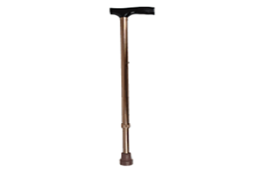
2 | Elbow crutches Large | pair | 25 | Large size, 85-110 cm  Height adjustable (3 cm between holes).  Height calculated from the rubber tip till  UNIT: pair  Material :Aluminium; hand cuff in palstic  extra: handgrip.Adjustable height and Hand grip height.Comfortable: Padded or soft forearm cuffs and ergonomic hand grips.Safety: Non-slip tips for stability. | 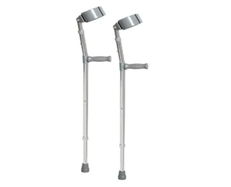
3 | Walking frame Adult without wheels | pcs | 10 | Size:75-95 cm  Foldable frame. Width of the frame= 51cm  Adjustables holes (3 cm between holes).  Material:Aluminum  UNIT: PC  Extra: Walker with 4 rupper Adjustable in height with ergonomic handles. | 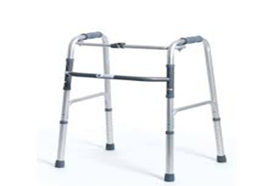
4 | Walking frame Child with wheels | pcs | 10 | Size:44-54 cm  Material: Aluminum  UNIT:PC  EXTRA: Walker with wheels. Adjustable in height with ergonomic handles. Foldable.child colours | 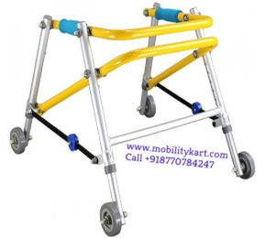
5 | Urinary flask (Male) | pcs | 5 | KY665B, AX: 400ML  urinal bottle for men | 
6 | Urinary flask (Female) | pcs | 5 | KY663B, MAX: 400ML  urinal bottle for female | 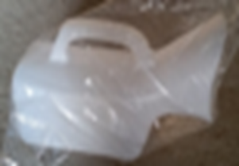
7 | Quadripode Cane | pcs | 10 | Size:75-95 cm  Cane with 4 feet. Holes adjustable (3 cm  between holes).  Material :Aluminium, ergonomic handle.  UNIT: PC | 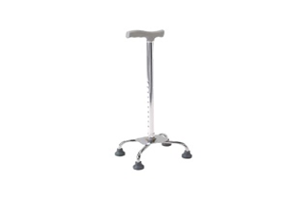
8 | White cane | pcs | 5 | SIZE:80-160 cm  UNIT:PC  Material: Aluminum  Extra: Adjustable Canes for The Blind persons | 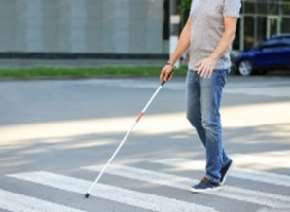
9 | Rubber Tip for elbow crutches | pcs | 25 | Elbow Crutches (Forearm Crutches): Usually use 19 mm (¾ inch) rubber tips because they have a thinner, lightweight frame. ✅ Smaller and lighter, meant for active users.  ✅ Often come with pivoting or articulated bases to adapt to movement.  ✅ Prioritize shock absorption for wrist and forearm comfort. | 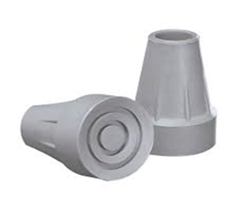
10 | Rubber tip for Walker | pcs | 25 | 22 mm (⅞ inch): Fits most standard lightweight aluminum walkers. | 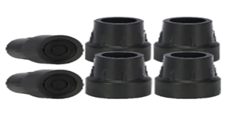
11 | Toilet chair (DY 821L) | pcs | 2 | Without wheel - steel commode chair & can be used as walker. | 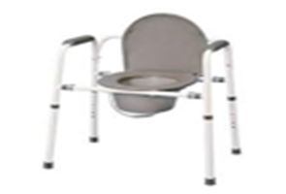
12 | COMMODE CHAIR (DY2608BGC-46) | pcs | 2 | Chromed plated steel frame, Reclining high back, Detachable armrest, Detatchable elevating leg rest,  8" PVC from castor, and 24" solid spoke wheel. | 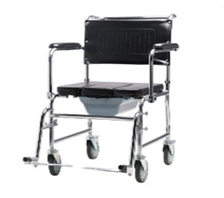
13 | Toilet chair (DY 2697L) | pcs | 2 | With wheel - aluminium commode & shower wheelchair , armrest fixed ,grey plastic.  Extra: Toilet seat with handels and adjustable height | 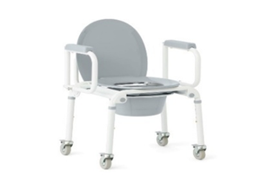
14 | Transfer Board | pcs | 2 | Slide Assist Device for Transportation from Wheelchair to Bed, Car, Bath and More, smooth and different size | 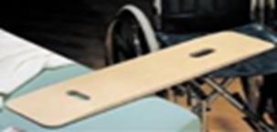
15 | Air Mattress H-5 | pcs | 10 | Anti bed sore mattress  Material: PVC 3 Ply Thickness: 0.3-0.4mm With big Cell Size: 200cmx90cm (inflated)Pump Specification: Size: 24x13x9 CM Weight: 1kgVoltage: AC 220VFrequency: 50Hz/60HzPower: 8W Pressure Range: 15-18kpaAir output: 4.5-5.5L/minutes Cycle time: 10-15 minutes Controlled by microcomputer | 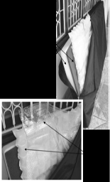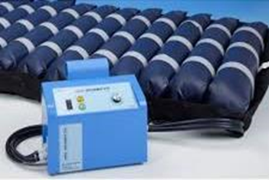
16 | Pressure relief cushion size 40 | pcs | 5 | Local made: Size 40CM L x 40 CM W and 5CM H. Foam with Oval CELL shape Covering Rexine. | 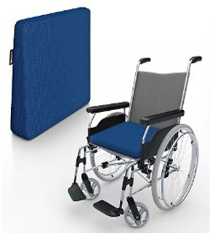
17 | Pressure Relief Cushion Size 45 | pcs | 6 | Local made: Size 40CM L x 45 CM W and 5CM H. Foam with Oval CELL shape Covering Rexine.
18 | Pressure Relief Cushion Size 50 | pcs | 5 | Local made: Size 40CM L x 50CM W and 5CM H. Foam with Oval CELL shape Covering Rexine.
19 | Pressure Relief Cushion Size 55 | pcs | 4 | Local made: Size 40CM L x 55 CM W and 5CM H. Foam with Oval CELL shape Covering Rexine.
20 | Wheel chair tyre pumb | pcs | 35 | valve similar to bike one , simple and lite weight , portable ...Pressure Capacity – Should be capable of at least 100 PSI (7 bar) to accommodate both standard and high-performance wheelchair tires. | 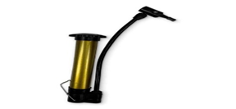
21 | Shoulder sling (Adult) | pcs | 5 | sizes: M,L&XL  Material: fabric (canvas  Features:  - Adjustable shoulder length design and easy to wear  - Shoulder strap with foam padded for great comfort  - Fits right or left arm  Indication:  - Shoulder immobilising  - Improve shoulder joint function | 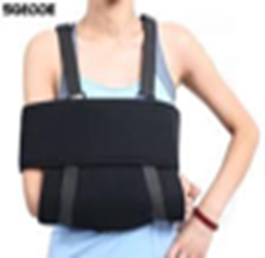
22 | Arm sling (Adult) | pcs | 5 | Sizes: S, M,L  Prefabricated articulated arm sling in light, washable fabric.  Reversible to fit right or left arm.  Sling needs to support a forearm in a plaster cast, if necessary.  A strap attached to the arm piece is worn around the neck to support the forearm.  Velcro fasteners.  If possible, choose an adjustable strap | 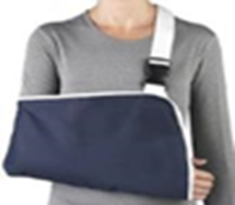
23 | Elastic bandage(Compressive 15cm and 10cm) | pcs | 20 | Width: 10 cm - 15 cm.Material: cotton and polyester Roll of maximum 1, 5 m in length extra: elastic compression bandage, has metal clip to hold in the place, washable and soft with different sizes and for amputee clients | 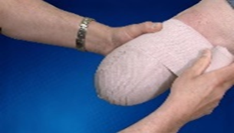
24 | standard wheelchair | pcs | 7 | (Designed for general use, basic mobility, and occasional transport)  Frame: Steel or aluminum (heavier, durable)  Weight: 15–25 kg (33–55 lbs)  Seat Width: 16"–20" (40–50 cm)  Seat Depth: 16"–18" (40–45 cm)  Backrest Height: 16"–20" (40–50 cm)  Armrests: Fixed or removable  Footrests: Swing-away or detachable  Wheels:  Rear: 24” solid or pneumatic tires  Front: 6”–8” casters  Brakes: Push-to-lock brakes  Folding Mechanism: Yes, foldable for transport  Usage: Short-term use, hospitals, and indoor settings  Push Efficiency: Low, requires more effort  Customization: Minimal | 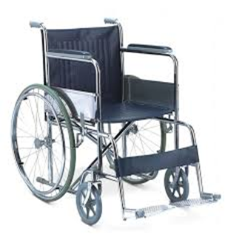
25 | CP wheelchair 35 | pcs | 5 | ""Designed for long-term use, providing postural support and mobility for CP patients.)  Frame Material: Lightweight aluminum, steel, or titanium  Weight: 10–20 kg (22–44 lbs) (varies by design)  Seat Width: 12""–18"" (30–45 cm) (custom-fit)  Seat Depth: Adjustable to suit the user  Backrest Height: High backrest (20""–30"") with headrest  Armrests: Adjustable, padded, and removable  Footrests: Elevating, adjustable, or tilt-in-space feature  Wheels:  Rear: 20”–24” (quick-release, large for self-propulsion)  Front: 3”–6” (smaller, for maneuverability)  Brakes: Manual brakes, optional attendant-controlled brakes  Folding Mechanism: Some models foldable, others rigid for stability  Reclining Feature: Often included for postural adjustments  Headrest & Side Support: Present for better head and trunk control  Tilt-in-Space Feature: Often included to reduce pressure sores and improve positioning Usage: Designed for children and adults with CP, providing support for sitting posture and mobility  Customization: Highly customizable with harnesses, lateral supports, cushions, and trays." | 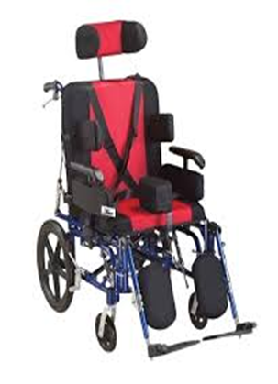
26 | CP wheelchair 40 | pcs | 4
27 | CP wheelchair 45 | pcs | 4
28 | CP wheelchair 50 | pcs | 4
29 | hospital wheelchair 40 | pcs | 5 | "Designed for short-term patient transport in hospitals and clinics.)  Frame Material: Steel or aluminum (durable but heavy)  Weight: 15–25 kg (33–55 lbs)  Seat Width: 16""–20"" (40–55 cm)  Seat Depth: 16""–18"" (40–45 cm)  Backrest Height: 16""–20"" (40–50 cm)  Armrests: Fixed or removable, padded for comfort  Footrests: Swing-away, detachable, or elevating  Wheels:  Rear: 24” solid rubber or pneumatic tires  Front: 6”–8” solid casters  Brakes: Push-to-lock manual brakes  Folding Mechanism: Yes, foldable for storage  Reclining Feature: Optional (for patients who need more support)  Headrest & Side Support: Usually absent  Usage: Short-term patient transport in hospitals, clinics, or nursing homes  Push Efficiency: Moderate, requires assistance from a caregive" | 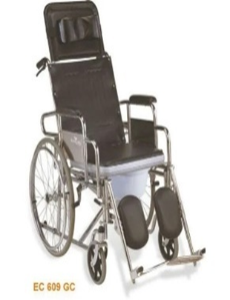
30 | hospital wheelchair 45 | pcs | 6
31 | hospital wheelchair 50 | pcs | 6
32 | hospital wheelchair 55 | pcs | 5
33 | active wheelchair 40 | pcs | 5 | "Designed for daily use, sports, and independent mobility)  Frame: Lightweight aluminum, titanium, or carbon fiber  Weight: 6–15 kg (13–33 lbs) (ultra-lightweight)  Seat Width: 12""–18"" (40–55 cm) (custom-fit)  Seat Depth: 14""–18"" (35–45 cm)  Backrest Height: 10""–18"" (25–45 cm) (adjustable for posture control)  Armrests: Minimal or absent for better movement  Footrests: Fixed or adjustable (sometimes integrated)  Wheels:  Rear: 24” to 26” quick-release, cambered for stability  Front: 3”–5” casters (smaller for maneuverability)  Brakes: High-performance, scissor, or sports brakes  Folding Mechanism: Some are rigid, some foldable  Usage: Daily active lifestyle, sports, outdoor and indoor use  Push Efficiency: High, requires less effort  Customization: Highly customizable (seat, wheels, backrest, frame, colors)" | 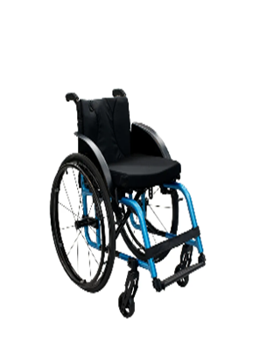
34 | active wheelchair 45 | pcs | 5
35 | active wheelchair 50 | pcs | 4
36 | active wheelchair 55 | pcs | 3
37 | Tilt Table | pc | 1 | size: 61cm wide x 195cm long x 80cm high  Safe working load and lifting capacity (from minimum height) of 225 kg. Height: minimum 47 cm - maximum 101 cm.  Electric height and tilting operation with hand control switch braked castor system adjustable angle dual foot boards: from +15° to -30° supplied with worktable. Patient hand grips and set of harnesses. tilt angle inclinometer fitted as standard iolite bearings on all pivot points clearance beneath frame for mobile hoist | 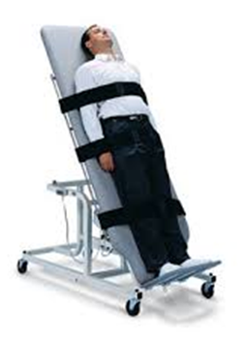
38 | Bed pan | pcs | 4 | Adult size: 14" X 11 3/8"  UNIT:PCS  Stainless steel material silver in color with cover easy to use and clean  Easy-to-clean, durable bed pan with a comfortable, larger design for enhanced comfort and spill-resistant features. | 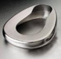

- Key Provisions:
- Bidders may decide to supply ALL or PART of the above listed Supplies. (Note that ability to supplying All is an added value).
- All bidders must reflect their Delivery Time in terms of number of WEEKS beginning from signing the contract.
- Delivery location of the items is at HI office in Lascanod -Heegan district -Lascanod General Hospital
- The Final Quantity to be Ordered may vary up to 25% Above or Below.
- HI reserves the right to award the whole supply for ONE Supplier/Importer.
- HI reserves the right to award the supply for TWO or MORE Suppliers/Importers if found necessary and agreed upon.

- Submission TECHNICAL:
ONE Original Technical in a sealed envelope and ONE Copy of Technical in a sealed Envelope must be submitted. The technical envelope must contain the following documents:
- Renewed business license for the year 2025 G.C
- VAT Registration certificate
- TIN Registration Certificate
- Tax Clearance
- Company profile showing experience in the importation or supply of related or similar items above
- Any Credentials showing experience in similar supplies to any entity.

- Submission FINANCIAL:
ONE Original and ONE Copy Financial must be submitted in SEPARATE ENVELOPES. This financial quotation must be given in the following way.
- Financial Quotation must be submitted only by filling price in a sequential order.
- Price must be given INCLUSIVE of VAT any other applied taxes.
- Each envelope and every page of the document inside must be duly stamped
Deviation from the above two Technical & Financial Submission instruction results in Immediate Disqualification.
Address to Collect & Submit the Tender Document is:
Humanity & Inclusion Office
Lascanod city , Heegan district, Lascanod General Hospital- HI office compound
Telephone: +25907264685/+252907740413
- Date of Collecting the Tender Document

Potential bidders may obtain the Tender documents from the above Mentioned Adress from 14th of April 2025.

- Date of Submission
From 15th April 2025 @ 09:00 AM - 27 April 2025 @4:00 PM
Any submission arriving later than 4:00 PM on 27 April 2025 will not be accepted.
- Bid Opening
Bid will be opened in Closed Session.
- Bid Evaluation
HI reserves the right to conduct Evaluation based on its internal procedure and best interest of the organization.

HI RESERVES THE RIGHT TO CANCEL THE BID IN PART OR IN FULL AND SELECT ANY BIDDER BASED ON ITS BEST INTEREST.

