List of hygiene kit per household

SN | ITEM | quantity | Picture | Unit price
1 | Jerry can Rigid 20 L circular 990g | 2 pcs per HH | 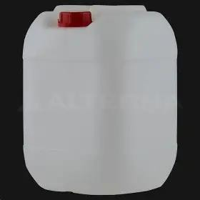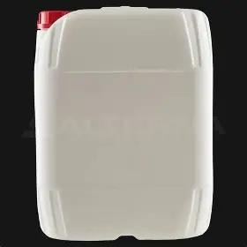
2 | Bucket,20L,  plastic w/ anse | 2 PCS PER HH | 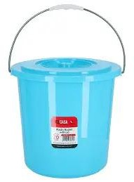

3 | 250 grams of soap for bathing per person | 24 pcs per HH | 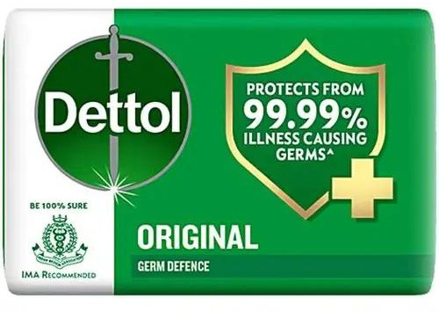

4 | SOAP, BAR, APPROX.200GR | 24 pcs per HH | 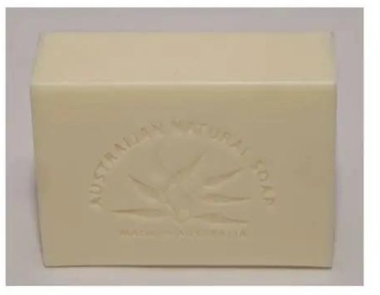
5 | Potty, to dispose of children’s faeces. | 2 pcs per HH | 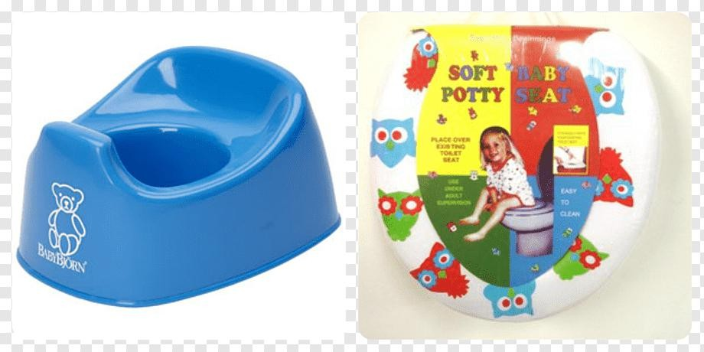
6 | Nail clippers | 6 Pcs per HH | 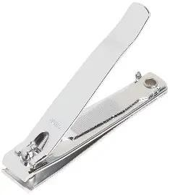

7 | Hair Comb Set | 6 pcs per HH | 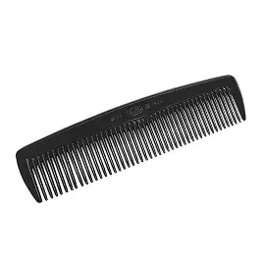
8 | Plastic bag | 1 pcs | 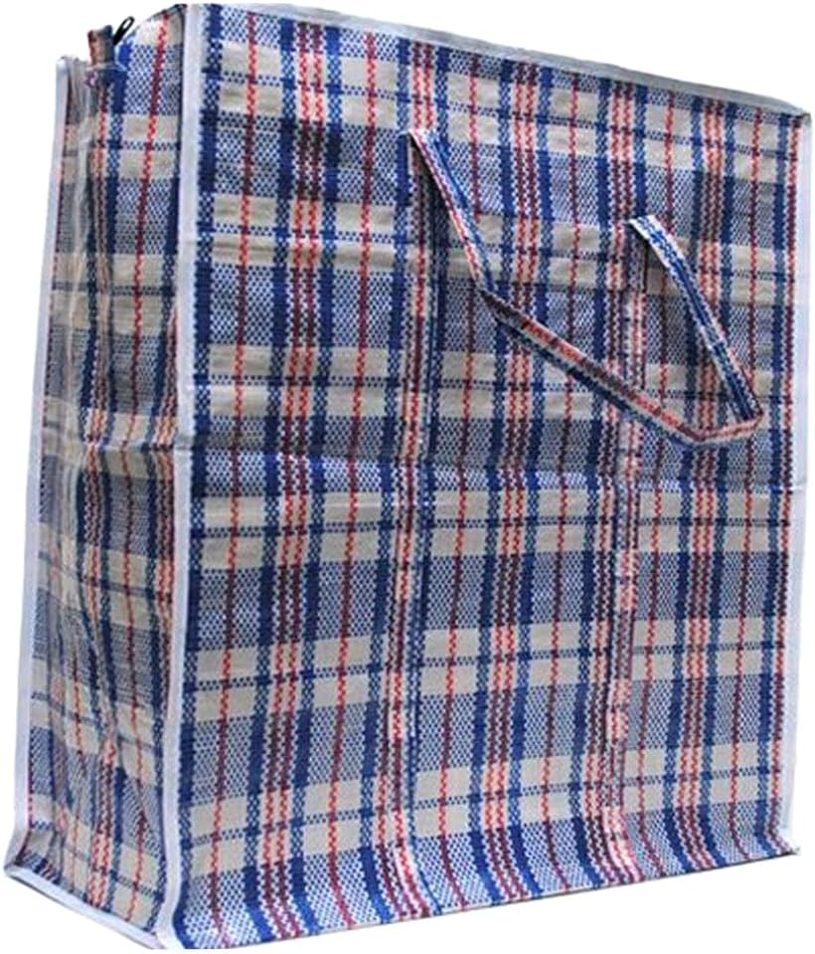
9 | Hand towel | 2 PCS PER HH | 