

EXPRESSION OF INTEREST (EOI)

S. No | TENDER NO. | DESCRIPTION
1 | WVSOM/25/10/FY25 | Procurement of Tractor Trailer with Lift

Introduction
World Vision Somalia is implementing the Joint Resilience Programme (JRP) in Galkacyo District, with funding support from KFW/WFP. The program aims to enhance the resilience of vulnerable households and communities in the Mudug region by addressing key issues such as food insecurity, economic vulnerability, and environmental shocks.

As part of the provided tractors in JRP 1 and continue its agricultural support interventions, the project seeks to procure a tractor trailer equipped with a hydraulic lift system, to facilitate the transportation of tractor disc ploughs, harrows, and related equipment. The trailer will be instrumental in supporting local farmers by enabling efficient mobility and field deployment of tractor discs, enhancing productivity and reducing labor constraints.

- Project Background:
Project name: Joint Resilience Programme (JRP)
Location: Mudug region
Sector: Food security and livelihood

2.1 Purpose, Scope and Objectives.
  - Enable the efficient transport of heavy farming implements (ploughs, harrows, etc.) to and from the fields.
  - Reduce manual labor associated with moving heavy equipment.
  - Support mechanized farming by enhancing mobility and accessibility of tractor attachments across multiple farming zones.
  - Contribute to improved land preparation and timely agricultural activities, thereby boosting crop production.
  - Increase operational efficiency of project-supported tractors.
  - Ensure long-term utility and durability of project assets by enabling safe equipment handling and transport.

2.2 3. Scope of Work / Requirements;

The selected supplier will be required to supply and deliver a tractor trailer with hydraulic lifting mechanism, meeting the technical specifications provided below. The trailer must be new, high-quality, durable, and suitable for use under local agricultural field condition

S/N | Item Description | Technical specification | Quantity | Image
1 | Tractor Trailer with lifter | Type:Hyd tipping,Capacitt 5ton, vessel size 10’x6’x2’, floor:MS Sheet SWG10, Sidewall: MS Sheet SWG12, Lower channel 7’x3’, Upper channel 6’x3’, Length 52’, outer dia 5’, wall thickness 3/8’, Size:8.25-20  Long 4m*wide 3m*up0.8m  Lifter: Mini Unic lifter, hydraulic, carry capacity 2tone | 2 | 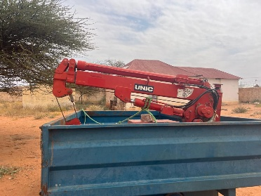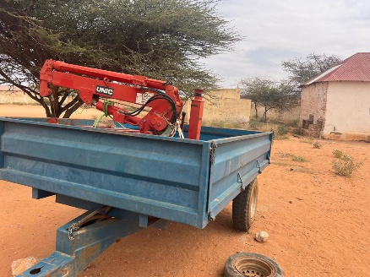  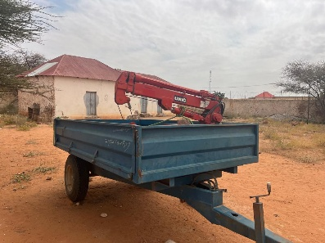  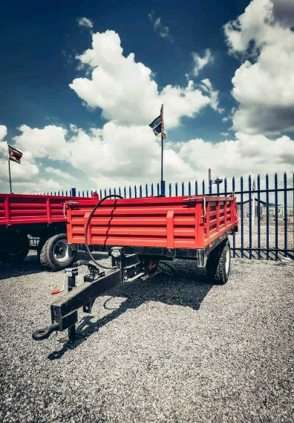

More Details to be provided in full RFQ upon Expression of Interest.

We hereby invite Expression of Interest from registered, approved and reputable consultants to provide above-named services to World Vision Somalia.

IMPORTANT NOTES TO BIDDERS

- Interested bidders must be registered to provide consultancy services in their respective countries.
- Request for Proposal documents will be available Free of Charge to all interested bidders who express interest by filling the form provided in this link https://forms.office.com/r/mSxWvYA7Lt by 5:00 Friday 3rd October2025
- Instructions for submission of completed proposals shall be indicated on the Request for Proposal document.
- Nothing in this Expression of Interest shall be construed to give rise to contractual obligations with World Vision.
- World Vision, may at its absolute discretion, suspend or defer this EOI process.
“World Vision reserves the right to accept or reject any Bid and is not bound to give reasons for its decision”

