PROJECT NAME: CLIMATE-RESILIENT WASH AND LIVELIHOODS PACKAGE FOR RESILIENT SOMALI LANDSCAPES
PROJECT NUMBER: SOM 1065 – TOP-UP

From: Welthungerhilfe
Airport Road, next to Djibouti Consulate
Hargeisa, Somaliland

RFQ-SOM1065-103

DATE: 22.12.2025

QUOTATION FOR PURCHASING 300 HYGIENE KITS FOR THE SITES IN NEW TOP-UP SITES
SPR REFERENCE NO: 65308

Submission Date
Company Name
Address
Tel/Mobile
Official Email

Your company is cordially invited by the Office of Welthungerhilfe to submit a firm offer for the following hygiene Kits

SN | ITEM DESCRIPTION | Unit | QTY | IMAGE | Unit Price | Total Price
1 | Jerricans Rigid, 20L, circular, white color | Pcs | 600 | 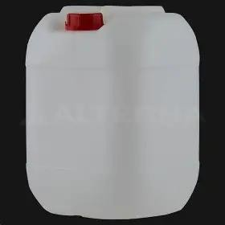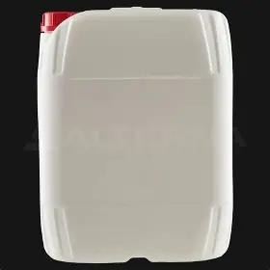
2 | Bucket 20l bucket 20l green/ blue/red | Pcs | 600 | 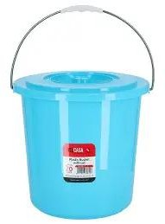
3 | Bath soap Dettol 250g | Pcs | 7200 | 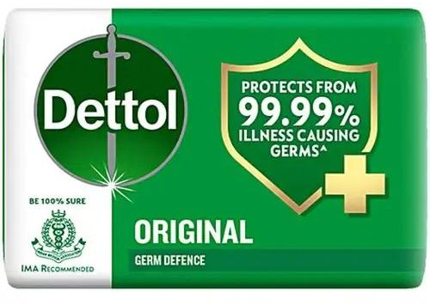
4 | Laundry soap bar  ex. Oomaar or ileys laundry soap 200 gram | Pcs | 7200 | 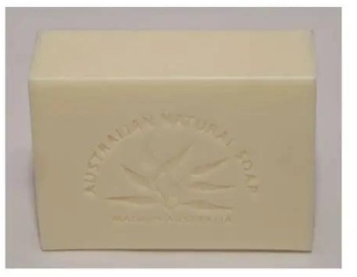
5 | Potty Children potty for feaces  disposal | Pcs | 600 | 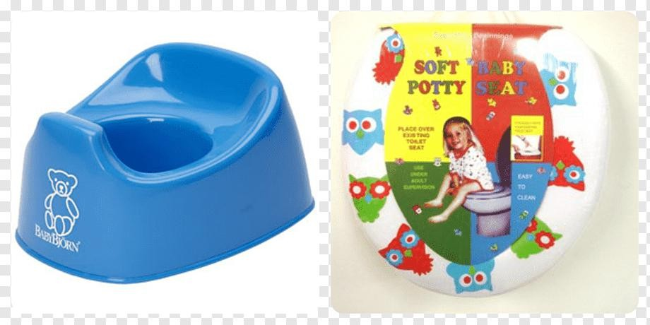
6 | Nail clipper different size (medium/large) | Pcs | 1800 | 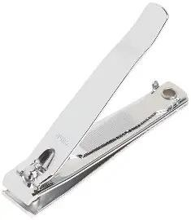
7 | Comb Hair comb | Pcs | 1800 | 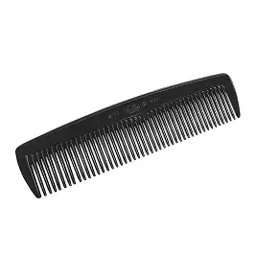
8 | Plastic bag Nigerian plastic bag with zipper  (large size) | Pcs | 300 | 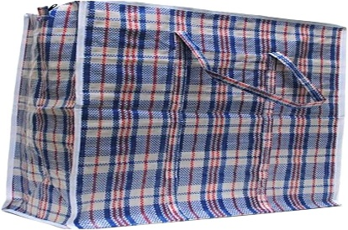
9 | Hand towel | Pcs | 600 | 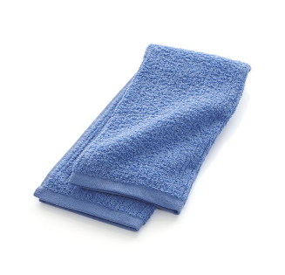
10 | Packaging per HH | Item | 360
 | Total Amount

Note: The Delivery location is Welthungerhilfe Burco and Borama Offices

Your quotation should also clearly indicate the following.
- Confirmed Delivery Period: ....................................................
- Validity of the offer (preferable 90days) …………………………………………….

Requirements for Compliance:
- Ensure timely submission of your quotation by the specified deadline, which is up to on 05th January 2026 at 23:59pm. Companies failing to submit their quotations by this deadline will not be considered at all.
Note: tender requirements and mandatory documents are captured in the invitation to the tender which is annexed to this document.

