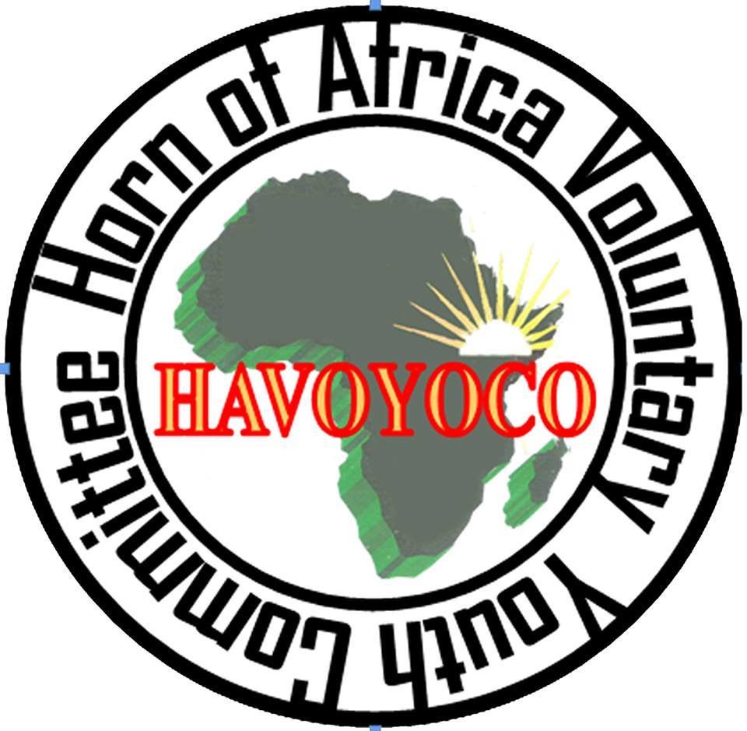

Horn of Africa Voluntary Youth Committee
(HAVOYOCO)
Invitation for Prequalification of Suppliers for Goods/Services 2025
Background
HAVOYOCO is regional organization founded in 1992 and since its inception in 1992; HAVOYOCO has successfully implemented different projects. HAVOYOCO learning from the past experiences decided to start development programs that would involve the beneficiaries at the grassroots and assists the nation’s reconstruction and development, endeavor through the long route process HAVOYOCO refocused and streamlined its projects.

What are we looking for? HAVOYOCO-Somaliland is inviting all pre-qualified suppliers to compete for the provision of various goods and services, including.
S/N | REFERENCE CODE | CATEGORY
1 | HAV/2025/01 | Supply Office Stationeries (Pen, Ink, Note books)
2 | HAV/2025/02 | Printings and Publication (Posters, Stickers, Banners Billboards, T-shirts, hats, pens, etc.
3 | HAV/2025/03 | Supply of Electronics and Electric Materials
4 | HAV/2025/04 | Office Furniture (chairs, tables, shelves,)
5 | HAV/2025/05 | Fuel station (Petrol, Diesel, Filters, Carwash, and Lubricants)
6 | HAV/2025/06 | Hotel Service and catering for meetings, workshops,
7 | HAV/2025/07 | Cafeteria Service and catering for meetings, workshops,
8 | HAV/2025/08 | Provision of Land Transport and Carriage Services e.g. Vehicle Rental and Leasing Services
9 | HAV/2025/09 | Supply of ICT Materials and Maintenance (computers, laptop, printers,)
10 | HAV/2025/10 | Building Materials e.g. Hardware Materials
11 | HAV/2025/11 | Tailoring Materials
12 | HAV/2025/12 | Food such as Rice, Spaghetti, and drinking water.
13 | HAV/2025/13 | Professional Consultancy Services and Training (auditing, training & capacity building, Translation, and Interpretation)
14 | HAV/2025/14 | Facilitators and Enumerators
15 | HAV/2025/15 | Construction companies/Dams
16 | HAV/2025/16 | Auto mechanics and Welding materials
17 | HAV/2025/17 | Vehicle Maintenance/Garages
18 | HAV/2025/18 | Office Sanitary Kits (Soap, Shampoo, Cleaning tools)
19 | HAV/2025/19 | Office Tea and Beverages Supplies (Black tea, Xawaasha, cups, flasks, containers)
20 | HAV/2025/20 | Communication Services i.e. Prepaid and Internet
21 | HAV/2025/21 | Media Advertisement Agencies i.e., News, Programming, Photography, and filming
22 | HAV/2025/22 | Artists (Billboards, Signboard)
23 | HAV/2025/23 | Office Maintenance: Plumbing, Electric heaters, Carpentering, and Minor
24 | HAV/2025/24 | Water Office Supply: Water for Office Cleaning Purposes
25 | HAV/205/25 | Architecture firms and Design
26 | HAV/2025/26 | Environmental and Social Impact Assessment firms
27 | HAV/2025/27 | Food and safety Experts
28 | HAV/2025/28 | Job and Tender Advert Suppliers
29 | HAV/2025/29 | Electronic Transfer Suppliers
REQUIREMENTs
Suppliers should submit (a) a Company profile indicating the year of establishment (b) a Company Capacity/Financial stability (c) a Valid registration certificate with a respective ministry, and commerce (d) an Updated CV (if your request is a consultant or Facilitator). (e) Past experience in similar work (f) Quoted amount per quotation.

How to collect the quotation
To apply please collect relevant quotations from the HAVOYOCO HQ office located in Badacas 527619 and Burco office 711272, from December 19^{th,} 2025 to 05 January 2025.

HOW TO APPLY
All interested suppliers should return the bid document in a sealed envelope to our Head Quarter Office located in Hargeis,Badacas 527619 and Burco Office 711272 marked in PRE-QUALIFIED QUOTATION mentioning your requested area not later than Sunday 05 January 2025. N.B: The quotation will be sent to your email.
For any enquires please contact procurement@havoyoco.org,or admin.hr@havoyoco.org,

