INVITATION TO RFQ, FOR SUPPLY WASH NFI KITS

Advertisement – Sunday 9th March 2025

OPEN LOCAL TENDER –SUPPLIES OF WASH NFI KITS

World Vision Somalia (WVS) is implementing various projects in different regions through local implementing partners as well as directing implementation of its program expansion and quality improvement of Livelihood, WASH, Health, Child protection and commodities activities in Somalia. WVS is advertising an Open Local Tender for WASH NFI Kits in Galmudug state.

Lot | Description of planned activities | Location | Tender Open | Tender Closure
1 | RFQ for supplies of WASH NFI Kits in Galmudug state. | Galkacyo Somalia | ^{9th} March 2025 | 20th March 2025 at 10;00am
Information to bidders:

Subject: Requirements: -
World Vision Somalia aims to procurer WASH NIF supplies in Galmudug, therefore we invite all the reliable companies in this sector to apply this RFQ and make their officer-based requirement in the below table.

Requirement schedule;

Item/Description | Unit | Qty | Unite price |  | Amount
Jerrycans 20-liter capacity | Pcs | 1000
Buckets 20-liter capacity with lid (HDPE bucket) | Pcs | 500
Laundry Bar Soap (200 grams) | Pcs | 5000
Lux 175g Bathing soup | Pcs | 4500
Total
.
Manner of Submission/Submission Procedure:

Kindly submit your bids in hard copy to WVS OFFICE in South Galkayo, Galmudug Galmdugu state.

Closing Date: Thursday 15th March 2025, 10:00 Hours East African Time

Important: Offers transmitted in any other manner than those indicated above will not be considered.
Your offer should clearly indicate and include:
- Unit Cost per item
- Validity Period of the Quote/ the offer:
- Lead time;
- Terms of Payment: to be paid after delivery in full specifications to be ordered
- Relevant experience for supplies of WASH NFI kits (contracts or recommendation from former clients)
- Companies should drop sealed hard copy bids to the tender box in WVS in Galkacyo Galmudug office

(MANDATORY REQUIREMENTS)
- Provide a certified copy of a certificate of business registration, certificate of incorporation, business license or similar document;
- Provide a certified copy of tax registration, tax clearance certificates or similar documents;
- Provide local government registration for any Galmudug Districts.

Note: Bidders who will not adhere to mandatory requirements will automatically be disqualified.

TECHNICAL REQUIREMENTS
- three (3) years’ experiences in similar works (attach current and previous contracts/LPOs) - past experiences for supplies of NFI kits that are similar to those that have been stated in this advert.
- Bank statement for the last 6 Months.
- A list and contacts of your clients receiving similar supplies from your company
- A brief description of your company profile (Attach company profile)

Information to bidders:

- Currency of offer should be in US Dollars Currency
- The items will be delivered to Word vision office in South Gakayo.
- Payment will be made to the supplier by check or bank transfer within 30 days from receipt by World Vision Puntland, Garowe office.
- World vision Somalia will not be responsible for any bank service charges.
- Inspection (at buyer’s expense or unless negotiated as seller’s expense) may be applicable and will be advised at time of purchase order and arranged by World vision Somalia or the supplier.
- World vision Somalia does not undertake to pay by letter of credit or in advance of delivery.
- World vision Somalia reserves the right to accept the whole or part of your offer.
- World vision Somalia not responsible for any taxes or levies.
- Hand-written, incomplete offers or offers which do not comply with any of our tender conditions will not be considered.
- When applied - There will be liquidated damages equivalent to a deduction of 0.1% per day or part thereof for late deliveries due to default on the part of the suppliers.
- Guarantee against anti-personnel mines: World vision Somalia has decided to support an international ban on anti-personnel mines. Anti-personnel mines have killed and maimed and continue to kill and maim many refugees. A high proportion of these innocent victims are women and children. These mines pose a serious obstacle to the return of millions of refugees and displaced people around the world. World vision Somalia shall therefore not knowingly buy products from companies that sell or manufacture anti-personnel mines or their components. If you submit a bid based on this request, it shall constitute a guarantee that neither your company nor any affiliate or a subsidiary controlled by your company sell or manufactures anti-personnel mines or their components. A contract clause confirming this will be included in an eventual purchase order based on this request.
- Environmental policy: World vision Somalia policy is to purchase products and services, which have the least negative impact on the environment. Environmental considerations covering manufacture, transport, packing, use and disposal of goods form part of World vision Somalia evaluation and selection criteria.
- Terrorists: World vision Somalia will not do any business with any known terrorist group or company involved in anyway with terrorists. World vision Somalia shall therefore not knowingly purchase goods or services from companies that are involved with terrorist groups in any form. If you submit a bid based on this request, it shall constitute a guarantee that neither your company nor any affiliate nor a subsidiary controlled by your company are not involved with any known terrorist group. A contract clause confirming this will be included in an eventual purchase order based on this request.
Please acknowledge receipt of this enquiry and indicate your interest to bid.
Thank you and regards,
World Vision Somalia
Tender Committee

Annex -Description and photos of the items
No. | Item Description | Image
1 | Water collection container Jerry can 20 litters with lid | 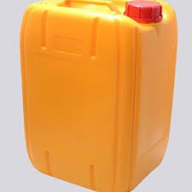
2 | 20 Liters Bucket with lid (HDPE bucket. | 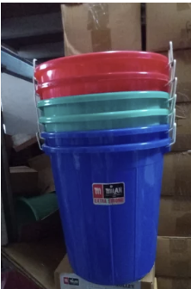
 | Laundry Bar Soap 200g | 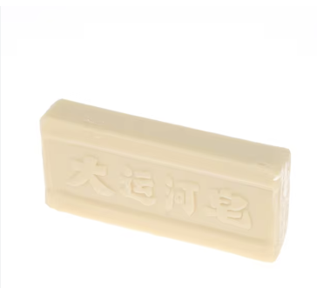
 | Lux 175g bathing soap | 