
Annex II_A: Technical Specifications and Photo
Prosopis Hand Tools
SPR_No: 68157 - prosopis tools

Pos | Quantity | Description | Specification
Pos | (incl.unit) | (Commodity or Service) | (can use several lines for details)
1 | 514 pair | Safety boots | Size assortment: FR 35-48, Color: Black, Upper: Barton Action Leather, Lining: Breathable Mesh, Anti-penetration sole: Steel Mid sole, Safety Toecap: Steel-Impact resistance 200 J  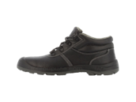
2 | 48 pcs | Round Shovel/ Spade | handle Material: Alloy Steel Color: Cold Steel.  Item dimensions: L x W x H 7.87 x 0.39 inches Item, Weight: 900 Grams Handle, Material: Metal Blade Material: Alloy Steel  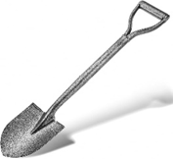
3 | 32 pcs | Rake | Steel, Aluminum, or Plastic (Head); Wood, Steel,  12 to 24 inches (30-60 cm)  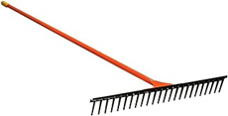
4 | 16 pcs | Wheelbarrow | with solid/puncture proof tires.  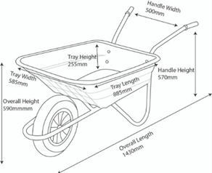
5 | 125 pcs | Iron sheet | (Length 220cm, width 70cm)  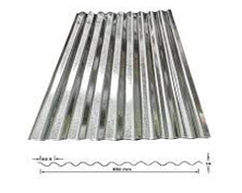
6 | 92 pcs | Axe | 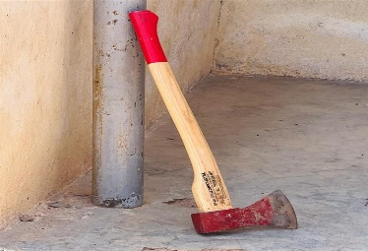  Material: Steel blade,  Handle: red wood, Handle Length: 70cm, Dimension: L92 x W28 x D4 cm, Weight: approx. 2.8kg
7 | 46pcs | Crow bars | 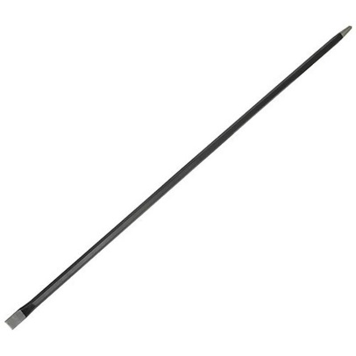  1.5m, Diameter 32mm two sided
8 | 46 pcs | Plastic sheet / tarpaulin | 6 M X 8 M Heavy-duty, waterproof

